The ‘Third’ Gender and a Room of One’s Own: Trans-Struggle for Identity and Existence in India

Date: 9 March 2021

Department of Languages, Manipal University Jaipur organized an invited online lecture on The ‘Third’ Gender and a Room of One’s Own: Trans-Struggle for Identity and Existence in India’ for students and faculty members. Expert for the lecture was Dr. Preeti Choudhary from Department of English, University of Rajasthan.  Dr Preeti was welcomed by Dr Tanuja Yadav, Head, Department of Languages, Manipal University jaipur.  Dr Preeti briefed about various issues being faced by transgenders in India. She briefed that studies on gender dynamics in society focus mostly on relations between women and men. Transgender people are often forgotten under the category of “diversity”. Transgender people are those whose gender identity or expression is different from the one typically associated with their assigned sex at birth. Further, she informed, when an individual is born, society interprets their body as belonging to a particular gender – in Indian society, female or male – and socializes them in accordance with the customs seen as pertaining to that body – respectively, femininity or masculinity. | 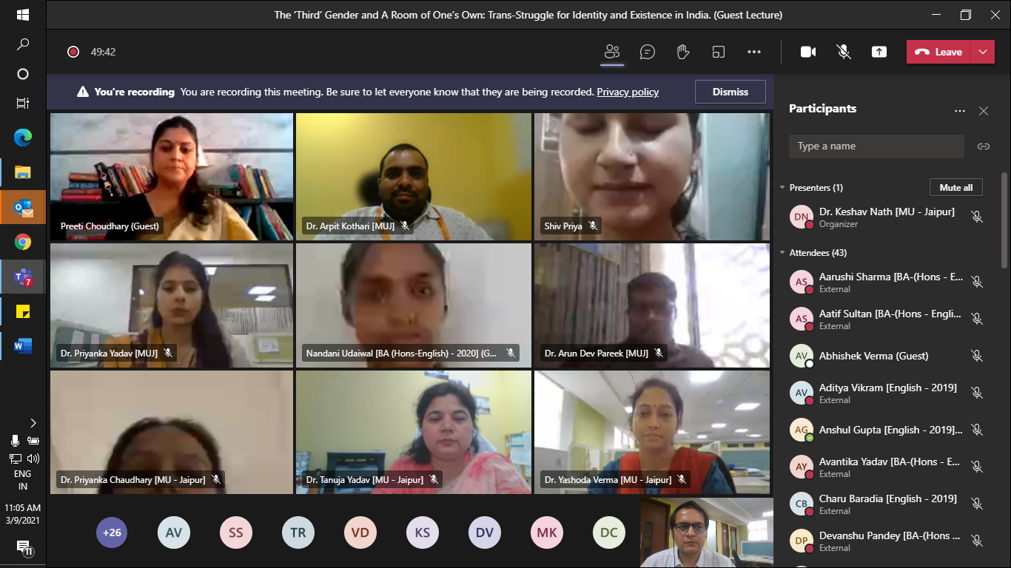  Dr Preeti Choudhary delivering expert lecture on The ‘Third’ Gender and a Room of One’s Own: Trans-Struggle for Identity and Existence in India’ at Department of Languages Manipal University jaipur.
She briefed that transgenders do not identify with the gender they are assigned or with the way society expects them to express such gender through clothes, gestures, mannerisms, and other characteristics. The way transgender people understand and express their gender, therefore, breaks with the binary logic.
Lecture concluded on the note that there is lot to be done for transgenders and as young scholars we should observe these patterns of social behavior. The lecture ended with vote of thanks from coordinator of the lecture Dr Keshav Nath, Assistant Professor to the expert and participants.

