FACULTY OF Arts

NAME OF SCHOOL
School of Media and Communication
NAME OF DEPARTMENT
Journalism and Mass Communication
NAME OF EVENT
Hindi Journalism and Language
Type of event-Industry Lecture
Date of Event
30 May 2022

- Brief Description of the event
In the session, the speaker Mr. Virendra Arya told about the importance of language in journalism. He suggested that language is a very important part of journalism, especially in Indian Language Journalism. Hindi is one of the popular language in the journalism industry. Most of the highest circulated newspaper are being published in Hindi language. The language of Hindi newspaper is changing with time and publication area. In NCR region, the Hindi language of newspaper is different from other regions like Uttar Pradesh, Bihar, Jharkhand etc. But in a common reference, the language of newspaper should be concise, clear and crisp. Dr. Vaishali Kapoor gave the welcome speech and Dr. Amit Sharma concluded the event with vote of thanks.

- 3 to 5 photographs of the event or screenshots of the event (if online) with captions

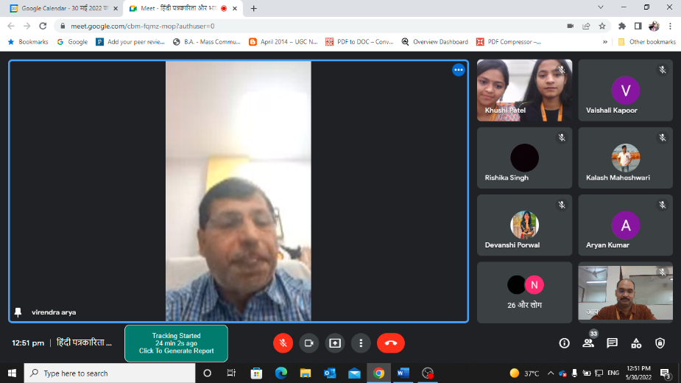
Mr. Virendra Arya, Editor, Amar Ujala during the session.

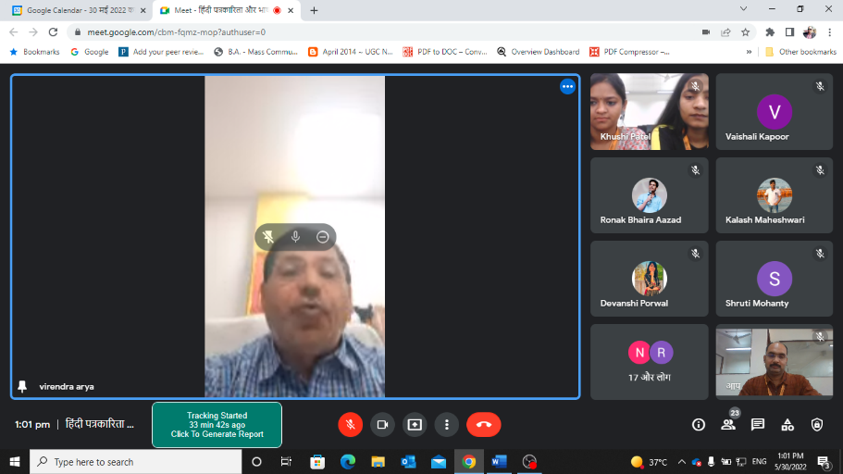
Mr. Virendra Arya, Editor, Amar Ujala interacted with the students of BA(J&MC) during the session on Hindi Journalism.
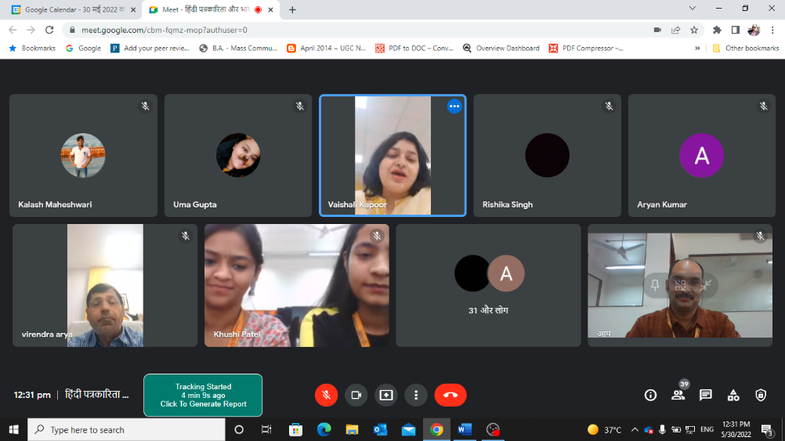
Mr. Virendra Arya, Editor, Amar Ujala interacted with the students of BA(J&MC) during the session and Dr. Vaishali Kapoor has given vote of thanks.

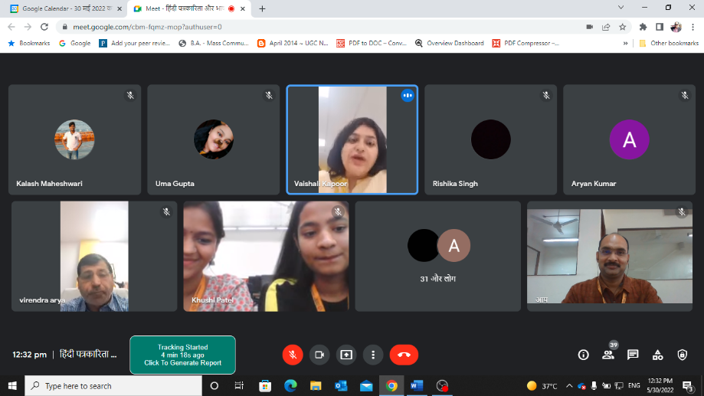
Mr. Virendra Arya, Editor, Amar Ujala interacted with the students of BA(J&MC), Dr. Vaishali Kapoor and Dr. Amit Sharma during the session.

- Brochure or creative of the event
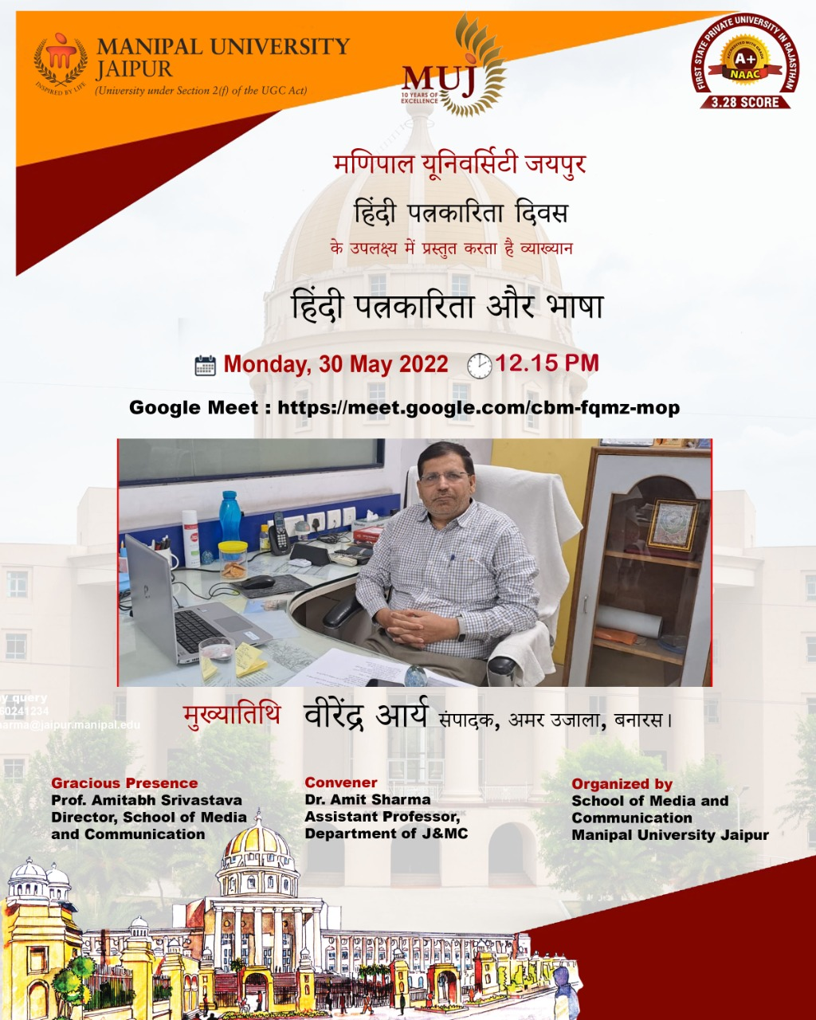

- Schedule of the event

- Attendance of the Event
Sr. No | Name of Institution | Place of Institution | Registration Number/Employee code | Name of Attendee | Name of Dept
 | MUJ | Jaipur | 211201001 | ANSH WALIA | J&MC
 | MUJ | Jaipur | 211201002 | HARSH VARDHAN SHARMA | J&MC
 | MUJ | Jaipur | 211201003 | SANSKRITI PRATEEK SHARMA | J&MC
 | MUJ | Jaipur | 211201004 | IPSITA KUMARI SAHU | J&MC
 | MUJ | Jaipur | 211201005 | JANHAVI RAITANI | J&MC
 | MUJ | Jaipur | 211201006 | VISHNU BANKA | J&MC
 | MUJ | Jaipur | 211201007 | HARSHITA OJHA | J&MC
 | MUJ | Jaipur | 211201008 | IPSHITA ARORA | J&MC
 | MUJ | Jaipur | 211201009 | SANIYA PRATEEK KUMAR | J&MC
 | MUJ | Jaipur | 211201010 | SAMYA SHARMA | J&MC
 | MUJ | Jaipur | 211201012 | DEVANSHI NILESH PORWAL | J&MC
 | MUJ | Jaipur | 211201013 | ANANNYA CHAKRABORTY | J&MC
 | MUJ | Jaipur | 211201014 | GOPAL SHRIVASTAVA | J&MC
 | MUJ | Jaipur | 211201015 | CHANCHAL SINGH | J&MC
 | MUJ | Jaipur | 211201016 | BHAVNA CHETRY | J&MC
 | MUJ | Jaipur | 211201017 | FLORA ALEXEN | J&MC
 | MUJ | Jaipur | 211201018 | KALASH MAHESHWARI | J&MC
 | MUJ | Jaipur | 211201019 | RIDDHI PRAVIN PAWAR | J&MC
 | MUJ | Jaipur | 211201020 | HARSHITA LALWANI | J&MC
 | MUJ | Jaipur | 211201021 | SALONI KHANDELWAL | J&MC
 | MUJ | Jaipur | 211201022 | SANSKAR BEHERA | J&MC
 | MUJ | Jaipur | 211201023 | UMA | J&MC
 | MUJ | Jaipur | 211201024 | RHYTHM GOYAL | J&MC
 | MUJ | Jaipur | 211201025 | PRACHI SIRVI | J&MC
 | MUJ | Jaipur | 211201026 | SAKET SUMAN | J&MC
 | MUJ | Jaipur | 211201027 | NASHRAH MATEEN | J&MC
 | MUJ | Jaipur | 211201028 | SAI MITHILESH PATRO | J&MC
 | MUJ | Jaipur | 211201029 | RINI PAL | J&MC
 | MUJ | Jaipur | 211201031 | SANJANA | J&MC
 | MUJ | Jaipur | 211201032 | KARAN ANAND | J&MC
 | MUJ | Jaipur | 211201033 | SHRUTI MOHANTY | J&MC
 | MUJ | Jaipur | 211201034 | NANDINI ASDEO | J&MC
 | MUJ | Jaipur | 211201035 | NANDINI AGGARWAL | J&MC
 | MUJ | Jaipur | 211201036 | NEHAL ACHARYA | J&MC
 | MUJ | Jaipur | 211201037 | MAHEK CHOKHANI | J&MC
 | MUJ | Jaipur | 211201038 | HRITHIK GOYAL | J&MC
 | MUJ | Jaipur | 211201079 | MALVIKA VARDHAN | J&MC
 | MUJ | Jaipur | 211201081 | SONALI MEHTA | J&MC
 | MUJ | Jaipur | 211201082 | BARKHA MADAAN | J&MC
 | MUJ | Jaipur | 211201040 | BHAVYA VASHISTH | J&MC
 | MUJ | Jaipur | 211201041 | KHUSHI PATEL | J&MC
 | MUJ | Jaipur | 211201042 | ARYAN | J&MC
 | MUJ | Jaipur | 211201043 | SUHANI SONI | J&MC
 | MUJ | Jaipur | 211201044 | VANSHIKA DADHICH | J&MC
 | MUJ | Jaipur | 211201046 | MEGHA PANDEY | J&MC
 | MUJ | Jaipur | 211201047 | SAMRIDDHI TIWARI | J&MC
 | MUJ | Jaipur | 211201048 | JYOTI KUMARI | J&MC
 | MUJ | Jaipur | 211201049 | ANUSHKA KUMAR | J&MC
 | MUJ | Jaipur | 211201050 | SHREYA JHA | J&MC
 | MUJ | Jaipur | 211201051 | KRATIGYA MANJHU | J&MC
 | MUJ | Jaipur | 211201052 | AKASH GORA | J&MC
 | MUJ | Jaipur | 211201053 | JOSHITA JOSHI | J&MC
 | MUJ | Jaipur | 211201054 | RINI GUPTA | J&MC
 | MUJ | Jaipur | 211201055 | GIRISH RATHORE | J&MC
 | MUJ | Jaipur | 211201056 | JUHI DAWRA | J&MC
 | MUJ | Jaipur | 211201057 | CHARMI RANJIT JAIN | J&MC
 | MUJ | Jaipur | 211201058 | SHACHI | J&MC
 | MUJ | Jaipur | 211201059 | MADHAV METHI | J&MC
 | MUJ | Jaipur | 211201060 | RITIKA NARANG | J&MC
 | MUJ | Jaipur | 211201061 | KHUSHI SURESH SINGHAL | J&MC
 | MUJ | Jaipur | 211201062 | AVNI GAUR | J&MC
 | MUJ | Jaipur | 211201064 | RIDDHI SUNIL DAGA | J&MC
 | MUJ | Jaipur | 211201065 | PRIYANSHU BRAJWASI | J&MC
 | MUJ | Jaipur | 211201066 | RAKSHITA SINGH PAL | J&MC
 | MUJ | Jaipur | 211201067 | AADYA CHATTERJEE | J&MC
 | MUJ | Jaipur | 211201068 | REET KLER | J&MC
 | MUJ | Jaipur | 211201073 | ISHIKA SURANA | J&MC
 | MUJ | Jaipur | 211201074 | MIMANSHA RANAWAT | J&MC
 | MUJ | Jaipur | 211201075 | RAJEEV JANGID | J&MC
 | MUJ | Jaipur | 211201076 | MANSI GOTHARWAL | J&MC
 | MUJ | Jaipur | MUJ1124 | Dr. Amit Sharma | J&MC
 | MUJ | Jaipur | MUJ0760 | Dr. Vaishali Kapoor | J&MC

Event Coordinator:
Dr. Amit Sharma, Assistant Professor,
Department of Journalism and Mass Communication.

