FACULTY of Arts

NAME OF SCHOOL
School of Media and Communication
NAME OF DEPARTMENT
Journalism and Mass Communication
NAME OF EVENT
Language of Electronic Media
Type of event- Industry Lecture

Date of Event
28 June 2022

- Brief Description of the event
Department of Journalism and Mass Communication organized an industrial lecture on Language of Electronic Media. The speaker of the event was Dr. Kumar Kaustubha, Associate Executive Producer, Aaj Tak. He told about the language of TV media. He suggested that language of TV is changing day by day. Hindi is under influence of local language. So, always use the simple language in news script. BA(J&MC) student Avisha Pareek moderated the session. Students learned about the language of TV Media. He shared his story and past to get us the perfect knowledge about this field. The topic of the lecture was the part of syllabus of course Hindi Bhasha Evem Media (JC1210). Dr. Amit Sharma course coordinator of Hindi Bhasha Evem Media coordinated the event.

- 3 to 5 photographs of the event or screenshots of the event.

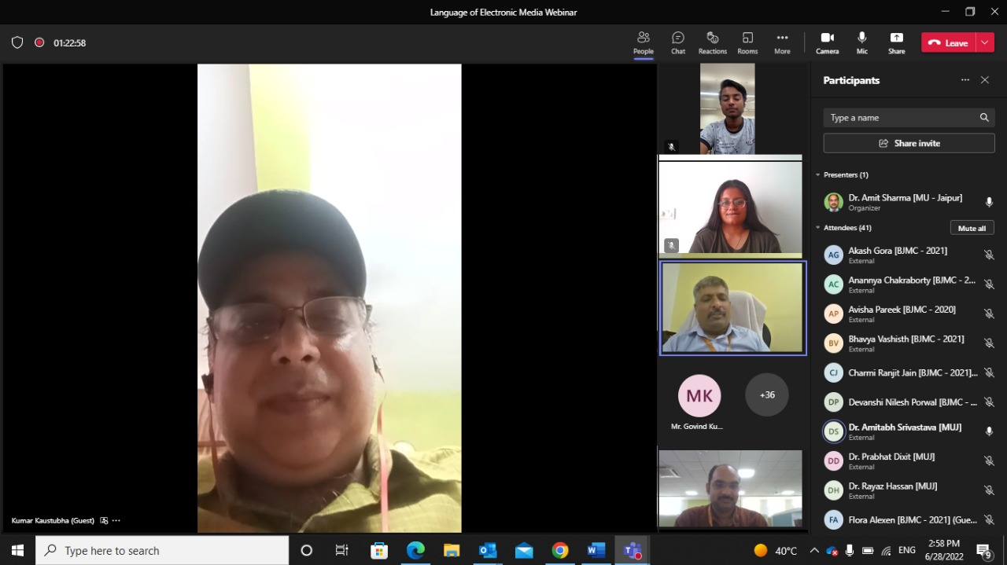
Expert Dr. Kumar Kaustubha interacted with the students of students of BA(JMC) first year and faculty members of SMC.
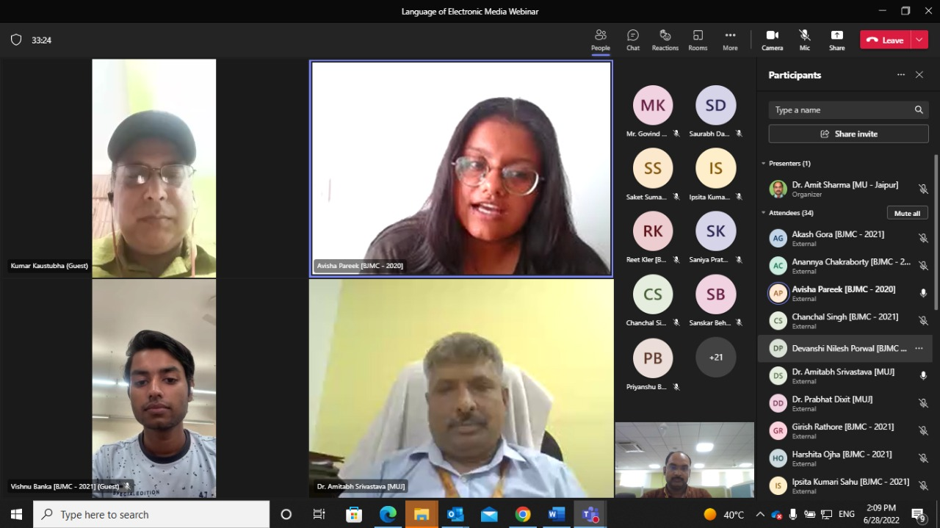
Expert Dr. Dr. Kumar Kaustubha interacted with the students of students of BA(JMC) first year and faculty members of SMC.
Expert Dr. Kumar Kaustubha interacted with the students of students of BA(JMC) first year and faculty members of SMC.

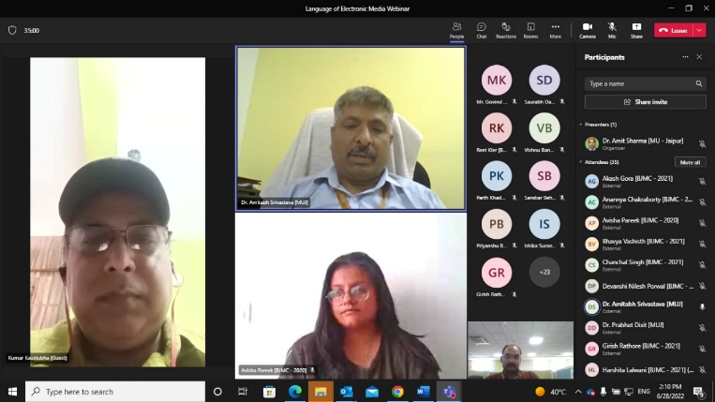
Expert Dr. Dr. Kumar Kaustubha interacted with the students of students of BA(JMC) first year and faculty members of SMC and moderator of the event Avisha Pareek.

- Brochure or creative of the event

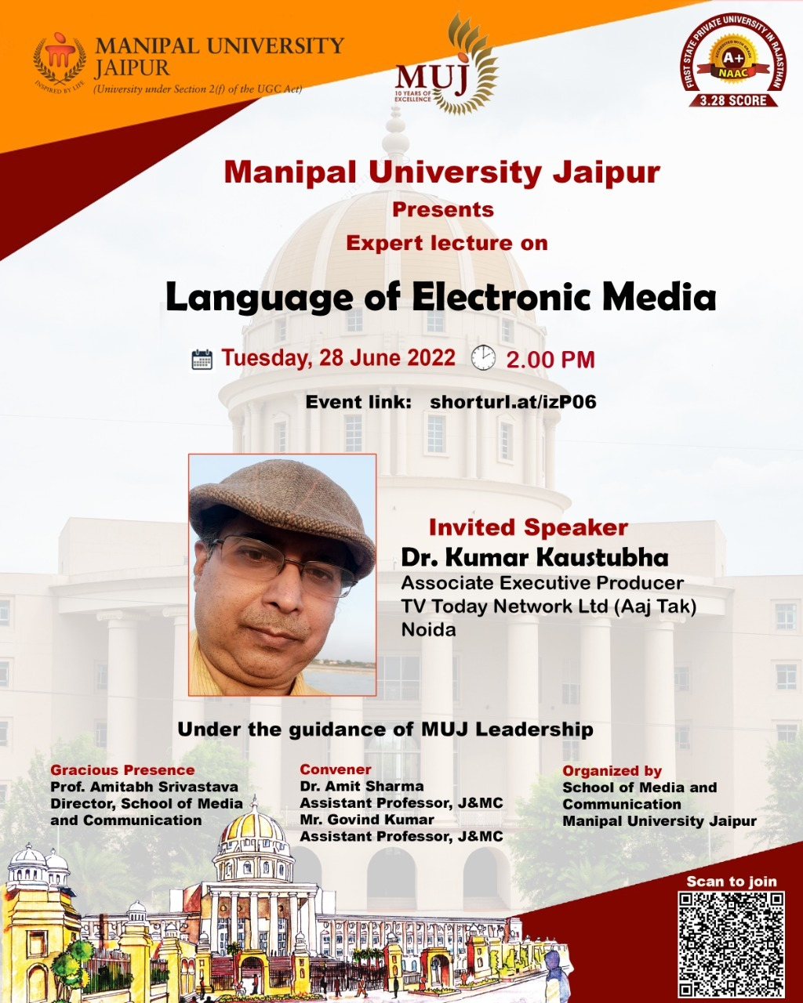

- Schedule of the event

- Attendance of the event

Sr. No | Name of Institution | Place of Institution | Registration Number/Employee code | Name of Attendee | Name of Dept
 | MUJ | Jaipur | 211201001 | ANSH WALIA | J&MC
 | MUJ | Jaipur | 211201002 | HARSH VARDHAN SHARMA | J&MC
 | MUJ | Jaipur | 211201003 | SANSKRITI PRATEEK SHARMA | J&MC
 | MUJ | Jaipur | 211201004 | IPSITA KUMARI SAHU | J&MC
 | MUJ | Jaipur | 211201005 | JANHAVI RAITANI | J&MC
 | MUJ | Jaipur | 211201006 | VISHNU BANKA | J&MC
 | MUJ | Jaipur | 211201007 | HARSHITA OJHA | J&MC
 | MUJ | Jaipur | 211201008 | IPSHITA ARORA | J&MC
 | MUJ | Jaipur | 211201009 | SANIYA PRATEEK KUMAR | J&MC
 | MUJ | Jaipur | 211201010 | SAMYA SHARMA | J&MC
 | MUJ | Jaipur | 211201012 | DEVANSHI NILESH PORWAL | J&MC
 | MUJ | Jaipur | 211201013 | ANANNYA CHAKRABORTY | J&MC
 | MUJ | Jaipur | 211201014 | GOPAL SHRIVASTAVA | J&MC
 | MUJ | Jaipur | 211201015 | CHANCHAL SINGH | J&MC
 | MUJ | Jaipur | 211201016 | BHAVNA CHETRY | J&MC
 | MUJ | Jaipur | 211201017 | FLORA ALEXEN | J&MC
 | MUJ | Jaipur | 211201018 | KALASH MAHESHWARI | J&MC
 | MUJ | Jaipur | 211201019 | RIDDHI PRAVIN PAWAR | J&MC
 | MUJ | Jaipur | 211201020 | HARSHITA LALWANI | J&MC
 | MUJ | Jaipur | 211201021 | SALONI KHANDELWAL | J&MC
 | MUJ | Jaipur | 211201022 | SANSKAR BEHERA | J&MC
 | MUJ | Jaipur | 211201023 | UMA | J&MC
 | MUJ | Jaipur | 211201024 | RHYTHM GOYAL | J&MC
 | MUJ | Jaipur | 211201025 | PRACHI SIRVI | J&MC
 | MUJ | Jaipur | 211201026 | SAKET SUMAN | J&MC
 | MUJ | Jaipur | 211201027 | NASHRAH MATEEN | J&MC
 | MUJ | Jaipur | 211201028 | SAI MITHILESH PATRO | J&MC
 | MUJ | Jaipur | 211201029 | RINI PAL | J&MC
 | MUJ | Jaipur | 211201031 | SANJANA | J&MC
 | MUJ | Jaipur | 211201032 | KARAN ANAND | J&MC
 | MUJ | Jaipur | 211201033 | SHRUTI MOHANTY | J&MC
 | MUJ | Jaipur | 211201034 | NANDINI ASDEO | J&MC
 | MUJ | Jaipur | 211201035 | NANDINI AGGARWAL | J&MC
 | MUJ | Jaipur | 211201036 | NEHAL ACHARYA | J&MC
 | MUJ | Jaipur | 211201037 | MAHEK CHOKHANI | J&MC
 | MUJ | Jaipur | 211201038 | HRITHIK GOYAL | J&MC
 | MUJ | Jaipur | 211201079 | MALVIKA VARDHAN | J&MC
 | MUJ | Jaipur | 211201081 | SONALI MEHTA | J&MC
 | MUJ | Jaipur | 211201082 | BARKHA MADAAN | J&MC
 | MUJ | Jaipur | 211201040 | BHAVYA VASHISTH | J&MC
 | MUJ | Jaipur | 211201041 | KHUSHI PATEL | J&MC
 | MUJ | Jaipur | 211201042 | ARYAN | J&MC
 | MUJ | Jaipur | 211201043 | SUHANI SONI | J&MC
 | MUJ | Jaipur | 211201044 | VANSHIKA DADHICH | J&MC
 | MUJ | Jaipur | 211201046 | MEGHA PANDEY | J&MC
 | MUJ | Jaipur | 211201047 | SAMRIDDHI TIWARI | J&MC
 | MUJ | Jaipur | 211201048 | JYOTI KUMARI | J&MC
 | MUJ | Jaipur | 211201049 | ANUSHKA KUMAR | J&MC
 | MUJ | Jaipur | 211201050 | SHREYA JHA | J&MC
 | MUJ | Jaipur | 211201051 | KRATIGYA MANJHU | J&MC
 | MUJ | Jaipur | 211201052 | AKASH GORA | J&MC
 | MUJ | Jaipur | 211201053 | JOSHITA JOSHI | J&MC
 | MUJ | Jaipur | 211201054 | RINI GUPTA | J&MC
 | MUJ | Jaipur | 211201055 | GIRISH RATHORE | J&MC
 | MUJ | Jaipur | 211201056 | JUHI DAWRA | J&MC
 | MUJ | Jaipur | 211201057 | CHARMI RANJIT JAIN | J&MC
 | MUJ | Jaipur | 211201058 | SHACHI | J&MC
 | MUJ | Jaipur | 211201059 | MADHAV METHI | J&MC
 | MUJ | Jaipur | 211201060 | RITIKA NARANG | J&MC
 | MUJ | Jaipur | 211201061 | KHUSHI SURESH SINGHAL | J&MC
 | MUJ | Jaipur | 211201062 | AVNI GAUR | J&MC
 | MUJ | Jaipur | 211201064 | RIDDHI SUNIL DAGA | J&MC
 | MUJ | Jaipur | 211201065 | PRIYANSHU BRAJWASI | J&MC
 | MUJ | Jaipur | 211201066 | RAKSHITA SINGH PAL | J&MC
 | MUJ | Jaipur | 211201067 | AADYA CHATTERJEE | J&MC
 | MUJ | Jaipur | 211201068 | REET KLER | J&MC
 | MUJ | Jaipur | 211201073 | ISHIKA SURANA | J&MC
 | MUJ | Jaipur | 211201074 | MIMANSHA RANAWAT | J&MC
 | MUJ | Jaipur | 211201075 | RAJEEV JANGID | J&MC
 | MUJ | Jaipur | 211201076 | MANSI GOTHARWAL | J&MC
 | MUJ | Jaipur | MUJ1124 | Dr. Amit Sharma | J&MC

Event Coordinator:
Dr. Amit Sharma, Assistant Professor,
Department of Journalism and Mass Communication.

