MUJ/Q&C/22/F/1.01 Event Report

FACULTY OF ARTS

NAME OF SCHOOL
School of Media & Communication

NAME OF DEPARTMENT
Journalism and Mass Communication

NAME OF EVENT
Future of TV Journalism
Type of Event
Industry Lecture

Date of Event
15/09/2022

Content of Report (index)

1. Introduction of the Event
2. Objective of the Event
3. Beneficiaries of the Event
4. Details of the Guests
5. Brief Description of the event
6. Geo-tagged Photographs
7. Brochure or creative of the event
8. Schedule of the Event
9. Attendance of the Event

- Introduction of the Event

Department of Journalism and Mass Communication has conducted the induction program for the first year students of BA(J&MC) and MA(J&MC). For making the students familiar with the media industry and the career opportunities, department has invited renowned media person to give expert lecture.

- Objective of the Event
- To make students aware about the industry need.
- To make student aware about the future career opportunities.
- To fill the gap between industry and academia.

- Beneficiaries of the Event
- Students of BA(J&MC) first year.
- Students of MA(J&MC) first year.
- Faculty members of the department of J&MC.

- Details of the Guests
Dr. Ajay Kumar Singh, Former Correspondent, DD News
Coordinator Research Centre, & Head of BA-JMC, Former Director Academic Campus and Former Dean Faculty of Mass Communication, HJU, Jaipur.

- Brief Description of the event
On the occasion of national TV Day, Department of Journalism and Mass Communication, School of Media and Communication, Manipal University Jaipur organized an expert lecture on ‘Future of TV Journalism’. Dr. Ajay Kumar Singh, Former Correspondent of DD News was the guest of the event. He shared his valuable experiences at television reporting. The interactive interaction witnessed the curiosity of students to get to know more about the realistic facet of the industry in a fun and learning way. He suggested that journalism is growing rapidly and if you want to become part of this journey, be skilled. Journalism needs teamwork. Dr. Vaishali Kapoor, HOD J&MC given vote of thanks. Dr. Amit Sharma welcomed the speaker in the university. The event was moderated by the Ms. Simran Agarwal and Ms. Yashashwani Singh. Dr. Amit Sharma and Dr. Prabhat Dixit were the coordinator of the event.

- Photographs

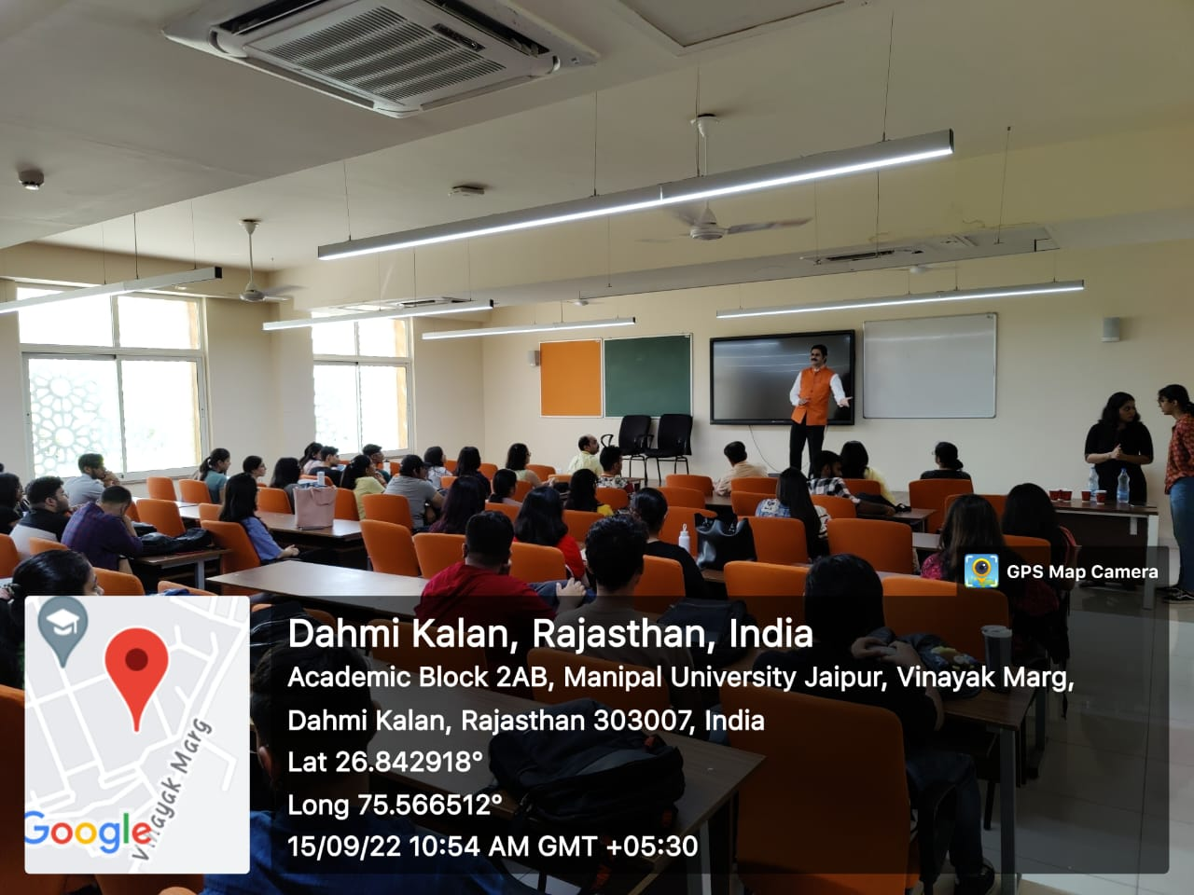
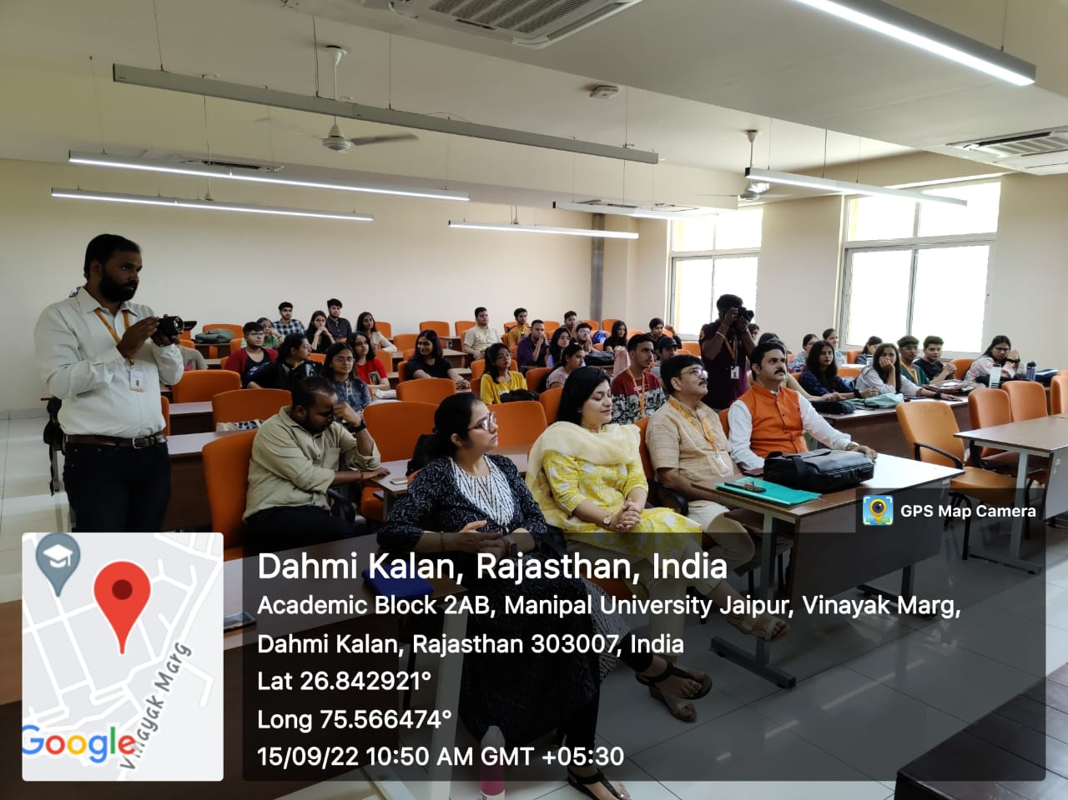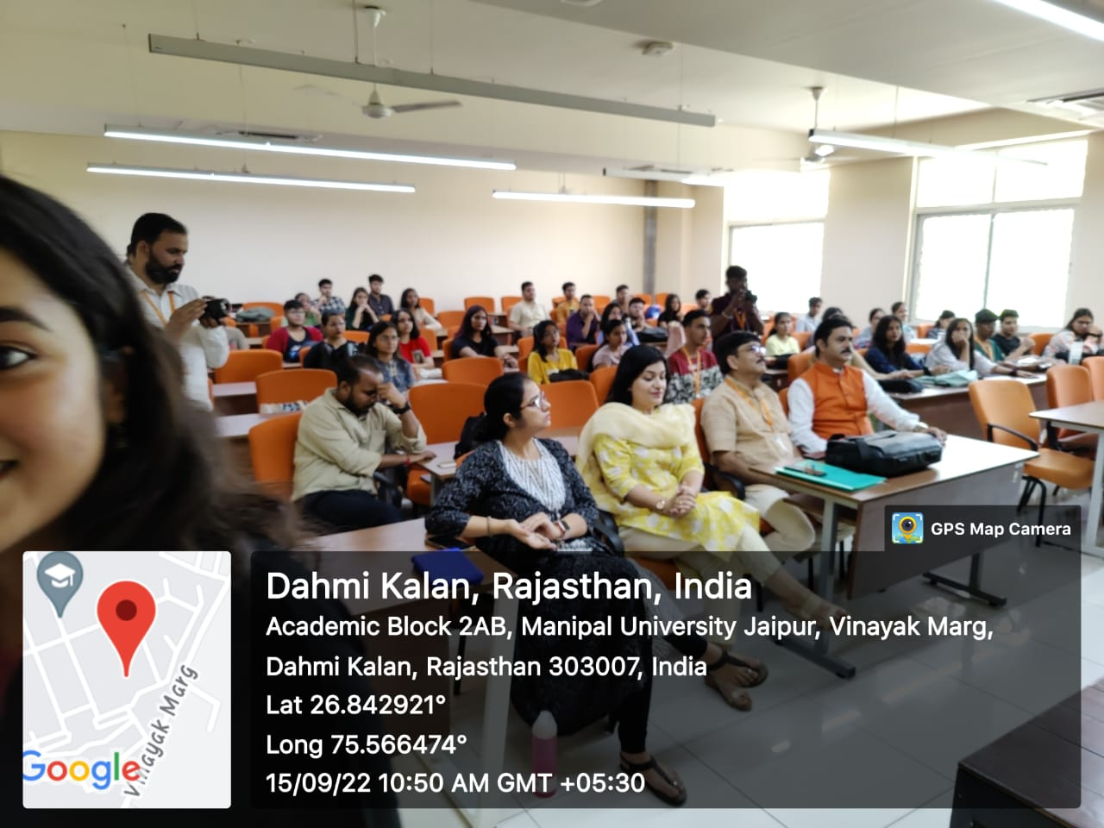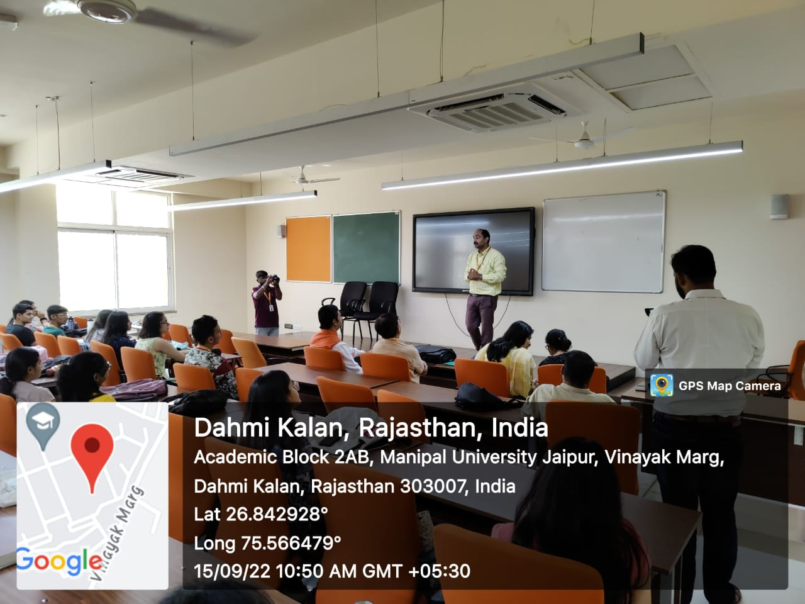

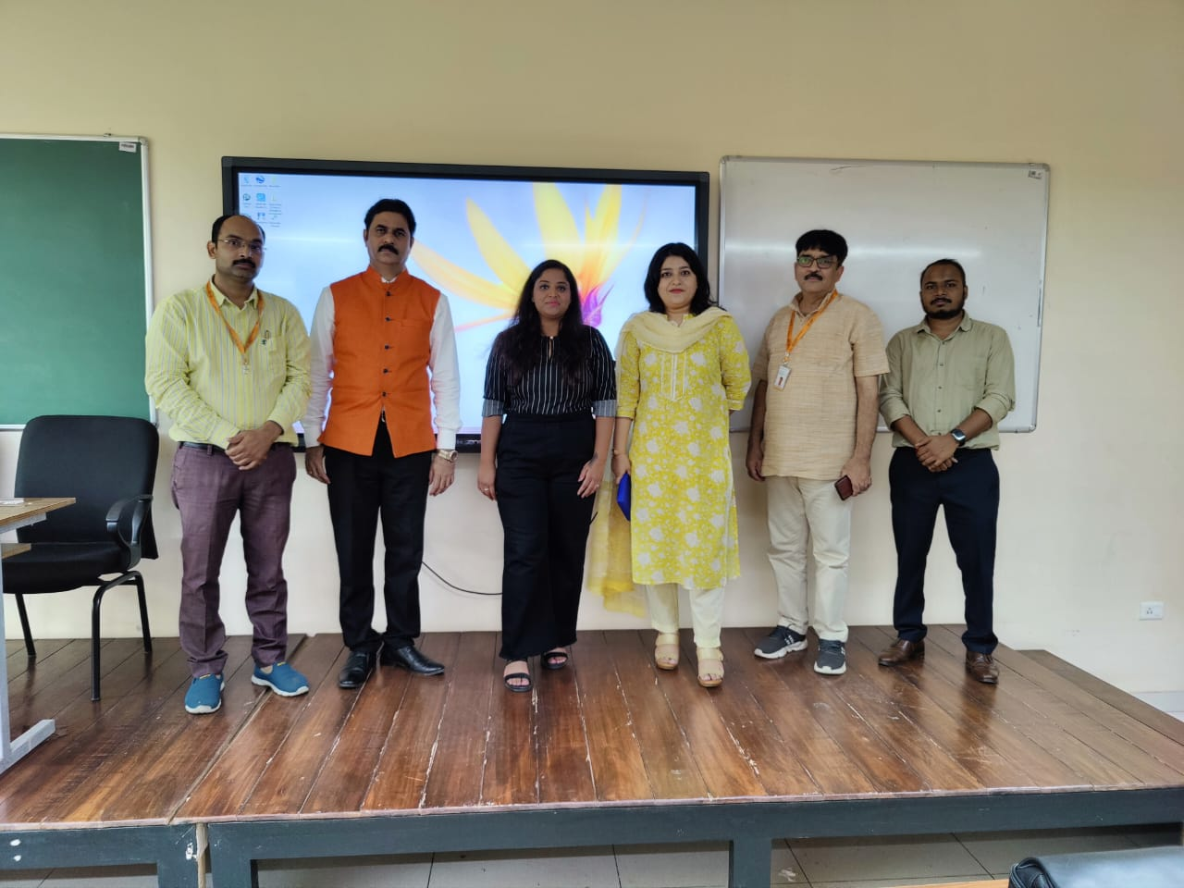

- Brochure or creative of the event

- Schedule of the event (insert in the report)
DATE | RESOURCE PERSON | TIME | TOPIC
15/09/2022 | Dr. Ajay Kumar Singh (ex-reporter, DD News) | 10:00 AM -12:00 PM  (Two hours) | Future of TV Journalism

- Attendance of the Event (insert in the document only)
Total attendee-………..
Sr. No | Name of Institution | Place of Institution | Registration Number/Employee code | Name of Attendee | Name of Dept

Event Coordinators:
Dr. Amit Sharma
Dr. Prabhat Dixit

Seal and Signature of Head with date

