MUJ/Q&C/22/F/1.01 Event Report

FACULTY OF ARTS

NAME OF SCHOOL
School of Media & Communication

NAME OF DEPARTMENT
Journalism and Mass Communication

NAME OF EVENT
Changing Face of Print Media
Type of Event
(Industry Lecture)

Date of Event
20/09/2022

Content of Report (index)

1. Introduction of the Event
2. Objective of the Event
3. Beneficiaries of the Event
4. Details of the Guests
5. Brief Description of the event
6. Geo-tagged Photographs
7. Brochure or creative of the event
8. Schedule of the Event
9. Attendance of the Event

- Introduction of the Event

Department of Journalism and Mass Communication has conducted the induction program for the first-year students of BA(J&MC) and MA(J&MC). For making the students familiar with the media industry and the career opportunities, department has invited renowned media person to deliver lecture.

- Objective of the Event
- To make students aware about the industry need.
- To make student aware about the future opportunities.
- To fill the gap between industry and academia.

- Beneficiaries of the Event
- Students of BA(J&MC) first year.
- Students of MA(J&MC) first year.
- Faculty members of the department of J&MC.

- Details of the Guests
Dr. Laxmi Prashad Pant (National Editor, Dainik Bhaskar)

- Brief Description of the event

Department of Journalism and Mass Communication, School of Media and Communication, Manipal University Jaipur organized an expert lecture on ‘Changing Face of Print Journalism’. Dr. L.P. Pant, National Editor of Dainik Bhaskar was the guest of the event. He shared his valuable experiences of newsroom and reporting in field. The interactive interaction witnessed the curiosity of students to get to know more about the realistic facet of the industry in a fun and learning way. He suggested that print journalism is changing its face now. Earlier it was on print medium now it is converting itself in digital. The future of journalism is bright but need to update yourself as a reporter or journalist. Dr. Vaishali Kapoor, HOD J&MC given welcomed the guest. Dr. Amit Sharma given vote of thanks. The event was moderated by the Ms. Shruti Srivastava and Ms. Saumi Chatterjee. Dr. Amit Sharma and Dr. Prabhat Dixit were the coordinator of the event.

- Photographs
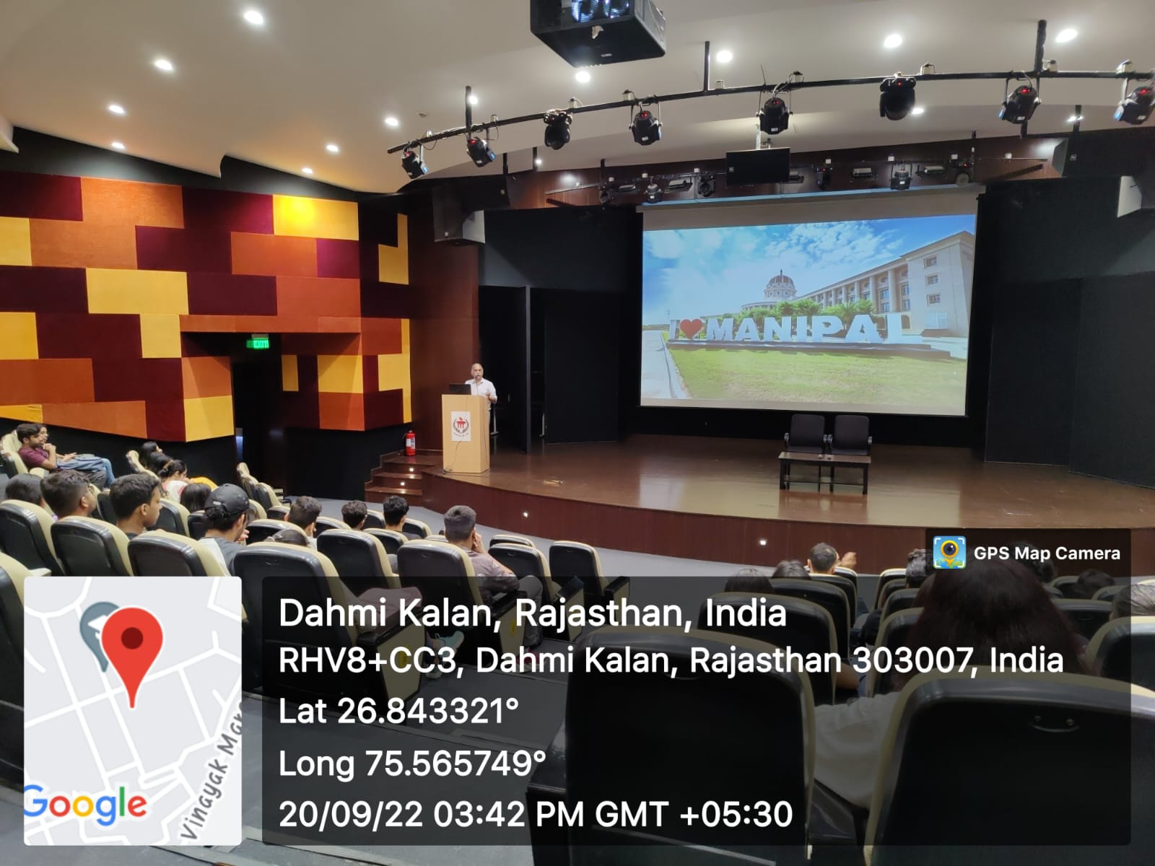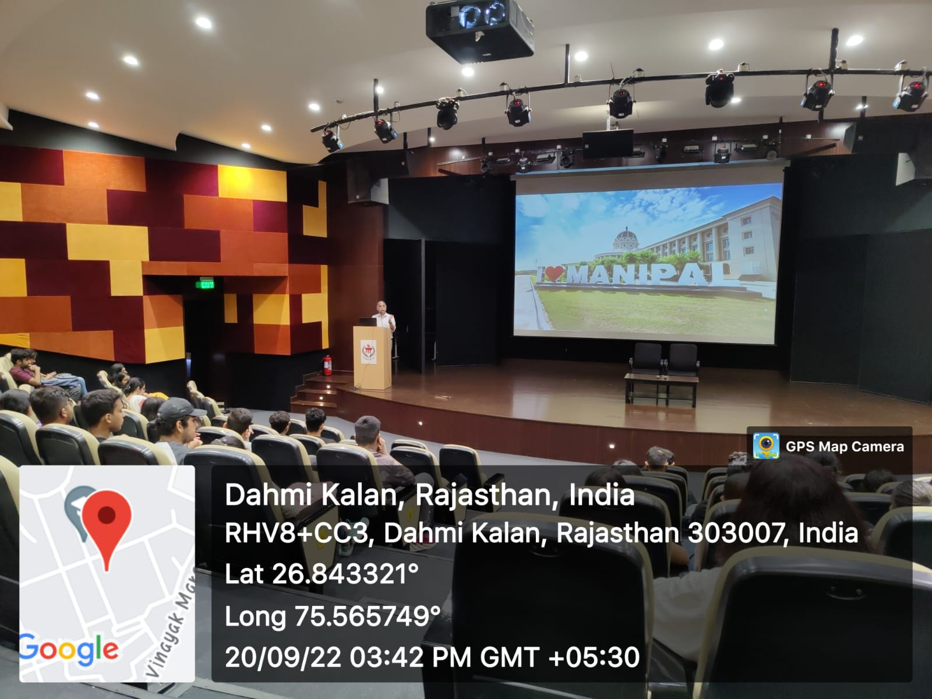

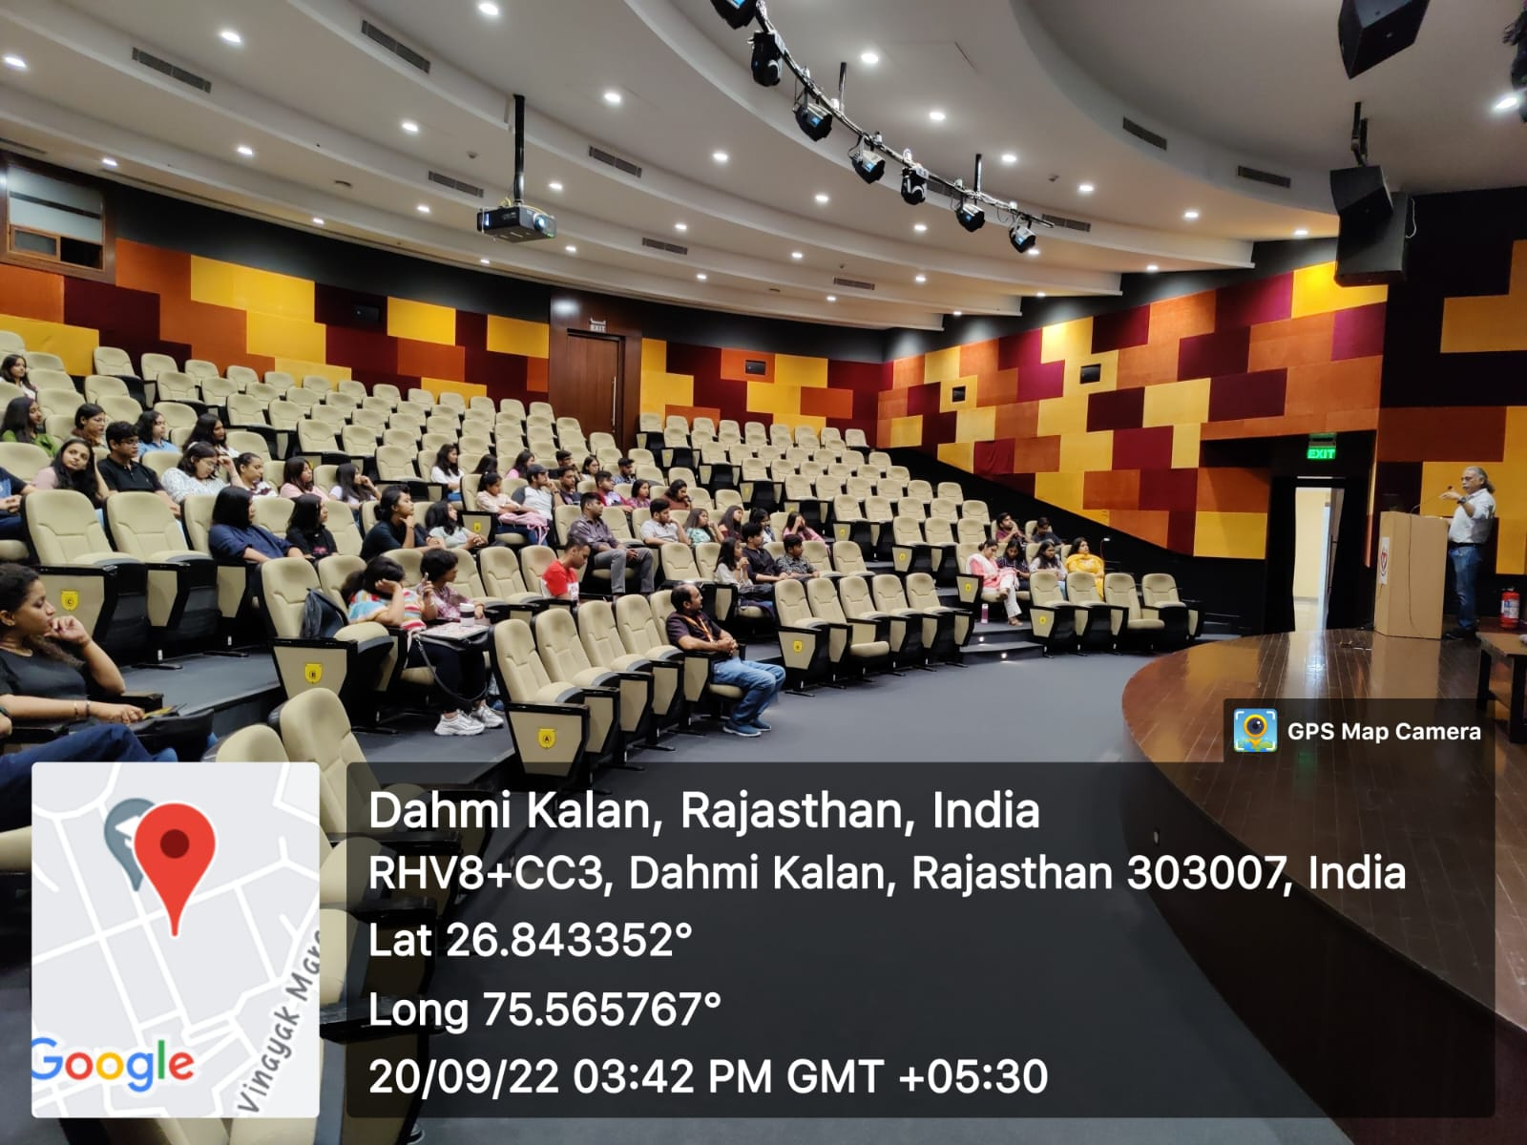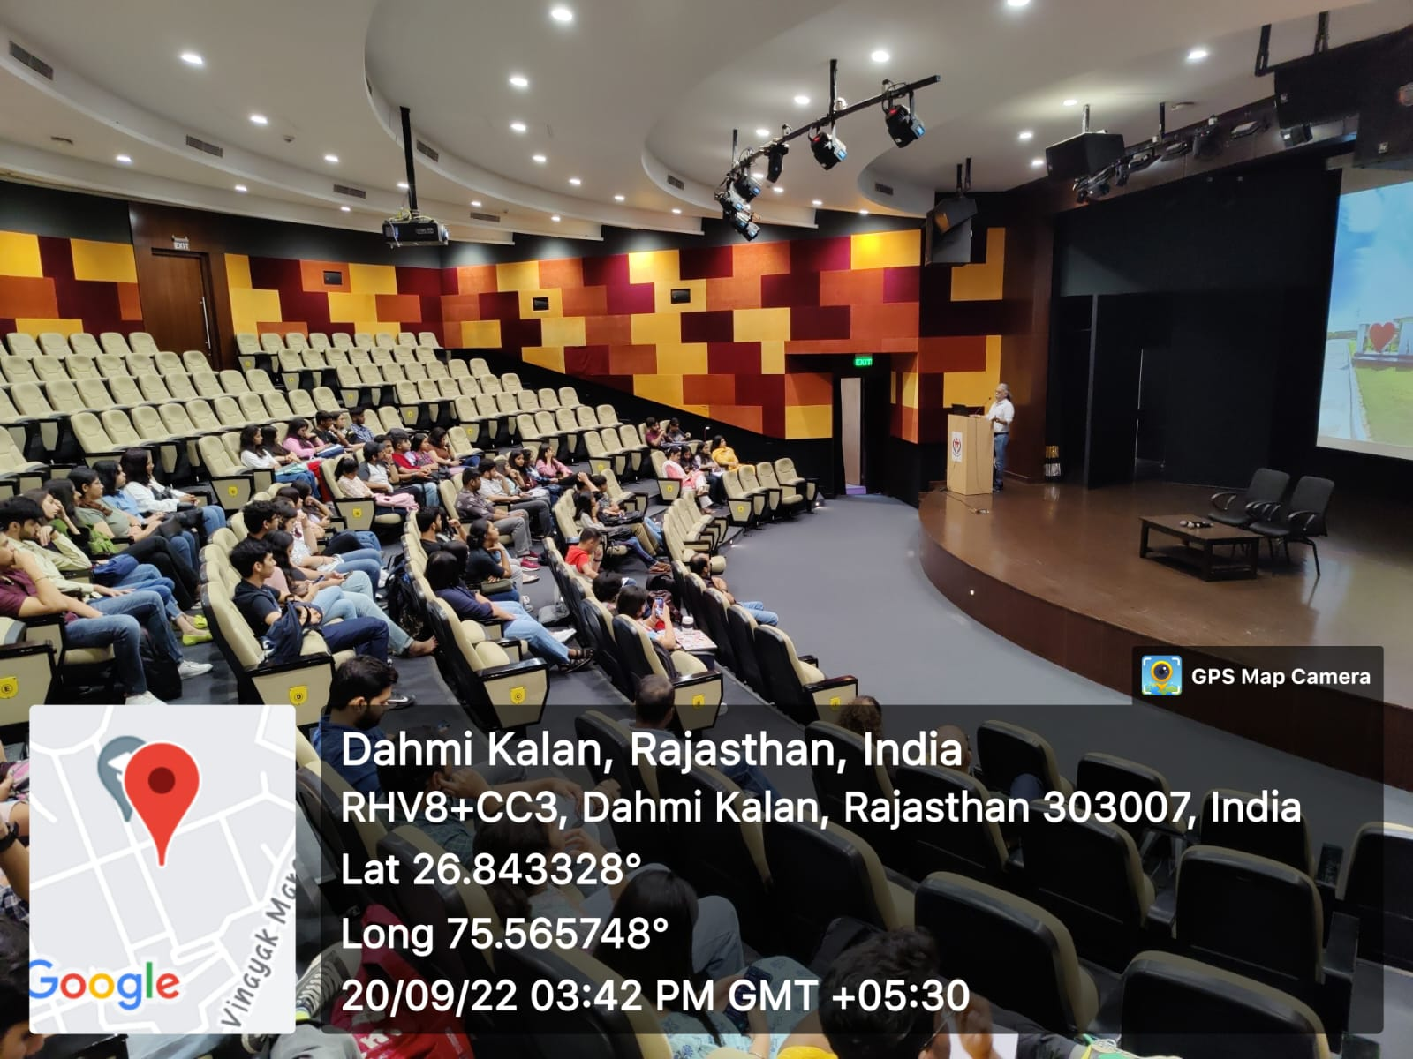

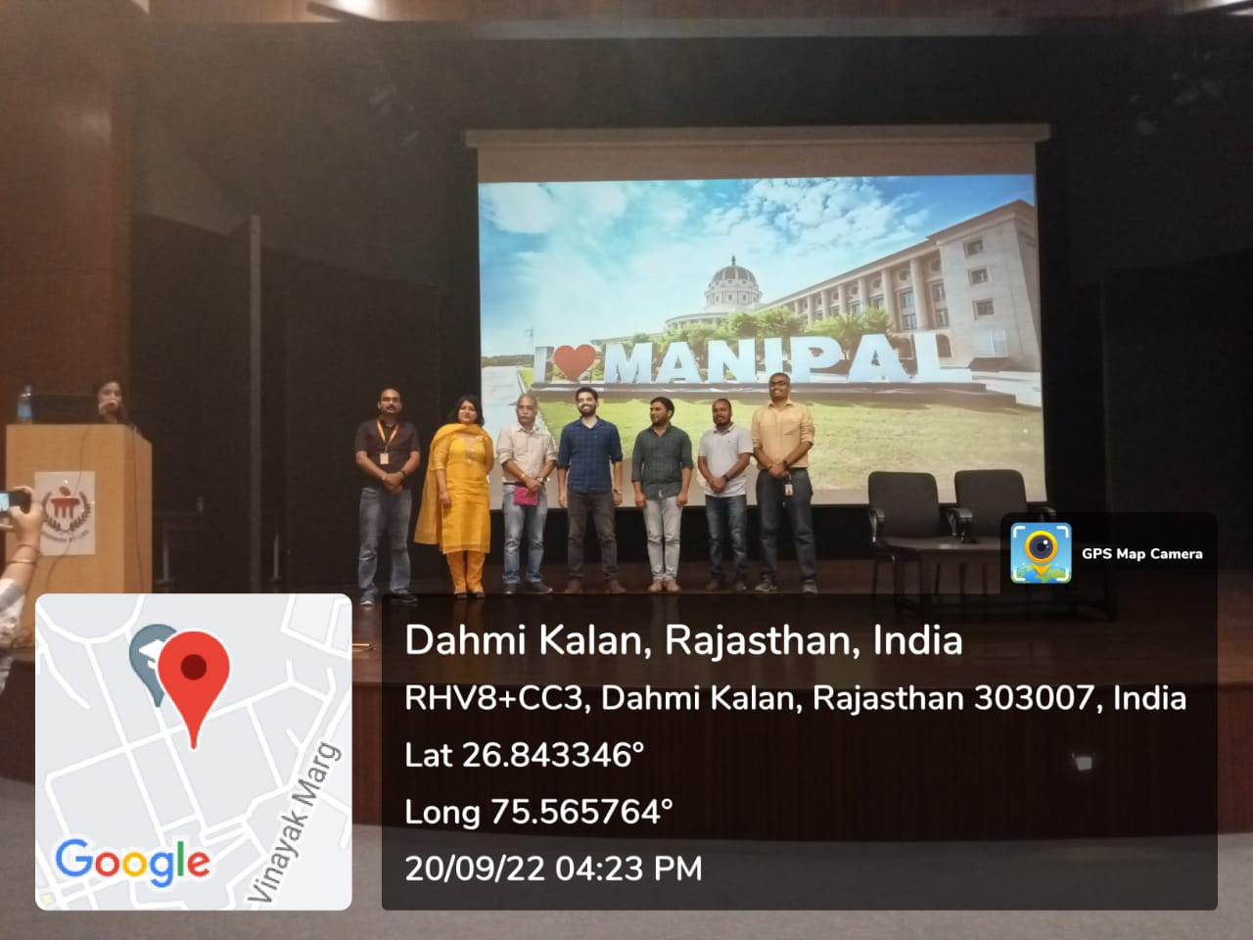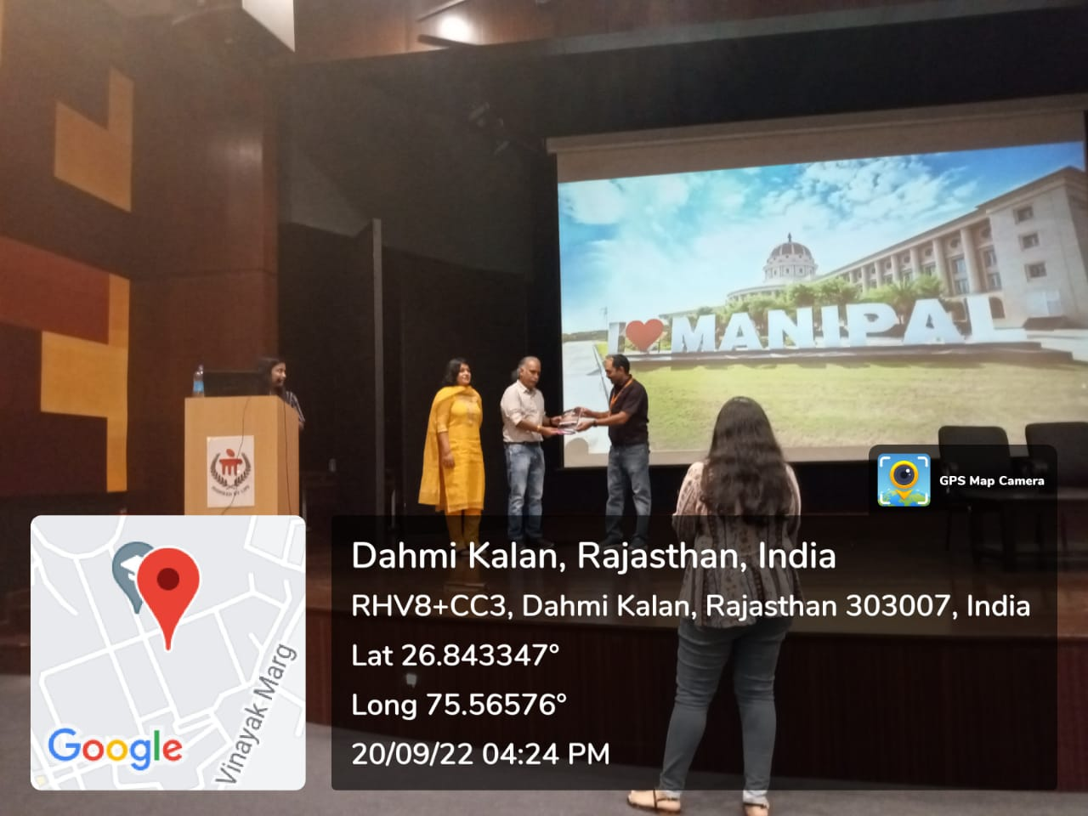

- Brochure or creative of the event (insert in the document only)

- Schedule of the event (insert in the report)
DATE | RESOURCE PERSON | TIME | TOPIC
20/09/2022 | Dr. L. P. Pant (National Editor, Dainik Bhaskar) | 03 PM - 05:00 PM  (Two hours) | Changing Face of Print Media

- Attendance of the Event (insert in the document only)
Total attendee-………..
Sr. No | Name of Institution | Place of Institution | Registration Number/Employee code | Name of Attendee | Name of Dept

Event Coordinators:
Dr. Amit Sharma
Dr. Prabhat Dixit

Seal and Signature of Head with date

