MUJ/Q&C/22/F/1.01 Event Report

FACULTY OF ARTS

NAME OF SCHOOL
School of Media & Communication

NAME OF DEPARTMENT
Journalism and Mass Communication

NAME OF EVENT
Digital Media: Today and Tomorrow
Type of Event
(Industry Lecture)

Date of Event
16/09/2022

Content of Report (index)

1. Introduction of the Event
2. Objective of the Event
3. Beneficiaries of the Event
4. Details of the Guests
5. Brief Description of the event
6. Geo-tagged Photographs
7. Brochure or creative of the event
8. Schedule of the Event
9. Attendance of the Event

- Introduction of the Event

Department of Journalism and Mass Communication has conducted the induction program for the first year students of BA(J&MC) and MA(J&MC). For making the students familiar with the media industry and the career opportunities, department has invited renowned media person to deliver lecture.

- Objective of the Event
- To make students aware about the industry need.
- To make student aware about the career opportunities.
- To fill the gap between industry and academia.

- Beneficiaries of the Event
- Students of BA(J&MC) first year.
- Students of MA(J&MC) first year.
- Faculty members of the Department of J&MC.

- Details of the Guests
Mr. Vishal Sharma (State Editor, Digital, Punjab Kesari, Rajasthan)

- Brief Description of the event
Department of Journalism and Mass Communication, Manipal University Jaipur welcomed Vishal Suryakant Sharma who graced one of the days of Induction program for the budding media students. He enlightened the students with unfolding the letters of the term 'JOURNALISM'. He talked about the traits and complexes this profession holds. His lecture was focused on digital media and how students can focus on online journalism? He presented realistic examples from his own experiences and, also the challenges one must face as a journalist. Dr. Vaishali Kapoor, HOD, J&MC has given welcome speech. Dr. Prabhat Dixit, Senior Assistant Professor, J&MC has given vote of thanks. Event was moderated by the BA(J&MC) students Ms. Yashashwani Singh and Saumi Chatterjee. Dr. Amit Sharma and Dr. Prabhat Dixit coordinated the lecture.

- Photographs

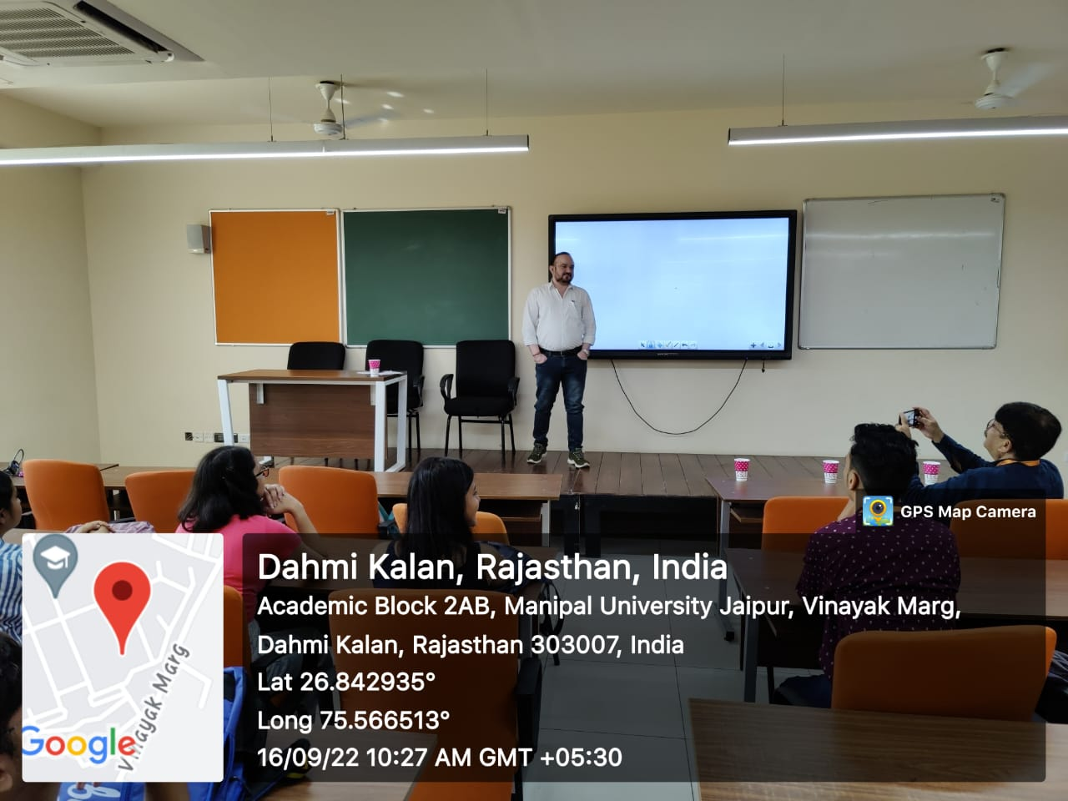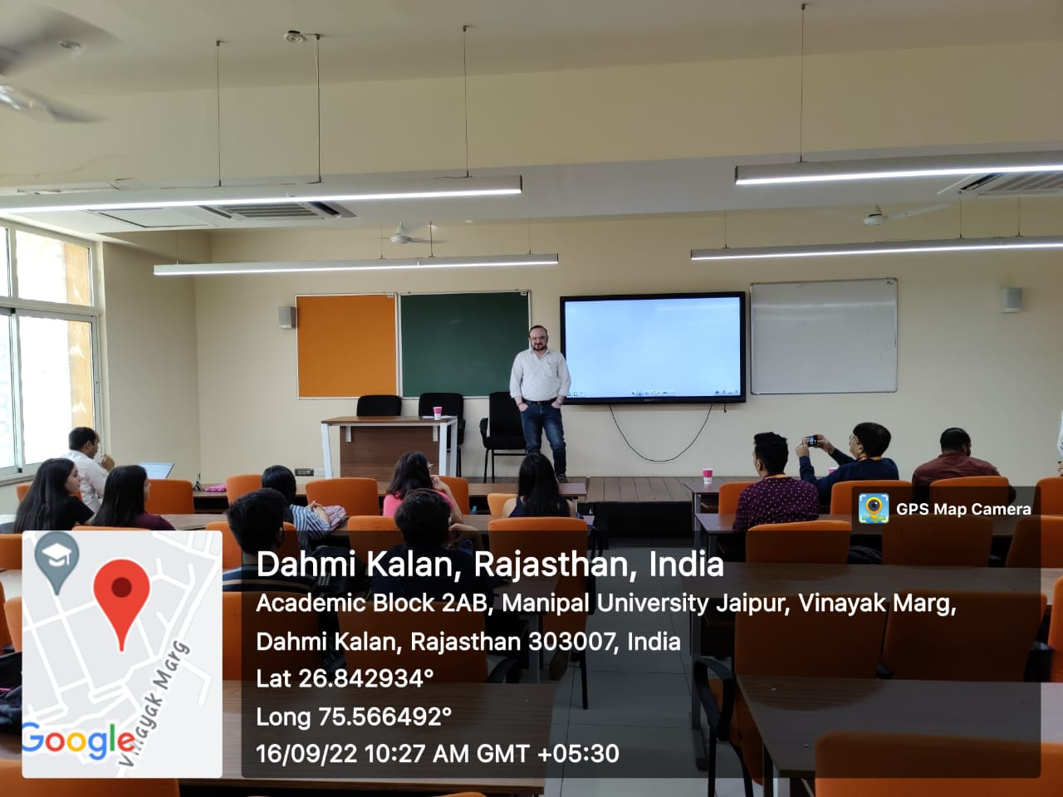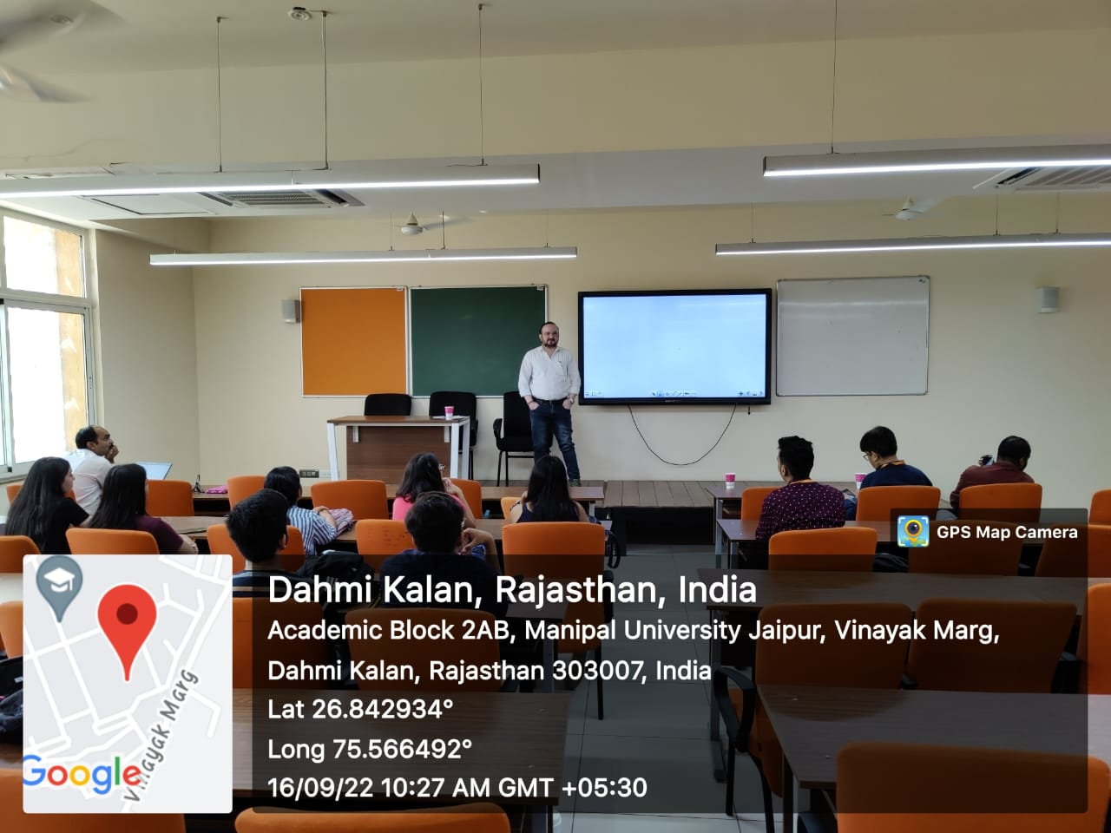

- Brochure or creative of the event

- Schedule of the event (insert in the report)
DATE | RESOURCE PERSON | TIME | TOPIC
16/09/2022 | Mr. Vishal Sharma (State Editor, Digital, Punjab Kesari) | 10 AM - 12:00 PM  (Two hours) | Digital Media: Today and Tomorrow

- Attendance of the Event (insert in the document only)
Total attendee-………..
Sr. No | Name of Institution | Place of Institution | Registration Number/Employee code | Name of Attendee | Name of Dept

Event Coordinators:
Dr. Amit Sharma
Dr. Prabhat Dixit

Seal and Signature of Head with date

