DEPARTMENT OF ECONOMICS
FACULTY OF ARTS & LAW
SCHOOL OF HUMANITIES AND SOCIAL SCIENCES
MANIPAL UNIVERSITY JAIPUR

Report

Title: Commodities Derivatives Awareness Program
Date: 31st March 2022
Brochure:
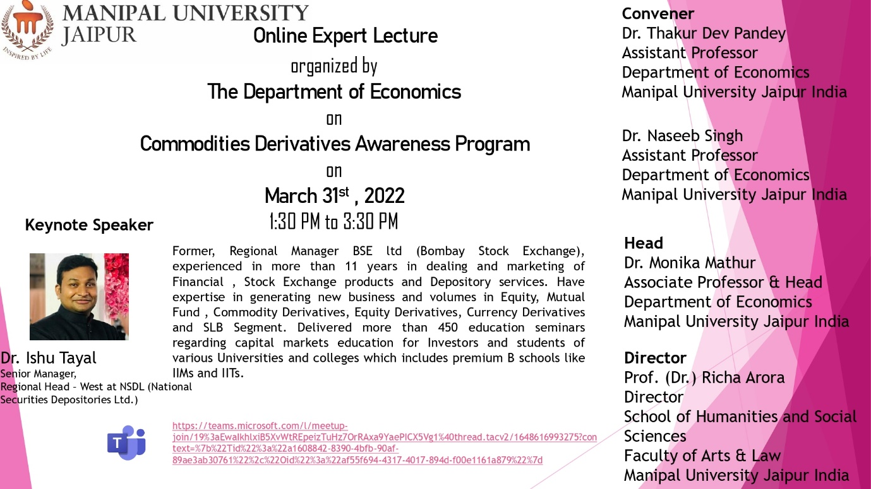

About the Event: On 31st of March 2022, In the guidance of Dr. Monika Mathur (Head of Department) the Department of Economics, Manipal University Jaipur, organized an event on “Commodities Derivative Awareness Program” in which the keynote speaker was Dr. Ishu Tayal who is senior manager, Regional Head- West at NSDL (National Securities Depositories Ltd.) This event was attended by approximately 75 participants and faculty members. In this event, Dr Ishu Tayal explained the functioning of the commodities market in a very elaborated way. He also explained the important factors, participant and strategies involved in the commodities market. At the end of the session, he also took an open session with the participants and tried to solve the maximum of queries of participants in the best possible manner. Based on open session, it can be concluded that it was a very beneficial session especially for the students as it helped the students to get more clarity about this market segment and helped them to identify new segment for their career as an option.

Attendance Sheet:
Full Name
Dr. Thakur Dev Pandey [MU - Jaipur]
Dr. Ishu Tayal (Guest)
Rishita Sandeep Tripathi [BA (Hons-Economics) - 2021]
Yash [BA (Hons-Economics) - 2021]
Shivangi Kapoor [BA (Hons-Economics) - 2021]
Gaurav Baasniwal [BA (Hons-Economics) - 2021]
Praseeda Kondru [BA (Hons-Economics) - 2021]
Akshay Verma [BA (Hons-Economics) - 2021]
Harsh Meena [BA (Hons-Economics) - 2021]
Atharv Aphale [BA (Hons-Economics) - 2021]
Sumriddhi Srivastava [BA (Hons-Economics) - 2021]
Fez Mastan Khan [BA (Hons-Economics) - 2021]
Saarthak Tiwari [BA (Hons-Economics) - 2021]
Harshit Sharma [BA (Hons-Economics) - 2021]
Riti Poddar [BA (Hons-Economics) - 2021]
Yashi Agrawal [BA (Hons-Economics) - 2021]
Paritosh Bhushan [BA (Hons-Economics) - 2021]
Dakshita Agarwal [BA (Hons-Economics) - 2021]
Dr. Monika Mathur [MU - Jaipur]
Divya Surana
Sara Sharma [BA (Hons - Economics] - 2020]
Heeral Lamba [BA (Hons - Economics] - 2020]
Mohit Kumar [BA (Hons - Economics] - 2020]
Navdeep Singh [BA (HONS-ECONOMICS) - 2020]
Anubhav Manoj Purohit [BA (Hons-Economics) - 2021]
Harsh Jain [BA (Hons - Economics] - 2020]
Naseeb Singh [MUJ]
Priyanshi Girdhar [BA (Hons - Economics] - 2020]
Nimish Sharma [BA (Hons - Economics] - 2020]
Aryan Pratap Chauhan [BA (Hons) - Economics - 2020]
Dhananjay [Economics(Hons) - 2019]
Vidul Tyagi [Economics(Hons) - 2019]
Sonali Gupta [Economics(Hons) - 2019]
Ritesh Kumar [BA (Hons - Economics] - 2020]
Abhishek Jeph [BA [Hons - Economics] - 2020]
Sachin Behera [BA [Hons - Economics] - 2020]
Rishika Mohata
Apoorva Lakhotia [Economics(Hons) - 2019]
Mumal Rathore [Economics(Hons) - 2019]
Nehal Takewal [BA (Hons - Economics] - 2020]
Kshitij Aarya [Economics(Hons) - 2019]
Gargi Pareek [BA (HONS-ECONOMICS) - 2020]
Dr. Poonam Mishra [MU - Jaipur]
Devraj Singh Rathore [BA (Hons) - Economics - 2020]
Utkarsh Patel [BA (Hons-Economics) - 2021]
KAJAL [BA (HONS-ECONOMICS) - 2020]
Yash Wadhawan [BA (Hons-Economics) - 2020]
Shalini Rai [BA (Hons - Economics] - 2020]
Simran Singh Ratra [Economics(Hons) - 2019]
Ruhani [Economics(Hons) - 2019]
Ms. Varuni [MUJ]
Rohit Kumar Choudhary [BA (Hons-Economics) - 2021]
Kavya Choudhary [BA (Hons-Economics) - 2021]
Ayush Pancholi [Economics(Hons) - 2019]
Sneha [BA (Hons - Economics] - 2020]
Bhawini Rathore [BA (Hons - Economics] - 2020]
Dev Bhutani [BA (Hons - Economics] - 2020]
Abhijit Kumar Udaysingh [BA (Hons - Economics] - 2020]
Niranjan Anand [BA (Hons - Economics] - 2020]
Disha Goyal [BA (Hons - Economics] - 2020]
Tanu Soni [Economics(Hons) - 2019]
Anushka Upadhyay [BA (Hons-Economics) - 2021]
Bhawini Rathore [BA (Hons - Economics] - 2020]
Dev Bhutani [BA (Hons - Economics] - 2020]
Abhijit Kumar Udaysingh [BA (Hons - Economics] - 2020]
Niranjan Anand [BA (Hons - Economics] - 2020]
Disha Goyal [BA (Hons - Economics] - 2020]
Tanu Soni [Economics(Hons) - 2019]
Anushka Upadhyay [BA (Hons-Economics) - 2021]

Pictures of the Event:
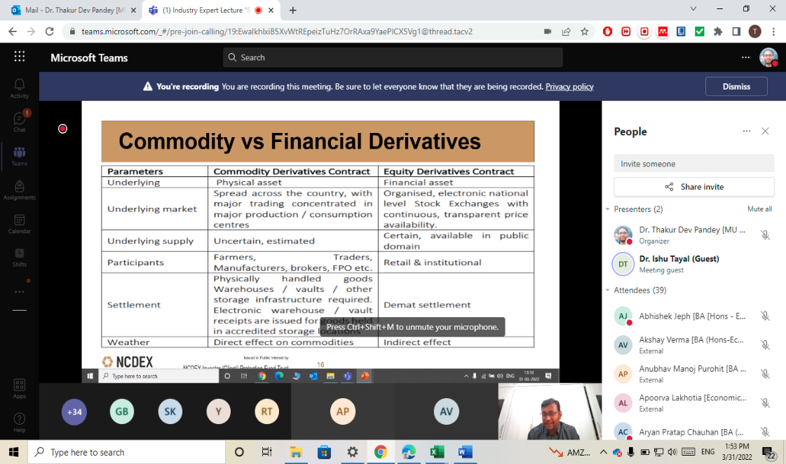
Picture 1 “Presentation by Dr. Ishu Tayal”
Location: Manipal University Jaipur, Rajasthan

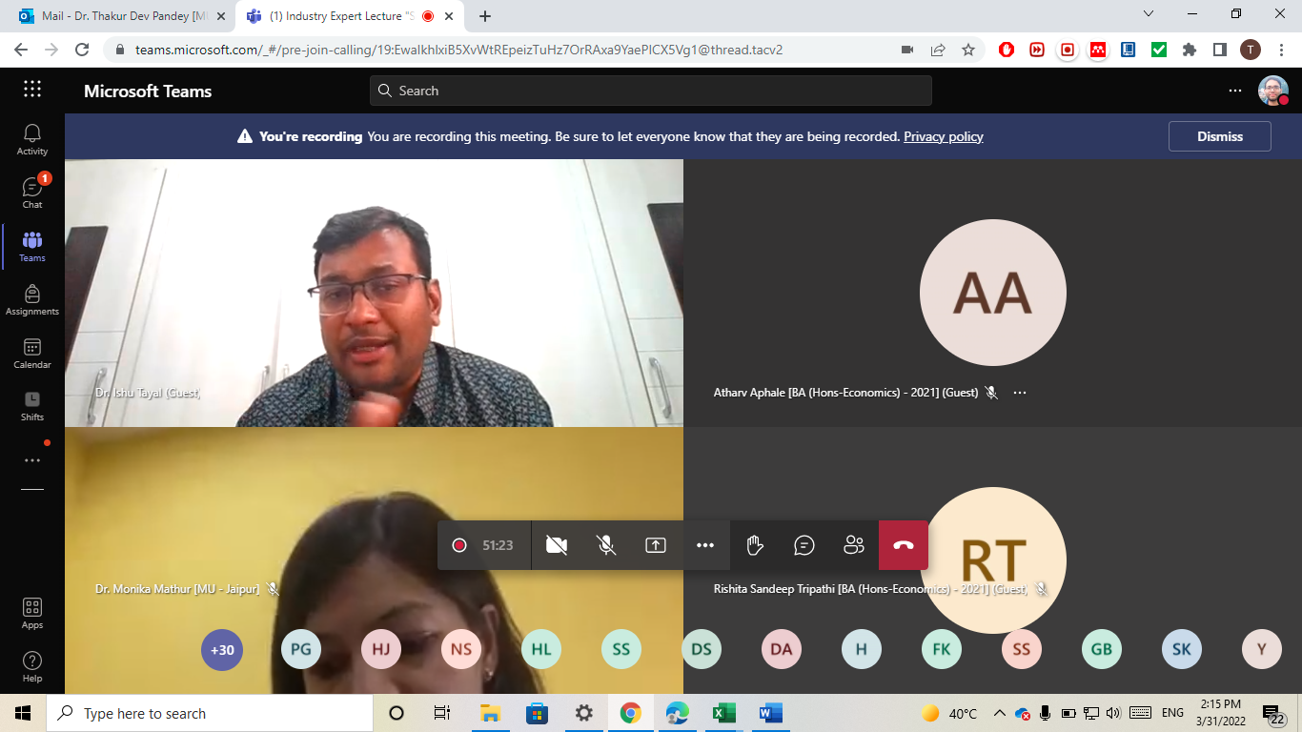
Picture 2 “Vote of Thanks by Dr. Monika Mathur”
Location: Manipal University Jaipur, Rajasthan

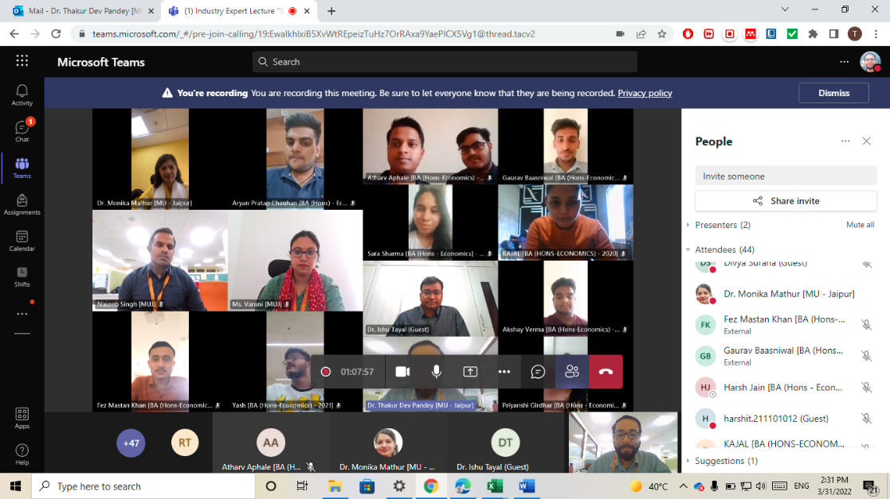
Picture 3 “Group photo of the participants”
Location: Manipal University Jaipur, Rajasthan

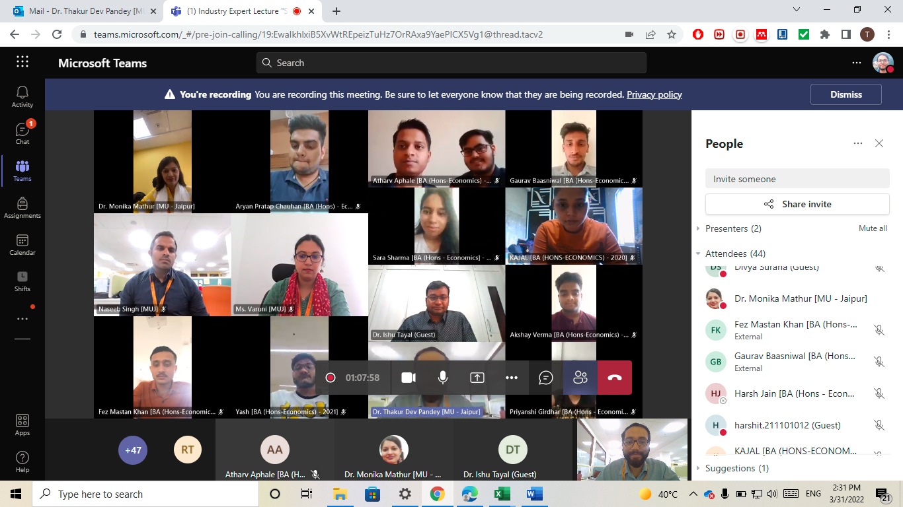
Picture 4 “Conclusion of Session”
Location: Manipal University Jaipur, Rajasthan

