MUJ/Q&C/22/F/1.01 Event Report Format

FACULTY OF ARTS

School of Humanities and Social Sciences

DEPARTMENT OF ECONOMICS

Field Visit
Type of Event (Conference/Seminar/Industry Lecture/ Capacity Enhancement Session/ Alumni Lecture/etc.)

02/09/2022

- Introduction of the Event

A field visit at Kalaneri Art Gallery and Jawahar Kala Kendra was organized for the students of the Department of Economics. This event was organized for the students to understand the economics of waste management. This visit proved to be an eye opener for the students by knowing the art of waste management and its importance and benefits for the waste management.

- Objective of the Event (bullet points or about 50 words)

The objective of the event was to understand the economics of waste management.
To learn the art of waste management.
To understand the importance of waste management in environment protection.

- Beneficiaries of the Event (Student/Faculty/Community etc) (25 words)
Students , Faculty, Community are the beneficiaries of the event.

- Details of the Guests (Chief Guests, speakers etc Designation, organization, contact details if any please give them in sr no)

- Picture 1- Soumya Sharma, MD , Kalaneri Arts Galley
- Picture 2- Dr Aparna Makkar , Co-founder , Samvaad
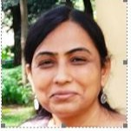
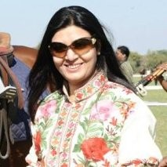

- Brief Description of the event (about 200 words)
On 02/09/2022 the Department of Economics organized a field visit for the students of the department at the Kalaneri Art Gallery and Jawahar Kala Kendra. The purpose of the field visit was to make the student understand the economics of the waste management at both the venues. So, the visit started with the Kalaneri Art Gallery where Dr Somya Sharma briefed all the students and faculty members about importance of the waste management for different aspects of the society and during the discussion, she also gave the tour of the gallery to all the students. At the end of the discussion, she also demonstrated some best out of waste projects of her gallery. After the visit of Kalaneri art gallery, students visited the Jawahar Kala Kendra, where the students attended the exhibition on waste management by Dr Aparna Makkar. During the exhibition Dr Apaprna Sharma tried to explain the art of converting waste into some product and the importnance of the from the society and the economics point of view.

Photographs
3 to 5 geotagged photographs of the event or screenshots of the event (if online) with captions

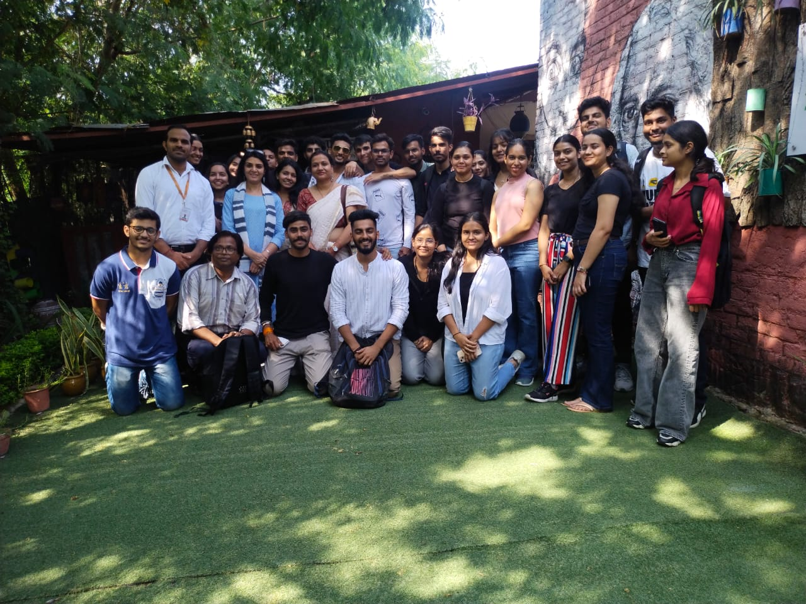

Picture 1: Group Photograph at the Kalaneri Art Gallery

Picture 2: Students at Jawahar Kala Kendra
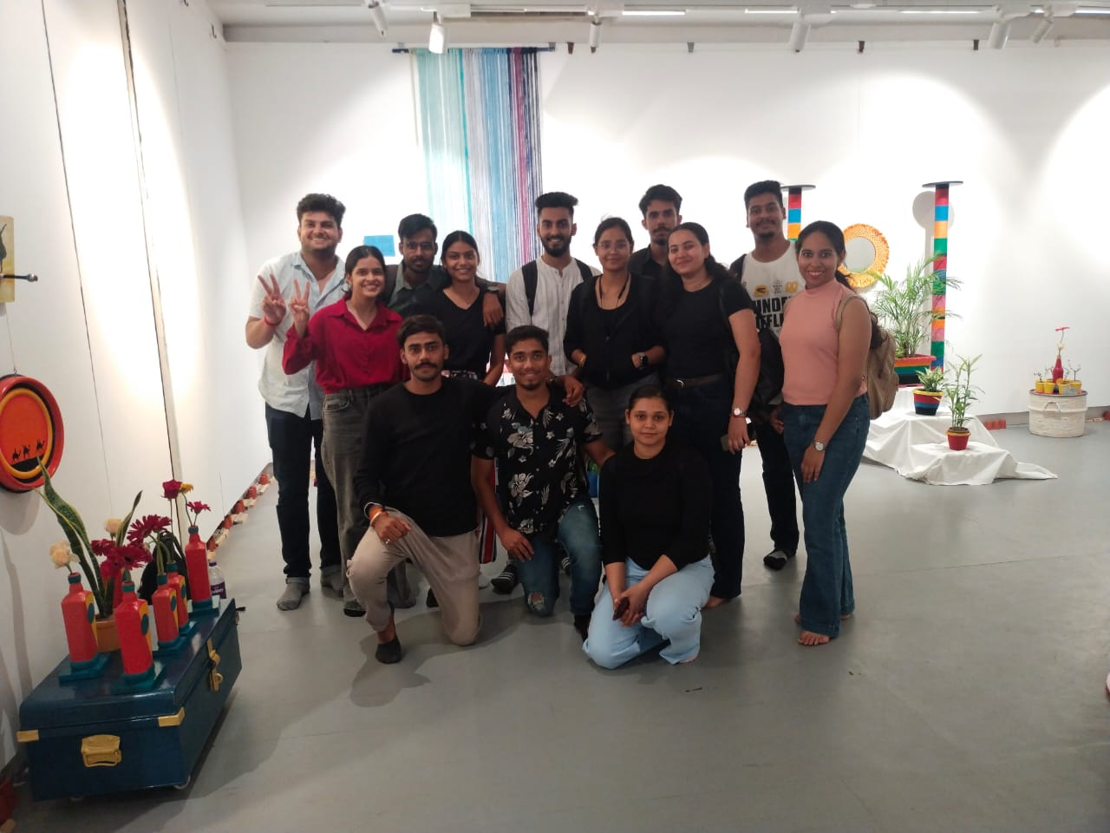

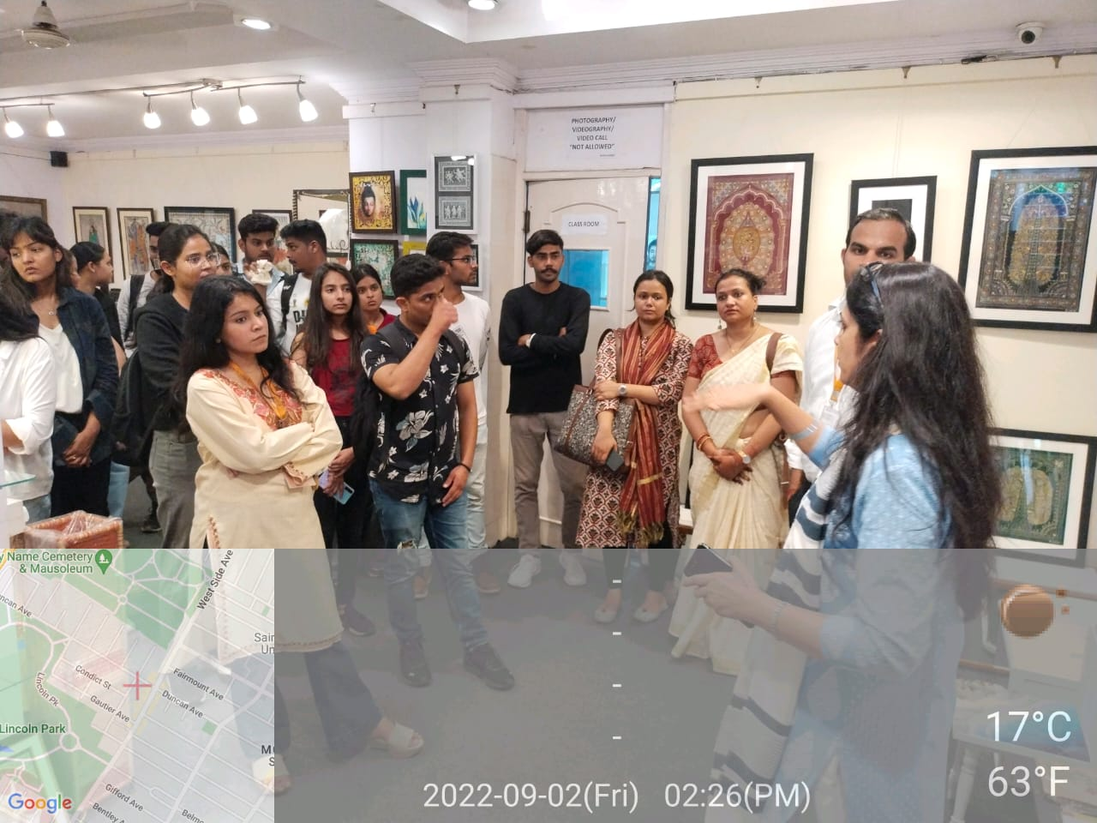

- Brochure or creative of the event (insert in the document only )
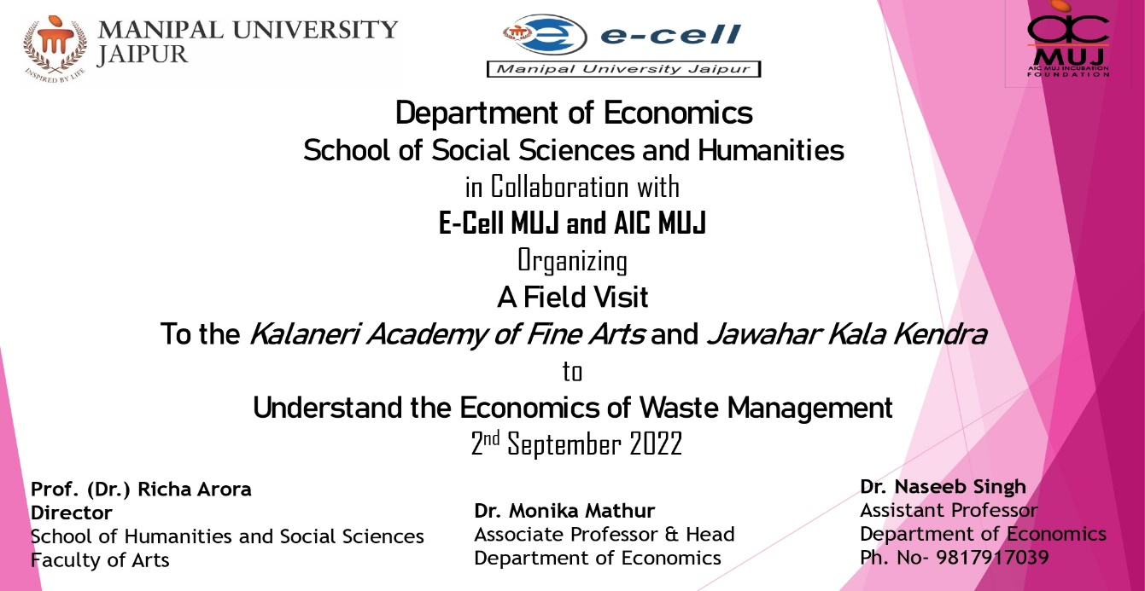

- Schedule of the event (insert in the report)
Time of the Event : 01:00 PM to 06:00PM

- Attendance of the Event (insert in the document only)
Total attendee-………..
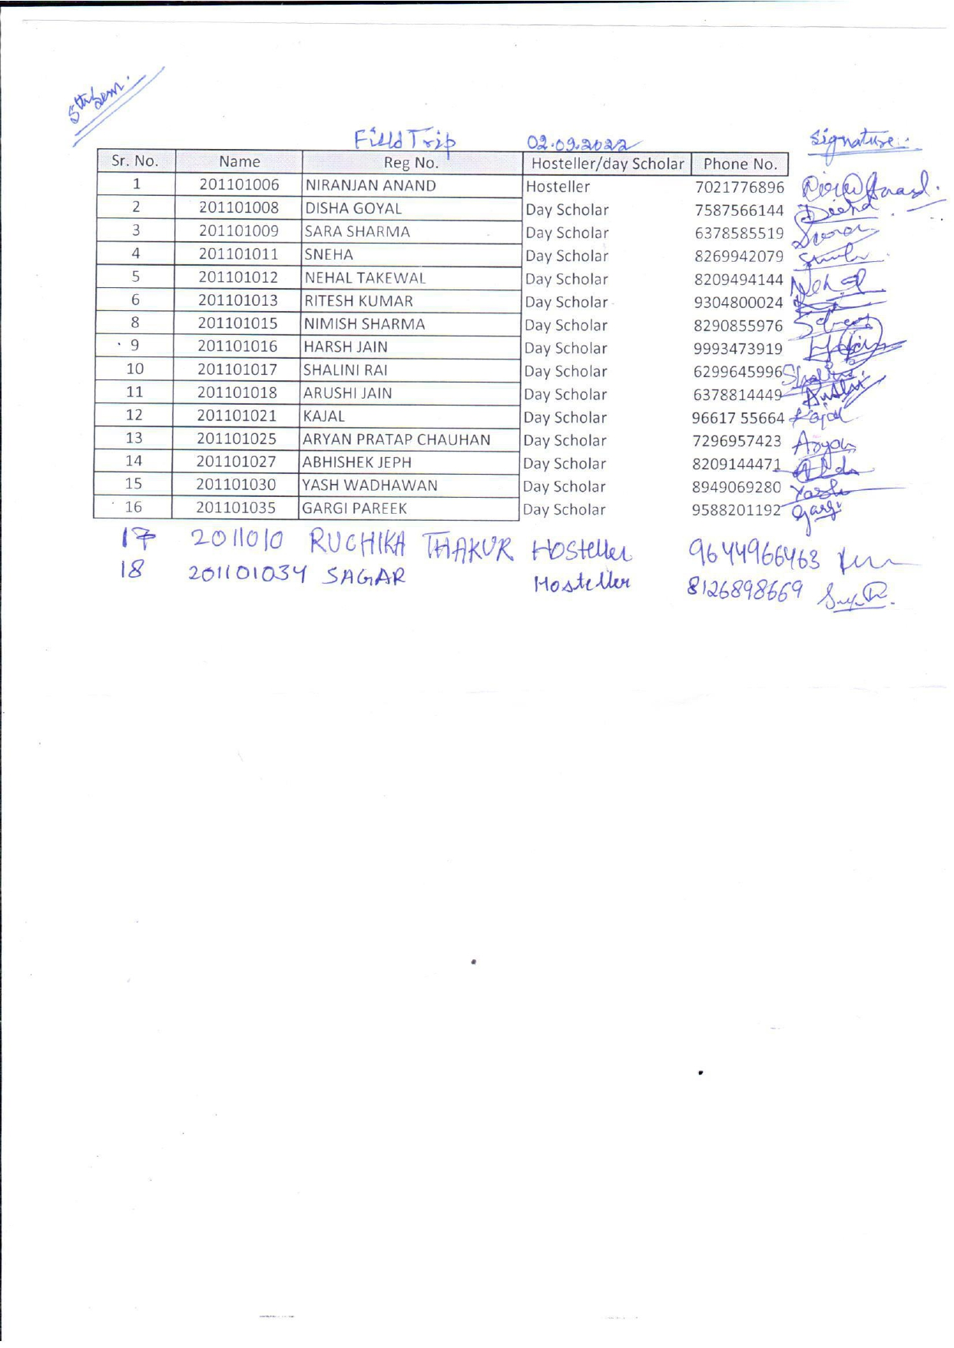

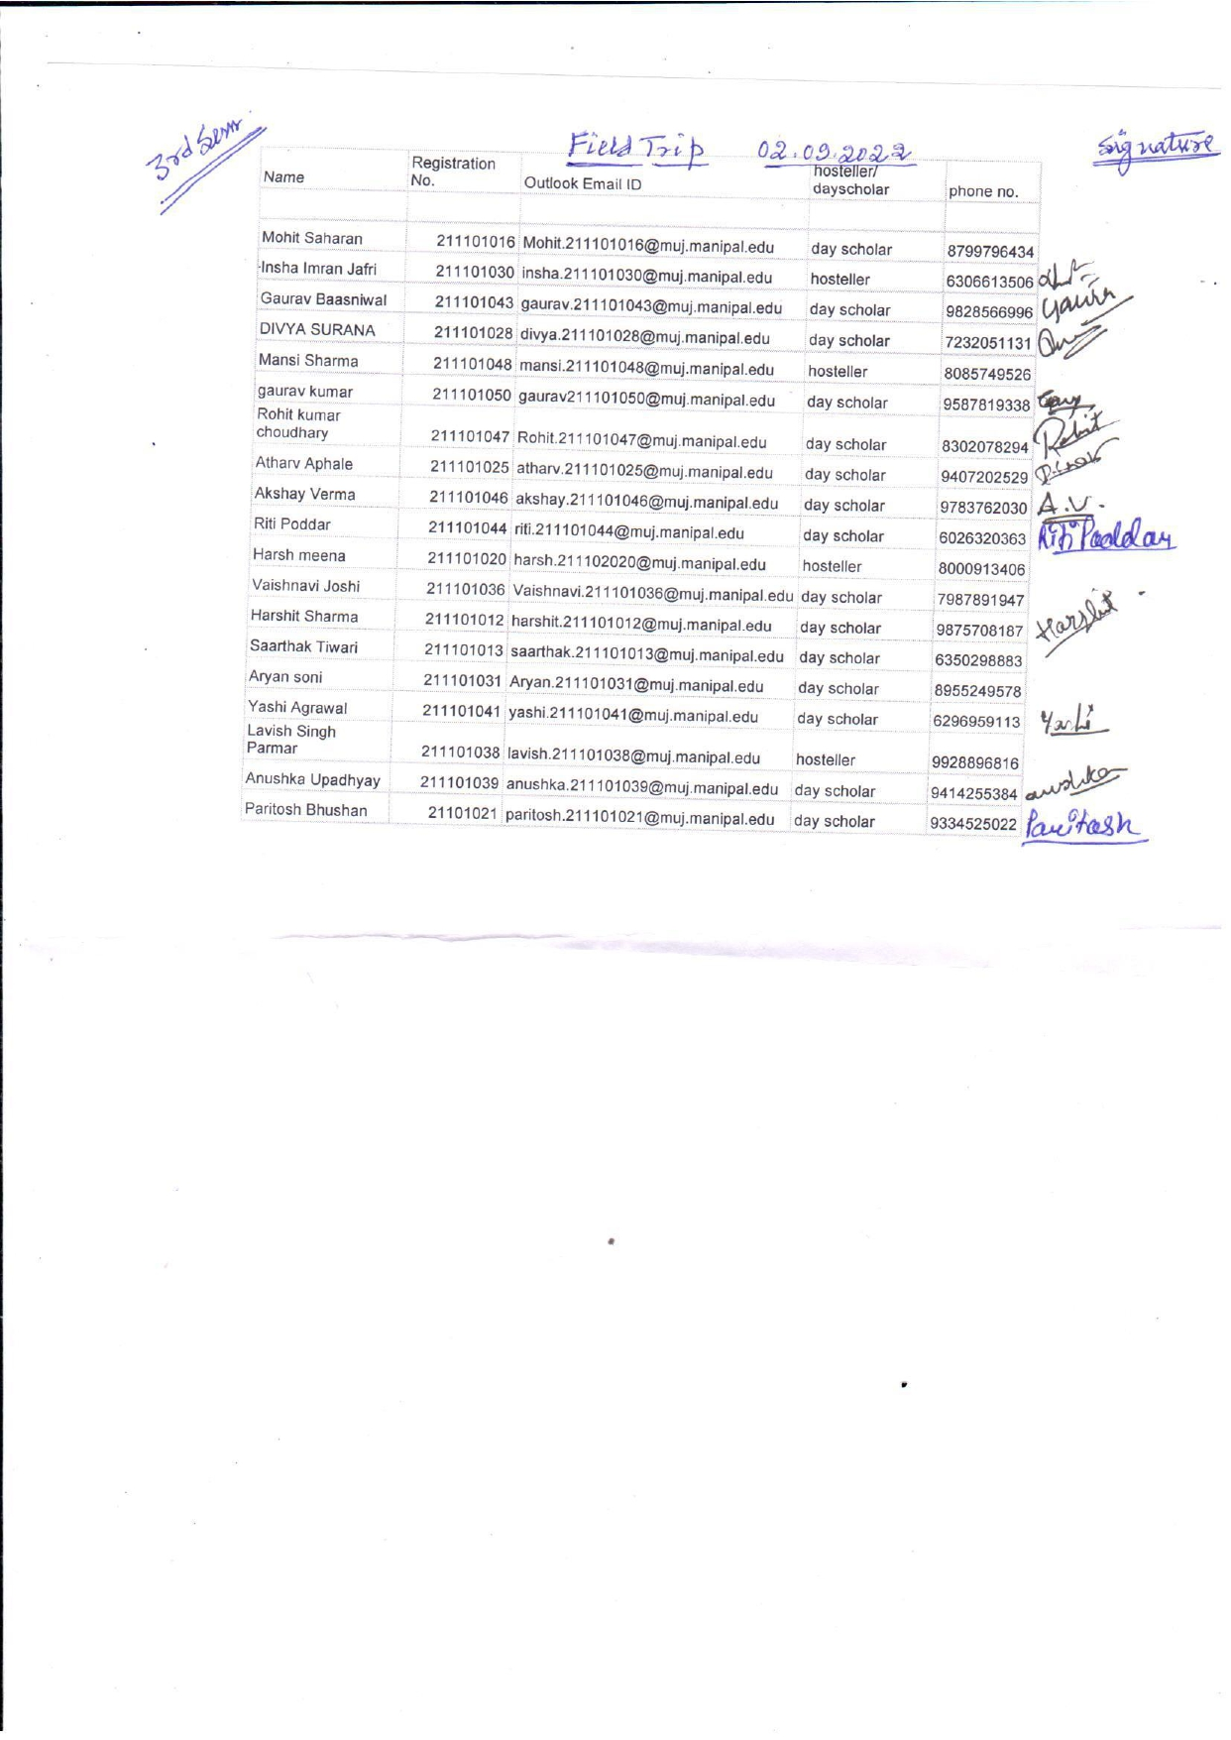

- News Publication- News printed in newspaper or online links (if any) for news – insert images)

NA

- Feedback report of the Event
As per students feedback, they learned so may things about the art of waste management and it will help them to protect the environment.

- Link of MUJ website stating the event is uploaded on website

Seal and Signature of Head with date

