**DEPARTMENT OF ECONOMICS**

**FACULTY OF ARTS**

**SCHOOL OF HUMANITIES AND SOCIAL SCIENCES**

**MANIPAL UNIVERSITY JAIPUR**

**Report**

**Title:** Workshop on self-awareness

**Date:** April 09, 2022

**Brochure:**

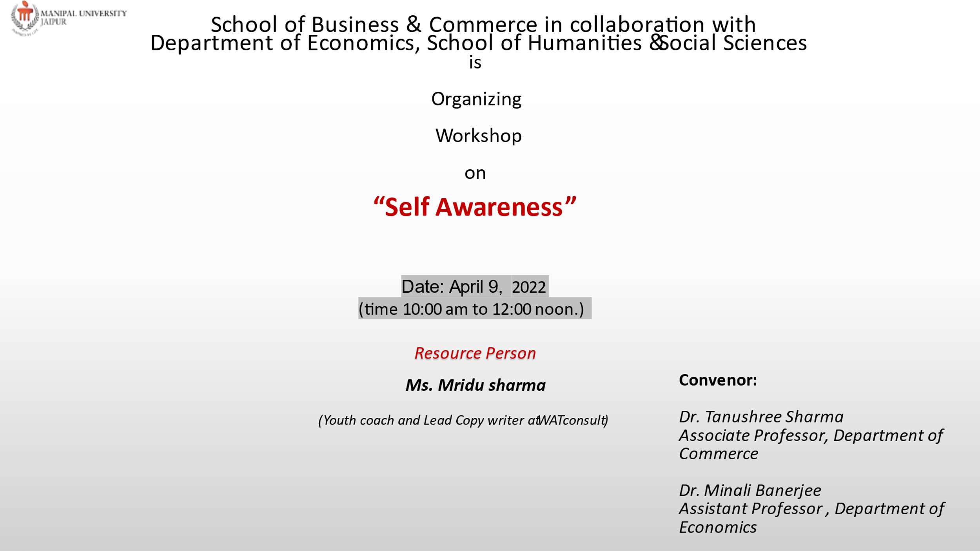

**About the Event:** Department of Economics, School of Humanities and Social Sciences, Manipal University Jaipur organised a webinar on May 09, 2022, at 10 A.M. for the undergraduate student’s training on self-awareness. The invited speaker was Ms. Mridu Sharma, Youth coach and Lead Copy writer at WATconsult. Around 30 students participated. The workshop was on making students understand oneself. This helped them realize their weaknesses and how to overcome them. The speaker also explained that the self-awareness helps in overcoming anxiety and depression that the current generation is facing. The workshop was a great learning for our young minds since it also trained them on controlling their anger. The students participated with enthusiasm and discussed their believes with the speaker.

**Attendance Sheet:**

|  |
| --- |
| Full Name |
| Apoorva Lakhotia [Economics(Hons) - 2019] |
| Mridu Sharma- The LifeForce Studio (Guest) |
| Aishwarya Seth [BA (HONS-ECONOMICS) - 2020] |
| Priyanshi Girdhar [BA (Hons - Economics] - 2020] (Guest) |
| Sakshi Kumawat [BA [Hons - Economics] - 2020] (Guest) |
| Dakshita Agarwal [BA (Hons-Economics) - 2021] |
| Gaurav Kumar [BA (Hons-Economics) - 2021] |
| Mohit Saharan [BA (Hons-Economics) - 2021] (Guest) |
| Kavya Choudhary [BA (Hons-Economics) - 2021] (Guest) |
| Lavish Singh Parmar [BA (Hons-Ecnomic) - 2021] |
| Yashi Agrawal [BA (Hons-Economics) - 2021] (Guest) |
| Paritosh Bhushan [BA (Hons-Economics) - 2021] (Guest) |
| Praseeda Kondru [BA (Hons-Economics) - 2021] |
| Disha Goyal [BA (Hons - Economics] - 2020] (Guest) |
| Anubhav Manoj Purohit [BA (Hons-Economics) - 2021] |
| Fez Mastan Khan [BA (Hons-Economics) - 2021] |
| Rohit Kumar Choudhary [BA (Hons-Economics) - 2021] |
| Saarthak Tiwari [BA (Hons-Economics) - 2021] (Guest) |
| Vasundhara Pawar [BA (Hons-Economics) - 2021] |
| Harsh Meena [BA (Hons-Economics) - 2021] |
| Harshit Sharma [BA (Hons-Economics) - 2021] (Guest) |
| Rishita Sandeep Tripathi [BA (Hons-Economics) - 2021] (Guest) |
| Ankit Bhatnagar [BA (Hons-Economics) - 2021] (Guest) |
| Atharv Aphale [BA (Hons-Economics) - 2021] (Guest) |
| Gaurav Baasniwal [BA (Hons-Economics) - 2021] |
| varuni (Guest) |
| Minali Banerjee [MU - Jaipur] |
| Heeral Lamba [BA (Hons - Economics] - 2020] (Guest) |
| sharatsalil@gmail.com (Guest) |
| sparshsaxena040803@gmail.com (Guest) |
| Shivangi Kapoor [BA (Hons-Economics) - 2021] (Guest) |
| nikhilkumarg02@gmail.com (Guest) |
| Divya Surana [BA (Hons-Economics) - 2021] |
| Insha Imran Jafri [BA (Hons-Economics) - 2021] |
| Aryan Soni [BA (Hons-Economics) - 2021] |
| Harsh Jain [BA (Hons - Economics] - 2020] (Guest) |
| Sher Singh Choudhary [Economics(Hons) - 2019] |
| Aryan Pratap Chauhan [BA (Hons) - Economics - 2020] (Guest) |
| KAJAL [BA (HONS-ECONOMICS) - 2020] |
| Sara Sharma [BA (Hons - Economics] - 2020] |

**Pictures of the Event:**

