Guest Lecture Report
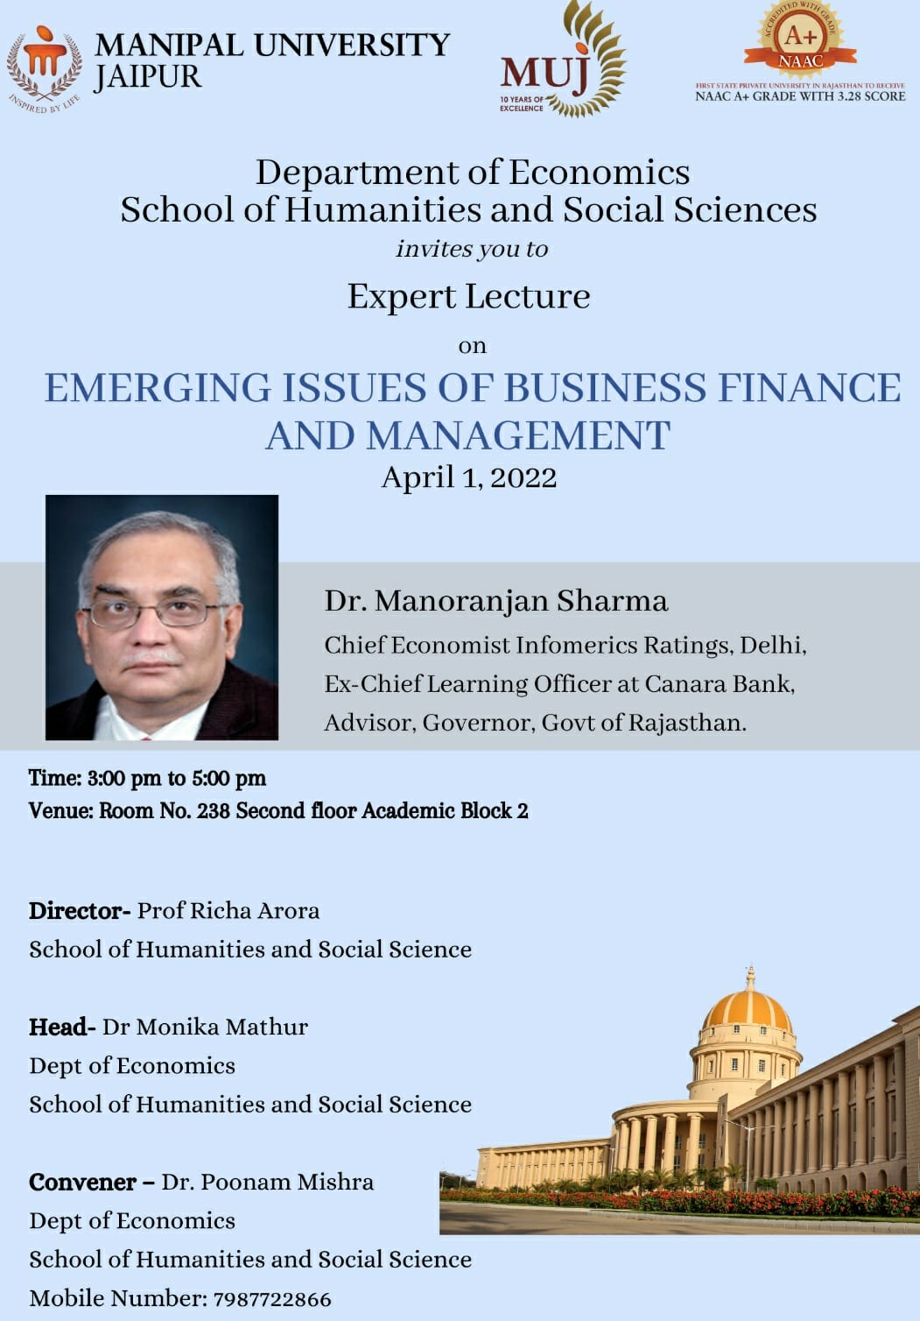

The Department of Economics, Manipal University Jaipur, organized a Guest Lecture on “Emerging Issues of Business Finance and Management” on April 1, 2022, from 3.00 PM onwards. Dr. Manoranjan Sharma, Chief Economist Infomerics Ratings, Delhi, Ex-chief Learning officer at Canara Bank, Advisor, Governor, Government of Rajasthan was the speaker for the event. The lecture was an introductory insight into the various emerging trends in Business Finance and Management of the country. It grew the interests of students in the field of banking and finance as Dr. Manorajan delivered a very interesting lecture starting from small banking jargon to covering a wide area of finance and economics. It was a fun learning experience, students were enlightened and asked many related questions. The event was attended by students and faculties of Manipal University Jaipur. 30 students from B. A (Hons) Economics participated in the lecture along with faculty members of the department.
Members actively participated in the discussion of various banking and economy-related concepts, issues in the implementation of policies, and modification expected in the upcoming time. Overall, it was a very fruitful session for all the students and faculties, to understand the concepts.

PICTURES FROM THE EVENTS

Welcome Plant Gifting ceremony by Dr. Monika Mathur, HOD, ECONOMICS

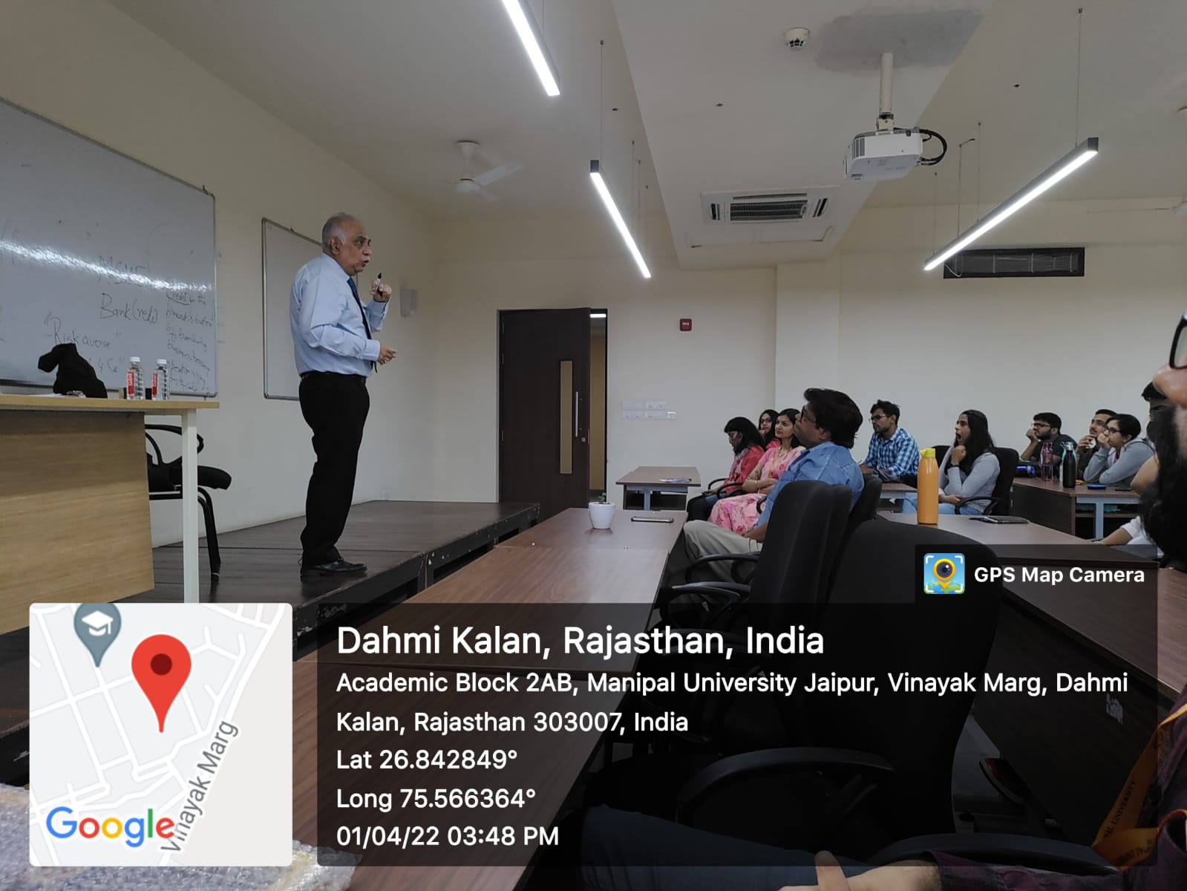

Attendance:
Dr. Poonam Mishra [Mu - Jaipur] | Paritosh Bhushan
Akshay Verma | Divya Malviya
Rohit Kumar Choudhary | Ankit Bhatnagar
Mansi Sharma | Fez Mastan Khan
Samyak Koolwal | Atharv Aphale
Gaurav Kumar | Dakshita Agarwal
Lavish Singh Parmar | Rishita Sandeep Tripathi
Anushka Upadhyay | Shivangi Kapoor
Yash | Utkarsh Patel
Yashi Agrawal | Harshit Sharma
Praseeda Kondru | Saarthak Tiwari
Gaurav Baasniwal | Samrat Singh
Riti Poddar | Sumriddhi Srivastava
Harsh Jain | Mohit Saharan
Shalini Rai | Harsh Meena
Arushi Jain | Sneha
Mohit Kumar | Nehal Takewal
Chaya Neeraj Jain | Ritesh Kumar
Ankita Sharma (Phd Scholar) | Dev Bhutani
Akanksha Choudhary (Phd Scholar) | Varuni
Dr. Manas Roy | Dr. Udai Bhan
Dr. Monika Mathur | Dr. Naseeb

Dr Poonam Mishra Dr Monika Mathur
Convener and Assistant Professor Asso Prof & Head
Department of Economics Department of Economics

