DEPARTMENT OF ECONOMICS
FACULTY OF ARTS
SCHOOL OF HUMANITIES AND SOCIAL SCIENCES
MANIPAL UNIVERSITY JAIPUR

Report

Title: ARTHASHASTRA 2022
Date: JULY 31, 2022
Brochure:
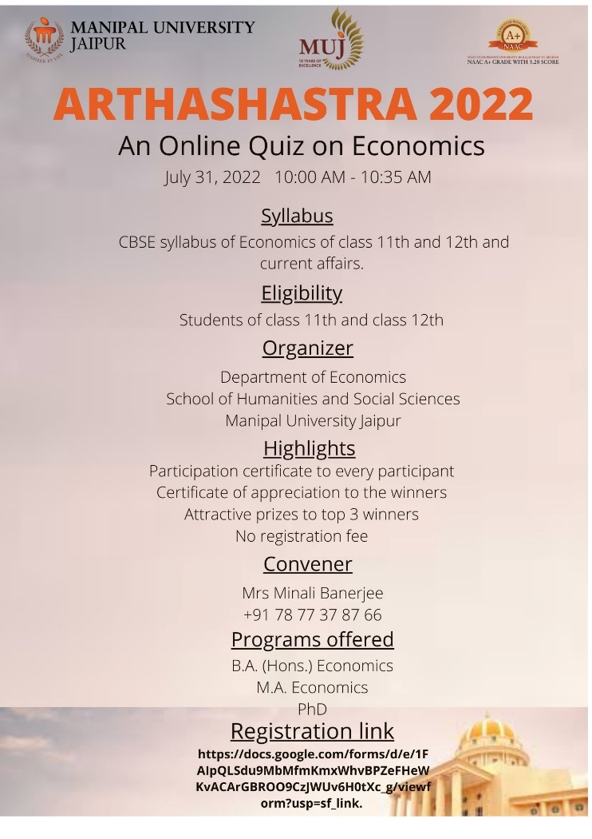
About the Event: The Department of Economics, Manipal University Jaipur, organized an online quiz titled “Arthashastra 2022” on July 31, 2022, from 10AM to 10:35 AM. It was organized for the students of class 11th and 12th. There was no registration fee to make large number of students participate in the event.
Fifty multiple choice questions were asked based on Economics and current affairs, considering the syllabus of class 11th and 12th.

Approximately 50 students registered for the event. The students were from different parts of India. The participants were provided with the certificate of Participation.

Attendance Sheet:
Email | Name of the Student | Whatsup Mobile Number | Father's Name | Father's Mobile Number | Class
smilewithpiyushmangal2004@gmail.com | Piyush mangal | 6367962446 | Ravi mangal | 9928941738 | 12
guptaaaradhay@gmail.com | Aaradhay gupta | 9783900945 | Dharmendra Gupta | 9783901531 | 12
nirjarakumawat@gmail.com | Nirjara kumawat | 9694652478 | Chetan Kumawat | 7737232714 | 12
ruchipunjabi31@gmail.com | Ruchi Punjabi | 7339830274 | C Arun Punjabi | 9610569851 | 12
tewanimohit1@gmail.com | Mohit Tewani | 7374906121 | Mr Naresh Tewani | 8440809169 | 12
gksinghal@gmail.com | Muskan gupta | 8952935188 | Gajendra singhal | 9672575859 | 12
praveengkp63@gmail.com | Praveen Pandey | 8840221593 | Byanketeshwar Pandey | 8467997550 | 12
rinichaturvedi88@gmail.com | Rini chatuvedi | 9672312131 | Pradeep Chaturvedi | 9079359130 | 12
rakhaagarwal6@gmail.com | Dhanvi Agarwal | 7568366031 | Vishnu Agarwal | 9829744560 | 12
goyalshreya424@gmail.com | Shreya Goyal | 9636572288 | Mrs. Meena Gupta | 9461070523 | 12
dishiijain@gmail.com | Bhoomi Jain | 7014242503 | Manish Jain | 9829809504 | 11
mayanksinghtanwar7@gmail.com | Mayank singh | 9649365990 | Mahendra singh | 9829737387 | 11
rishabh280305@gmail.com | Rishabh Agarwal | 7014565059 | Shivcharan Gupta | 9414345070 | 12
suman02871@gmail.com | Raghav Agarwal | 9602252046 | Shiv Charan Gupta | 9414345070 | 12
Madhavisinghani2007@gmail.com | Madhavi Singhani | 8619739429 | Dilip kumar Singhani | 9829187078 | 11
teenasahu583@gmail.com | Teena Sahu | 9653776133 | Mohan Sahu | 9887171333 | 11
nakulpatel20055@gmail.com | Nakul patel | 9636306847 | Jatin patel | 9950467666 | 12
Kittyyy2506@gmail.com | Kinjal tulsani | 9983904616 | Chetan Prakash Tulsani | 7568247874 | 11
himanshugangwani59@gmali.com | Himanshu Gangwani | 9782730567 | Mr. Manoj Kumar gangwani | 8000387693 | 12
komalsoni08413@gmail.com | Komal Soni | 8619637659 | Ram Prasad Soni | 8619637659 | 12
tanvi.ag10@gmail.com | Tanvi agarwal | 6367567918 | R k agarwal | 7850881449 | 11
bmudit869@gmail.com | Mudit Bansal | 8952837345 | Rajesh Kumar Bansal | 9829548621 | 11
teenasahu583@gmail.com | Teena Sahu | 9653776133 | Mohan Sahu | 9887171333 | 11
palashgupta84@gmail.com | Palash Gupta | 6377989269 | Ashish Gupta | 9694513446 | 11
mayanksinghtanwar7@gmail.com | MAYANK SINGH | 9649365990 | Mahendra singh | 9829737387 | 11
tewarikirti8@gmail.com | Sanvi Tiwari | 9782861462 | Gyanandra Tiwari | 9784842476 | 11
aksharasingh847@gmail.com | Akshara Singh | 8302609293 | Vinod Kumar Singh | 9785587681 | 12
Takewalakshya@gmail.com | Lakshya Takewal | 7726021206 | Jitendra Takewal | 7726021206 | 12
adv.raverma@gmail.com | Aditya Singh | 8107982919 | Ramavtar | 9314608134 | 11
Ashabhati764@gmail.com | Chesta singh | 9829788058 | Surendra singh bhati | 8003646004 | 12
gdimple37@gmail.com | Anuj Agarwal | 7425980312 | Alok Gupta | 9509636312 | 11
shikharm533@gmail.com | Shikhar Mathur | 7300463571 | Rajeev Mathur | 9413892894 | 12
ds262535@gmail.com | Dimple Sharma | 8503998479 | Mukesh Sharma | 9460419867 | 12
sanchitsharma7662@gmail.com | Sanchit Sharma | 9772303550 | Sagar Sharma | 9079788413 | 12
arthnagar153@gmail.com | Arth Nagar | 9828702090 | Sanjeev Nagar | 9784607090 | 11
riyashrivastava2005@gmail.com | Riya Shrivastava | 73405695905 | Ashish Shrivastava | 7296844944 | 12
sangita8619612729@gmail.com | Tanishk Khandelwal | 8619612729 | Mr. Pradeep Khandelwal | Mrs. Sangita Khandelwal | 11
nairakiara@gmail.com | nairakiara | 9897188776 | python op | 9897144556 | 12
teenasahu583@gmail.com | Teena sahu | 9653776133 | Mohan sahu | 9887171333 | 11
Kailash1969agarwal@gmail.com | Nilesh gupta | 8963092345 | Adv.Kailash chand gupta | 8963092345 | 12
Krishsoni20040610@gmail.com | Krish Soni | 9351617383 | Nilesh soni | 9351617383 | 12
mayanksinghtanwar7@gmail.com | Mayank | 9649365990 | Mahendra singh | 9829737387 | 11
K.Soni.20040610@gmail.com | Krish soni | 9351617383 | Ankit soni | 9351617383 | 12

Pictures of the Event:
Photographs are not available as this was a quiz organized online.

