DEPARTMENT OF ECONOMICS
FACULTY OF ARTS & LAW
SCHOOL OF HUMANITIES AND SOCIAL SCIENCES
MANIPAL UNIVERSITY JAIPUR

Report
International Conference “Building a Resilient Global Economy (ICBRGE-2022)”

Title: International Conference “Building a Resilient Global Economy (ICBRGE-2022)”

Date: 13th – 14th April 2022
Brochure:
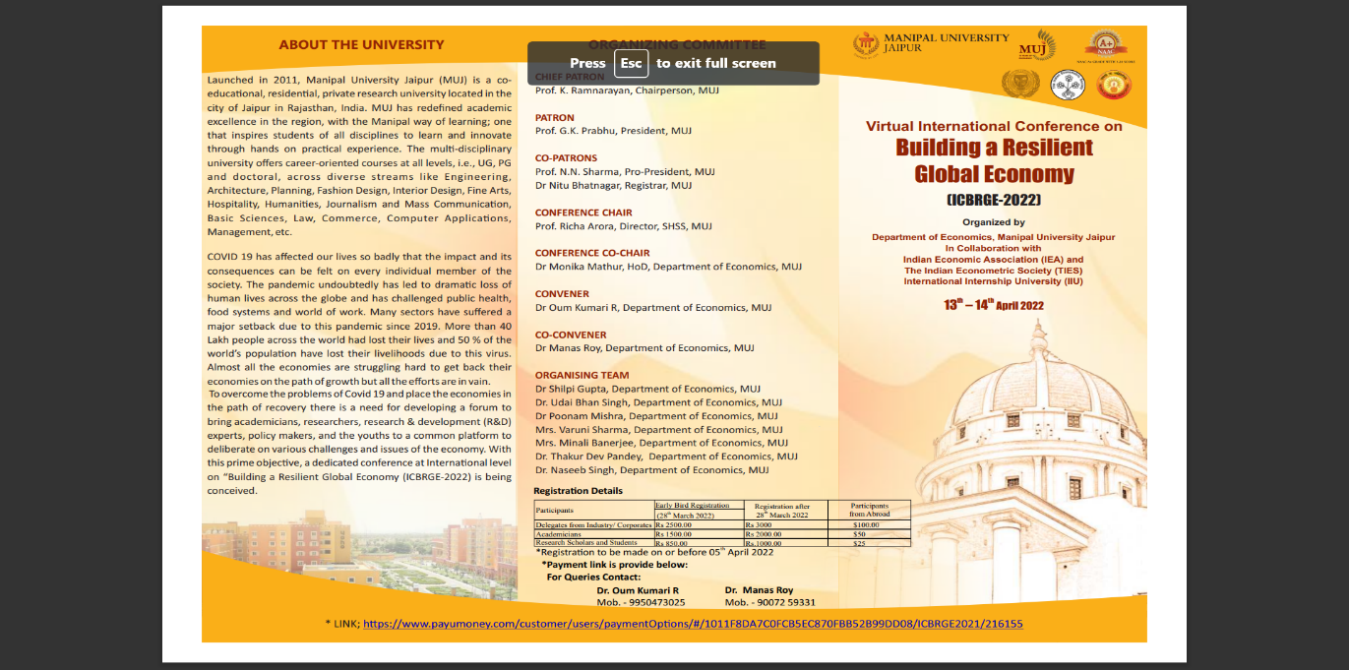
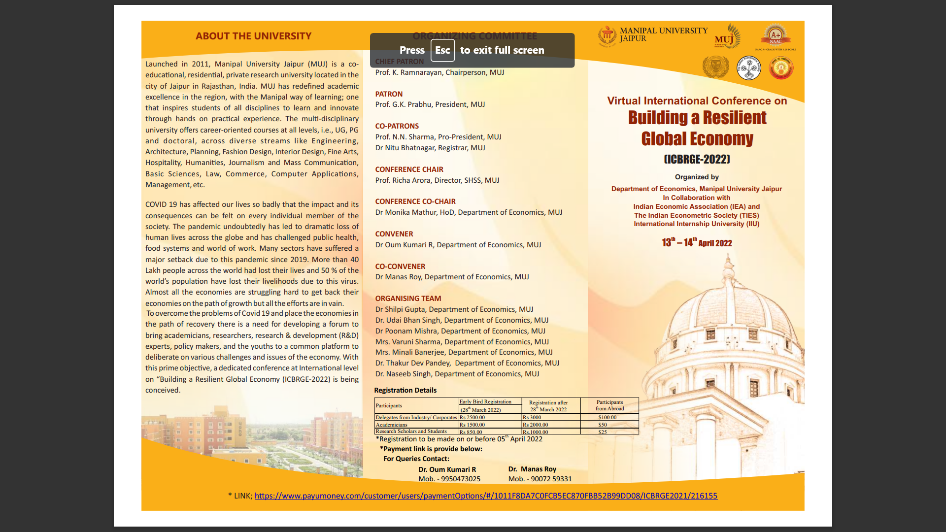

About the Event:
The Department of Economics, Manipal University Jaipur, organized an online International Conference titled “Building a Resilient Global Economy (ICBRGE-2022)” on 13th – 14th April 2022 in Collaboration with Indian Economic Association (IEA), The Indian Econometric Society (TIES) and International Internship University (IIU). Keynote address was delivered by Prof Brijesh Purohit from Madras School of Economics. There were THREE technical sessions chaired by Prof N D Mathur, Dean, School of Humanities & Social Sciences, JECRC, Dr Dipti Sharma, Head, School of Humanities, MNIT & Dr Mahasweta Saha, Asso Professor, Central University of Tripura. The speakers of Plenary sessions were Mr Mihail-Alexandru Stănescu from Romania & Mr Hamdan Al Anazat, Al-Balqa Applied University, Jordan. The Chief Guest for Valedictory session was Prof Ramesh Mittal.

Attendance Sheet: NA
Pictures of the Event:
