DEPARTMENT OF ECONOMICS
FACULTY OF ARTS
SCHOOL OF HUMANITIES AND SOCIAL SCIENCES
MANIPAL UNIVERSITY JAIPUR

Report

Title: The World café- Understanding SDGs
Date: April 27, 2022
Brochure:
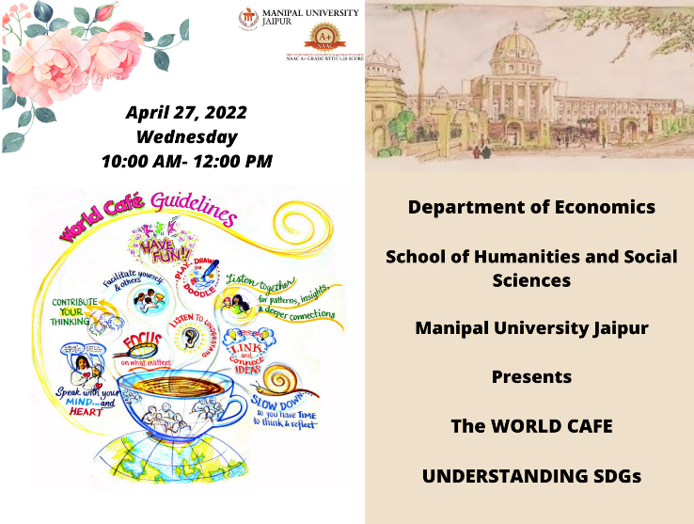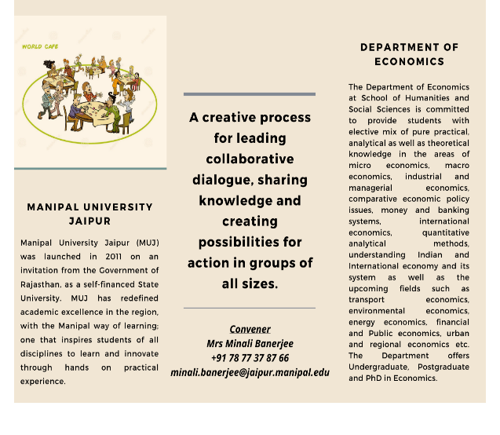
About the Event:
A school connect activity titled the World café was organised by the Department of Economics, School of Humanities and Social Sciences, Manipal University Jaipur on ‘Sustainable Development Goals. Fifty-eight students of class XII from Spring field school, Mansarovar Jaipur, participated. The aim was to make students self-reflect and discuss some of the emerging global issues.
The three rounds of discussion took place on Poverty, Quality education, good health, climate action, responsible consumption, Economic growth, gender equality, and clean water. The students participated very enthusiastically. The discussion took place informally in a café setup. The students reflected on these issues by colouring their ideas into the chart papers.
The event winds up with some career counselling sessions.

Attendance Sheet:
Name | WhatsApp contact number | Email | Father name | Father's WhatsApp contact number
Rupali kumawat | 9887444772 | rupaliprivate24@gmail.com | Sunil kumawat | 9887444772
Anukrat Gupta | 8949614426 | anukratg@gmail.com | Satish gupta | 7737369000
Gauri maheshwari | 7976390662 | maloomeenakshi@gmail.com | Mr. Anurag maheshwari | 9571630009
Rishita Kanwar | 7877159214 | rishitakanwar2@gmail.com | Manohar Singh | 8696526934
Rini Chaturvedi | 9672312131 | rinichaturvedi88@gmail.com | Pradeep Chaturvedi | 9079359130
Dhanvi Agarwal | 7568366031 | rakhaagarwal6@gmail.com | Vishnu Agarwal | 9829744560
Hashneet Kaur | 8209538858 | hashneetkaur25@gmail.com | Jogendra Singh | 9829094846
Tanishka Chouhan | 9829115575 | tanishkachouhan0610@gmail.com | Gaurav Chouhan | 9875000013
Shagun Sharma | 7728046797 | sharmalb62@gmail.com | Lal Bahadur Sharma | 9829628747
Sania Sharma | 9887769247 | saniasharma6251@gmail.com | Taresh Sharma | 8058353788
Himanshu Gangwani | 9782730567 | bhavikagangwani0447@gmail.com | Mr. Manoj Kumar Gangwani | 9214458270
Rishabh Agarwal | 7014565059 | rishabh280305@gmail.com | Shiv Charan Gupta | 9414345070
Raghav Agarwal | 9602252046 | suman02871@gmail.com | Shiv Charan Gupta | 9414345070
Tanisha Sharma | 9024477741 | 1975.sharmamanju@gmail.com | Yogesh Sharma | 9692796877
Komal Soni | 8619637659 | komalsoni08413@gmail.com | Ram Prasad Soni | 8619637659
Rini Chaturvedi | 9672312131 | rinichaturvedi88@gmail.com | Pradeep Chaturvedi | 9079359130
Aditi Saidawat | 8619013662 | saidawataditi@gmail.com | Trilok Saidawat | 9783179202
Yash Soni | 9166853702 | rsys1513@gmail.com | Neeraj Verma | 8386964171
Chesta singh | 9829788058 | ashabhati@gmail.com | Surendra singh bhati | 8003646004
Jahanvi Rathore | 7737734638 | kalpnarathore82@gmail.com | Ganpat Singh Rathore | 9314234638
Shikhar Mathur | 7300463571 | shikharm533@gmail.com | Rajeev Mathur | 9413892894
Sumit nihalani | 7742766861 | sumitnihalani416@gmail.com | Kamal Kishore nihalani | 9928014246
Yashasvi yadav | 9414876663 | yadavyashasvi2@gmail.com | Rajkumar yadav | 9413395588
Riya rajpurohit | 9896526032 | mansiraj9896@gmail.com | Mr shravan Singh | 8053317555
Akshara Singh | 8302609293 | aksharasingh847@gmail.com | Vinod Kumar Singh | 9785587681
Tanisha Singhal | 7851013094 | singhaltanisha7@gmail.com | Lakhmi chand Singhak | 9829144284
Tanisha Singhal | 7851013094 | singhaltanisha7@gmail.com | Lakhmi chand Singhal | 9829144284
Nakul patel | 9636306847 | nakulpatel20055@gmail.com | Jatin patel | 9950467666
Dimple Sharma | 8503998479 | ds262535@gmail.com | Mukesh Sharma | 9460419867
Shreya Goyal | 9636572288 | goyalshreya424@gmail.com | Meena Gupta | 9461070523
KRISH SONI | 9351617383 | k.soni.20040610@gmail.com | Nilesh soni | 9351617383
Deepanshi khatri | 8209416178 | deepanshi9125@gmail.com | Naresh kumar khatri | 9928350278
Garvit Jain | 9314225640 | garvit1928@gmail.com | Gordhan Jain | 9929685972
Riya Shrivastava | 7340569505 | riyashrivastava2005@gmail.com | Ashish Shrivastava | 7296844944
Sanchit Sharma | 9772303550 | sanchitsharma7662@gmail.com | Sagar Sharma | 9079788413
Garvita Ramani | 9119211959 | ramanigarvita858@gmail.com | Sunil Ramani | 8107008770
Tisha Saini | 9352474275 | tishasaini04@gmail.com | Subhash Saini | 9414072402
Nilesh gupta | 8963092345 | kailash1969agarwal@gmail.com | Adv.Kailash chand gupta | 8963092345
Khushi Sharma | 8058264898 | kskhushis2005@gmail.com | Shivdutt Sharma | 9413133992
Pawan Harwani | 9509577264 | pawanharwani009@gmail.com | Naresh harwani | 7976386799
Kshitiz ojha | 8955394546 | ojhakshitiz2005@gmail.com | Mr.Pankaj Ojha | 7737769525
Lakshya | +91 7728899483 | lakshyakumarjaipur@gmail.com | Vinod manghani | +91 7728899483
Kawaldeep Singh | 9351721883 | kawaldeep9211@gmail.com | Harmeet Singh | 9828138236
Harshit vyas | 8209276772 | vyasharshit54@gmail.com | Bhavesh vyas | 9636436994
Sameeksha meena | 8441076622 | sameekshameena17@gmail.com | Balkrishan meena | 9001771176
Meghansh Kumar | 7597467631 | kumarmeghansh777@gmail.com | Narendra Kumar Methwani | 9413158683
Nikhil Gorani | 8824700829 | nikhilgorani04@gmail.com | Mr.Manoj kumar Gorani | 8739919999
Sumit nihalani | 7742766861 | sumitnihalani416@gmail.com | Kamal Kishore nihalani | 9928014246
Mananshi sethi | 9251811151 | sethimananshi@gmail.com | Rajendra kumar Sethi | 9251811151
Komal Soni | 8619637659 | komalsoni08413@gmail.com | Ram Prasad Soni | 8619637659
Riya Nagar | 7300318366 | riyanagar467@gmail.com | Naval Nagar | 9887766366
Jai Sharma | 8619332023 | audacious0141@gmail.com | Nirmal Sharma | 9587101010
Riya Nagar | 7300318366 | riyanagar467@gmail.com | Naval Nagar | 9887766366
krish bansal | 9460234407 | bmagic580@gmail.com | vijay agarwal | 9828112521
Devyansh Sharma | 9660939056 | devyanshsharma070@gamil.com | Vineet sharma | 7073739990
Lokaswi Prakash | 8529714680 | lokaswi25pr@gmail.com | Kamal Prakash | 9413487734
Deepanshi kalra | 8905687374 | deepanshikalra11@gmail.com | Parveen kalra | 9929352577
Nishi Jain | +91 94628 04227 | nishikjain11@gmail.com | Sudhir kumar patni | +91 94628 04227
Monisha Kumawat | 9928355779 | lakshitakumawat3869@gmail.com | Ashish Kumawat | 9983097000
Purvik Sharma | +91 86195 82715 | yopurvik@gmail.com | Amit Sharma | +91 86195 82715
Dev Bhandari | 7597457875 | devsinghbhandari06@gmail.com | Rakesh Singh Bhandari | 9460435770

Pictures of the Event:
