MUJ/Q&C/22/F/1.01 Event Report Format

FACULTY OF ENGINEERING

SCHOOL OF CIVIL AND CHEMICAL ENGINEERING

DEPARTMENT OF CIVIL DEPARTMENT

Intellectual Property Rights (IPRs) & IP Management for Startup
(Workshop)

22nd April, 2022

Content of Report (index)
1. Introduction of the Event
2. Objective of the Event
3. Beneficiaries of the Event
4. Details of the Guests
5. Brief Description of the event
6. Geo-tagged Photographs
7. Brochure or creative of the event
8. Schedule of the Event
9. Attendance of the Event
10. Link of MUJ website

- Introduction of the Event
Atal Incubation Centre-Manipal University Jaipur has organized a workshop on Intellectual Property Rights and IP Management for start-ups in association with Department of Civil Engineering & Department of Commerce on 22nd April 2022.

- Objective of the Event
- To spread awareness about the IPR and IP Management
- To explain the various field for IPR and IP Management
- To explore the process of filing paper on IPR and IP Management

- Beneficiaries of the Event
The main beneficiaries of the workshop are MUJ faculties, research scholars and undergraduate and post graduate students

- Details of the Guests
  - Peggy Bengtsson, Director, Portfolio Outstanding, ZACCO – Senior European Patent Attorney, has More than 36 years of experience both as in-house attorney in ABB, Ericsson and Sony Mobile and consultant in patent drafting, prosecution and strategy work in various domains including Telecommunications and Mechanical. She joined ZACCO in 2004. She graduated in 1983 with a Master’s of Science degree in mechanical engineering from Lund University’s faculty of engineering (LTH). She has also successfully completed her European Qualifying Examination and is a certified European Patent Attorney

  - Edwin Selvraj, Team Manager, Patents, ZACCO - Region India, Lead Patent Attorney, S&H Partners, is an expert of drafting, prosecution of patent applications in US, EP and India, focus on consulting and strategy. His notable representation includes Electronics / Telecommunication / Software companies for drafting and prosecuting their patent application in India, US and Europe. In addition, Edwin has been assisting several multinational corporations, prestigious Indian establishments, Indian institutions, and many start-ups in India for handling their IP portfolio strategic creation and management.
  - Debasish Kundu, Head - Business Development, ZACCO - Region India, has over 15 years of experience in International Sales & Marketing. He has hands-on experience in Software Product Development. He also has an expertise in Strategic Initiatives, International Marketing, Marketing Communication, Brand Management, Market Research, Digital Marketing, Product Management, Event Management, Management Training, CRM and Automation (software product development). Debasish held key positions in both corporate and academic institutions. He was the Head – Marketing & Strategy at ProTeam Software and Campus In-charge cum Chairperson Academics at International School of Business & Media, Bangalore.

- Brief Description of the event
Atal Incubation Centre-Manipal University Jaipur has organized a workshop on Intellectual Property Rights and IP Management for Startups in association with Department of Civil Engineering & Department of Commerce, E-cell, S & H Partners, ZACCO on 22nd April 2022. Understanding the role of IPR in this competitive world of technology is a must. The main objective behind the workshop is to help entrepreneur understand. The workshop commenced with an address to the participants about the significance of IPR and cybersecurity in the modern world. The history of intellectual property, from its beginnings to its evolving phase was also covered. Participants got the insights on cybersecurity and IP management in the tech world. The resource persons of the workshop were Peggy Bengtsson (Director, Portfolio Outsourcing – ZACCO Senior European Patent Attorney), Debasish Kundu (Head -Business development-ZACCO Region India), Edwin Selvaraj (Lead patent attorney at S&H Partners). The workshop was attended by faculty members and students of Manipal University Jaipur.

- Photographs
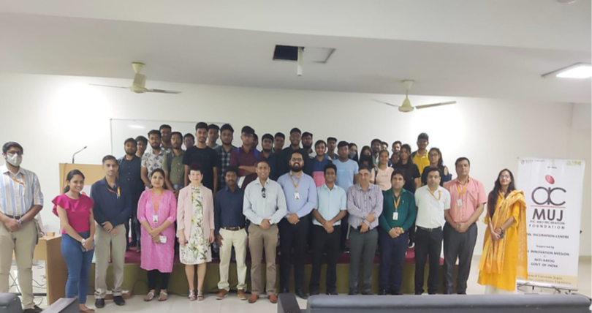
Participants and key speakers during the IPR & IP Management workshop on 22nd April, 2022

- Brochure or creative of the event
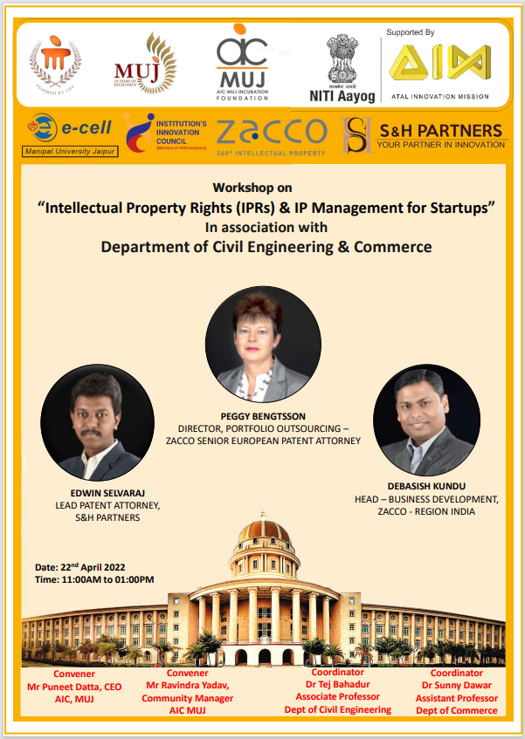

- Schedule of the event
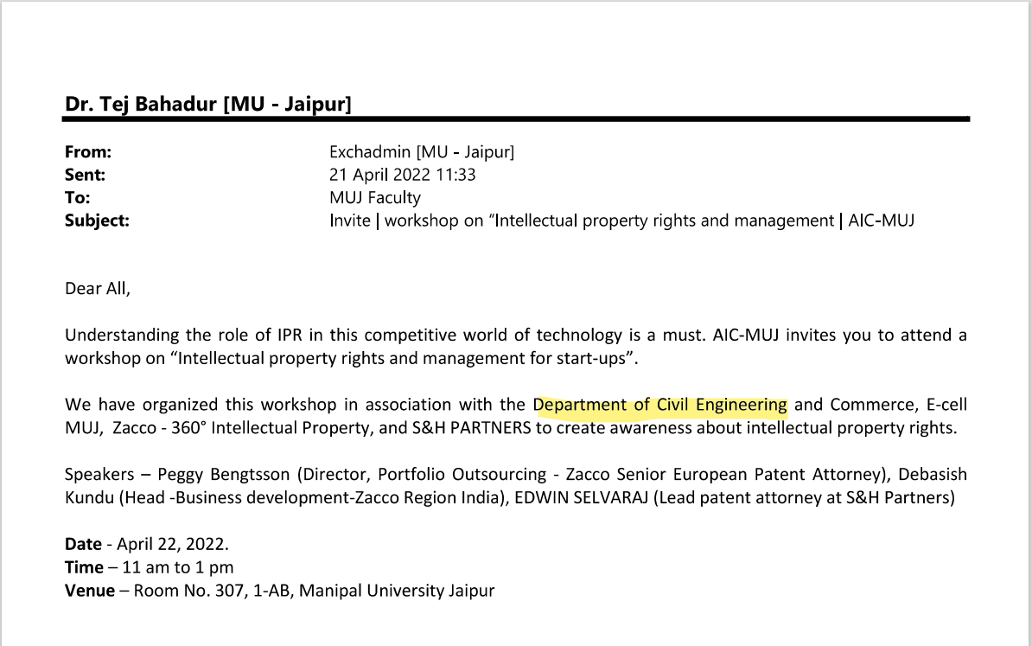

- Attendance of the Event - Total attendee- 34
