cid:image001.png@01D3CCBE.2100A7E0

**FDP and Training of Strategic Business Reporting (SBR) for ACCA**

**MICROSOFT TEAMS**

**ONLINE**

**23RD OCTOBER 2020**

**03 PM TO 5 PM**

**Prof. Raavi, ISDC Prof. Dr. Gaurav Lodha, MUJ**

**MANIPAL UNIVERSITY JAIPUR**

**Department of Commerce**

**FDP and Training of Strategic Business Reporting (SBR) for ACCA**

**(23RD OCTOBER 2020, FRIDAY)**

**REPORT**

FDP and training for ACCA Paper of Strategic Business Reporting (SBR) was organized for B.Com Honours V Semester Faculties teaching the course and the students of the class. The training was being taken up on 23RD OCTOBER 2020 by Prof. Raavi from ISDC contributing important inputs for the course to the faculty concerned and the students guiding them for the pattern of the papers for ACCA exams. The Inputs made by Prof. Raavi were really helpful for the participants of the training as it delivered the process of Solving the problems related to SBR and the way of attempting the questions usually asked in the ACCA examinations.

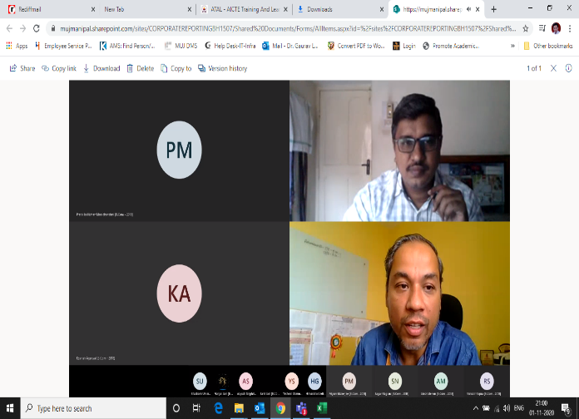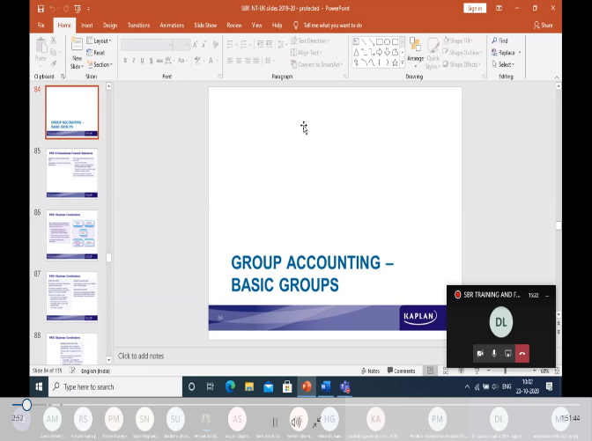

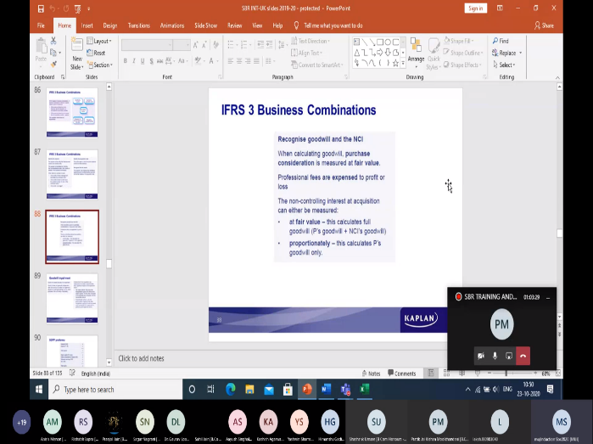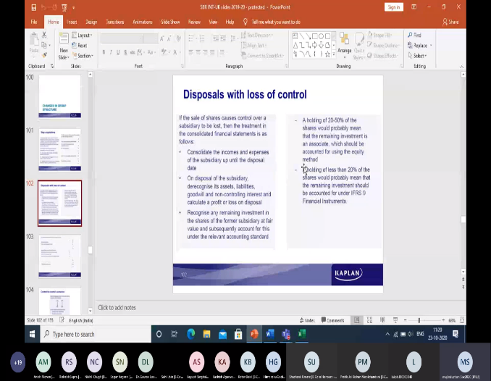

**ATTENDANCE**

FDP and Training of Strategic Business Reporting (SBR) for ACCA

(23RD OCTOBER 2020, FRIDAY)

|  |  |
| --- | --- |
| Full Name | User Action |
| Dr. Gaurav Loadha [MU - Jaipur] | Joined |
| mujInduction Sbc2020 [MUJ] | Joined |
| Pratik Jai Kishan Moolchandani [B.Com - 2018] | Joined |
| Priyam Mukerjee [B.Com - 2018] | Joined |
| Priyam Mukerjee [B.Com - 2018] | Left |
| Priyam Mukerjee [B.Com - 2018] | Joined |
| Kashish Agarwal [B.Com - 2018] | Joined |
| Anish Menon [B.Com - 2018] | Joined |
| Himanshu Gadia [B.Com - 2018] | Joined |
| Yashwin Sharma [B.Com - 2018] | Joined |
| Yashwin Sharma [B.Com - 2018] | Left |
| Yashwin Sharma [B.Com - 2018] | Joined |
| Yashwin Sharma [B.Com - 2018] | Left |
| Sagar Nagrani [B.Com - 2018] | Joined |
| Sahil Jain [B.Com - 2018] | Joined |
| Sahil Jain [B.Com - 2018] | Left |
| Aayush Singhal [B.Com - 2018] | Joined |
| Rishabh Sapra [B.Com - 2018] | Joined |
| Pranjal Jain [B.Com - 2018] | Joined |
| Pranjal Jain [B.Com - 2018] | Left |
| Pranjal Jain [B.Com - 2018] | Joined |
| Pranjal Jain [B.Com - 2018] | Left |
| Pranjal Jain [B.Com - 2018] | Joined |
| Shashank Umare [B Com Honours - 2017] | Joined |
| Yash Garg [BBA - 2018] | Joined |
| Yash Garg [BBA - 2018] | Left |
| Nikhil Chugh [B.Com - 2018] | Joined |
| LAKSH GOSWAMI [B.Com - 2018] | Joined |
| Ketan Baid [B.Com - 2018] | Joined |
| Yashswani Kathuria [B.Com - 2018] | Joined |
| Bhagyashree Taparia [B.Com - 2018] | Joined |
| Bhagyashree Taparia [B.Com - 2018] | Left |
| Bhagyashree Taparia [B.Com - 2018] | Joined |
| Kritika Khandelwal [B.Com - 2018] | Joined |
| Anand Singh [B.Com - 2018] | Joined |
| Anand Singh [B.Com - 2018] | Left |
| Anand Singh [B.Com - 2018] | Joined |
| Deepesh Khanchandani [B.Com - 2018] | Joined |
| Pulkit Goyal [B.Com - 2018] | Joined |
| Purti Balani [B.Com - 2018] | Joined |
| PREET MANDA [BBA - 2018] | Joined |
| Sahaj Khandelwal [B.Com - 2018] | Joined |
| Sahaj Khandelwal [B.Com - 2018] | Left |
| Sahaj Khandelwal [B.Com - 2018] | Joined |
| Sakshi Jain [B.Com - 2018] | Joined |
| Devraj Soyal [B.Com - 2018] | Joined |
| Riya Batra [B.Com - 2018] | Joined |
| Ashi Khandelwal [B.Com - 2018] | Joined |
| Vardhini Gupta [B.Com - 2018] | Joined |
| Vardhini Gupta [B.Com - 2018] | Left |
| Vardhini Gupta [B.Com - 2018] | Joined |
| Devendra Singh Rathore [B.Com - 2018] | Joined |
| RAJAT BANSAL [B.Com - 2018] | Joined |
| Aditya Mani [B.Com - 2018] | Joined |
| Shalu Soni [B.Com - 2018] | Joined |

**FEEDBACK**

FDP and Training of Strategic Business Reporting (SBR) for ACCA

(23RD OCTOBER 2020, FRIDAY)

|  |
| --- |
| Feedback |
| SBR is very well explained |
| It's useful. |
| The quality of teaching is fantastic |
| Satisfactory for way of attempting questions in ACCA |
| Quality of teaching was very good Madam has taught in very good way |
| Teaching is good and understandable |
| Excellent way of explanation |
| very nice |
| Perfect!!! It's was a great experience. |
| Good |
| Great Job |
| Best and we'll knowledgeable |
| The Best |
| It was good. Raavi Sir taught us very nicely |
| Excellent! |
| Excellent |
| Good Job |
| Really good one |
| Very Useful |