cid:image001.png@01D3CCBE.2100A7E0

**FDP and Training of Financial Accounting (FA) for ACCA**

**MICROSOFT TEAMS**

**ONLINE**

**29TH OCTOBER 2020**

**3 PM TO 5 PM**

**Prof. Darshan Shah, ISDC Prof. Dr. Gaurav Lodha, MUJ**

**MANIPAL UNIVERSITY JAIPUR**

**Department of Commerce**

**FDP and Training of Financial Accounting (FA) for ACCA**

**(29TH OCTOBER 2020, Thursday)**

**REPORT**

FDP and training for ACCA Paper of Financial Accounting (FA) was organized for B.Com Honours I Semester Faculties teaching the course and the students of the class. The training was being taken up on 29TH OCTOBER 2020 by Prof. Darshan Shah from ISDC contributing important inputs for the course to the faculty concerned and the students guiding them for the pattern of the papers for ACCA exams. The Inputs made by Prof. Darshan Shah were really helpful for the participants of the training as it delivered the process of Solving the problems related to SBR and the way of attempting the questions usually asked in the ACCA examinations.

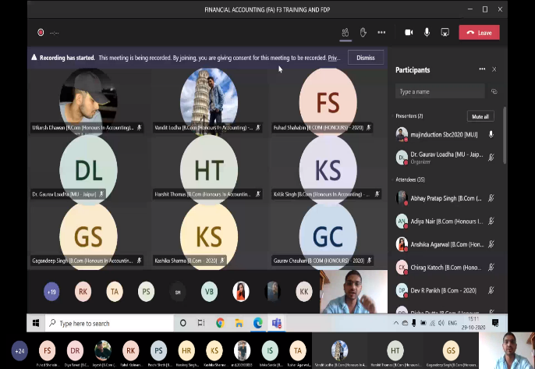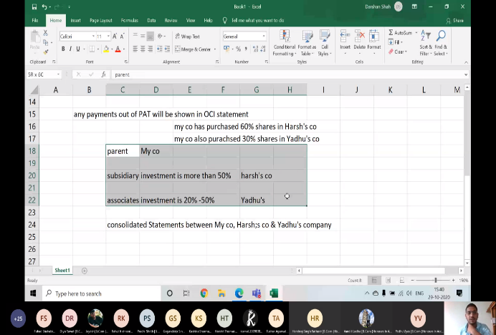

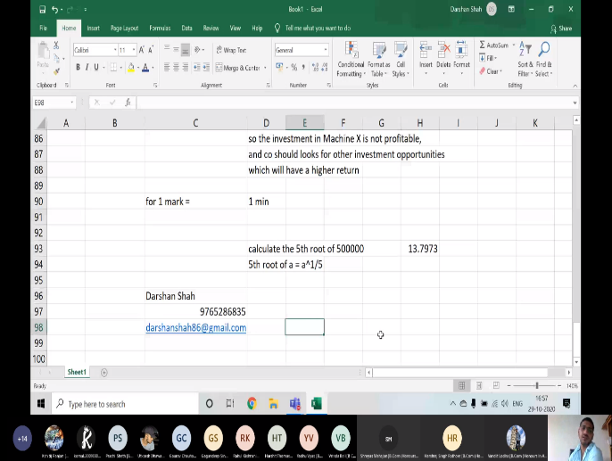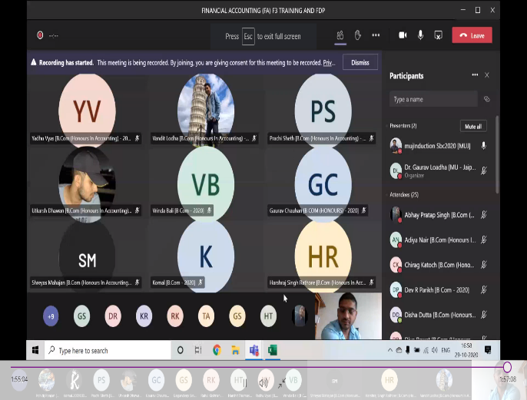

**ATTENDANCE**

FDP and Training of Financial Accounting (FA) for ACCA

(29th OCTOBER 2020, Thursday)

|  |  |
| --- | --- |
| Full Name | User Action |
| Dr. Gaurav Loadha [MU - Jaipur] | Joined |
| Sudhish Trigunayat [Bachelor of Commerce (B.Com) - 2020] | Joined before |
| mujInduction Sbc2020 [MUJ] | Joined before |
| Yadhu Vyas [B.Com (Honours In Accounting) - 2020] | Joined before |
| Yadhu Vyas [B.Com (Honours In Accounting) - 2020] | Left |
| Yadhu Vyas [B.Com (Honours In Accounting) - 2020] | Joined |
| Anushka Gupta [B.Com (Honours In Accounting) - 2020] | Joined before |
| Madhu Mishra [B.Com (Honours In Accounting) - 2020] | Joined before |
| Shreya Thakre [B.Com - 2020] | Joined before |
| Harshit Thomas [B.Com (Honours In Accounting) - 2020] | Joined before |
| Jayesh [B.Com (Honours In Accounting) - 2020] | Joined before |
| Kashika Sharma [B.Com - 2020] | Joined before |
| Gauransh Singhal [B.Com (Honours In Accounting) - 2020] | Joined before |
| Gauransh Singhal [B.Com (Honours In Accounting) - 2020] | Left |
| Priyasha Singh [B.Com (Honours In Accounting) - 2020] | Joined before |
| Puneeth H B [B.Com (Honours In Accounting) - 2020] | Joined before |
| Dev Raghuvanshi [B.Com (Honours In Accounting) - 2020] | Joined before |
| Harshraj Singh Rathore [B.Com (Honours In Accounting) - 2020] | Joined before |
| Ishika Sarda [B.Com (Honours In Accounting) - 2020] | Joined before |
| Md Habibur Rahman [B.Com (Honours In Accounting) - 2020] | Joined before |
| Vandit Lodha [B.Com (Honours In Accounting) - 2020] | Joined before |
| Prachi Sheth [B.Com (Honours In Accounting) - 2020] | Joined before |
| Prachi Sheth [B.Com (Honours In Accounting) - 2020] | Left |
| Anshika Agarwal [B.Com (Honours In Accounting) - 2020] | Joined before |
| Md Munibur Rahman [B.Com (Honours In Accounting) - 2020] | Joined before |
| Vrinda Bali [B Com - 2020] | Joined before |
| Dev R Parikh [B Com - 2020] | Joined before |
| Adiya Nair [B.Com (Honours In Accounting) - 2020] | Joined before |
| Adiya Nair [B.Com (Honours In Accounting) - 2020] | Left |
| Adiya Nair [B.Com (Honours In Accounting) - 2020] | Joined |
| Gagandeep Singh [B.Com (Honours In Accounting) - 2020] | Joined before |
| Shreyas Mahajan [B.Com (Honours In Accounting) - 2020] | Joined before |
| Kshitij Ranjan [B.Com (Honours In Accounting) - 2020] | Joined before |
| Naman Mehta [B.Com (Honours In Accounting) - 2020] | Joined |
| Disha Dutta [B.Com (Honours In Accounting) - 2020] | Joined |
| Vansh Sharma [Bachelor of Commerce (B.Com) - 2020] | Joined |
| Vaibhav Dulatani [B.Com (Honours In Accounting) - 2020] | Joined |
| K R Krishnapriya [B.Com (Honours In Accounting) - 2020] | Joined |
| Mansi Singh [B.Com (Honours In Accounting) - 2020] | Joined |
| Aditya Pawriya [B.Com (Honours In Accounting) - 2020] | Joined |
| Aditya Pawriya [B.Com (Honours In Accounting) - 2020] | Left |
| Chirag Katoch [B.Com (Honours In Accounting) - 2020] | Joined |
| Diya Rawat [B.Com (Honours In Accounting) - 2020] | Joined |
| Ritik Kumar [B.Com (Honours In Accounting) - 2020] | Joined |
| Utkarsh Dhawan [B.Com (Honours In Accounting) - 2020] | Joined |
| Shivam Gupta [B.Com (Honours In Accounting) - 2020] | Joined |
| Shivam Gupta [B.Com (Honours In Accounting) - 2020] | Left |
| Shubh Gupta [B.Com (Honours In Accounting) - 2020] | Joined |
| Kartikeya Yogi [B.Com (Honours In Accounting) - 2020] | Joined |
| Gurleen Sood [B.Com (Honours In Accounting) - 2020] | Joined |
| Uttam Agarwal [B.Com (Honours In Accounting) - 2020] | Joined |

**FEEDBACK**

FDP and Training of Financial Accounting (FA) for ACCA

(29th OCTOBER 2020, Thursday)

|  |
| --- |
| Feedback |
| Goods Session on Financial Accounting |
| It's good one |
| The quality of teaching is fantastic |
| Satisfactory for way of attempting questions in ACCA |
| Quality of teaching was very good Madam has taught in very good way |
| Teaching is good and understandable |
| Excellent way of explanation |
| very nice |
| Perfect!!! It's was a great experience. |
| Good |
| Great Job |
| Best and we'll knowledgeable |
| The Best |
| It was good. Raavi Sir taught us very nicely |
| wonderful |
| Excellent |
| Good work |
| FA is well explained |
| Great Session |