cid:image001.png@01D3CCBE.2100A7E0

**FDP and Training of Strategic Business Leader (SBL) for ACCA**

**MICROSOFT TEAMS**

**ONLINE**

**19TH OCTOBER 2020**

**10.30 AM TO 12.30 PM**

**Prof. Santosh, ISDC Prof. Dr. Gaurav Lodha, MUJ**

**MANIPAL UNIVERSITY JAIPUR**

**Department of Commerce**

**FDP and Training of Strategic Business Leader (SBL) for ACCA**

**(19TH OCTOBER 2020, Monday)**

**REPORT**

FDP and training for ACCA Paper of Strategic Business Leader (SBL) was organized for B.Com Honours V Semester Faculties teaching the course and the students of the class. The training was being taken up on 19TH OCTOBER 2020 by Prof. Santosh from ISDC contributing important inputs for the course to the faculty concerned and the students guiding them for the pattern of the papers for ACCA exams. The Inputs made by Prof. Santosh were really helpful for the participants of the training as it delivered the process of Solving the problems related to SBR and the way of attempting the questions usually asked in the ACCA examinations.

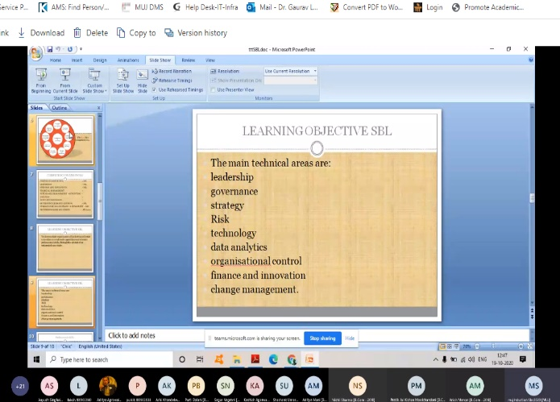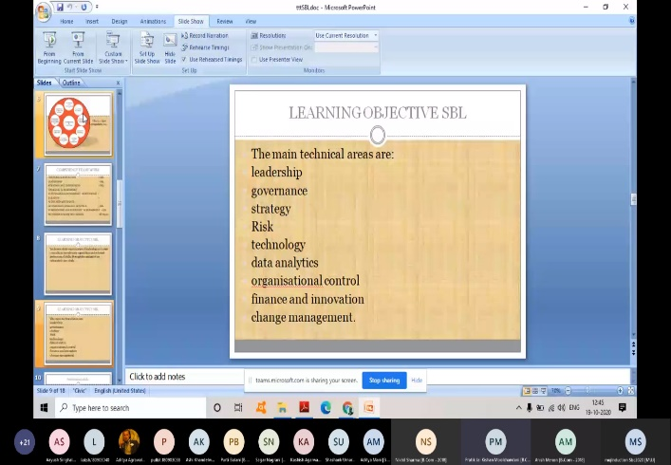

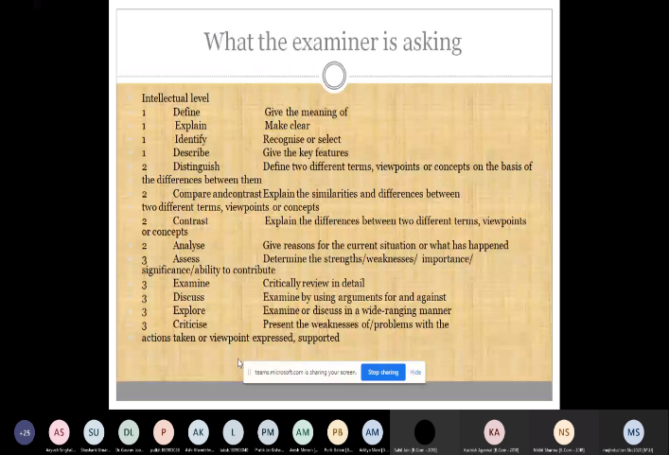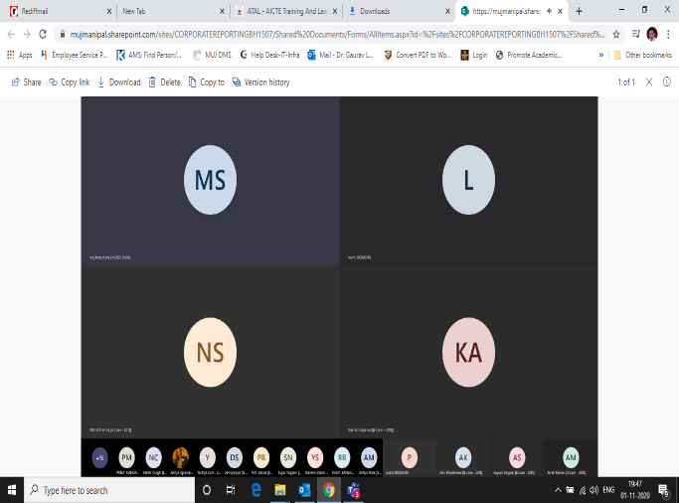

**ATTENDANCE**

FDP and Training of Strategic Business Leader (SBL) for ACCA

(19TH OCTOBER 2020, Monday)

|  |  |
| --- | --- |
| Full Name | User Action |
| Dr. Gaurav Loadha [MU - Jaipur] | Joined |
| mujInduction Sbc2020 [MUJ] | Joined |
| LAKSH GOSWAMI [B.Com - 2018] | Joined |
| Sakshi Jain [B.Com - 2018] | Joined |
| Pranjal Jain [B.Com - 2018] | Joined |
| Himanshu Gadia [B.Com - 2018] | Joined |
| PARVATI DUBEY [BBA - 2018] | Joined |
| Pratik Jai Kishan Moolchandani [B.Com - 2018] | Joined |
| Purti Balani [B.Com - 2018] | Joined |
| Ashi Khandelwal [B.Com - 2018] | Joined |
| Priyam Mukerjee [B.Com - 2018] | Joined |
| Yashswani Kathuria [B.Com - 2018] | Joined |
| Sahil Jain [B.Com - 2018] | Joined |
| Sanchit Sharma [B.Com - 2018] | Joined |
| Sanchit Sharma [B.Com - 2018] | Left |
| Aayush Singhal [B.Com - 2018] | Joined |
| Shashank Umare [B Com Honours - 2017] | Joined |
| Ketan Baid [B.Com - 2018] | Joined |
| Anand Singh [B.Com - 2018] | Joined |
| Yash [B.Com - 2018] | Joined |
| Yash [B.Com - 2018] | Left |
| Sahaj Khandelwal [B.Com - 2018] | Joined |
| Nikhil Chugh [B.Com - 2018] | Joined |
| Shalu Soni [B.Com - 2018] | Joined |
| Bhagyashree Taparia [B.Com - 2018] | Joined |
| Deepesh Khanchandani [B.Com - 2018] | Joined |
| Riya Batra [B.Com - 2018] | Joined |
| Aditya Agrawal [BBA - 2018] | Joined |
| Anish Menon [B.Com - 2018] | Joined |
| Devraj Soyal [B.Com - 2018] | Joined |
| Devendra Singh Rathore [B.Com - 2018] | Joined |
| Devendra Singh Rathore [B.Com - 2018] | Left |
| Rishabh Sapra [B.Com - 2018] | Joined |

**FEEDBACK**

FDP and Training of Strategic Business Leader (SBL) for ACCA

(19TH OCTOBER 2020, Monday)

|  |
| --- |
| Feedback |
| SBL can be learnt easily after this session |
| It's good one |
| The quality of teaching is fantastic |
| Satisfactory for way of attempting questions in ACCA |
| Quality of teaching was very good Madam has taught in very good way |
| Teaching is good and understandable |
| Excellent way of explanation |
| very nice |
| Perfect!!! It's was a great experience. |
| Good |
| Great Job |
| Best and we'll knowledgeable |
| The Best |
| It was good. Raavi Sir taught us very nicely |
| wonderful |
| Excellent |
| Good work |
| Adding to our value |
| Really useful |