cid:image001.png@01D3CCBE.2100A7E0

**Webinar on “Listing of Securities”**

**School of Business & Commerce**

**MUJ**

**11th of November 2020**

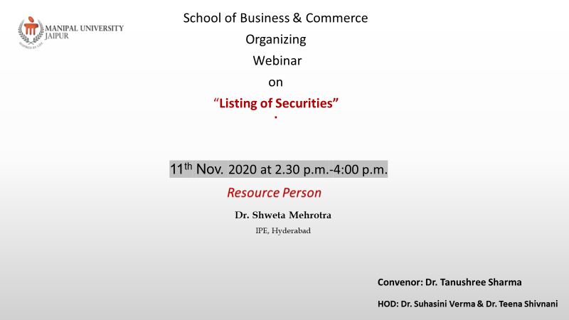

**Dr. Shweta Mehrotra, Resource Person, IPE, Hyderabad.**

**Dr. Tanushree Sharma,Convenor, FoMC, MUJ**

**MANIPAL UNIVERSITY JAIPUR**

**School of Business and Commerce**

**A Webinar on" Lising of Securities”**

**(11th Nov.’ 2020, Wednesday)**

**REPORT**

**School of Business & Commerce Organized a webinar on “Listing of Securities” –** A webinar was organised by school of business and commerce on 11th November 2020. Dr. Tanushree Sharma was the convenor of this workshop. Dr. Shweta Mehrotra was the speakers of the webinar Dr. Shweta Mehrotra is an Assistant Professor in Finance and Course Coordinator for PGDM-BIF (Banking Insurance and Financial Services) at Institute of Public Enterprise in Hyderabad. She told importance of listing of securities, for trading in the stock market, a company has to list its securities in the stock exchange. It means that the name of the company is registered in the stock exchange. The company has to fulfil certain conditions according to Companies Act. The company has to offer its shares or [debentures to the public for subscription](https://accountlearning.com/issue-of-debentures-sebi-guidelines/). Only then, the company will be allowed to list its security in the [stock exchange](https://accountlearning.com/stock-exchange-bye-law-terms-used-share-classification/) The entire session was informative for students.

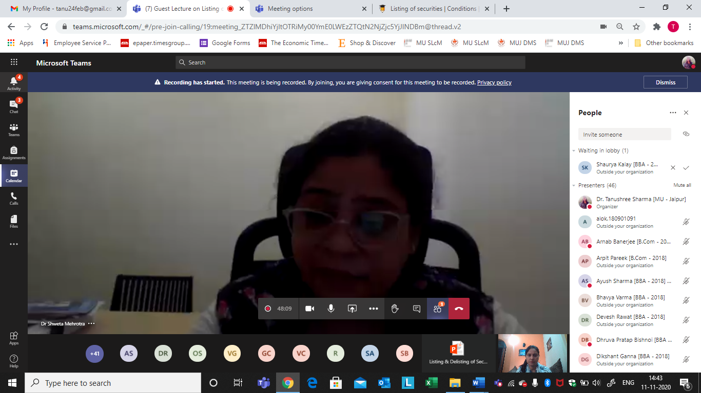

**Attendance Sheet**

|  |  |  |
| --- | --- | --- |
| 1 | Dr. Tanushree Sharma [MU - Jaipur] | |
| 2 | Anusha Masuna [BBA - 2018] | |
| 3 | Sanskar Bansal [BBA - 2018] | |
| 4 | Sidhesh Aggarwal [B.Com - 2018] (Guest) | |
| 5 | ritvik.180901169 |  |
| 6 | Vishveshwar Choudhary [BBA - 2018] | |
| 7 | Gyaneshwar N Chandnani [BBA - 2018] (Guest) | |
| 8 | Vipin Goyal [BBA - 2018] (Guest) | |
| 9 | Onkar Shukla [B Com - 2016] | |
| 10 | Mohd Yusuf Nasir [B.Com - 2018] (Guest) | |
| 11 | Devesh Rawat [BBA - 2018] | |
| 12 | Ayush Sharma [BBA - 2018] (Guest) | |
| 13 | Purvit Jhanwar [BBA - 2018] | |
| 14 | Shantam Sahai [BBA - 2018] | |
| 15 | Kanishk Tyagi [BBA 2018] | |
| 16 | sujay.180901018@muj.manipal.edu (Guest) | |
| 17 | kush.180901124 |  |
| 18 | Abhimanyu Surana [B.Com - 2019] | |
| 19 | Dhruva Pratap Bishnoi [BBA - 2018] (Guest) | |
| 20 | Arnab Banerjee [B.Com - 2018] (Guest) | |
| 21 | Rahul Soni [BBA - 2018] (Guest) | |
| 22 | Shivang Duggal [BBA - 2018] | |
| 23 | alok.180901091 |  |
| 24 | Rudraksh Goyal [BBA - 2018] (Guest) | |
| 25 | Shubham Agarwal [BBA - 2018] | |
| 26 | Dikshant Ganna [BBA - 2018] | |
| 27 | Rahul Sharma [B.Com - 2018] | |
| 28 | Abhay Singh Rajawat [BBA - 2018] | |
| 29 | Dr Shweta Mehrotra | |
| 30 | Abhishek Patodi [BBA - 2018] (Guest) | |
| 31 | Himanshu Patidar [B.Com - 2018] | |
| 32 | gaurav goyal |  |
| 33 | Bhavya Varma [BBA - 2018] | |
| 34 | Siddharth Singh [BBA - 2018] (Guest) | |
| 35 | dushyant.180902034 (Guest) | |
| 36 | rudranshsingh438 (Guest) | |
| 37 | Milan Singh Saluja [BBA - 2018] | |
| 38 | Arpit Pareek [B.Com - 2018] | |
| 39 | Shally Kothari [BBA - 2018] (Guest) | |
| 40 | Aditya Goyal [B.Com - 2018] (Guest) | |
| 41 | Priyanshu Nandwana [B.Com - 2018] | |
| 42 | Tushar Joshi [BBA - 2018] | |
| 43 | Vijay Jhurani [BBA - 2018] | |
| 44 | Prayan P Gupta [B.Com - 2018] | |
| 45 | Naman Madhwani [B.Com - 2018] (Guest) | |
| 46 | Sumit Singh Rathore [B.Com - 2018] (Guest) | |
| 47 | Gurusha Bagora [BBA - 2018] (Guest) | |
| 48 | Rishabh Raj [BBA - 2018] (Guest) | |
| 49 | Vishesh Chopda [BBA - 2018] | |
| 50 | Hritik Gupta [BBA - 2018] | |
| 51 | Divyanshee Yadav [BBA - 2018] | |
| 52 | amay.180901048 |  |
| 53 | Varun Amore [BBA - 2018] | |
| 54 | sarfaraziqqu306 (Guest) | |
| 55 | Shaurya Kalay [BBA - 2018] | |
| 56 | Luv Anand [BBA - 2018] | |