Seminar on Investment Awareness

Jointly Organized by School of Business & Commerce & Centre for Investment Education & Learning (CIEL) in collaboration with UTI Swatantra
(September 29, 2020 & Tuesday)
Duration: 1 Hour (11:45 am to 1:15 pm)

Session Expert:
Mr. Nishant Baraya Conveners
Dr. Ity Patni Dr. Somya Choubey Dr. Sunny Dawar Ms. Nishu Gupta

MANIPAL UNIVERSITY JAIPUR
School of Business & Commerce

Seminar on Investment Awareness

REPORT
(September 29, 2020 & Tuesday)

Mr. Nishant Baraya, Founder, Nishant Baraya Trainings Inc. was invited for guest lecture in seminar on ‘Investment Awareness’. It was jointly organized by the School of Business & Commerce and Centre for Investment Education & Learning (CIEL) in collaboration with UTI Swatantra under Finance Club- MUJ on 29th September 2020. The final year students of BBA, B.Com (Pass Course), B.Com (Hons-Accounting) understood the aspects of Investment Climate. Mr. Baraya discussed the investment environment which is affected by inflation. Inflation largely grows like anything as it eats income. Money creates money and one should atleast invest 45% of salary and if salary is rising by 15% annually, one must increase the investment component. Mr. Baraya made session interactive wherein chat session was used to interact with the students and students actively participated in clearing their doubts and confusions.
.

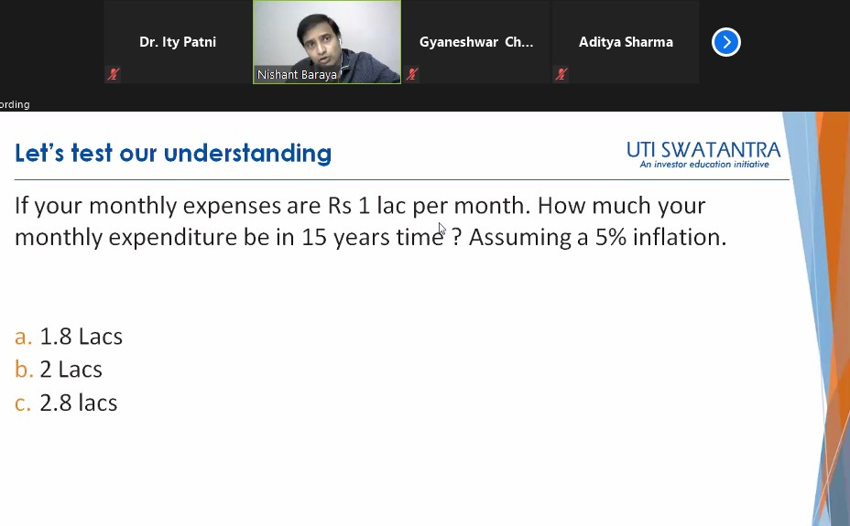
Guest Lecture by Mr. Nishant Baraya

ATTENDANCE
Seminar on Investment Awareness
29th September, 2020 (Tuesday)
 | S.  No. | Registration No. | Name | Email | Mobile No.
 | 1 | 180902001 | Sidhesh Aggarwal | sidhesh.aggarwal20@gmail.com | 7082258539
 | 2 | 180902015 | Bharat Patidar | patidarbharat1999@gmail.com | 6378041363
 | 3 | 180903018 | Kashish Agarwal | kashish.180903018@muj.manipal.edu | 9672091600
 | 4 | 180903010 | Priyam Mukerjee | priyammukerjee12345@gmail.com | 9799214916
 | 5 | 180903007 | Sakshi Jain | hasijain123@gmail.com | 9897542141
 | 6 | 170903025 | Shashank Umare | shashankumare@gmail.com | 8239752541
 | 7 | 180902022 | Mohit Sharma | mhtms939@gmail.com | 7986417990
 | 8 | 180903028 | Deepesh  Khanchandani | deepeshkhanchandani.80@gmail.com | 7073671307
 | 9 | 180903012 | Gurujeet Arora | gurujeetarora21@gmail.com | 9315276304
 | 10 | 180903029 | Yash Kansal | ykkansall@gmail.com | 7455053010
 | 11 | 180902023 | Prayan P Gupta | prayangupta28.pg@gmail.com | 9690008132
 | 12 | 180903030 | Purti Balani | purtibalani@gmail.com | 9460355512
 | 13 | 180903013 | Asif Sohel | asifsohel21@gmail.com | 7002907499
 | 14 | 180902036 | Abhimanyu Surana | abhimanyu1900@gmail.com | 9868820011
 | 15 | 180902020 | Ujjaval Legha | ujjavallegha@gmail.com | 9549534111
 | 16 | 180903001 | Himanshu Gadia | himanshugadia80@gmail.com | 7073264390
 | 17 | 180903035 | Nikhil Chugh | nikhilchugh1206@gmail.com | 8295454688
 | 18 | 180903015 | Pranjal Jain | jain.pranjal199@gmail.com | 9926971294
 | 19 | 180902037 | Yusuf Nasir | ynasir56@gmail.com | 9782321710
 | 20 | 180902021 | Priyanshu  Nandwana | priyanshu.nandwana26@gmail.com | 7340272926
 | 21 | 180903009 | Yashwin Sharma | yashwin.sharma2000@gmail.com | 8209978497
 | 22 | 180903034 | Nikhil Sharma | nikhil95211@gmail.com | 9521199021
 | 23 | 180903040 | Laksh Goswami | lakshgoswami34@gmail.com | 9057721778
 | 24 | 180903033 | Pratik  Moolchandani | pratik.moolchandani10@gmail.com | 6376381794
 | 25 | 180902005 | Devendra Rathore | rathoredevendra2000@gmail.com | 9950033045
 | 26 | 180902010 | Rahul Sharma | rahul28098@gmail.com | 9166612725

S. No. | Registration No. | Name | Email | Mobile No.
27 | 180902013 | Sumit Singh Rathore | mearthiyarathore456@gmail.com | 9602167768
28 |  | Onkar Shukla | onkarshuklaa@gmail.com | 8209302017
29 | 180903043 | Rajat Bansal | rajat.180903043@muj.manipal.edu | 9804136666
30 | 180903004 | Anand Singh | singhanand6207@gmail.com | 7742109998
31 | 180903011 | Sanchit Sharma | ssanchit461@gmail.com | 9529635233
32 | 180902027 | Daksh Sindal | dakshsindal0987@gmail.com | 9724584227
33 | 180902017 | Himanshi Singh | singhhimanshi620@gmail.com | 7388927457
34 | 180902014 | Arnab Banerjee | arnabanerjee01@gmail.com | 8890870423
35 | 180903024 | Ketan Baid | ketanbaid50@gmail.com | 6378099523
36 | 180903023 | Vivek Pratap | vivek3marchsingh@gmail.com | 9058013478
37 | 180902029 | Aditya Goyal | goyaladitya32@gmail.com | 6378257160
38 | 180903002 | Yashaswani  Kathuria | kathuriayashaswani@gmail.com | 9116097778
39 | 180902018 | Arpit Pareek | pareek.arpit09@gmail.com | 9166794338
40 | 180903022 | Aditya Mani | jinkasama12345@gmail.com | 7017821618
41 | 180902019 | Naman Madhwani | namanmadhwani@gmail.com | 7985611272
42 | 180902038 | Mohd Sarfaraz  Sarfaraz | sarfaraziqqu306@gmail.com | 8619881438
43 | 180902028 | Shalu Soni | shalusoni833@gmail.com | 9602157414
44 | 180903006 | Sahil Jain | mr.sahilzain@gmail.com | 9530119595
45 | 180901156 | Yash Garg | yashg6816@gmail.com | 8791475551
46 | 180903016 | Vardhini Gupta | vardhini.180903016@muj.manipal.ed  u | 9929941318
47 | 180902012 | Syed Zeeshan  Moin Usmani | syedzeeshanmoinusmani@gmail.com | 9694786918
48 | 180901021 | Vaibhav Kumar | vaibhav.kumar2308@gmail.com | 9783500036

FEEDBACK
Seminar for Investment Awareness
(29th Sep.’ 2020, Tuesday)

Feedback
Easy to understand and learn the concept and avenues of Investment.
It's useful.
The quality of teaching is fantastic
Satisfactory for way of attempting questions related to Investment
Quality of teaching was very good, Sir has taught the subject area in very good way
Teaching is good and understandable
Excellent way of explanation
very nice
Perfect!!! It's was a great experience.
Good
Great Job
Best and we'll knowledgeable
The Best Faculty
It was good.
Excellent
Excellent
Good Job
Fantastic Inputs
Really Appreciable!

