DEPARTMENT OF BUSINESS ADMINISTRATION
SCHOOL OF BUSINESS & COMMERCE
MANIPAL UNIVERSITY JAIPUR
Date: 22/03/2021
EXPERT LECTURE
ON
“Youth Adventure and Courage”

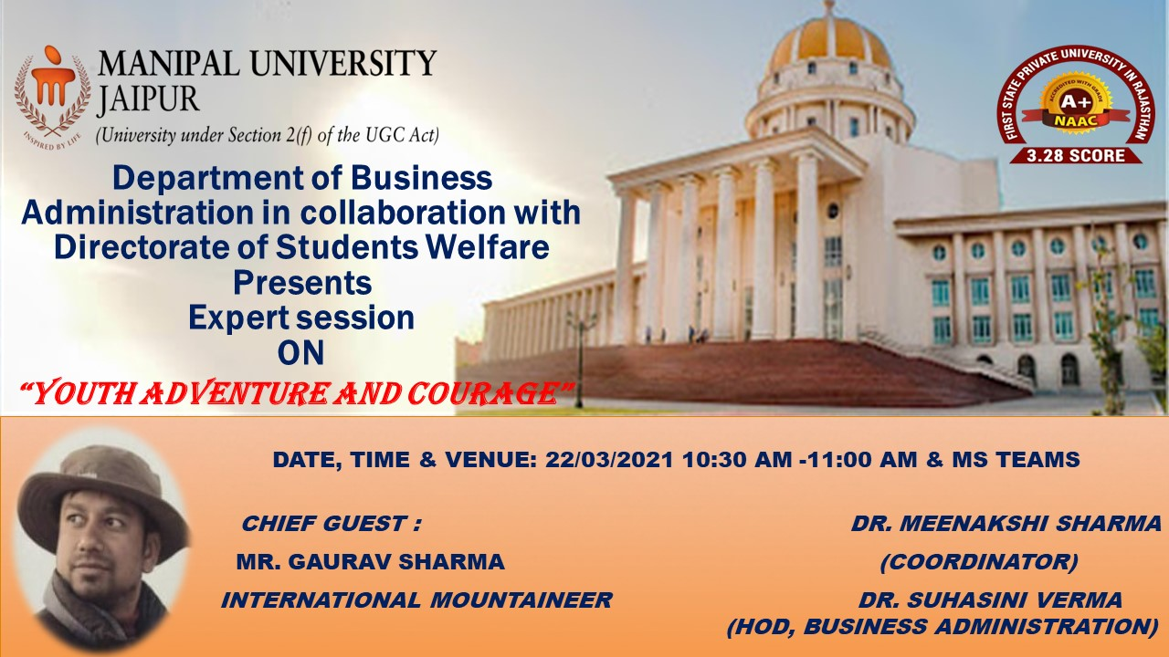

Department of Business Administration organized an expert lecture on “Youth Adventure and Courage” for the students of BBA I Year Batch (2020-2023) on March 22, 2021. The resource person of session was Mr. Gaurav Sharma, international mountaineer and the only youngest civilian from Rajasthan who scale Mt. Everest. The session was organised to make students understand that in present scenario how adventure can enhance courage in one’s life. Also, how one can make adventure as their career. What all essential qualification, accreditation needed to have career in adventure. Mr. Sharma discussed his experience in this field. Mr. Sharma addressed different queries raised by the students during the session. The session was concluded by taking students feedback and thanking the expert. This expert session was convened by Dr. Meenakshi Sharma, Assistant Professor, Department of Business Administration, Manipal University Jaipur.
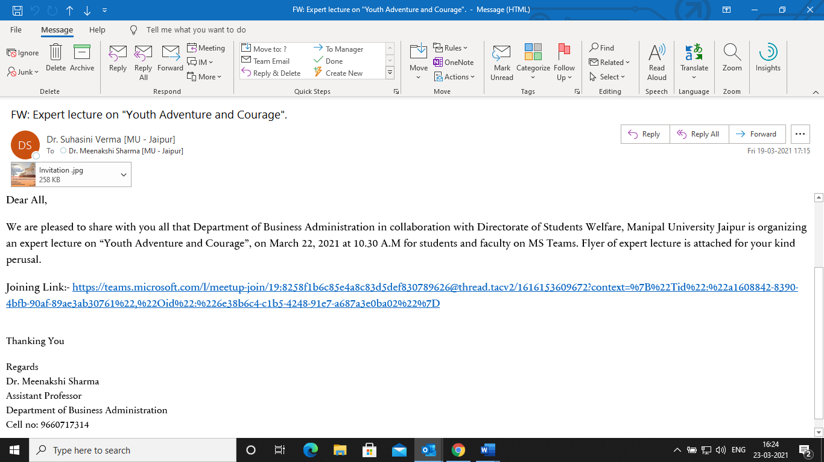
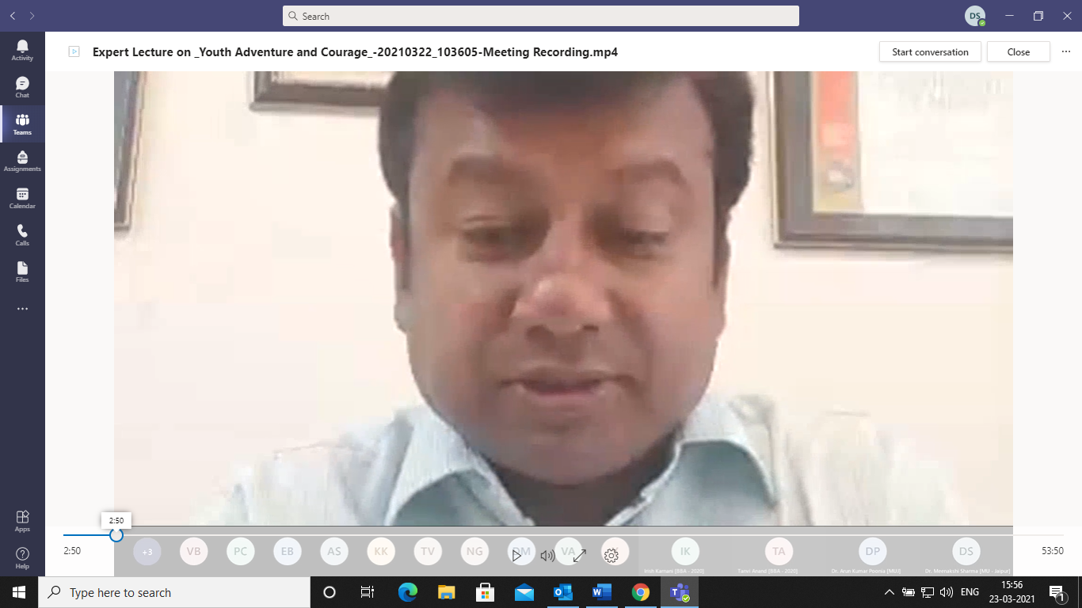

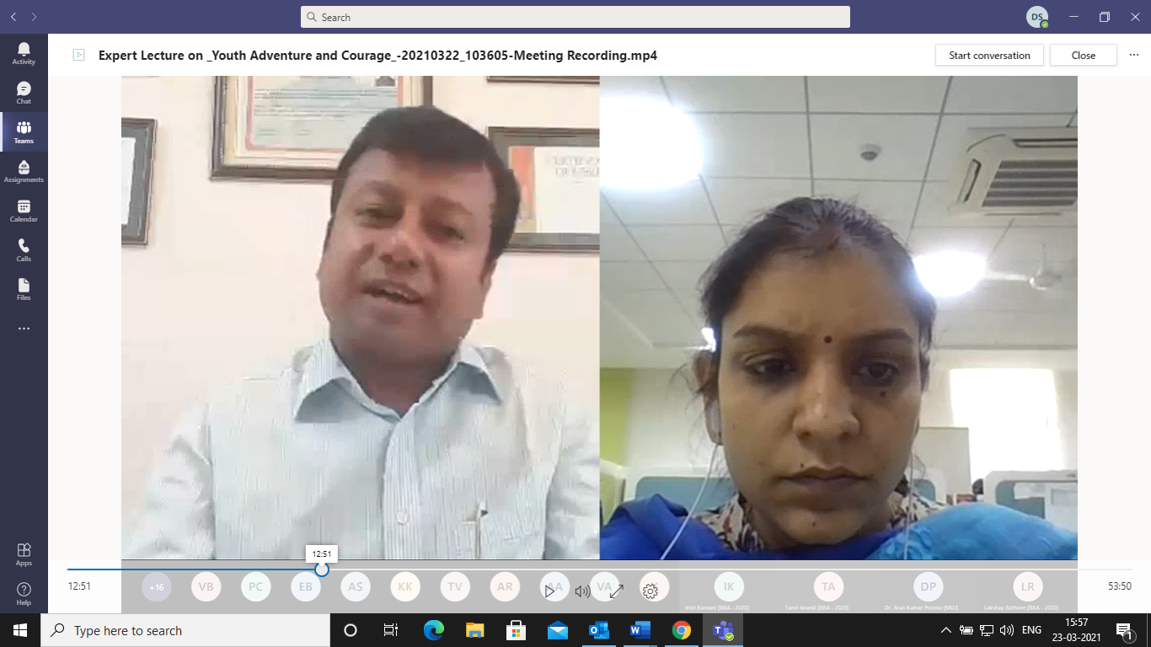

ATTENDANCE SHEET

S. No. | Student Name
1 | Aman Kumar Jain
2 | Amish Raj Rastogi [BBA - 2020]
3 | Anamaya Sharma [BBA - 2020] (Guest)
4 | Arjun Vijay [BBA - 2020]
5 | Arpit Agarwal [BBA - 2020] (Guest)
6 | Chirag Jhalani [BBA - 2020]
7 | Disha Mantri [BBA - 2020]
8 | Eklavya Bansal [BBA - 2020]
9 | Gaurav Himalaya (Guest)
10 | Harsh Mittal [BBA - 2020]
11 | Irish Karnani [BBA - 2020] (Guest)
12 | Keshav Goyal [BBA - 2020]
13 | Khushi Koolwal [BBA - 2020]
14 | Krishna Jindal [BBA - 2020]
15 | Kunal Soni [BBA - 2020]
16 | Lakshay Rathore [BBA - 2020]
17 | Lalit Kumawat [BBA - 2020]
18 | Mukul Agarwal [BBA - 2020]
19 | Nihal Gupta [BBA - 2020]
20 | peeyush (Guest)
21 | Piyush Chouhan [BBA - 2020]
22 | Preet Goyal [BBA - 2020]
23 | Pulkit Arora [BBA - 2020] (Guest)
24 | Rishiraj Singh Rathore [BBA - 2020]
25 | Ronak Shekhawat [BBA - 2020]
26 | Sahil Khan [BBA - 2020]
27 | saksham.200901035
28 | Samarth Agarwal [BBA - 2020]
29 | Sayush Yadav [BBA - 2020]
30 | Shashwat Singh [BBA - 2020]
31 | Shiv Alok Khanna [BBA - 2020]
32 | Shriyansh Bohara [BBA - 2020]
33 | Suryansh Verma [BBA - 2020] (Guest)
34 | Tanish Garg [BBA - 2020]
35 | Tanish Vijay [BBA - 2020] (Guest)
36 | Tanvi Anand [BBA - 2020] (Guest)
37 | Vaibhav Bhagya [BBA - 2020]
38 | Vaibhav Bhalla [BBA - 2020] (Guest)
39 | Vatsal Choukhani [BBA - 2020]
40 | Vinit Agarwal [BBA - 2020] (Guest)
41 | Yash [BBA - 2020]

