Department of Business Administration
Organized
Alumni Interaction Under the
Technical Chapter

Session Expert: Departmental Coordinator:
Ms. Arpita Sharma Dr. Priyanka Sharma
(Assistant Professor, Business Administration)

MANIPAL UNIVERSITY JAIPUR
School of Business & Commerce
Department of Business Administration
Organized “Alumni Interaction”
under the Technical Chapter
(10th February 2021, Wednesday)

REPORT

In the series of alumni connect, Department of Business Administration organized Alumni interaction under the Technical Chapter in association with directorate of Alumni Relations by Ms. Arpita Sharma. She is an alumna of the batch 2020. She talked about “How to motivate students in this new world after Covid, to reinforce and maintain a sense of community”. She talked about the recent changes in the corporate world during this covid situation. The participants interacted with her asking the queries and she guided and answered their questions. She shared about her journey in Manipal University, Jaipur.

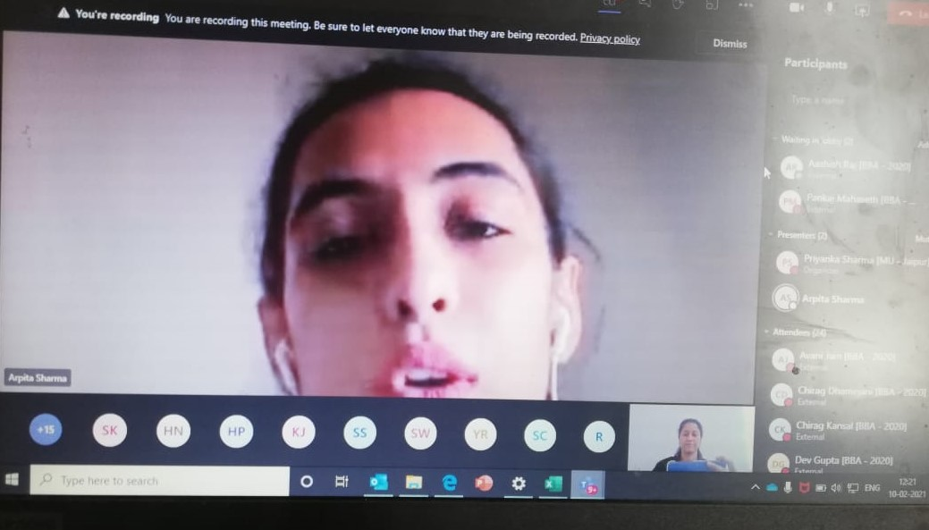

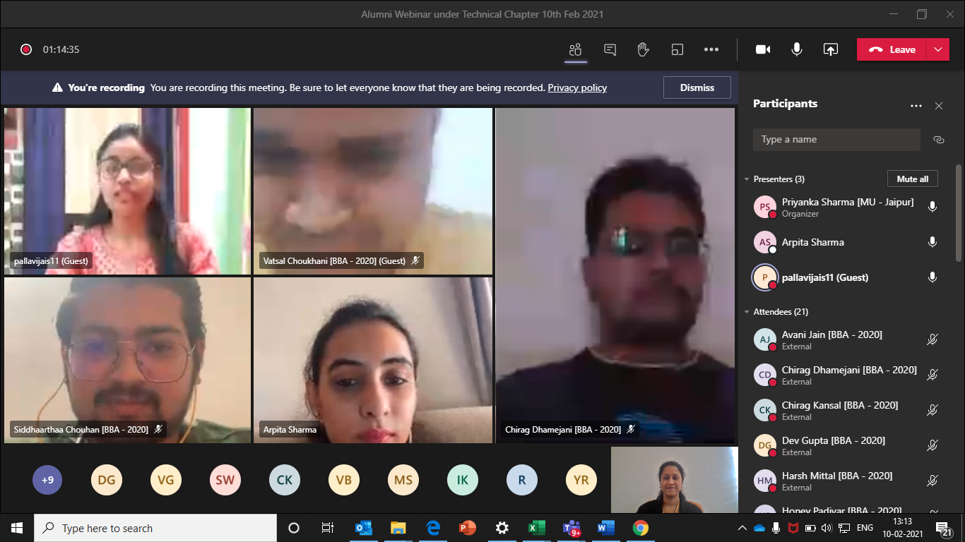

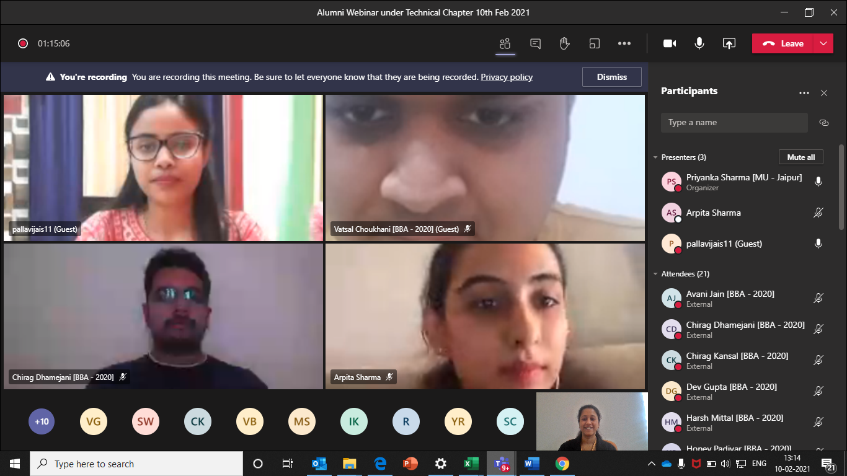

ATTENDANCE SHEET
S. No. | Registration No. | Name | Mobile No. | E-Mail ID
1 | 200901121 | IRISH KARNANI | 8299181127 | irish.200901121@muj.manipal.edu
2 | 200901122 | SAUMYA NARULA | 9161977555 | saumya.200901122@muj.manipal.edu
3 | 200901124 | KAUSHIK SANKHLA | 7737472068 | kaushik.200901124@muj.manipal.edu
4 | 200901125 | KHUSHI KOOLWAL | 9928333244 | khushi.200901125@muj.manipal.edu
5 | 200901126 | CHANDRAJEET SINGH BHATI | 9783737315 | chandrajeet.200901126@muj.manipal.edu
6 | 200901128 | ASHUTOSH GUPTA | 8005851460 | ashutosh.200901128@muj.manipal.edu
7 | 200901130 | VISHAL GOSWAMI | 7909008502 | vishal.200901130@muj.manipal.edu
8 | 200901131 | PAWAN SINGH | 9079140289 | pawan.200901131@muj.manipal.edu
9 | 200901132 | HARSH MITTAL | 9334145544 | harsh.200901132@muj.manipal.edu
10 | 200901134 | KESHAV GEHLOT | 7340236080 | keshav.200901134@muj.manipal.edu
11 | 200901137 | VATSAL CHOUKHANI | 7340069238 | vatsal.200901137@muj.manipal.edu
12 | 200901139 | AVANI JAIN | 9414061127 | avani.200901139@muj.manipal.edu
13 | 200901140 | SANCHIT WADHWA | 9415179582 | sanchit.200901140@muj.manipal.edu
14 | 200901142 | VEDANT GARG | 9425326140 | vedant.200901142@muj.manipal.edu
15 | 200901143 | SHASHWAT SINGH | 9569848905 | shashwat.200901143@muj.manipal.edu
16 | 200901144 | HIMANSHU NAGWANI | 9575373138 | himanshu.200901144@muj.manipal.edu
17 | 200901145 | GRANTH JAIN | 9929997423 | granth.200901145@muj.manipal.edu
18 | 200901147 | DINESH GEHLOT | 7073828567 | dinesh.200901147@muj.manipal.edu
19 | 200901148 | KAPIL SAINI | 8003178713 | kapil.200901148@muj.manipal.edu
20 | 200901149 | RADHIKA AGARWAL | 9983347666 | radhika.200901149@muj.manipal.edu
21 | 200901150 | MUDIT SINGH | 9415186531 | mudit.200901150@muj.manipal.edu
22 | 200901155 | HONEY PADIYAR | 6367200451 | honey.200901155@muj.manipal.edu
23 | 200901157 | VAIBHAV | 7014196248 | vaibhav.200901157@muj.manipal.edu
24 | 200901158 | MUDITA GUPTA | 8003617494 | mudita.200901158@muj.manipal.edu
25 | 200901159 | VIDHI BHATIA | 9509522348 | vidhi.200901159@muj.manipal.edu
26 | 200901161 | ANURAG SINGH | 8306828624 | anurag.200901161@muj.manipal.edu
27 | 200901162 | YUVRAJ SINGH RAJAWAT | 9079086093 | yuvraj.200901162@muj.manipal.edu
28 | 200901164 | PRATHAM KAPOOR | 9871814444 | pratham.200901164@muj.manipal.edu
29 | 200901166 | SIDDHAARTHAA CHOUHAN | 9828443311 | siddhaarthaa.200901166@muj.manipal.edu
30 | 200901167 | LAKSHAY MAHIPAL | 9166076555 | lakshay.200901167@muj.manipal.edu
31 | 200901168 | GAURAV KUMAWAT | 6736449182 | gaurav.200901168@muj.manipal.edu
32 | 200901170 | CHIRAG KANSAL | 8923599690 | chirag.200901170@muj.manipal.edu
33 | 200901172 | KHUSHI SINGHAL | 7505202230 | khushi.200901172@muj.manipal.edu
34 | 200901174 | PARANJAY PALIWAL | 8979065924 | paranjay.200901174@muj.manipal.edu
35 | 200901175 | TANISHKA ANJANA | 9145821228 | tanishka.200901175@muj.manipal.edu
36 | 200901176 | SAMARTH AGARWAL | 7017723253 | samarth.200901176@muj.manipal.edu
37 | 200901177 | SAJAL AGRAWAL | 9982415275 | sajal.200901177@muj.manipal.edu
38 | 200901179 | JATIN SHARMA | 7477067660 | priyesh.200901178@muj.manipal.edu
39 | 200901180 | KHUSHI DUBEY | 8696734619 | jatin.200901179@muj.manipal.edu
40 | 200901198 | CHIRAG DHAMEJANI | 8955814205 | khushi.200901180@muj.manipal.edu
41 | 200901274 | PANKAJ MAHASETH | 8306695795 | pankaj.200901274@muj.manipal.edu
42 | 200901288 | DEV GUPTA | 9719377007 | dev.200901288@muj.manipal.edu
43 | 200901290 | BHRIGU PAL SINGH | 9352000300 | bhrigu.200901290@muj.manipal.edu

