Department of Business Administration
Organized
Alumni Interaction Under the
Technical Chapter

Session Expert: Departmental Coordinator:
Ms. Pallavi Jaiswal Dr. Priyanka Sharma
(Assistant Professor, Business Administration)

MANIPAL UNIVERSITY JAIPUR
School of Business & Commerce
Department of Business Administration
Organized “Alumni Interaction”
under the Technical Chapter
(10th February 2021, Wednesday)

REPORT

In the series of alumni connect, Department of Business Administration organized Alumni interaction under the Technical Chapter in association with directorate of Alumni Relations by Ms. Pallavi Jaiswal. She is an alumna of the batch 2020. She talked about “Journey of Manipal University- Challenges and Opportunities”. It was an interactive session where she interacted with the current students sharing how they can Manipal University gives lot of opportunities to students to groom themselves and how learning and fun goes together. She said this is best time that they can utilize to the best to enjoy and learn. Participants asked their queries which she answered. It was a wonderful interactive session. She shared about her journey in Manipal University, Jaipur.

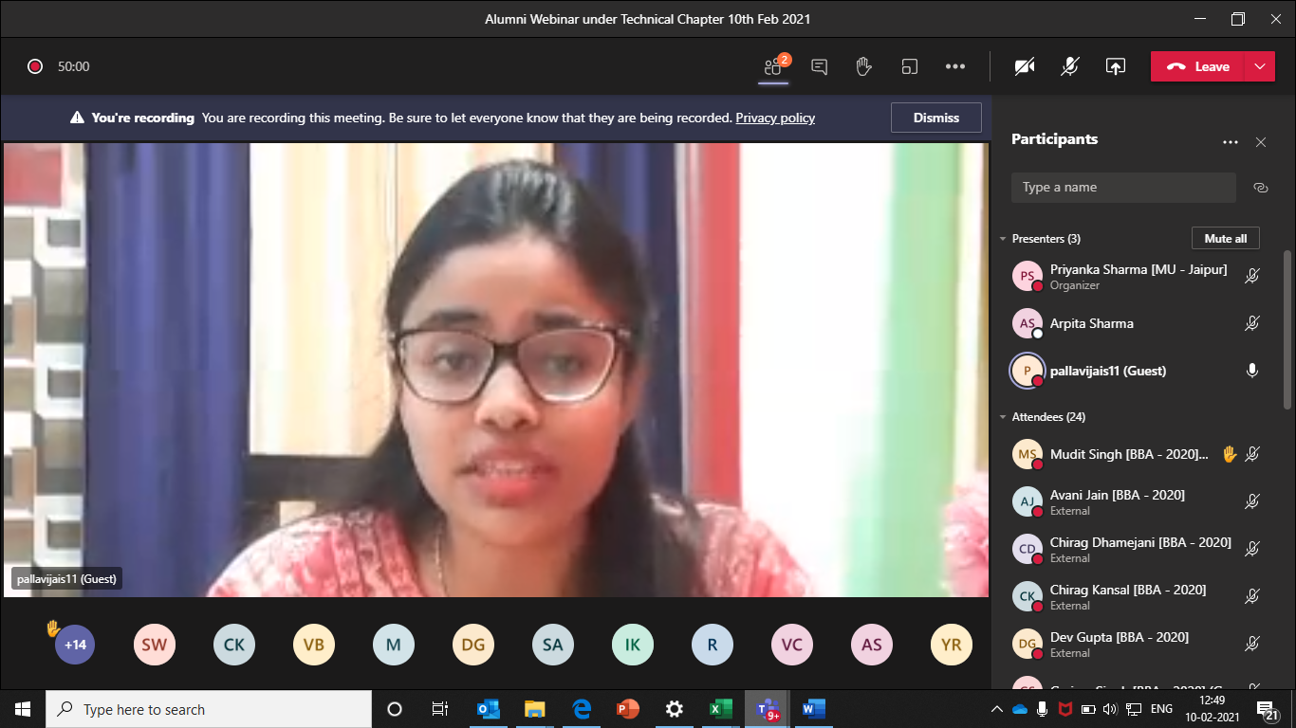

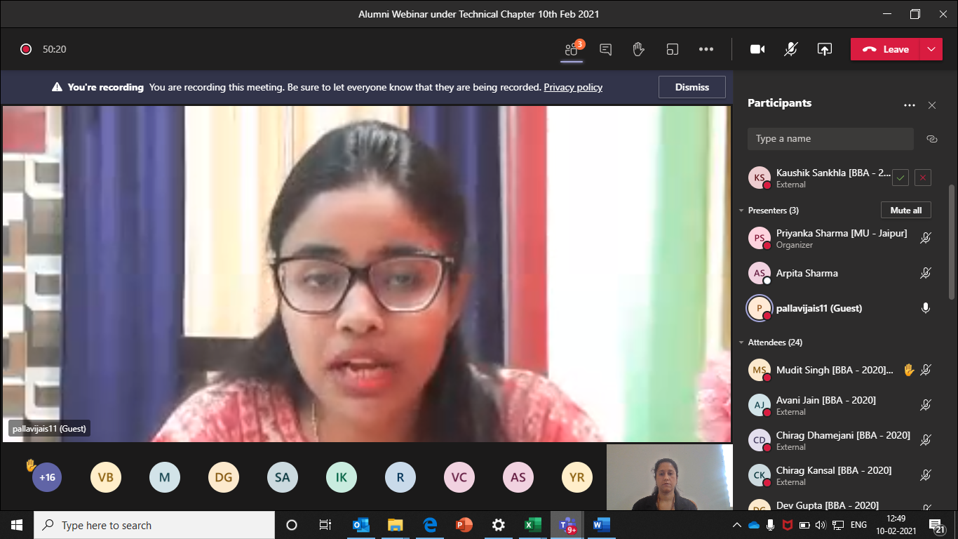

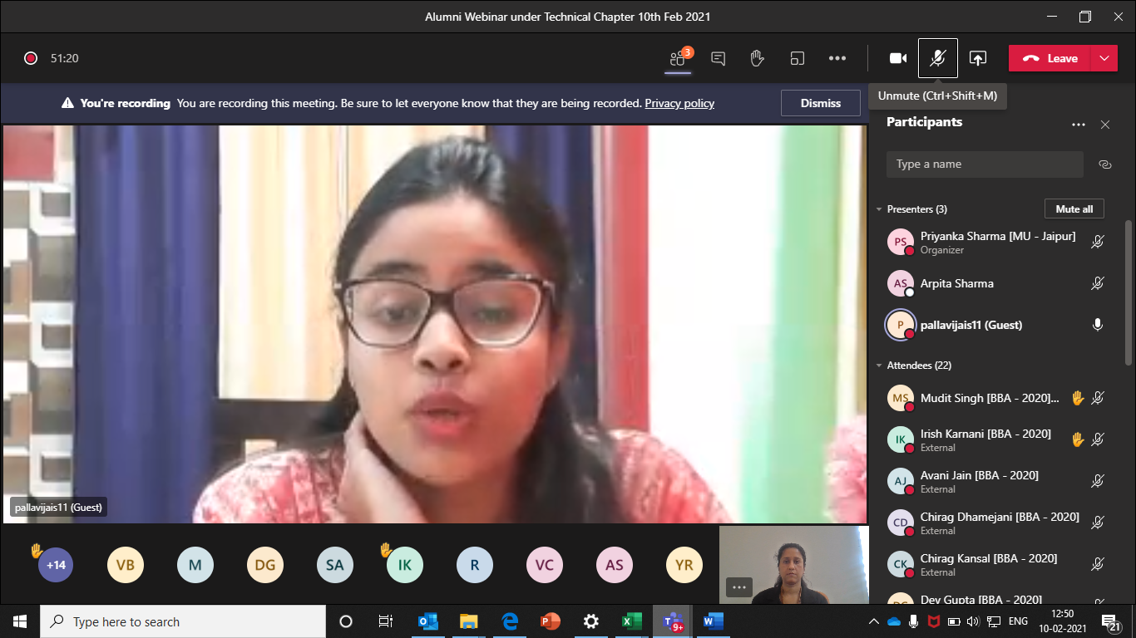

ATTENDANCE SHEET
S. No. | Registration No. | Name | Mobile No. | E-Mail ID
1 | 200901121 | IRISH KARNANI | 8299181127 | irish.200901121@muj.manipal.edu
2 | 200901122 | SAUMYA NARULA | 9161977555 | saumya.200901122@muj.manipal.edu
3 | 200901124 | KAUSHIK SANKHLA | 7737472068 | kaushik.200901124@muj.manipal.edu
4 | 200901125 | KHUSHI KOOLWAL | 9928333244 | khushi.200901125@muj.manipal.edu
5 | 200901126 | CHANDRAJEET SINGH BHATI | 9783737315 | chandrajeet.200901126@muj.manipal.edu
6 | 200901128 | ASHUTOSH GUPTA | 8005851460 | ashutosh.200901128@muj.manipal.edu
7 | 200901130 | VISHAL GOSWAMI | 7909008502 | vishal.200901130@muj.manipal.edu
8 | 200901131 | PAWAN SINGH | 9079140289 | pawan.200901131@muj.manipal.edu
9 | 200901132 | HARSH MITTAL | 9334145544 | harsh.200901132@muj.manipal.edu
10 | 200901134 | KESHAV GEHLOT | 7340236080 | keshav.200901134@muj.manipal.edu
11 | 200901137 | VATSAL CHOUKHANI | 7340069238 | vatsal.200901137@muj.manipal.edu
12 | 200901139 | AVANI JAIN | 9414061127 | avani.200901139@muj.manipal.edu
13 | 200901140 | SANCHIT WADHWA | 9415179582 | sanchit.200901140@muj.manipal.edu
14 | 200901142 | VEDANT GARG | 9425326140 | vedant.200901142@muj.manipal.edu
15 | 200901143 | SHASHWAT SINGH | 9569848905 | shashwat.200901143@muj.manipal.edu
16 | 200901144 | HIMANSHU NAGWANI | 9575373138 | himanshu.200901144@muj.manipal.edu
17 | 200901145 | GRANTH JAIN | 9929997423 | granth.200901145@muj.manipal.edu
18 | 200901147 | DINESH GEHLOT | 7073828567 | dinesh.200901147@muj.manipal.edu
19 | 200901148 | KAPIL SAINI | 8003178713 | kapil.200901148@muj.manipal.edu
20 | 200901149 | RADHIKA AGARWAL | 9983347666 | radhika.200901149@muj.manipal.edu
21 | 200901150 | MUDIT SINGH | 9415186531 | mudit.200901150@muj.manipal.edu
22 | 200901155 | HONEY PADIYAR | 6367200451 | honey.200901155@muj.manipal.edu
23 | 200901157 | VAIBHAV | 7014196248 | vaibhav.200901157@muj.manipal.edu
24 | 200901158 | MUDITA GUPTA | 8003617494 | mudita.200901158@muj.manipal.edu
25 | 200901159 | VIDHI BHATIA | 9509522348 | vidhi.200901159@muj.manipal.edu
26 | 200901161 | ANURAG SINGH | 8306828624 | anurag.200901161@muj.manipal.edu
27 | 200901162 | YUVRAJ SINGH RAJAWAT | 9079086093 | yuvraj.200901162@muj.manipal.edu
28 | 200901164 | PRATHAM KAPOOR | 9871814444 | pratham.200901164@muj.manipal.edu
29 | 200901166 | SIDDHAARTHAA CHOUHAN | 9828443311 | siddhaarthaa.200901166@muj.manipal.edu
30 | 200901167 | LAKSHAY MAHIPAL | 9166076555 | lakshay.200901167@muj.manipal.edu
31 | 200901168 | GAURAV KUMAWAT | 6736449182 | gaurav.200901168@muj.manipal.edu
32 | 200901170 | CHIRAG KANSAL | 8923599690 | chirag.200901170@muj.manipal.edu
33 | 200901172 | KHUSHI SINGHAL | 7505202230 | khushi.200901172@muj.manipal.edu
34 | 200901174 | PARANJAY PALIWAL | 8979065924 | paranjay.200901174@muj.manipal.edu
35 | 200901175 | TANISHKA ANJANA | 9145821228 | tanishka.200901175@muj.manipal.edu
36 | 200901176 | SAMARTH AGARWAL | 7017723253 | samarth.200901176@muj.manipal.edu
37 | 200901177 | SAJAL AGRAWAL | 9982415275 | sajal.200901177@muj.manipal.edu
38 | 200901179 | JATIN SHARMA | 7477067660 | priyesh.200901178@muj.manipal.edu
39 | 200901180 | KHUSHI DUBEY | 8696734619 | jatin.200901179@muj.manipal.edu
40 | 200901198 | CHIRAG DHAMEJANI | 8955814205 | khushi.200901180@muj.manipal.edu
41 | 200901274 | PANKAJ MAHASETH | 8306695795 | pankaj.200901274@muj.manipal.edu
42 | 200901288 | DEV GUPTA | 9719377007 | dev.200901288@muj.manipal.edu
43 | 200901290 | BHRIGU PAL SINGH | 9352000300 | bhrigu.200901290@muj.manipal.edu

