Department of Business Administration
Organized
Alumni Interaction

Session Expert: Departmental Coordinator:
Ms. Kanika Lalwani Dr. Priyanka Sharma
(Assistant Professor, Business Administration)

MANIPAL UNIVERSITY JAIPUR
School of Business & Commerce
Department of Business Administration
Organized “Alumni Interaction”
under the Technical Chapter
(18th December 2020, Friday)

REPORT

In the series of alumni connect, Department of Business Administration organized Alumni interaction by Ms. Kanika Lalwani. She is an alumna of the batch 2020. She talked about “Make it happen Make it matter”. She talked about how one can achieve what they want. She guided students as to how to manage time and make the most out of it. She shared about her journey in Manipal University, Jaipur and how it gave her a platform to boost her confidence.

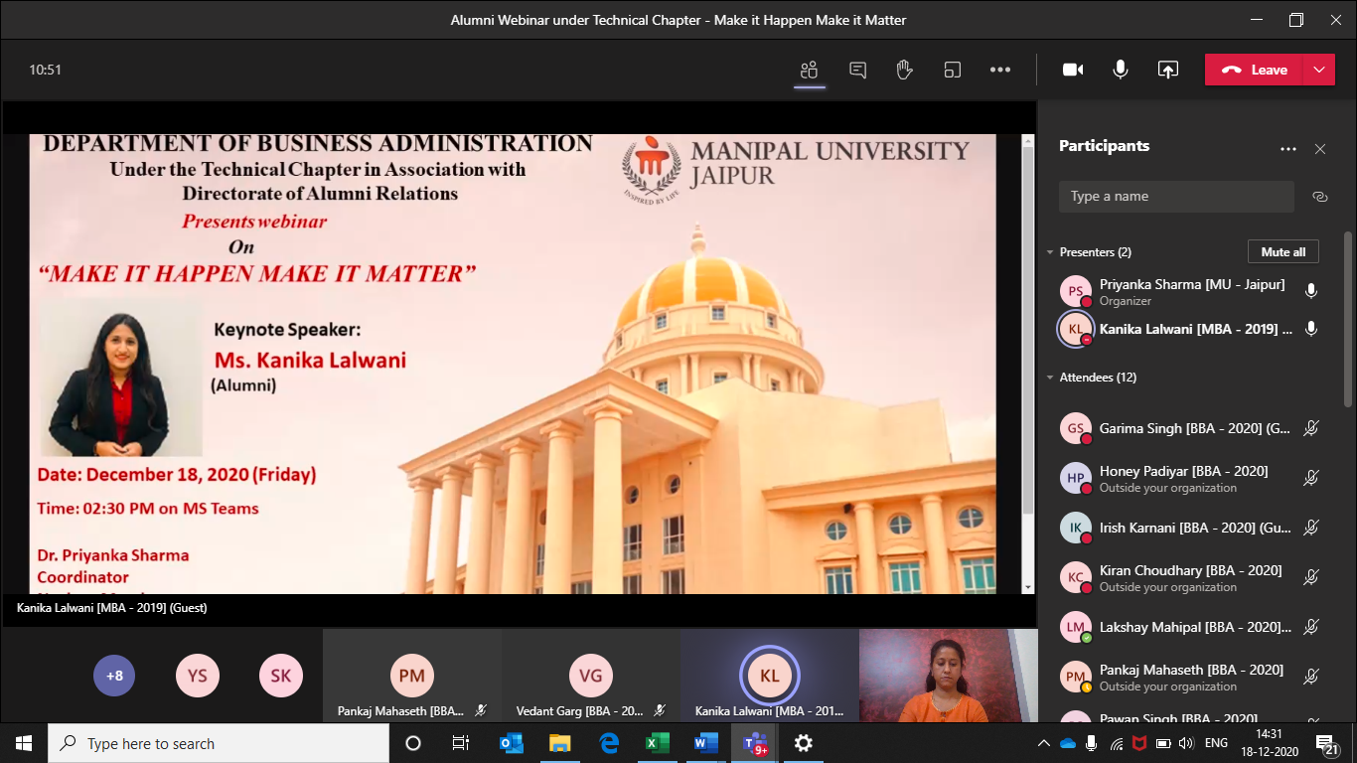

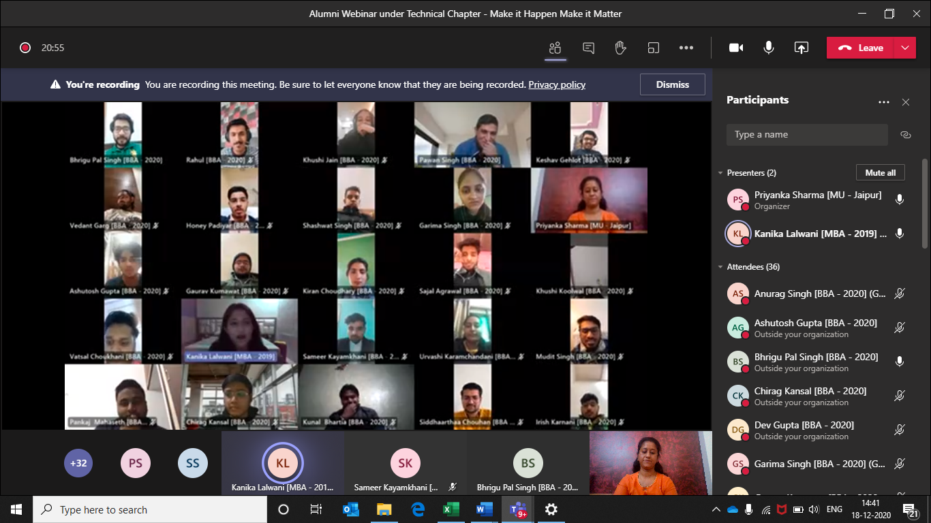

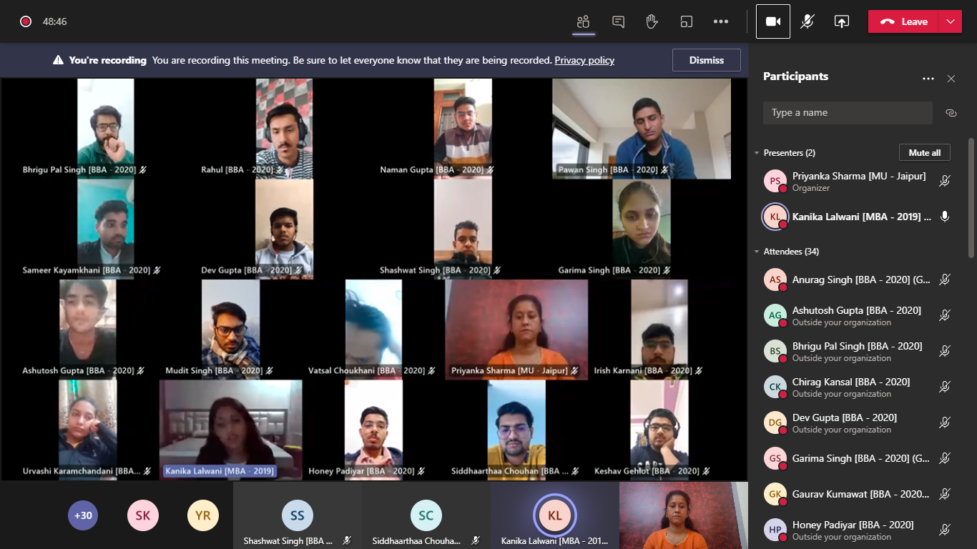

ATTENDANCE SHEET

S. No. | Registration No. | Name | Mobile No. | E-Mail ID
1 | 200901121 | IRISH KARNANI | 8299181127 | irish.200901121@muj.manipal.edu
2 | 200901122 | SAUMYA NARULA | 9161977555 | saumya.200901122@muj.manipal.edu
3 | 200901123 | SAMEER KAYAMKHANI | 8949923894 | sameer.200901123@muj.manipal.edu
4 | 200901124 | KAUSHIK SANKHLA | 7737472068 | kaushik.200901124@muj.manipal.edu
5 | 200901125 | KHUSHI KOOLWAL | 9928333244 | khushi.200901125@muj.manipal.edu
6 | 200901126 | CHANDRAJEET SINGH BHATI | 9783737315 | chandrajeet.200901126@muj.manipal.edu
7 | 200901127 | KIRAN CHOUDHARY | 8005948492 | kiran.200901127@muj.manipal.edu
8 | 200901128 | ASHUTOSH GUPTA | 8005851460 | ashutosh.200901128@muj.manipal.edu
9 | 200901130 | VISHAL GOSWAMI | 7909008502 | vishal.200901130@muj.manipal.edu
10 | 200901131 | PAWAN SINGH | 9079140289 | pawan.200901131@muj.manipal.edu
11 | 200901132 | HARSH MITTAL | 9334145544 | harsh.200901132@muj.manipal.edu
12 | 200901133 | VEDANT | 9044435247 | vedant.200901133@muj.manipal.edu
13 | 200901134 | KESHAV GEHLOT | 7340236080 | keshav.200901134@muj.manipal.edu
14 | 200901137 | VATSAL CHOUKHANI | 7340069238 | vatsal.200901137@muj.manipal.edu
15 | 200901138 | RAHUL | 9521733949 | rahul.200901138@muj.manipal.edu
16 | 200901139 | AVANI JAIN | 9414061127 | avani.200901139@muj.manipal.edu
17 | 200901140 | SANCHIT WADHWA | 9415179582 | sanchit.200901140@muj.manipal.edu
18 | 200901142 | VEDANT GARG | 9425326140 | vedant.200901142@muj.manipal.edu
19 | 200901143 | SHASHWAT SINGH | 9569848905 | shashwat.200901143@muj.manipal.edu
20 | 200901144 | HIMANSHU NAGWANI | 9575373138 | himanshu.200901144@muj.manipal.edu
21 | 200901145 | GRANTH JAIN | 9929997423 | granth.200901145@muj.manipal.edu
22 | 200901147 | DINESH GEHLOT | 7073828567 | dinesh.200901147@muj.manipal.edu
23 | 200901148 | KAPIL SAINI | 8003178713 | kapil.200901148@muj.manipal.edu
24 | 200901149 | RADHIKA AGARWAL | 9983347666 | radhika.200901149@muj.manipal.edu
25 | 200901150 | MUDIT SINGH | 9415186531 | mudit.200901150@muj.manipal.edu
26 | 200901152 | PARINEETA JAIN | 9560192182 | parineeta.200901152@muj.manipal.edu
27 | 200901155 | HONEY PADIYAR | 6367200451 | honey.200901155@muj.manipal.edu
28 | 200901157 | VAIBHAV | 7014196248 | vaibhav.200901157@muj.manipal.edu
29 | 200901158 | MUDITA GUPTA | 8003617494 | mudita.200901158@muj.manipal.edu
30 | 200901159 | VIDHI BHATIA | 9509522348 | vidhi.200901159@muj.manipal.edu
31 | 200901161 | ANURAG SINGH | 8306828624 | anurag.200901161@muj.manipal.edu
32 | 200901162 | YUVRAJ SINGH RAJAWAT | 9079086093 | yuvraj.200901162@muj.manipal.edu
33 | 200901164 | PRATHAM KAPOOR | 9871814444 | pratham.200901164@muj.manipal.edu
34 | 200901166 | SIDDHAARTHAA CHOUHAN | 9828443311 | siddhaarthaa.200901166@muj.manipal.edu
35 | 200901167 | LAKSHAY MAHIPAL | 9166076555 | lakshay.200901167@muj.manipal.edu
36 | 200901168 | GAURAV KUMAWAT | 6736449182 | gaurav.200901168@muj.manipal.edu
37 | 200901170 | CHIRAG KANSAL | 8923599690 | chirag.200901170@muj.manipal.edu
38 | 200901171 | MITISHA JAIN | 9829016494 | mitisha.200901171@muj.manipal.edu
39 | 200901172 | KHUSHI SINGHAL | 7505202230 | khushi.200901172@muj.manipal.edu
40 | 200901174 | PARANJAY PALIWAL | 8979065924 | paranjay.200901174@muj.manipal.edu
41 | 200901175 | TANISHKA ANJANA | 9145821228 | tanishka.200901175@muj.manipal.edu
42 | 200901176 | SAMARTH AGARWAL | 7017723253 | samarth.200901176@muj.manipal.edu
43 | 200901177 | SAJAL AGRAWAL | 9982415275 | sajal.200901177@muj.manipal.edu
44 | 200901179 | JATIN SHARMA | 7477067660 | priyesh.200901178@muj.manipal.edu
45 | 200901180 | KHUSHI DUBEY | 8696734619 | jatin.200901179@muj.manipal.edu
46 | 200901198 | CHIRAG DHAMEJANI | 8955814205 | khushi.200901180@muj.manipal.edu
47 | 200901274 | Pankaj mahaseth | 8306695795 | pankaj.200901274@muj.manipal.edu
48 | 200901288 | DEV GUPTA | 9719377007 | dev.200901288@muj.manipal.edu
49 | 200901290 | BHRIGU PAL SINGH | 9352000300 | bhrigu.200901290@muj.manipal.edu
50 | 200901156 | GARIMA SINGH | 9897876723 | garima.200901156@muj.manipal.edu

