Department of Business Administration
Organized
Alumni Interaction

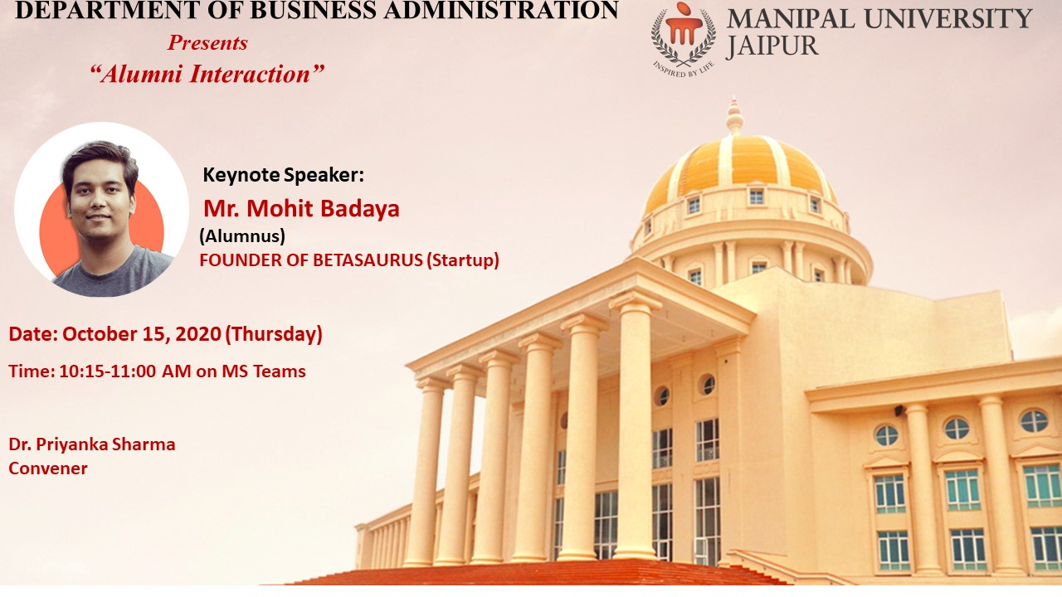

Session Expert: Departmental Coordinator:
Mr. Mohit Badaya Dr. Priyanka Sharma
(Assistant Professor, Business Administration)

MANIPAL UNIVERSITY JAIPUR
School of Business & Commerce
Department of Business Administration
Organized “Alumni Interaction”
(15th October 2020, Thursday)

REPORT

In the series of alumni connect, Department of Business Administration organized Alumni interaction by Mr. Mohit Badaya. He is an Alumnus of the Batch 2018. He has his own startup Betasaurus, a startup marketing agency founded in 2018, which has a 360° Integrated agency helping startups and SMBs scale online. He was invited to interact with the current students and share his experience related to the startup. He shared the challenges faced by him and how he overcomed it.
In his session with students, he shared how being into MUJ helped him achieve his vision related to his startup. The students asked him questions related to the same and he answered them. He talked about how the students develop their entrepreneurship skills and what it takes to be a successful entrepreneur.

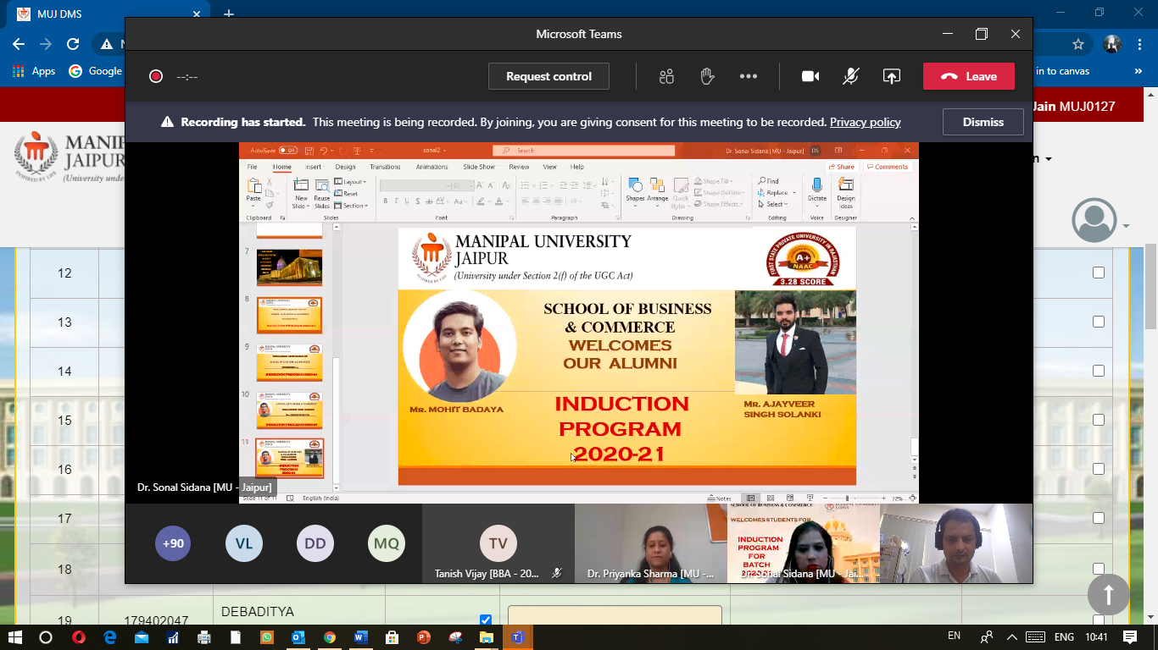

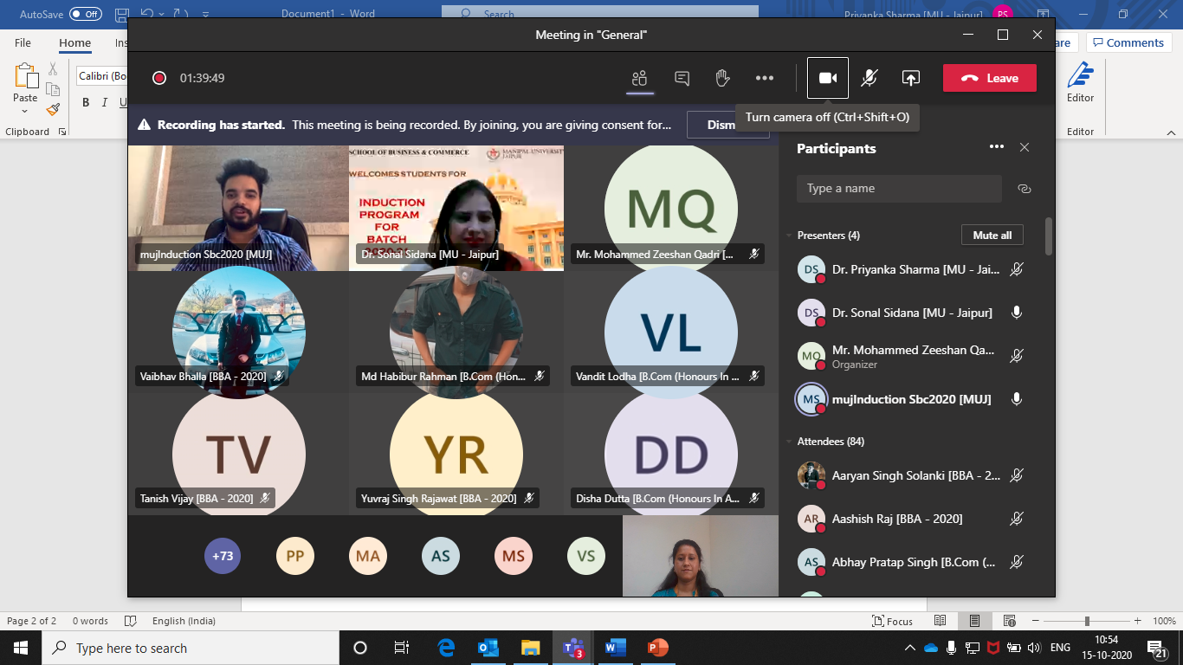

ATTENDANCE SHEET
S. No | Name of the Student
1 | Khushi Dubey [BBA - 2020]
2 | Vatsal Choukhani [BBA - 2020]
3 | Deepak Vijay [BBA - 2020]
4 | Avani Jain [BBA - 2020]
5 | Dr. Sonal Sidana [MU - Jaipur]
6 | Harsh Mittal [BBA - 2020]
7 | Parineeta Jain [BBA - 2020]
8 | Neeraj Dhakar [BBA - 2020]
9 | Mr. Mohammed Zeeshan Qadri [MU - Jaipur]
10 | Dhruveika Dhupia [BBA - 2020]
11 | Paranjay Paliwal [BBA - 2020]
12 | Akshit Kothari [BBA - 2020]
13 | Nishant Goel [BBA - 2020]
14 | Priyasha Singh [B.Com (Honours In Accounting) - 2020]
15 | Yash [BBA - 2020]
16 | Jay Prakash Khandelwal [BBA - 2020]
17 | Md Munibur Rahman [B.Com (Honours In Accounting) - 2020]
18 | Chirag Jhalani [BBA - 2020]
19 | Md Habibur Rahman [B.Com (Honours In Accounting) - 2020]
20 | Kartikey Mittal [BBA - 2020]
21 | Shreyas Mahajan [B.Com (Honours In Accounting) - 2020]
22 | Tanishq Tyagi [BBA - 2020]
23 | Rahul [BBA - 2020]
24 | Bhavyaveer Singh Rawal [BBA - 2020]
25 | Anamaya Sharma [BBA - 2020]
26 | Preet Goyal [BBA - 2020]
27 | Uttam Agarwal [B.Com (Honours In Accounting) - 2020]
28 | Nikhil Dhaka [BBA - 2020]
29 | Vaibhav Bhalla [BBA - 2020]
30 | Chirag Dhamejani [BBA - 2020]
31 | Krish Bhanushali [BBA - 2020]
32 | Abhay Pratap Singh [B.Com (Honours In Accounting) - 2020]
33 | Kartikya Singh [Bachelor of Commerce (B.Com) - 2020]
34 | Rakesh Kumawat [BBA - 2020]
35 | Somil Jain [BBA - 2020]
36 | Harshraj Singh Rathore [B.Com (Honours In Accounting) - 2020]
37 | Harsh Repuriya [BBA - 2020]
38 | Lakshay Mahipal [BBA - 2020]
39 | Saksham Jain [BBA - 2020]
40 | Dr. Sunny Dawar [MU - Jaipur]
41 | Shiv Alok Khanna [BBA - 2020]
42 | Shiv Alok Khanna [BBA - 2020]
43 | Lucky Goyal [BBA - 2020]
44 | Kartikeya Yogi [B.Com (Honours In Accounting) - 2020]
45 | Disha Dutta [B.Com (Honours In Accounting) - 2020]
46 | Pratham Verma [BBA - 2020]
47 | Pratham Verma [BBA - 2020]
48 | Aaryan Singh Solanki [BBA - 2020]
49 | Aaryan Singh Solanki [BBA - 2020]
50 | Vishal Jetwal [BBA - 2020]
51 | Amandeep Maheshwari [BBA - 2020]
52 | Vipul Sharma [BBA - 2020]
53 | Stuti Arora [BBA - 2020]
54 | Adiya Nair [B.Com (Honours In Accounting) - 2020]
55 | Khushi Rawat [BBA - 2020]
56 | Khushi Hora [BBA - 2020]
57 | Chandrajeet Singh Bhati [BBA - 2020]
58 | Keshav Gehlot [BBA - 2020]
59 | Naman Mehta [B.Com (Honours In Accounting) - 2020]
60 | Neeraj Dhakar [BBA - 2020]
61 | K R Krishnapriya [B.Com (Honours In Accounting) - 2020]
62 | Naman Vijay [BBA - 2020]
63 | Khushi Koolwal [BBA - 2020]
64 | Jayesh [B.Com (Honours In Accounting) - 2020]
65 | Vandit Lodha [B.Com (Honours In Accounting) - 2020]
66 | Khushi Gohil [BBA - 2020]
67 | Chirag Makkar [BBA - 2020]
68 | Kritik Singh [B.Com (Honours In Accounting) - 2020]
69 | Anushka Gupta [B.Com (Honours In Accounting) - 2020]
70 | Tanish Vijay [BBA - 2020]
71 | Anshika Agarwal [B.Com (Honours In Accounting) - 2020]
72 | Kunal Padaliya [BBA - 2020]
73 | Eklavya Bansal [BBA - 2020]
74 | Naman Agrawal [BBA - 2020]
75 | Tanman Agarwal [BBA - 2020]
76 | Harshvardhan Singh Champawat [BBA - 2020]
77 | Saurav Rajbir Singh [BBA - 2020]
78 | Gurleen Sood [B.Com (Honours In Accounting) - 2020]
79 | Harshil [BBA - 2020]
80 | Umesh Khatri [Bachelor of Commerce (B.Com) - 2020]
81 | Jai Verma [BBA - 2020]
82 | Vaibhav Dulatani [B.Com (Honours In Accounting) - 2020]
83 | Mansi Singh [B.Com (Honours In Accounting) - 2020]
84 | Aparajita Chakravertty [BBA - 2020]
85 | Sahil Khan [BBA - 2020]
86 | Mehar Ahuja [BBA - 2020]
87 | Abhinav Goyal [BBA - 2020]
88 | Harshal Bhalodiya [BBA - 2020]
89 | Yuvraj Singh Rajawat [BBA - 2020]
90 | Tejesvi Purohit [BBA - 2020]
91 | Shubh Gupta [B.Com (Honours In Accounting) - 2020]
92 | Kapil Saini [BBA - 2020]
93 | Ritik Raj Tiwari [BBA - 2020]
94 | Himanshu Nagwani [BBA - 2020]
95 | Devansh Goyal [BBA - 2020]
96 | Yash Bansal [BBA - 2020]
97 | Kartik Garg [BBA - 2020]
98 | Lakshya Porwal [BBA - 2020]
99 | Sparsh Garg [BBA - 2020]
100 | Amish Raj Rastogi [BBA - 2020]
101 | Sahastranshu Chandel [BBA - 2020]
102 | Harshil Airen [BBA - 2020]
103 | Tanishka Anjana [BBA - 2020]
104 | Aman Choudhary [BBA - 2020]
105 | Hrithek Repuriya [BBA - 2020]
106 | Aditya Kilawat [BBA - 2020]
107 | Rahul Burdak [BBA - 2020]
108 | Suhani Jain [BBA - 2020]
109 | Sameer Kayamkhani [BBA - 2020]
110 | Jatin Sharma [BBA - 2020]
111 | Jatin Sharma [BBA - 2020]
112 | Divyaraj Singh Rathore [BBA - 2020]
113 | Puneeth H B [B.Com (Honours In Accounting) - 2020]
114 | Aashish Raj [BBA - 2020]
115 | Aishwary Kumar [Bachelor of Commerce (B.Com) - 2020]
116 | Dr. Sushil Kumar Jain [MU - Jaipur]
117 | Ayushman Tomar [BBA - 2020]
118 | Arin Goyal [BBA - 2020]
119 | Manvi Verma [Bachelor of Commerce (B.Com) - 2020]
120 | Harshit Thomas [B.Com (Honours In Accounting) - 2020]
121 | Irish Karnani [BBA - 2020]
122 | Shreya Gupta [BBA - 2020]
123 | Sayush Yadav [BBA - 2020]
124 | Rohan [BBA - 2020]
125 | Yash Toshniwal [B.Com (Honours In Accounting) - 2020]
126 | Ishika Sarda [B.Com (Honours In Accounting) - 2020]
127 | Krishna Jindal [BBA - 2020]
128 | Ajay [BBA - 2020]
129 | Utkarsh Dhawan [B.Com (Honours In Accounting) - 2020]
130 | Gagandeep Singh [B.Com (Honours In Accounting) - 2020]
131 | Mudit Singh [BBA - 2020]
132 | Pratik [Bachelor of Commerce (B.Com) - 2020]
133 | Diya Rawat [B.Com (Honours In Accounting) - 2020]
134 | Parth Agarwal [BBA - 2020]
135 | Anshika Jadoun [BBA - 2018]

