Department of Business Administration
Organized
Guest Lecture on
“NETWORKING 101”

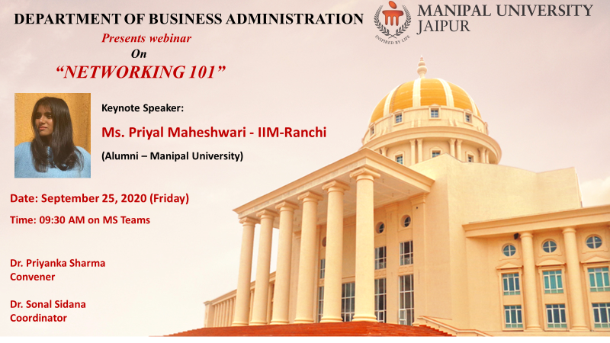

Session Expert: Departmental Coordinator:
Ms. Priyal Maheshwari Dr. Priyanka Sharma
(Assistant Professor, Business Administration)

MANIPAL UNIVERSITY JAIPUR
School of Business & Commerce
Department of Business Administration
Guest Lecture on
“NETWORKING 101”
(25th September’2020, Friday)

REPORT

In the series of alumni connect, Department of Business Administration organized guest lecture on ‘NETWORKING 101’ by Ms. Priyal Maheshwari. Ms. Priyal Maheshwari was invited to interact with the current students. She completed her BBA in the year 2020. During her course in Manipal University, Jaipur, she participated in various activities like debates, elocution etc. She held various positions of responsibility like core member of E-conclave, president Flash Mob, Captain under 14 women Table Tennis Tournaments (State Level) etc. She is presently pursuing her higher students from IIM-Ranchi. In her session with students, she shared how networking helps an individual grow and learn. She made this session interactive by sharing her experience at MUJ and how she took part in various extracurricular activities. She shared how all these events and activities help her groom herself and she build on the network to develop herself. She gained confidence and held various key positions and responsibilities in the University.
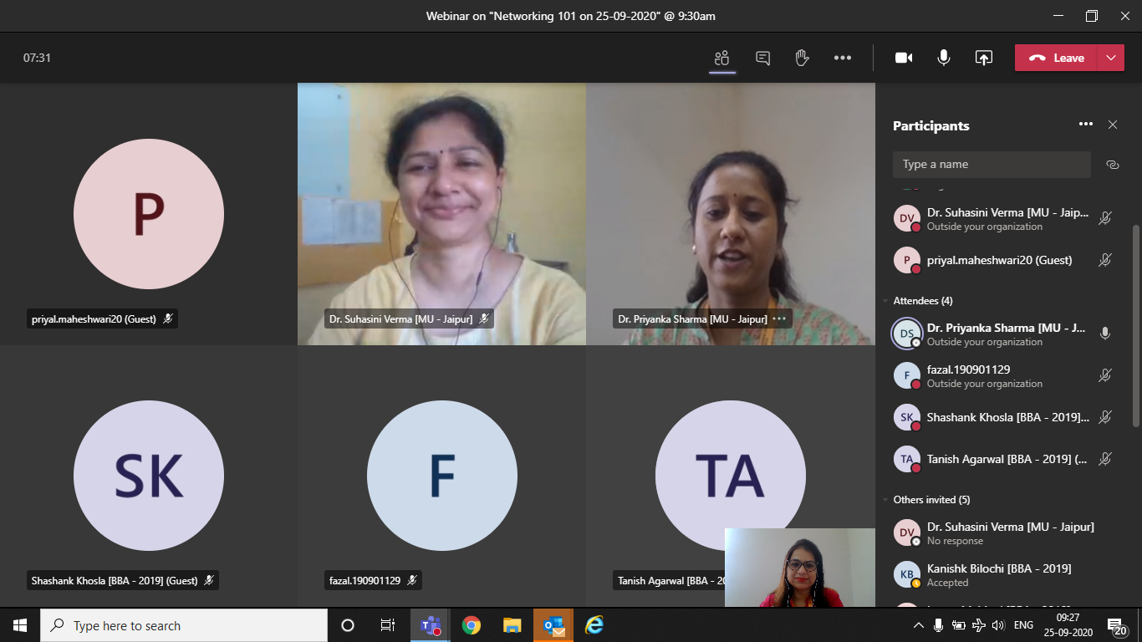
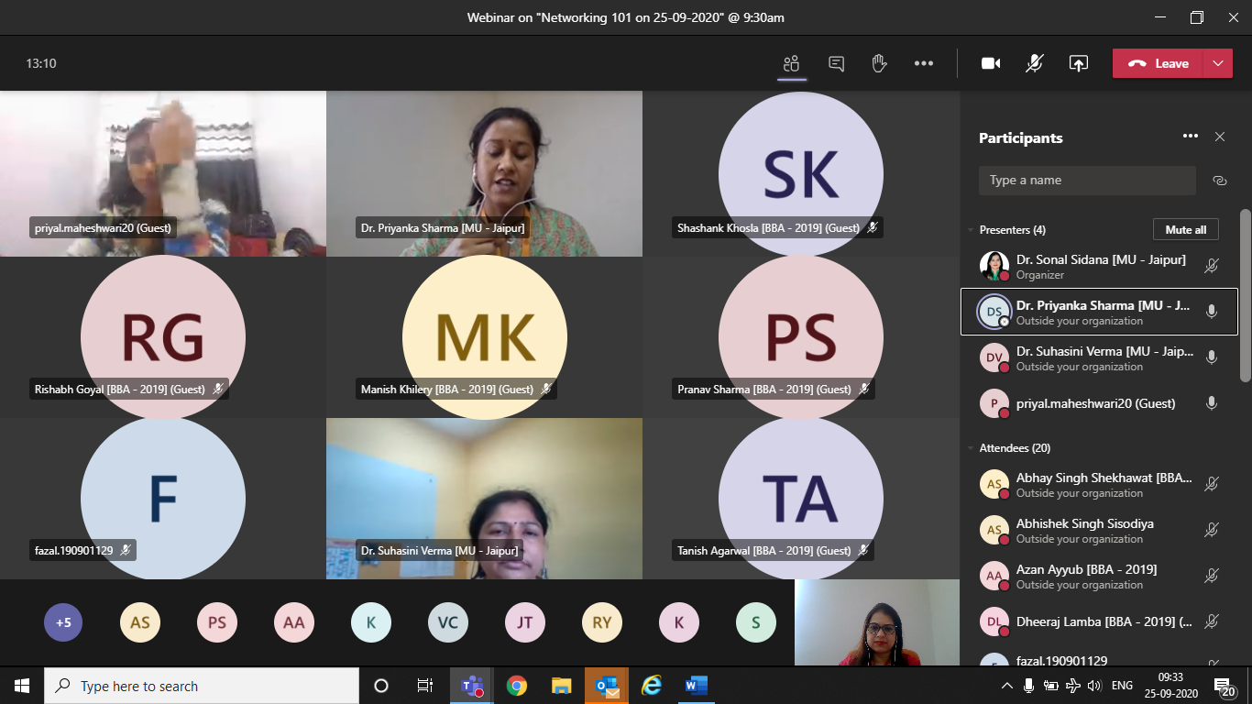

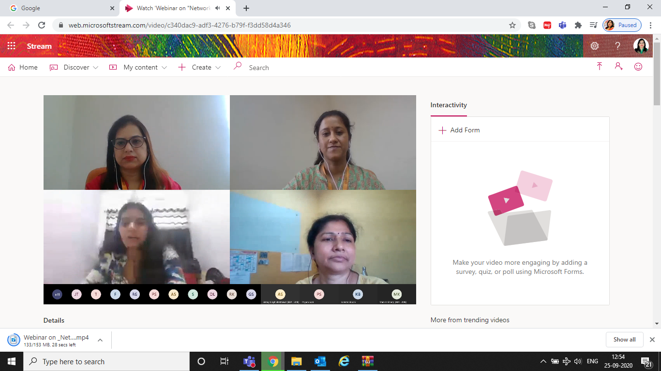
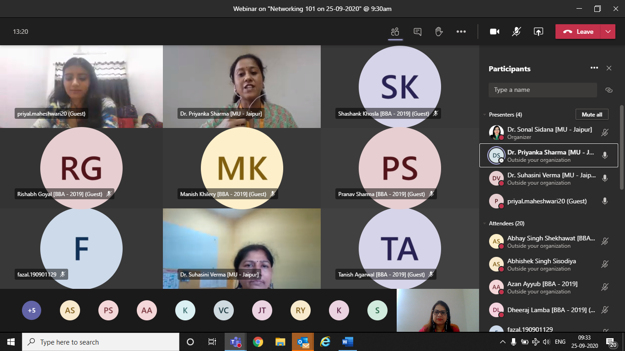

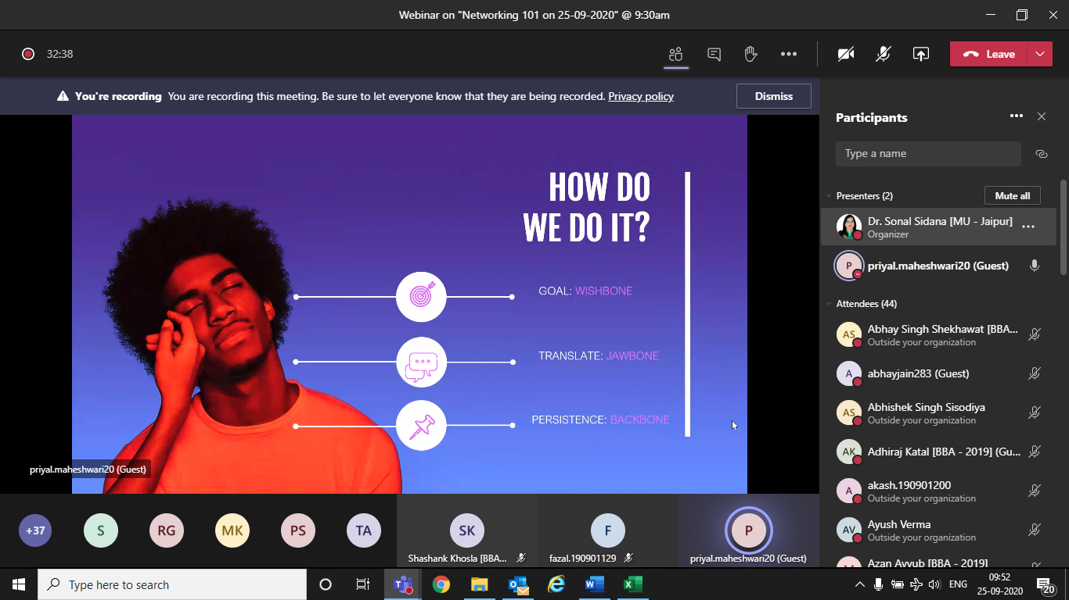
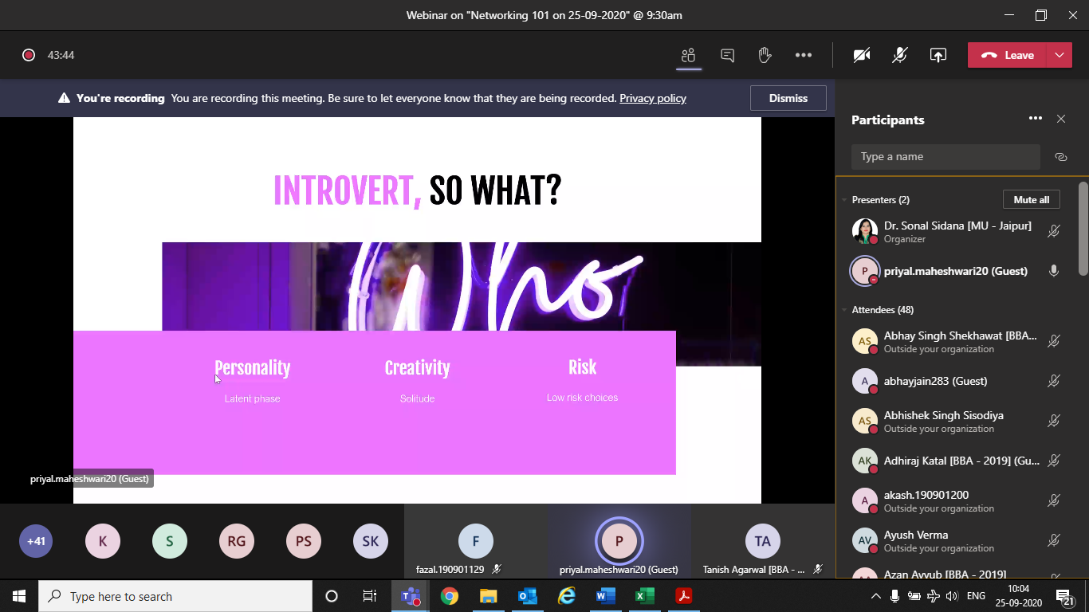

A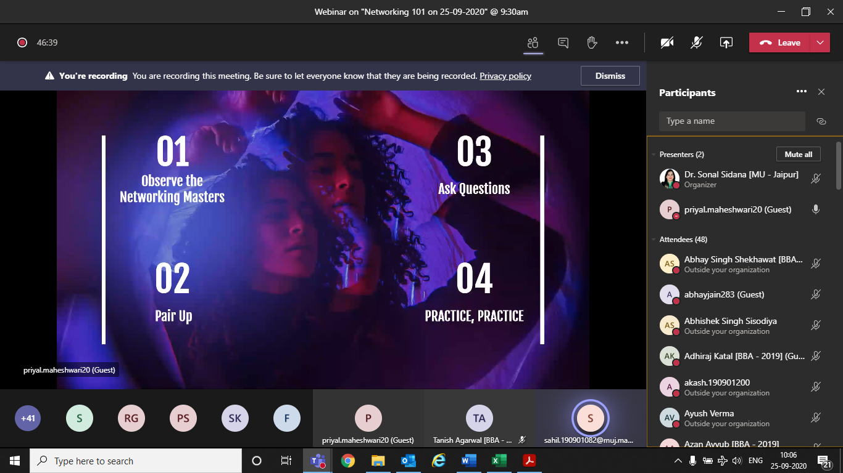

ATTENDANCE

S. No. | Registeration Number | Name of the student | E-Mail ID | Phone Numbers
1 | 190901084 | AADITYA CHOPRA | aaditya.190901084@muj.manipal.edu | 9829799132
2 | 190901192 | AAKASH JAIN | aakash.190901192@muj.manipal.edu | 9057833497
3 | 190901070 | ABHAY SINGH SHEKHAWAT | Abhay.190901070@muj.manipal.edu | 8239337238
4 | 190901176 | ABHAY JAIN | abhay.190901276@muj.edu | 9461575605
5 | 190901052 | ABHISHEK SINGH SISODIYA | abhishek.190901052@muj.manipal.edu | 9602496523
6 | 190901182 | ADHIRAJ KATAL | adhiraj.190901182@muj.manipal.edu | 7009929026
7 | 190901200 | AKASH JINDAL | akash.190901200@muj.manipal.edu | 8890363606
8 | 190901180 | ARVIND VISHNOI | arvind.190901180@muj.manipal.edu | 8839968291
9 | 190901058 | ASHUTOSH SHARMA | ashutosh.190901058.muj.manipal.edu | 6375924956
10 | 190901209 | ASHUTOSH TIWARI | ashutosh.190901209@muj.manipal.edu | 9354547210
11 | 190901110 | AYUSH VERMA | ayush.190901110@muj.manipal.edu | 9369813732
12 | 190901089 | AZAN AYYUB | Azan.190901089@muj.manipal.edu | 9829990786
13 | 190901061 | CHIRAYU KHANDELWAL | chirayu.190901061@muj.manipal | 8233806660
14 | 190901205 | DEEPAK THAWANI | Deepak190901205@muj.manipal.edu | 8058602588
15 | 190901094 | DEEPENDRA GURJAR | deependra.190901094@muj.manipal.edu | 8955115854
16 | 190901088 | DHANANJAY SINGH SARIN | dhananjay190901088@muj.manipal.edu | 7668721587
17 | 190901096 | DHEERAJ LAMBA | dheeraj.190901096@muj.manipal.edu | 8696477477
18 | 190901169 | DHEERAJ SHARMA | dheeraj.190901169@muj.manipal.edu | 9774032285
19 | 190901218 | DIPTI RAKESH PATWARI | dipti.190901218@muj.manipal.edu | 9330496118
20 | 190901091 | DIVYANSHI CHOUKSEY | divyanshi.190901091@muj.manipal.edu | 9131755997
21 | 190901186 | GAGANJEET KHANGAROT | gaganjeet.190901186@muj.manipal.edu | 7299999133
22 | 190901074 | GAURAV SHARMA | gaurav.190901074@manipal.edu | 7976115536
23 | 190901065 | HARDIK RAHEJA | hardik.190901065@muj.manipal.edu | 9799014468
24 | 190903025 | HARSH TEMANI | harsh.190903025@muj.manipal.edu | 9829093109
25 | 190901056 | HARSHIT GUPTA | harshit.190901056@muj.manipal.edu | 8769769343
26 | 190901148 | JAIPAL SINGH TANWAR | jaipal.190901148@muj.manipal.edu | 9116515360
27 | 190901098 | KANISHK BILOCHI | Kanishk.190901098@muj.manipal.edu | 9785402815
28 | 190901073 | KASHISH SHARMA | Kashish.190901073@muj.manipal.edu | 9950924524
29 | 190901055 | KHUSHI WADHWA | khushi.190901055@muj.manipal.edu | 8824974070
30 | 190901075 | LAGAN MAHIPAL | lagan.190901075@muj.manipal.edu | 8003225266
31 | 190901067 | LAKSHYA SHARMA | lakshya.190901067@muj.manipal.edu | 7340053537
32 | 190901106 | LUCKY CHOUDHARY | Lucky.190901106@muj.manipal.edu | 7014249295
33 | 190901062 | MANISH KHILERY | manish.190901062@muj.manipal.edu | 9413384235
34 | 190901207 | MIHIR AGRAWAL | mihir.190901207@muj.manipal.edu | 8878888996
35 | 190901060 | NAMAN JAIN | naman.190901060@muj.manipal.edu | 9784568143
36 | 190901083 | NAMAN SINGH | Naman.190901083@muj.manipal.edu | 9587418181
37 | 190901171 | NEHA GOPLANI | neha.190901171@muj.manipal.edu | 9889469469
38 | 190901095 | PARIJA GUPTA | parija.190901095@muj.manipal.edu | 8112246274
39 | 190901181 | PARTH GAUTAM | parth.190901181@muj.manipal.edu | 9810592114
40 | 190901178 | PRABAL VAID | prabal.190901178@muj.manipal.edu | 7018073708
41 | 190901086 | PRANAV SHARMA | pranav.190901086@muj.manipal.edu | 9314804899
42 | 190901108 | PRIYAM SONI | Priyam.190901108@muj.edu | 9664428721
43 | 190901173 | SRAJAL PURWAR | purwarramkishor@gmail.com | 7268000777
44 | 190901068 | RAGHAV MALPANI | raghav.190901068@muj.manipal.edu | 7742064994
45 | 190901195 | RAGHAV SINGHAL | raghav.190901195@muj.manipal.edu | 8827421127
46 | 190901078 | RAJVEER SINGH ANAND | rajveer.190901078@muj.manipal.edu | 9672399832
47 | 190901199 | RISHABH GOYAL | Rishabh.190901199@muj.manipal.edu | 9829140888
48 | 190901146 | RISHI KANOONGO | rishi.190901146@muj.manipal.edu
49 | 190901101 | RITIK YADAV | ritik. 190901101@muj.manipal.edu | 9521110558
50 | 190901184 | RITVIK SETHI | ritvik.190901184@muj.manipal.edu | 9540000791
51 | 190901202 | SACHIN YADAV | sachin.190901202@muj.manipal.edu | 8387838884
52 | 190901223 | SAGAR SHIRVI | sagar.190901223@muj.manipal.edu | 9898945239
53 | 190901082 | SAHIL KHANDELWAL | sahil.190901082@muj.manipal.edu | 9587114198
54 | 190901185 | SAMRAT KUMAR SINGH | samrat.190901185@muj.manipal.edu
55 | 190901189 | SANGYA GUPTA | sangya.190901189@muj.manipal.edu | 8009476037
56 | 190901183 | SHASHANK KHOSLA | shashank.190901183@muj.manipal.edu | 7976003361
57 | 190901019 | SHIVAM | shivam.190901019@muj.manipal.edu | 9672229351
58 | 190901170 | SHRIYANSH JAIN | shriyansh.190901170@muj.manipal.edu | 7073300822
59 | 190901077 | SHUBHANG MANDHANIYA | Shubhang.190901077@muj.Manipal.edu | 9829060358
60 | 190901196 | SURBHI SINGHAL | surbhi.190901196@muj.manipal.edu | 7024550806
61 | 190901172 | TANISH AGARWAL | Tanish.190901172@muj.manipal.edu | 9782043251
62 | 190901208 | TARUN SINGH | tarun.190901208@muj.manipal.edu | 7530861915
63 | 190901138 | UJJWAL GUPTA | ujjwal.190901138@muj.manipal.edu | 7976054612
64 | 190901203 | VAISHNAVI MISHRA | vaishnavi.190901203@muj.manipal.edu | 7668599336
65 | 190901107 | VIKRAMADITYA SINGH KALYANOT | Vikramaditya.190901107@muj.manipal.edu | 8005766931
66 | 190901153 | VISHAL CHOUDHARY | vishal.190901153@muj.manipal.edu | 9449777774
67 | 190901220 | YASHASVI PUROHIT | Yashashvi.190901220.muj@manipal.edu | 7830555771
68 | 190901104 | YASHPAL SINGH MAHECHA | Yashpal.190901104@muj.manipal.edu | 9079867588

