Department of Business Administration
Organized
Guest Lecture on

“The Game of Same 24 Hours”

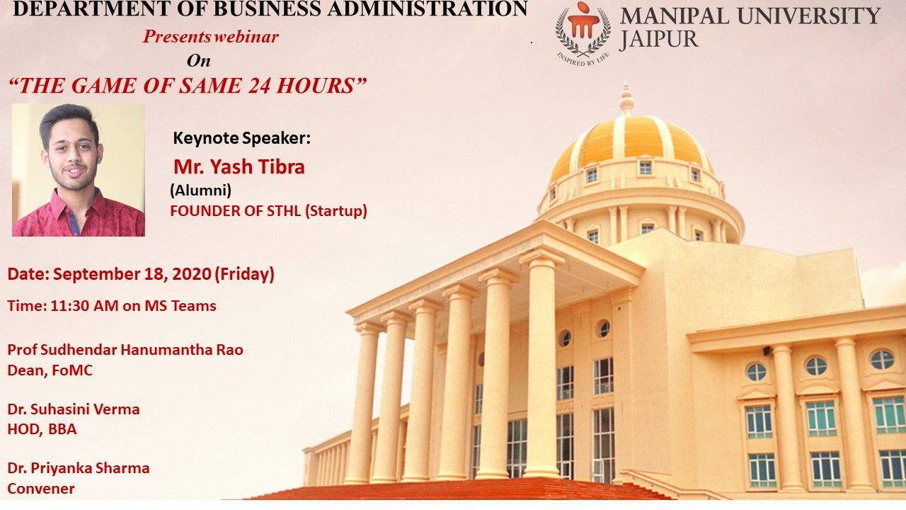

Session Expert: Departmental Coordinator:

Mr. Yash Tibra Dr. Priyanka Sharma
(Assistant Professor, Business Administration)

REPORT
MANIPAL UNIVERSITY JAIPUR
School of Business & Commerce
Department of Business Administration
Guest Lecture on
“The Game of Same 24 Hours”
Tagline : You are what you do, not what you say you'll do
(18th September’2020, Friday)

In the series of alumni connect, Department of Business Administration organized guest lecture on ‘The Game of Same 24 Hours’ by our Alumni Yash Tibra. Yash Tibra was invited to interact with the current students. Yash completed his BBA in the year 2020 with his specialization in the field of Finance and Banking. He is an entrepreneur; he started his first startup of event management in December 2017. In January 2019, he started a new startup named “Sthl”, it is an online platform for reservation of Banquet Halls, Lounges and Hotels. He shared his journey in Manipal University and his journey of entrepreneur with the current students. The students asked him their queries and solved their queries. It was an interactive session.

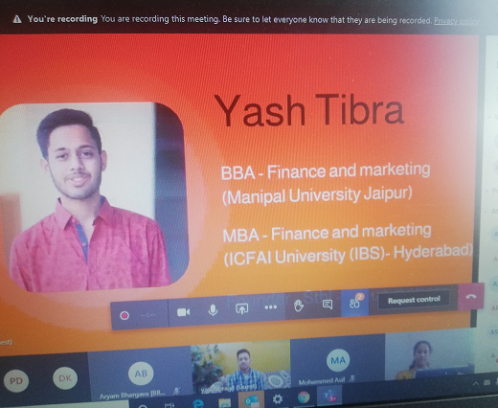
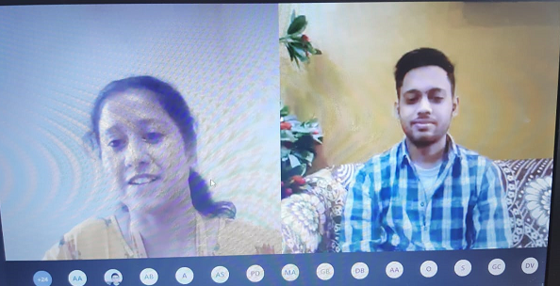
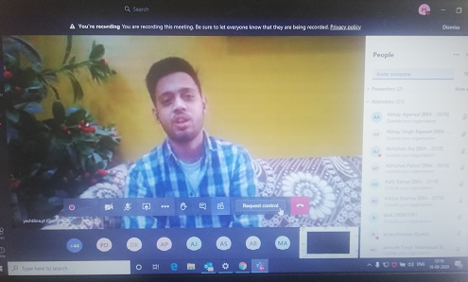

ATTENDANCE

S. No. | Registration No. | Name of the Student | E-Mail ID
1 | 180901097 | Abhay Agarwal | abhay.180901097@muj.manipal.edu
2 | 180901010 | Abhay Singh Rajawat | abhay.180901010@muj.manipal.edu
3 | 180901137 | Abhishek Jha | abhishek.180901137@muj.manipal.edu
4 | 180901119 | Abhishek Patodi | abhishek.180901119@muj.manipal.edu
5 | 180901006 | Aditya Sharma | aditya.180901006@muj.manipal.edu
6 | 180901091 | Alok Anand | alok.180901091@muj.manipal.edu
7 | 180901048 | Amay Choukse | amay.180901048@muj.manipal.edu
8 | 180901085 | Amogh Chhabra | amogh.180901085@muj.manipal.edu
9 | 180901022 | Anirudh Singh Shekhawat | anirudh.180901022@muj.manipal.edu
10 | 180901127 | Ankit kumar | ankit.180901127@muj.manipal.edu
11 | 180901069 | Ankush Ahuja | ankush.180901069@muj.manipal.edu
12 | 180901052 | Anshika Jadoun | anshika.180901052@muj.manipal.edu
13 | 180901128 | Anuj bansal | anuj.180901128@muj.manipal.edu
14 | 180901086 | Anusha masuna | anusha.180901086@muj.manipal.edu
15 | 180901044 | Anvaya Vyas | anvaya.180901044@muj.manipal.edu
16 | 180901040 | Apratim kumar singh | apratim.180901040@muj.manipal.edu
17 | 180901071 | Arpan Agrawal | arpan.180901071@muj.manipal.edu
18 | 180901115 | Arushi Agrawal | arushi.180901115@muj.manipal.edu
19 | 180901032 | Aryam Bhargava | aryam.180901032@muj.manipal.edu
20 | 180901159 | Atharv Gupta | atharv.180901159@muj.manipal.edu
21 | 180901003 | Atul Khantwal | atul.180901003@muj.manipal.edu
22 | 180901172 | AVINAV ROHAN | avinav.180901172@muj.manipal.edu
23 | 180901113 | Ayush Agrawal | ayush.180901113@muj.manipal.edu
24 | 181015009 | Ayush Sharma | ayush.181015009@muj.manipal.edu
25 | 180901045 | Bhavya varma | bhavya.180901045@muj.manipal.edu
26 | 180901161 | Chirag Madaan | chirag.180901161@muj.manipal.edu
27 | 180901066 | Chirag Meena | chirag.180901166@muj.manipal.edu
28 | 180901167 | Devesh Rawat | devesh.180901167@muj.manipal.edu
29 | 180901011 | Devika Khurana | devika.180901011@muj.manipal.edu
30 | 180901035 | Dhruva pratap bishnoi | dhruva.180901035@muj.manipal.edu
31 | 180901126 | Gaurav goyal | gaurav.180901126@muj.manipal.edu
32 | 180901026 | Girish Meena | girish.180901026@muj.manipal.edu
33 | 180901061 | Goonj Sethi | goonj.180901061@muj.manipal.edu
34 | 180901051 | Gurusha Bagora | gurusha.180901051@muj.manipal.edu
35 | 180901134 | Gyaneshwar.N.Chandnani | gyaneshwar.180901134@muj.manipal.edu
36 | 180901103 | Harsh Jindal | harsh.180901103@muj.manipal.edu
37 | 180901041 | Harshita Sainani | harshita.180901041@muj.manipal.edu
38 | 180901104 | Hritik Gupta | hritik.180901104@muj.manipal.edu
39 | 180901092 | Imran Ahmed | imran.180901092@muj.manipal.edu
40 | 180901068 | Jai Vardhan Singh Rathore | jaivardhan.180901068@muj.manipal.edu
41 | 180901088 | Jayti Upadhyay | jayti.180901088@muj.manipal.edu
42 | 180901046 | Jyoti Kumari | jyoti.180901046@muj.manipal.edu
43 | 180901057 | Karan Singh | karan.180901057@muj.manipal.edu
44 | 180901009 | Kartikey Khandelwal | kartikey.180901009@muj.manipal.edu
45 | 180901201 | Khushboo Wadhwani | Khushboo.180901201@muj.manipal.edu
46 | 180901036 | Kush kishnani | kush.180901036@muj.manipal.edu
47 | 180901123 | Luv anand | luv.180901123@muj.manipal.edu
48 | 180901064 | MANAN SHARMA | manan.180901064@muj.manipal.edu
49 | 180901108 | Mayank ameriya | mayank.180901108@muj.manipal.edu
50 | 180901139 | Mohd. Asif Khan | mohammed.180901139@muj.manipal.edu
51 | 180901054 | Nandini sharma | nandini.180901054@muj.manipal.edu
52 | 180901043 | Om Agarwal | om.180901043@muj.manipal.edu
53 | 180901049 | Priyam Dowerah | priyam.180901049@muj.manipal.edu
54 | 180901193 | Shailly Kothari | shally.180901193@muj.manipal.edu
55 | 180905607 | Arpita (Research scholar) | arpita.180905607@muj.manipal.edu

