cid:image001.png@01D3CCBE.2100A7E0

**Guest Lecture On**

**“Benefits of Value Added Courses”**

**By Bombay Stock Exchange Institute Ltd.**

**School of Business and Commerce**

**MUJ**

**2nd of November 2020**

**Mr. Sachin Agarwal, Resource Person, (Star Faculty, BSE Inst.)**

**Dr. Tanushree Sharma, Convenor, School of Business and Commerce, MUJ**

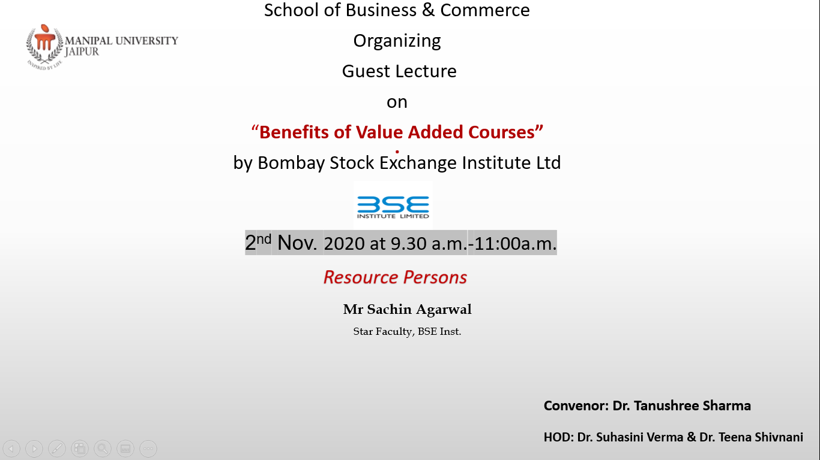

**MANIPAL UNIVERSITY JAIPUR**

**School of Business and Commerce**

**Guest Lecture on "Benefits of Value Added Courses” by Bombay Stock Exchange Institute Ltd.**

**(2nd Nov.’ 2020, Monday)**

**REPORT**

**School of Business & Commerce Organized guest lecture on “Benefits of Value Added Courses ” by Bombay Stock Exchange Institute Ltd. –** A guest lecture was organised by school of business and commerce on 2nd November 2020. Dr. Tanushree Sharma was the convenor of this workshop. Mr Sachin Aggarwal, Technical Analyst & Star Faculty, BSE was the speakers of the workshop. He is a Chartered Accountant but due to his passion for Financial markets he has dedicated his time and life to Financial Markets. He is Technical Analyst and Investor in Stock Markets, having vast experience of investing and trading in different testing times

With a legacy of more than 144 years BSE Ltd is Asia’s first and the world’s fastest stock exchange with the speed of 6 microseconds. With a strong vision to create a platform for genuine training and education in the Financial Markets BSE established its learning arm BSE Institute Ltd.  
  
The BSE Institute Ltd. is a 100% subsidiary of BSE Limited. BSE Institute Ltd. inherits from BSE the knowledge and insights into the capital markets industry, garnered over the past 144 years. He told benefits of doing value added courses from BSE. The first-hand experience of faculty and subject matter experts helps in dealing with the realities of this market, enables students to appreciate how organizations, entrepreneurs, and investors identify and respond to these new challenges and opportunities.  
  
He explained how these programs are designed to help learners develop an actionable framework to delve into key aspects like identifying which market institutions are working, and which institutions are missing? which parts of our business model can be adversely affected by these institutional voids? how can we build competitive advantage based on our ability to navigate institutional voids?, How can we profit from the structural reality of emerging markets by identifying opportunities to fill voids, serving as market intermediaries?  
  
For more than two decades, the BSE Institute Ltd. faculty have drawn on their passion for teaching, their experience in working with organizations worldwide, and the insights gained from their experience to educate professionals who have shaped the practice of business in financial markets not only in India but also many other countries around the world.  
  
BSE course design and development is firmly grounded in knowledge of business processes—in entrepreneurial companies and established firms unconstrained by the boundaries of academic disciplines.

Participants had many queries about these courses which were answered by the speaker. The session was very informative for students.

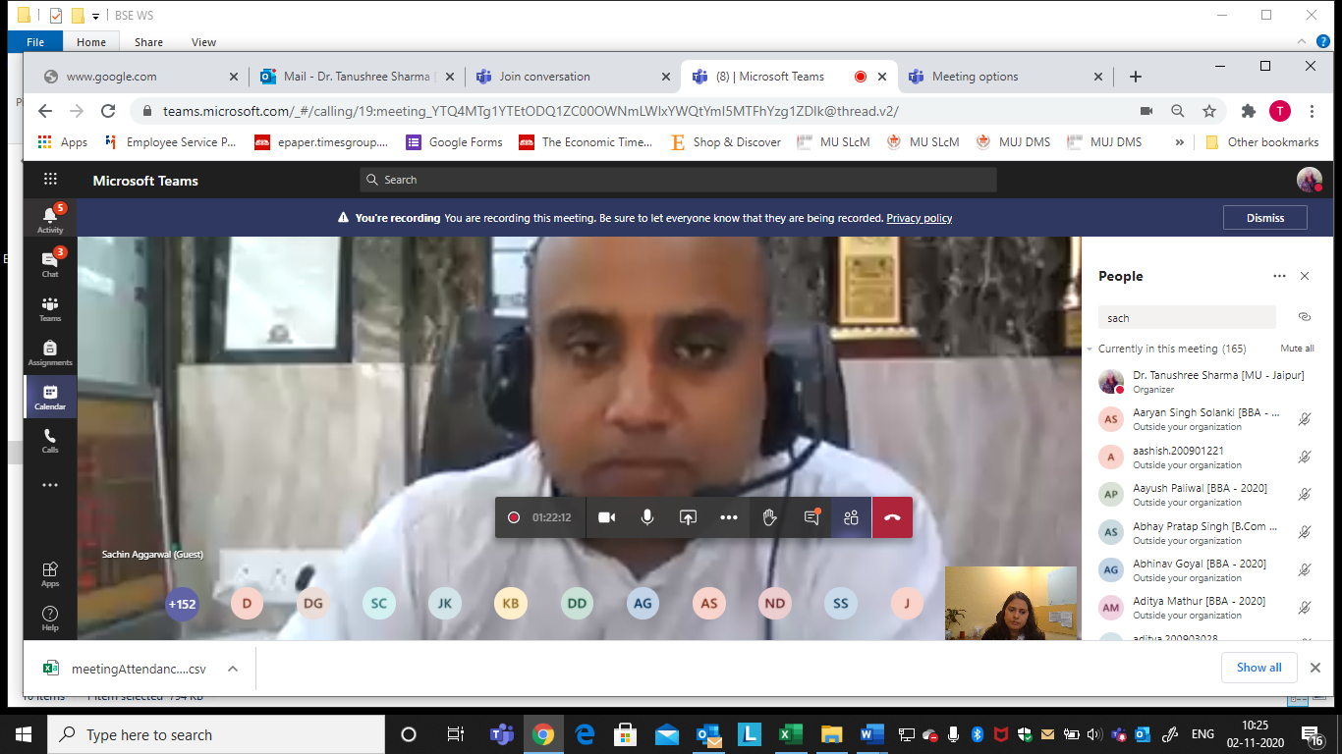

**Attendance Sheet**

|  |  |
| --- | --- |
| 1 | Dr. Tanushree Sharma [MU - Jaipur] |
| 2 | Aaryan Singh Solanki [BBA - 2020] |
| 3 | Abhinav Goyal [BBA - 2020] |
| 4 | Dhruveika Dhupia [BBA - 2020] |
| 5 | Sachin Aggarwal (Guest) |
| 6 | Krish Bhanushali [BBA - 2020] |
| 7 | Jay Prakash Khandelwal [BBA - 2020] |
| 8 | Siddhaarthaa Chouhan [BBA - 2020] |
| 9 | Devansh Goyal [BBA - 2020] |
| 10 | disha.200903027 |
| 11 | Kashika Sharma [B.Com - 2020] |
| 12 | Harsh Mittal [BBA - 2020] |
| 13 | Arin Goyal [BBA - 2020] (Guest) |
| 14 | harshal.200901087 |
| 15 | Avani Jain [BBA - 2020] |
| 16 | Garima Singh [BBA - 2020] |
| 17 | Sachinstockview (Guest) |
| 18 | Madhu Mishra [B.Com (Honours In Accounting) - 2020] |
| 19 | Madhu Mishra [B.Com (Honours In Accounting) - 2020] |
| 20 | Aarchi Khandelwal [BBA - 2020] |
| 21 | sachinjat5201 (Guest) |
| 22 | Ayushman Tomar [BBA - 2020] |
| 23 | Khushi Singhal [BBA - 2020] |
| 24 | Aman Choudhary [BBA - 2020] (Guest) |
| 25 | Charchit Taneja [BBA - 2020] |
| 26 | Paranjay Paliwal [BBA - 2020] |
| 27 | aashish.200901221 |
| 28 | Irish Karnani [BBA - 2020] (Guest) |
| 29 | Irish Karnani [BBA - 2020] (Guest) |
| 30 | Sudhish Trigunayat [Bachelor of Commerce (B.Com) - 2020] |
| 31 | Nihal Choudhary [BBA - 2020] |
| 32 | Nilesh Kumar Dangi [BBA - 2020] |
| 33 | Chandrajeet Singh Bhati [BBA - 2020] |
| 34 | Dinesh Gehlot [BBA - 2020] |
| 35 | Dinesh Gehlot [BBA - 2020] |
| 36 | Pankaj Mahaseth [BBA - 2020] |
| 37 | Dev R Parikh [B Com - 2020] |
| 38 | komal.200903048 |
| 39 | gagandeep.200903042 |
| 40 | Saksham Naraniya [BBA - 2020] |
| 41 | Priyasha Singh [B.Com (Honours In Accounting) - 2020] |
| 42 | Gauransh Pandey [BBA - 2020] (Guest) |
| 43 | Ajay Khatri [B.Com (Honours In Accounting) - 2020] |
| 44 | Sahastranshu Chandel [BBA - 2020] |
| 45 | Deepika Aiery [BBA - 2020] |
| 46 | Keshav Goyal [BBA - 2020] (Guest) |
| 47 | Vishal Jetwal [BBA - 2020] (Guest) |
| 48 | Rahul [BBA - 2020] (Guest) |
| 49 | Mudit Singh [BBA - 2020] |
| 50 | Fuhad Shahabin [B COM (HONOURS) - 2020] |
| 51 | Mudita Gupta [BBA - 2020] |
| 52 | Disha Mantri [BBA - 2020] (Guest) |
| 53 | Gurleen Sood [B.Com (Honours In Accounting) - 2020] |
| 54 | Tanvi Anand [BBA - 2020] (Guest) |
| 55 | Sanchit Wadhwa [BBA - 2020] |
| 56 | Vidhi Bhatia [BBA - 2020] |
| 57 | Chirag Katoch [B.Com (Honours In Accounting) - 2020] |
| 58 | Pratham Kapoor [BBA - 2020] |
| 59 | Samarth Agarwal [BBA - 2020] |
| 60 | Samarth Agarwal [BBA - 2020] |
| 61 | Gautam Agrawal [B COM (HONOURS) - 2020] |
| 62 | Kshitij Ranjan [B.Com (Honours In Accounting) - 2020] |
| 63 | Rishika Singodia [BBA - 2020] |
| 64 | Vandit Lodha [B.Com (Honours In Accounting) - 2020] |
| 65 | Vandit Lodha [B.Com (Honours In Accounting) - 2020] |
| 66 | Chirag Kansal [BBA - 2020] (Guest) |
| 67 | Abhay Pratap Singh [B.Com (Honours In Accounting) - 2020] |
| 68 | Jatin Sharma [BBA - 2020] |
| 69 | Hardik Kothari [Bachelor of Commerce (B.Com) - 2020] |
| 70 | Harshita Sharma [BBA - 2020] |
| 71 | Naman Vijay [BBA - 2020] |
| 72 | Tanishka Anjana [BBA - 2020] |
| 73 | Eklavya Bansal [BBA - 2020] |
| 74 | Ishika Sarda [B.Com (Honours In Accounting) - 2020] |
| 75 | shashwat |
| 76 | gaurav.200901074 |
| 77 | Piyush Chouhan [BBA - 2020] |
| 78 | Prakhar Modi [BBA - 2020] |
| 79 | Muskan Khetrapal [BBA - 2020] (Guest) |
| 80 | Pawan Singh [BBA - 2020] |
| 81 | Vaibhav [BBA - 2020] (Guest) |
| 82 | Shreyas Mahajan [B.Com (Honours In Accounting) - 2020] |
| 83 | Vedant Garg [BBA - 2020] |
| 84 | Jessica Kapoor [BBA - 2020] |
| 85 | K R Krishnapriya [B.Com (Honours In Accounting) - 2020] |
| 86 | KRITKSINGH.268 (Guest) |
| 87 | Rahul Kishnani [B.Com - 2020] |
| 88 | Tejesvi Purohit [BBA - 2020] |
| 89 | Gauransh Singhal [B.Com (Honours In Accounting) - 2020] |
| 90 | Mohit Jangid [Bachelor of Commerce (B.Com) - 2020] |
| 91 | Rishabh Joshi [BBA - 2020] |
| 92 | Prianshu Tandon [Bachelor of Commerce (B.Com) - 2020] |
| 93 | mitisha.200901171 |
| 94 | Khushi Jain [BBA - 2020] |
| 95 | Goutam Karwa [BBA - 2020] (Guest) |
| 96 | Dr. Gaurav Loadha [MU - Jaipur] |
| 97 | yash.200903036 |
| 98 | Bhrat [B COM (HONOURS) - 2020] |
| 99 | Naman Agrawal [BBA - 2020] |
| 100 | Shivam Saini [BBA - 2020] (Guest) |
| 101 | Disha Sancheti [BBA - 2020] (Guest) |
| 102 | Himanshu Nagwani [BBA - 2020] |
| 103 | Yashika Siddha [BBA - 2020] |
| 104 | Khushi Gohil [BBA - 2020] |
| 105 | Harshit Thomas [B.Com (Honours In Accounting) - 2020] |
| 106 | Parineeta Jain [BBA - 2020] |
| 107 | Shashwat Singh [BBA - 2020] (Guest) |
| 108 | Vikas Kumar Fageria [BBA - 2020] (Guest) |
| 109 | Vansh Sharma [Bachelor of Commerce (B.Com) - 2020] |
| 110 | Uttam Agarwal [B.Com (Honours In Accounting) - 2020] |
| 111 | Vatsal Choukhani [BBA - 2020] (Guest) |
| 112 | Vatsal Choukhani [BBA - 2020] (Guest) |
| 113 | Shashwat Singh [BBA - 2020] |
| 114 | Rahul [BBA - 2020] |
| 115 | Devyani Gurjar [BBA - 2020] |
| 116 | Taruna Kanwar Rathore [Bachelor of Commerce (B.Com) - 2020] |
| 117 | Priyanshu Bijarnia [Bachelor of Commerce (B.Com) - 2020] |
| 118 | Manvi Verma [Bachelor of Commerce (B.Com) - 2020] |
| 119 | Sameer Kayamkhani [BBA - 2020] (Guest) |
| 120 | Rahul Choudhary [BBA - 2020] |
| 121 | Kunal Padaliya [BBA - 2020] |
| 122 | Stuti Arora [BBA - 2020] |
| 123 | Umesh Khatri [Bachelor of Commerce (B.Com) - 2020] |
| 124 | ritik.200903037 |
| 125 | Lakshay Garg [Bachelor of Commerce (B.Com) - 2020] |
| 126 | Adiya Nair [B.Com (Honours In Accounting) - 2020] |
| 127 | Utkarsh Dhawan [B.Com (Honours In Accounting) - 2020] |
| 128 | Gaurav Kumawat [BBA - 2020] (Guest) |
| 129 | Kartikya Singh [Bachelor of Commerce (B.Com) - 2020] |
| 130 | Harshil Airen [BBA - 2020] (Guest) |
| 131 | Lakshay Mahipal [BBA - 2020] (Guest) |
| 132 | Anushka Gupta [B.Com (Honours In Accounting) - 2020] |
| 133 | Ishu Godara [Bachelor of Commerce (B.Com) - 2020] |
| 134 | Kartikeya Yogi [B.Com (Honours In Accounting) - 2020] |
| 135 | Pratik [Bachelor of Commerce (B.Com) - 2020] |
| 136 | Pratik [Bachelor of Commerce (B.Com) - 2020] |
| 137 | Shubh Gupta [B.Com (Honours In Accounting) - 2020] |
| 138 | Kaushik Sankhla [BBA - 2020] |
| 139 | naman.200903030 |
| 140 | Yadhu Vyas [B.Com (Honours In Accounting) - 2020] |
| 141 | aditya.200903028 |
| 142 | Vrinda Bali [B Com - 2020] |
| 143 | Anurag Singh [BBA - 2020] |
| 144 | Saurav Rajbir Singh [BBA - 2020] (Guest) |
| 145 | Khushi Dubey [BBA - 2020] |
| 146 | Andeep [B.Com - 2020] |
| 147 | Dev Raghuvanshi [B.Com (Honours In Accounting) - 2020] |
| 148 | Jayesh [B.Com (Honours In Accounting) - 2020] |
| 149 | Mansi Singh [B.Com (Honours In Accounting) - 2020] |
| 150 | Neeraj Dhakar [BBA - 2020] |
| 151 | Krishna Jindal [BBA - 2020] |
| 152 | Shreya Gupta [BBA - 2020] |
| 153 | Diya Rawat [B.Com (Honours In Accounting) - 2020] |
| 154 | Aayush Paliwal [BBA - 2020] (Guest) |
| 155 | Anshika Agarwal [B.Com (Honours In Accounting) - 2020] |
| 156 | Deepak Vijay [BBA - 2020] (Guest) |
| 157 | Rishabh Singhal [BBA - 2020] |
| 158 | Saurav Kumar [BBA - 2020] |
| 159 | C.K.Tanishq [BBA - 2020] |
| 160 | Shivam Gupta [B.Com (Honours In Accounting) - 2020] |
| 161 | Gourav |
| 162 | Puneeth H B [B.Com (Honours In Accounting) - 2020] |
| 163 | Lakshay Rathore [BBA - 2020] |
| 164 | Khushi Koolwal [BBA - 2020] |
| 165 | Gaurav Chauhan [B COM (HONOURS) - 2020] |
| 166 | Jatin Mahlawat [BBA - 2020] |
| 167 | Bahadur Singh Chauhan [BBA - 2020] (Guest) |
| 168 | Arpit Agarwal [BBA - 2020] |
| 169 | Vaibhav Dulatani [B.Com (Honours In Accounting) - 2020] |
| 170 | Amish Raj Rastogi [BBA - 2020] |
| 171 | saksham.200901035 |
| 172 | Amandeep Maheshwari [BBA - 2020] (Guest) |
| 173 | Bhupendra Chhanang [BBA - 2020] (Guest) |
| 174 | Prachi Sheth [B.Com (Honours In Accounting) - 2020] |
| 175 | Ritik Raj Tiwari [BBA - 2020] |
| 176 | Tushar Totlani [BBA - 2020] |
| 177 | Nitesh Singh Tanwar [Bachelor of Commerce (B.Com) - 2020] |
| 178 | Urvashi T Purswany [BBA - 2020] |
| 179 | Vishal Goswami [BBA - 2020] |
| 180 | nihal.200901236 |
| 181 | Vanshika Choudhary [Bachelor of Commerce (B.Com) - 2020] |
| 182 | Bahadur Singh Chauhan [BBA - 2020] |
| 183 | pulkit.200901028 (Guest) |
| 184 | Kiran Choudhary [BBA - 2020] (Guest) |
| 185 | Rishi Mathur [B.Com (Honours In Accounting) - 2020] |
| 186 | Aayush Paliwal [BBA - 2020] |
| 187 | Sanchit Wadhwa [BBA - 2020] (Guest) |
| 188 | Lakshya Porwal [BBA - 2020] (Guest) |
| 189 | Vinit Agarwal [BBA - 2020] (Guest) |
| 190 | Kartikey Mittal [BBA - 2020] (Guest) |
| 191 | Sayush Yadav [BBA - 2020] (Guest) |
| 192 | Khushi Rawat [BBA - 2020] (Guest) |
| 193 | Gaurav [BPES - 2020] |
| 194 | Keshav gehlot |
| 195 | Mukul Agarwal [BBA - 2020] |
| 196 | DHRUV SHARMA |
| 197 | Shreya Thakre [B.Com - 2020] |
| 198 | khushi.200901245 |
| 199 | Aparajita Chakravertty [BBA - 2020] |
| 200 | Ayush Dev [Bachelor of Commerce (B.Com) - 2020] |
| 201 | Preet Goyal [BBA - 2020] |
| 202 | Tanman Agarwal [BBA - 2020] |
| 203 | Kush Malhotra [BBA - 2020] |
| 204 | Pulkit Arora [BBA - 2020] |
| 205 | Aditya Mathur [BBA - 2020] |
| 206 | bhavyaveer.200901007 |
| 207 | Akshit Kothari [BBA - 2020] (Guest) |
| 208 | Devansh Garg [BBA - 2020] (Guest) |
| 209 | Harshraj Singh Rathore [B.Com (Honours In Accounting) - 2020] |
| 210 | Tushar Agarwal [B.Com (Honours In Accounting) - 2020] |
| 211 | Saral Dasot [BBA - 2020] (Guest) |
| 212 | Saral Dasot [BBA - 2020] (Guest) |
| 213 | Vipul Sharma [BBA - 2020] |
| 214 | Kushal Jain [BBA - 2020] (Guest) |
| 215 | Kushal Jain [BBA - 2020] (Guest) |
| 216 | Lakshya Porwal [BBA - 2020] |
| 217 | Akshat Mishra [BBA - 2020] |
| 218 | Tanish Garg [BBA - 2020] |
| 219 | Tanish Vijay [BBA - 2020] (Guest) |
| 220 | Deepanshu Kushwaha [BBA - 2020] (Guest) |
| 221 | Honey Padiyar [BBA - 2020] |
| 222 | Gaurav Bajaj [BBA - 2020] (Guest) |