MUJ/Q&C/021/F/1.01 Event Report Format

FACULTY OF MANAGEMENT & COMMERCE

SCHOOL OF BUSINESS & COMMERCE

DEPARTMENT OF BUSINESS ADMINISTRATION
Organizes
A Behavioral Change Workshop
On
Wrong Side of the Road

7th April 2022

Event Report

- Introduction of the Event
- Objective of the Event
- Beneficiaries of the Event
4. Details of the Guests
5. Brief Description of the event
6. Photographs
7. Brochure or creative of the event
8. Schedule of the Event
9. Attendance of the Event

- Introduction of the Event

There are many reasons for road accidents but two of the main reasons are wrong side of the road and drunk driving. A report published by Statista Department shows that in India in the year 2019, 151 thousand fatalities recorded due to road accidents. Thus, it is the need of hour to save life and people must understand that life is very costly, and the due precautions must be taken care of.

- Objective of the Event

The objective of the workshop was to broaden the dimensions for road safety measures. The purpose of workshop is to extend the awareness for road safety measures, making audience understand about signs and symbols used on the road and to understand the traffic management.

- Beneficiaries of the Event

The target audience is students of School of Business & Commerce both of Department of Business Administration and Department of Commerce.

- Details of the Guest

Mr. Sunil Chaturvedi, Secretary-Connect Signal.
Mr. Sunil Chaturvedi has done B tech in Textile Technology and MBA in International Business. He is in Education and Training field for last 18 years. His specialization is in Apparel Merchandising, Exports and International Business. He has been Regional Head of Rajasthan State in Apparel Training and Design Centre for 12 years. In 2016, he started Connect Signal initiative. This organization works in Women Empowerment, Livelihood generation. He has been in executive committee of RIICO for organizing Vastra an International Apparel and textile Fair held at Jaipur. Presently, he is also associated with Sukhadia University, Udaipur, NIFT, Jodhpur, Export Promotion Council for Handicrafts as international Business expert.
- Brief Description of the event
The workshop was organized for the benefit of students as road safety is the issue that affects every household. The economic loss due to road accidents is also very huge. Awareness amongst public specially for young adults it is utmost required. The safety measures must be adopted by every individual who is on road as it costs the life of person. We cannot calculate the road accidents daily, it is only because of lack of rules followed on road, these types of casualties happened. The workshop was organized with an aim to give this issue a thought and to drive safe for avoiding the risk of injury on road.

- Photographs of the event or screenshots of the event
Mr. Sunil Chaturvedi, discussing the issue of ‘Wrong Side of the Road’
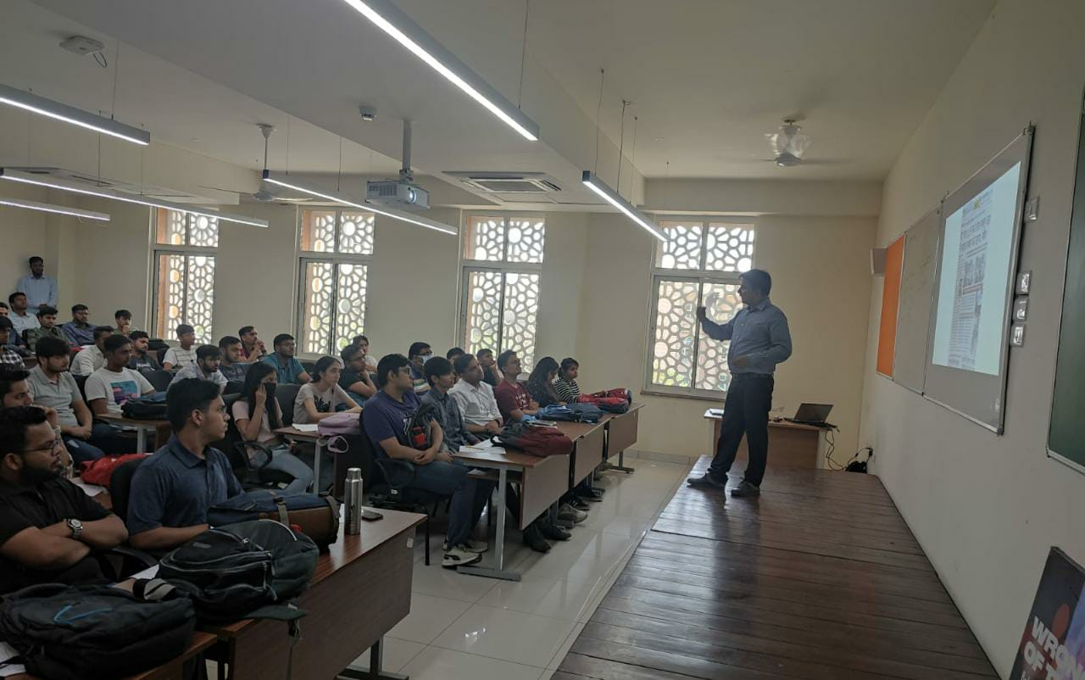

Mr. Sunil Chaturvedi, discussing the issue of ‘Need of Change in Behaviour for Safety on Road’
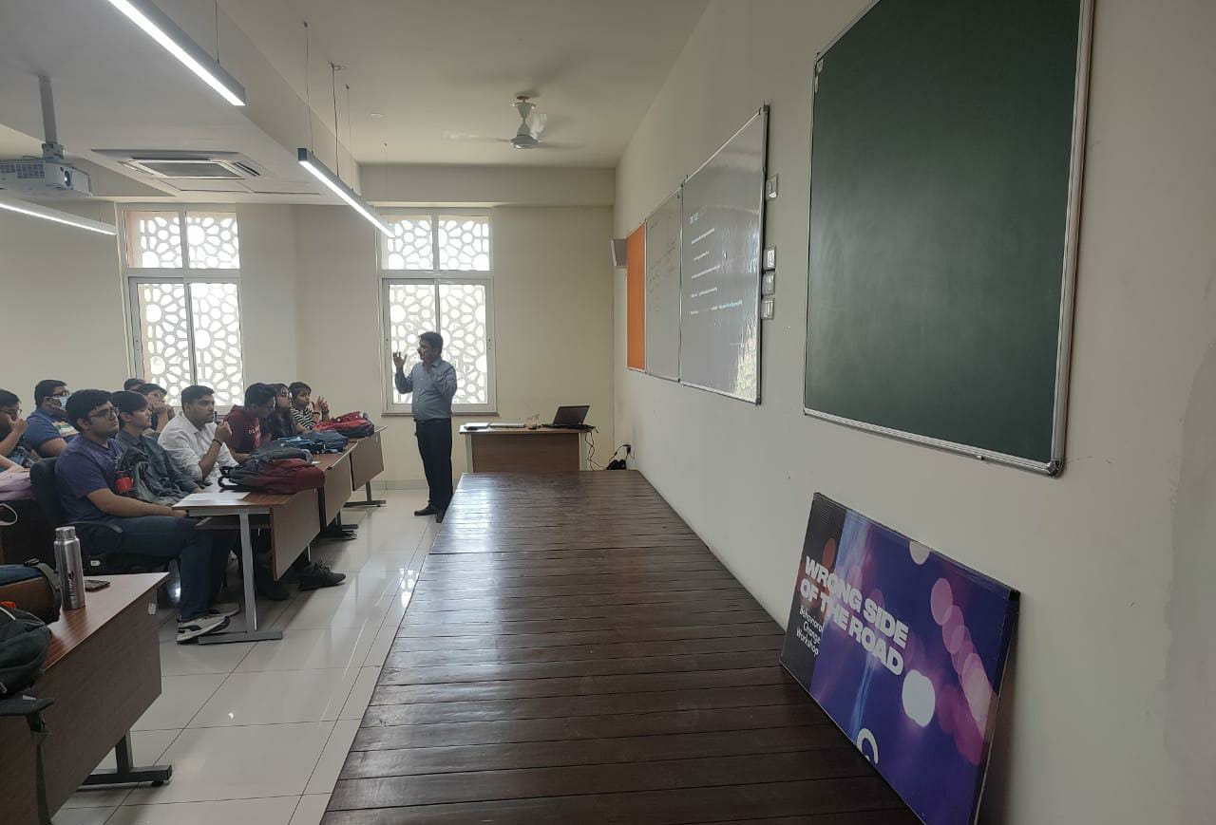

- Brochure or Creative of the event

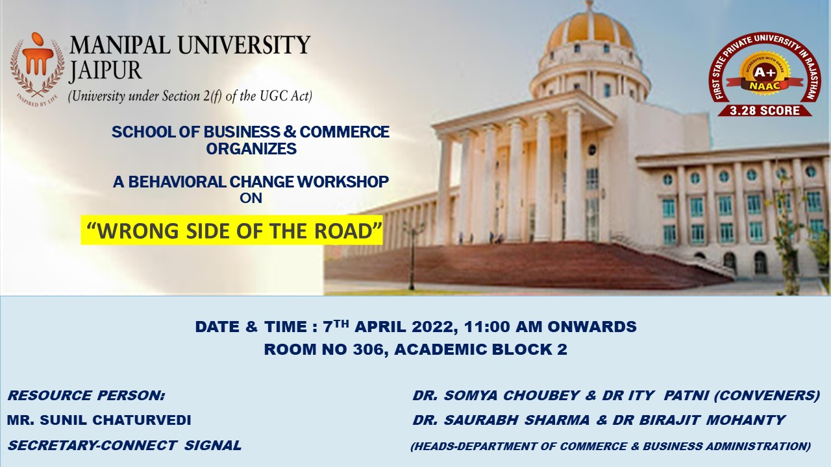

- Schedule of the event (insert in the report)
The event was scheduled on 7th April 2022 from 11 AM to 1 PM noon in an offline mode in Academic Block 2, Room No 306, Third Floor.
Attendance of the Event (insert in the document only)
Total attendee
Sr. No | Name of Institution | Place of Institution | Registration Number/Employee code | Name of Attendee | Name of Dept
1 | Manipal University Jaipur | Jaipur | MUJ0691 | Dr. Ity Patni | Business Administration
2 | Manipal University Jaipur | Jaipur | MUJ1019 | Dr. Somya Choubey | Commerce
3 | Manipal University Jaipur | Jaipur | 210901017 | Rishik Malhotra | Business Administration
4 | Manipal University Jaipur | Jaipur | 210901017 | RISHIK MALHOTRA | Business Administration
5 | Manipal University Jaipur | Jaipur | 210901018 | PRATHAM CHOUDHARY | Business Administration
6 | Manipal University Jaipur | Jaipur | 210901019 | RUDRAKSH PAREEK | Business Administration
7 | Manipal University Jaipur | Jaipur | 210901023 | ROHAN MITTAL | Business Administration
8 | Manipal University Jaipur | Jaipur | 210901025 | PARV KUMAR SINGH | Business Administration
9 | Manipal University Jaipur | Jaipur | 210901026 | SALONI NIMJE | Business Administration
10 | Manipal University Jaipur | Jaipur | 210901039 | RISHU GOYAL | Business Administration
11 | Manipal University Jaipur | Jaipur | 210901041 | PRADHYUMAN SINGH | Business Administration
12 | Manipal University Jaipur | Jaipur | 210901048 | PRIYANKA KUMARI | Business Administration
13 | Manipal University Jaipur | Jaipur | 210901049 | PARTH PATNI | Business Administration
14 | Manipal University Jaipur | Jaipur | 210901062 | SANJAY KUMAR DHAKER | Business Administration
15 | Manipal University Jaipur | Jaipur | 210901067 | RAHUL CHOUDHARY | Business Administration
16 | Manipal University Jaipur | Jaipur | 210901079 | RAGHAV JAKHAR | Business Administration
17 | Manipal University Jaipur | Jaipur | 210901083 | PRADYUMN DIXIT | Business Administration
18 | Manipal University Jaipur | Jaipur | 210901084 | SAHIL JAIN | Business Administration
19 | Manipal University Jaipur | Jaipur | 210901087 | PREM JAIN | Business Administration
20 | Manipal University Jaipur | Jaipur | 210901093 | RUDRAKSH SARUPARIA | Business Administration
21 | Manipal University Jaipur | Jaipur | 210901099 | PUSHPENDU BISWAS | Business Administration
22 | Manipal University Jaipur | Jaipur | 210901119 | RAM DARSHAN SUTHAR | Business Administration
23 | Manipal University Jaipur | Jaipur | 210901124 | RISHABH CHOPRA | Business Administration
24 | Manipal University Jaipur | Jaipur | 210901135 | RAUNAK TIBREWAL | Business Administration
25 | Manipal University Jaipur | Jaipur | 210901144 | SARA THAKUR | Business Administration
26 | Manipal University Jaipur | Jaipur | 210901165 | PARVEZ ALI | Business Administration
27 | Manipal University Jaipur | Jaipur | 210901168 | SANJAY CHOUDHARY | Business Administration
28 | Manipal University Jaipur | Jaipur | 210901169 | PRAVEEN MAHRAWDIYA | Business Administration
29 | Manipal University Jaipur | Jaipur | 210901171 | SACHIN GURNANI | Business Administration
30 | Manipal University Jaipur | Jaipur | 210901172 | PARTH NAGPAL | Business Administration
31 | Manipal University Jaipur | Jaipur | 210901176 | PULKIT JAIN | Business Administration
32 | Manipal University Jaipur | Jaipur | 210901181 | RITIKA MATHUR | Business Administration
33 | Manipal University Jaipur | Jaipur | 210901188 | ROHAN RAJESH SINHA | Business Administration
34 | Manipal University Jaipur | Jaipur | 210901189 | SANNIDHYA MALIK | Business Administration
35 | Manipal University Jaipur | Jaipur | 210901192 | SANJAY SINGH SISODIA | Business Administration
36 | Manipal University Jaipur | Jaipur | 210901193 | PUJI KRIMMEL CHENNU | Business Administration
37 | Manipal University Jaipur | Jaipur | 210901203 | RITIK KUMAR | Business Administration
38 | Manipal University Jaipur | Jaipur | 210901216 | RISHABH PARAKH | Business Administration
39 | Manipal University Jaipur | Jaipur | 210901219 | RAHUL JAIN | Business Administration
40 | Manipal University Jaipur | Jaipur | 210901231 | SANYOGEETA SAHOO | Business Administration
41 | Manipal University Jaipur | Jaipur | 210901233 | RAVI RAJESH MEEL | Business Administration
42 | Manipal University Jaipur | Jaipur | 210901241 | RAMAY MEHTA | Business Administration

