cid:image001.png@01D3CCBE.2100A7E0

**"आत्म निर्भर आप-SECURITY OF INVESTMENTS IN TOUGH TIMES OF COVID 19"**

**Microsoft Teams**

**MUJ**

**16th of July 2020**

**3 PM TO 4 PM**

**CS Mukesh Bansal, Founder Chairman, Jodhpur ICSI, Resource Person for Financial Literacy**

**Prof. Dr. Sudhendar Hanumantha Rao, Dean, FoMC, MUJ**

**Prof. Dr. Gaurav Lodha, Professor, SBC, MUJ**

**MANIPAL UNIVERSITY JAIPUR**

**Department of Commerce**

**"आत्म निर्भर आप-SECURITY OF INVESTMENTS IN TOUGH TIMES OF COVID 19"**

**(16th July.’ 2020, Thursday)**

**REPORT**

A webinar with the theme **"आत्म निर्भर आप-SECURITY OF INVESTMENTS IN TOUGH TIMES OF COVID 19"** was organised by **Department of Commerce, School of Business and Commerce, Manipal University Jaipur** under the aegis **of Investor Protection and Awareness Drive from BSE Investor Protection Fund** on 16**th of July 2020** from 03:00 pm to 04:00 pm for the faculties, research scholars of Faculty of Management and Commerce. The webinar was chaired by the Dean, Faculty of Management and Commerce, MUJ, Prof. Dr. Sudhendar Hanumantha Rao with the introductory speech.

Subsequently CS Mukesh Bansal, Founder Chairman, Jodhpur ICSI, Resource Person for Financial Literacy addressed the faculty members focussing on relevance of spreading the financial awareness and planning among the youth and the working professionals.

The webinar was managed and anchored by Prof. Dr. Gaurav Lodha and moderated by Prof. R.K Tailor. Good number of the faculty members and the research scholars took keen interest in the webinar and all the queries of them were duly addressed and clarified by the expert. Vote of thanks was delivered by HoD, Dr. Teena Shivnani.

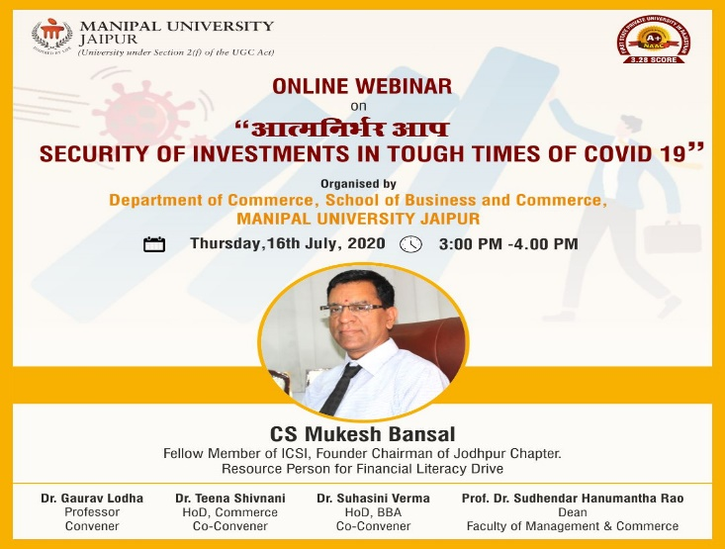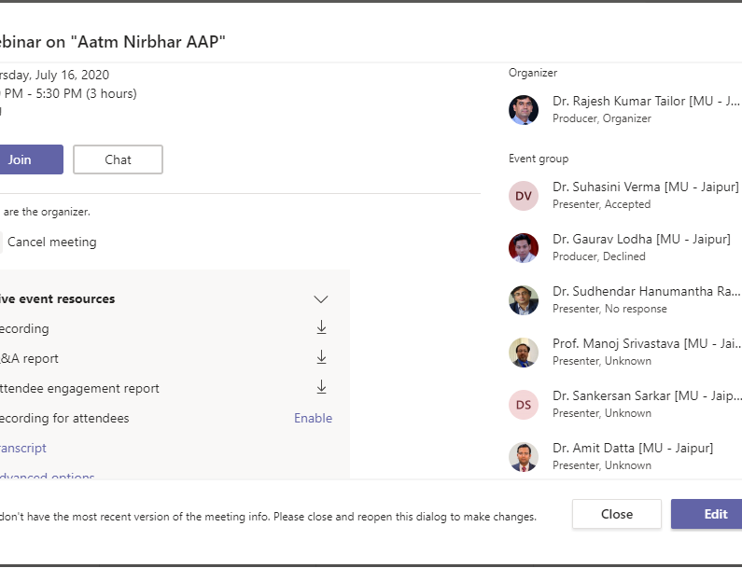

**ATTENDANCE**

"आत्म निर्भर आप-SECURITY OF INVESTMENTS IN TOUGH TIMES OF COVID 19"

(**16th July.’ 2020, Thursday**)

|  |  |  |  |
| --- | --- | --- | --- |
| **S.No.** | **Candidate Name** | **Mobile** | |
| 1 | Dr. Gaurav Lodha | gaurav.lodha@jaipur.manipal.edu |  |
| 2 | Ram saini | admin@MUJ327.onmicrosoft.com |  |
| 3 | Dr. Gaurav Lodha | gaurav.lodha@jaipur.manipal.edu |  |
| 4 | Dr. Rajesh Kumar Tailor | rajeshkumar.tailor@jaipur.manipal.edu |  |
| 5 | Arun Gautam | aryan20gautam_gmail.com#EXT#@manipaleducations.onmicrosoft.com |  |
| 6 | Dr. Ravindra R Kaikini | ravindrar.kaikini@jaipur.manipal.edu | |
| 7 | Trilok Kumar Jain | trilok.jain@jaipur.manipal.edu |  |
| 8 | Dr. Ity Patni | ity.patni@jaipur.manipal.edu |  |
| 9 | Nishu Gupta | nishu.gupta@jaipur.manipal.edu |  |
| 10 | Sunny Dawar | sunny.dawar@jaipur.manipal.edu |  |
| 11 | Priyanka Budania | priyanka.200906602_muj.manipal.edu#EXT#@manipaleducations.onmicrosoft.com |  |
| 12 | Savita Panwar | savita.panwar@jaipur.manipal.edu |  |
| 13 | Sunny Dawar | sunny.dawar@jaipur.manipal.edu |  |
| 14 | Dr. Bhawna Chahar | bhawna.chahar@jaipur.manipal.edu |  |
| 15 | Dr. Birajit Mohanty | birajit.mohanty@jaipur.manipal.edu |  |
| 16 | Dr. Ity Patni | ity.patni@jaipur.manipal.edu |  |
| 17 | JaiPrakash Mishra | deepsm1984_gmail.com#EXT#@manipaleducations.onmicrosoft.com |  |
| 18 | Dr. Saurabh Sharma | drsaurabh.sharma@jaipur.manipal.edu |  |
| 19 | Dr. Somya Choubey | somya.choubey@jaipur.manipal.edu |  |
| 20 | Dr. Archana Poonia | archana.poonia@jaipur.manipal.edu |  |
| 21 | Sunishtha Dhaka | sunishtha.dhaka@jaipur.manipal.edu |  |
| 22 | Mahesh Jampala | mahesh.jampala@jaipur.manipal.edu |  |
| 23 | Priyanka Sharma | priyanka.sharma@jaipur.manipal.edu |  |
| 24 | Sonal Sidana | sonal.sidana@jaipur.manipal.edu |  |
| 25 | Shilpa Joshi | shilpa.joshi@jaipur.manipal.edu |  |
| 26 | Ram saini | admin@MUJ327.onmicrosoft.com |  |
| 27 | Dr. Ity Patni | ity.patni@jaipur.manipal.edu |  |

**FEEDBACK**

"आत्म निर्भर आप-SECURITY OF INVESTMENTS IN TOUGH TIMES OF COVID 19"

(**16th July.’ 2020, Thursday**)

|  |
| --- |
| Feedback |
| It's useful. |
| Perfect!!! It's was a great experience. |
| Good |
| Great Job |
| Best and we'll knowledgeable |
| It was good. |
| Excellent |
| Excellent |
| THANK YOU, SIR |