cid:image001.png@01D3CCBE.2100A7E0

**Two Days Workshop On**

**“How To Create Wealth”**

**By Bombay Stock Exchange Institute Ltd.**

**School of Business and Commerce**

**MUJ**

**5-6th of October 2020**

**Mr. Pulock Bhattacharji, Resource Person, (VP & Head, Business Development BSE)**

**Mr. Sachin Agarwal, Resource Person, (Technical Analyst & Star Faculty, BSE)**

**Dr. Tanushree Sharma, Convenor, School of Business and Commerce, MUJ**

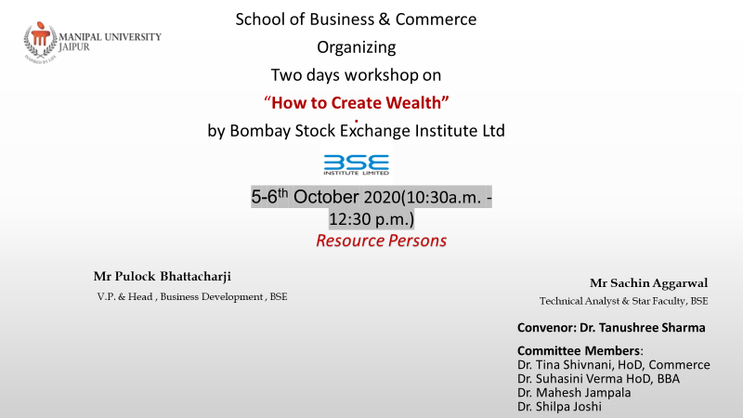

**MANIPAL UNIVERSITY JAIPUR**

**School of Business and Commerce**

**Two Days Workshop on "How To Create Wealth” by Bombay Stock Exchange Institute Ltd**

**(5-6th Oct.’ 2020, Monday-Tuesday)**

**REPORT**

**School of Business & Commerce Organized two days workshop on “How to Create Wealth” by Bombay Stock Exchange Institute Ltd. –** A two day workshop was organised by school of business and commerce on 5-6th October 2020. Mr Pulock Bhattacharji ,V.P. & Head , Business development , BSE and Mr Sachin Aggarwal ,Technical Analyst & Star Faculty, BSE were the speakers of the workshop. Dr. Tanushree Sharma was the convenor and Dr. Teena Shivnani , HOD, Commerce, Dr. Suhasini Verma, HOD, Business Administration, Dr Mahesh Jampala and Dr Shilpa Joshi were the committee members of this workshop.

On first day the topic of discussion was “Stock Market : A modern temple for Wealth creation " and the Speaker was Mr Pulock Bhattacharji . He is an experienced professional specialising in the BFSI sector where he has more than 30 years of hands on experience, both in India and abroad. Wealth creation is ultimately the process of creating and building a stable source of sustenance so that one would not have to struggle to make ends meet. In other words, one can live the aspirations. An individual’s smart and rationale financial decisions determine the value of wealth that he or she can create. Mr. Pullock spoke about basics of stock exchange, myths and reality, trends in stock exchange, growth trends in India and industry linked courses of BSE. Dr. Shilpa delivered vote of thanks.

On day 2 Topic of the session was “How to trade profitably in the Stock Market : Some simple and practical steps” and Speaker of the session was Mr Sachin Aggarwal , Technical Analyst & Star Faculty, BSE. He is a Chartered Accountant but due to his passion for Financial Markets he has dedicated his time and life to Financial Markets. He is Technical Analyst and Investor in Stock Markets, having vast experience of investing and trading in different testing times. He explained how to do online trading, economic, Fundamental and technical analysis and answered queries of participants. Dr. Mahesh Jampala delivered vote of thanks. Participants enjoyed their interesting way of teaching. We received huge response not only from students but from colleagues and friends. Two days workshop was very informative and enlightening for students

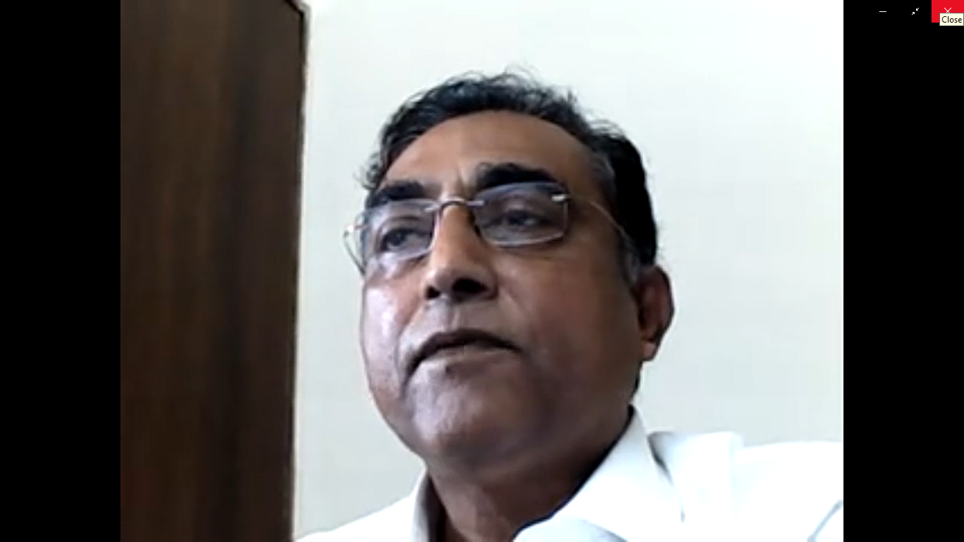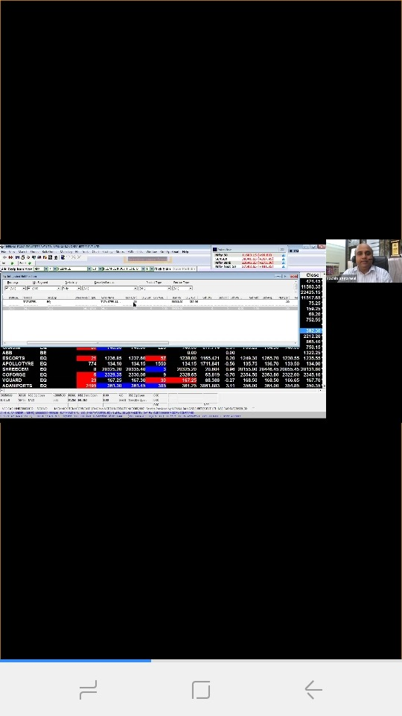

**Attendance Sheet**

|  |  |  |
| --- | --- | --- |
| S.No. | Name (Original Name) | User Email |
| 1 | Purti Balani | purtibalani@gmail.com |
| 2 | Nikhil Chugh | nikhilchugh1999@gmail.com |
| 3 | Pranjal Jain | jain.pranjal199@gmail.com |
| 4 | Purvit Jhanwar | purvitjhanwar@gmail.com |
| 5 | Gurusha Bagora | bagoragurusha@gmail.com |
| 6 | Tanushree Sharma | tanushree.sharma@jaipur.manipal.edu |
| 7 | Sanskar bansal | sanskarbansal82@gmail.com |
| 8 | Priyanshu Nandwana | priyanshu.nandwana26@gmail.com |
| 9 | Onkar Shukla | onkarshuklaa@gmail.com |
| 10 | Tushar Joshi | joshitushar97@gmail.com |
| 11 | Aditya Kakkad | kakkadaditya42@gmail.con |
| 12 | Vipin goyal | vipin.goyal117@gmail.com |
| 13 | Vashu dev Mehra | vashumehra0951@gmail.com |
| 14 | Dikshant Ganna | dikshantganna123@gmail.com |
| 15 | Anirudh Singh Shekhawat | anirudh.180901022@muj.manipal.edu |
| 16 | shrey jain | shreyjain162@gmail.com |
| 17 | Ankush Ahuja | ankushahuja306@gmail.com |
| 18 | Aditya Goyal | goyaladitya32@gmail.com |
| 19 | shalu soni | shalusoni833@gmail.com |
| 20 | Anand Singh | singhanand6207@gmail.com |
| 21 | dushyant devgun | dushyant.devgun@gmail.com |
| 22 | Ujjaval Legha | ujjavallegha@gmail.com |
| 23 | mahesh jampala | mahesh.jampala@jaipur.manipal.edu |
| 24 | Shubham Agarwal | ashubham80@gmail.com |
| 25 | Girish Meena | girish.180901026@muj.manipal.edu |
| 26 | Vishveshwar Choudhary | vishveshwar09@gmail.com |
| 27 | Abhishek Patodi | jainabhi2504@gmail.com |
| 28 | BSE Institute Ltd | custcollege@gmail.com |
| 29 | Ashish Bhati | mnsibabu@gmail.com |
| 30 | vishesh chopda | visheshchopda2420@gmail.com |
| 31 | GOONJ sethi | goonjsethi18@gmail.com |
| 32 | Anuj Bansal | bansalanuj923@gmail.com |
| 33 | Laksh Goswami | lakshgoswami34@gmail.com |
| 34 | Arnab Banerjee | arnabanerjee01@gmail.com |
| 35 | Asif Sohel | asifsohel21@gmail.com |
| 36 | Sahil Jain | mr.sahilzain@gmail.com |
| 37 | kanishk tyagi | kanishk.tyagi313@gmail.com |
| 38 | Daksh Sindal | dakshsindal0987@gmail.com |
| 39 | priyam dowerah | priyam6@gmail.com |
| 40 | Milan Singh | milansingh963@icloud.com |
| 41 | Devendra | rathoredevendra2000@gmail.com |
| 42 | Harsh Jindal | harshjindal2998@gmail.com |
| 43 | Yashwin Sharma | yashwin.sharma2000@gmail.com |
| 44 | Rahul Sharma | rahul28098@gmail.com |
| 45 | Aditi Bansal | baditi100@gmail.com |
| 46 | Kashish | kashish.180903018@muj.manipal.edu |
| 47 | Sumit Rathore | mearthiyarathore456@gmail.com |
| 48 | Laxmi Gurjar | laxmigurjar2299@gmail.com |
| 49 | Gaurav goyal | grvgoyal99@gmail.com |
| 50 | Jai Vardhan Singh Rathore | jai.rathhore.28@gmail.com |
| 51 | Suddhendu DasMahapatra | suddm.kgp@gmail.com |
| 52 | GAGAN JAIN | gagan.jain@jaipur.manipal.edu |
| 53 | Himanshu Medatwal | hssharma8854@gmail.com |
| 54 | Gourang Papriwal | gourangjain4@gmail.com |
| 55 | Bhagyashree Taparia | bhagu0410@gmail.com |
| 56 | Luv Anand | luva9655@gmail.com |
| 57 | Poorva Bhardwaj | poorva2276@gmail.com |
| 58 | RAHUL SONI | asmirahulsoni1999@gmail.com |
| 59 | yashaswani kathuria | kathuriayashaswani@gmail.com |
| 60 | Piyush Yadav | nypd9876@gmail.com |
| 61 | Arpan Agrawal | arpanagrawal14@gmail.com |
| 62 | Ankit kumar | ankit1234kumar@gmail.com |
| 63 | Dr. Umesh Solanki | umesh.solanki@jaipur.manipal.edu |
| 64 | Alok Anand | kvalokanand24@gmail.com |
| 65 | Deepesh Khanchandani | deepeshkhanchandani.80@gmail.com |
| 66 | Ayush Sharma | sharmaayush37596@gmail.com |
| 67 | Kush Anand | kush.anand00@gmail.com |
| 68 | Abhishek Jha | avijha67@gmail.com |
| 69 | Devesh Rawat | devesh.180901167@muj.manipal.edu |
| 70 | Anusha Masuna | anunitie@gmail.com |
| 71 | Anish Menon | anish.180903017@muj.manipal.edu |
| 72 | Nikhil Nain | nikhil.180901037@muj.manipal.edu |
| 73 | sachin aggarwal | sachinstockview@gmail.com |
| 74 | Misal Agarwal | misalagarwal@gmail.com |
| 75 | Naman Madhwani | namanmadhwani@gmail.com |
| 76 | Abhay Rajawat | abhayrajawat013@gmail.com |
| 77 | Vaibhav Kalra | vaibhavkalra719@gmail.com |
| 78 | shivang duggal | shivang.duggal5@gmail.com |
| 79 | Ritvik jain | jainritvik23@gmail.com |
| 80 | Sakshi Jain | sakshijain1712@gmail.com |
| 81 | Arpit Pareek | pareek.arpit09@gmail.com |
| 82 | Mohd Rizwanullah | mohd.rizwanullah@jaipur.manipal.edu |
| 83 | Devika Khurana | dekhurana@gmail.com |
| 84 | Rajat Bansal | rajat.180903043@muj.manipal.edu |
| 85 | Aditya Mani | jinkasama12345@gmail.com |
| 86 | Vijay Jhurani | vijay.jhurani@gmail.com |
| 87 | DIVYANSHEE YADAV | divyanshee.180901189@muj.manipal.edu |
| 88 | Arushi Agrawal | arushiagrawal764@gmail.com |
| 89 | Mehak Jain | mehakjain2000.mj@gmail.com |
| 90 | Shantam Sahai | sahai.shantam123@gmail.com |
| 91 | Yash Khandelwal | ykkhandelwal0002@gmail.com |
| 92 | Aanshita Pandey | aanshitap@gmail.com |
| 93 | Anshika Jadoun | anshikajadoun@gmail.com |
| 94 | Syed zeeshan | syedzeeshanmoinusmani@gmail.com |
| 95 | ashi khandelwal | ashi991khandelwal@gmail.com |
| 96 | Ketan Baid | ketanbaid50@gmail.com |
| 97 | Vaibhav Kumar | vaibhav.kumar2308@gmail.com |
| 98 | Om Agarwal | omagarwal2001@gmail.com |
| 99 | Hritik Gupta | hritik655@gmail.com |
| 100 | Khushboo Wadhwani | khushboowadhwani.12@gmail.com |
| 101 | Ritik Bansal | ritikbansal24sept1998@gmail.com |
| 102 | Sidhesh Aggarwal | sidhesh.aggarwal20@gmail.com |
| 103 | AMOGH CHHABRA | amoghchhabra46@gmail.com |
| 104 | Rohit agarwal | rohitagarwal101999@gmail.com |
| 105 | Nandini Sharma | nandini12.2000@gmail.com |
| 106 | Pulkit | pulkitgoyal789@gmail.com |
| 107 | UTI Mutual Funds | aikanshigupta6@gmail.com |
| 108 | Dhruv Bhargava | dhruv1311@gmail.com |
| 109 | Kanishk mittal | kanishkmittal21@gmail.com |
| 110 | Apratim kumar singh | apratimsingh786@gmail.com |
| 111 | Gyaneshwar Chandnani | nik.chandnani@gmail.com |
| 112 | Chirag Lalwani | chirag.180901067@muj.manipal.edu |
| 113 | Aryam bhargava | aryambhargava2006@gmail.com |
| 114 | Rudransh pratap Singh | rudranshsingh438@gmail.com |
| 115 | Aayush Singhal | aayushsinghal99@gmail.com |
| 116 | Ankit Singh Rathore | ankit.180902031@muj.manipal.edu |
| 117 | Nikhil Sharma | nikhil95211@gmail.com |
| 118 | Mohit Sharma | mhtms939@gmail.com |
| 119 | Shashank Umare | shashankumare@gmail.com |
| 120 | Abhimanyu Surana | abhimanyu1900@gmail.com |
| 121 | Priyam Ahuja | priyamahuja14@gmail.com |
| 122 | Prayan P Gupta | prayangupta28.pg@gmail.com |
| 123 | Avinav Handique | avihandique@yahoo.com |
| 124 | Rishabh Sapra | rishabh.sapra99@gmail.com |
| 125 | Himanshu Gadia | himanshugadia80@gmail.com |
| 126 | Harshita Vyas | harshita.7.vyas@gmail.com |
| 127 | Rishabh Raj | rishabh.180901096@muj.manipal.edu |
| 128 | Dhruva pratap Bishnoi | dhruvapratapbishnoi29@gmail.com |
| 129 | Jayti Upadhyay | 18jaytiupadhyay18@gmail.com |
| 130 | Aditya Kakkad | kakkadaditya42@gmail.com |
| 131 | Jayesh Gurnani | jayeshgurnani110@gmail.com |
| 132 | Pratik Moolchandani | pratik.moolchandani10@gmail.com |
| 133 | Amay Choukse | amay.180901048@muj.manipal.edu |
| 134 | Priyam Mukerjee | priyammukerjee12345@gmail.com |
| 135 | Vardhini Gupta | guptavardhini@gmail.com |
| 136 | Atharv Gupta | atharv.gupta1@gmail.com |
| 137 | shailly kothari | shallyjain21@gmail.com |
| 138 | himanshu patidar | himpatidar1520@gmail.com |
| 139 | Dhruva pratap Bishnoi | dhruva.180901035@muj.manipal.edu |
| 140 | Varun more | morevarun3@gmail.com |
| 141 | Anvaya Vyas | anvaya.av@gmail.com |