Heading  (2-7 words) | Expert Lecture Series under Decennial year Celebration, Manipal University Jaipur
Author  (Department name) | Department of Commerce
Caption  (1-2 lines) | Department of Commerce under Decennial year Celebration organized an online Expert Lecture on the Topic “Emerging issues under Income Tax Laws”.
Main Body | On 24th May 2022, an expert lecture was organized via virtual mode at 11.30 AM onwards by the School of Business and Commerce, Manipal University Jaipur. The Expert Speaker of the event was CA Rinkesh Devnani, Partner BSR and Company LLP which is the affiliate to KPMG. The objective of the event was to acquaint the students about the latest developments in the field of Taxation and the challenges being faced by the taxation system in the Indian and foreign perspective. More than 80 participants participated in this virtual event.  On this occasion, Cmde (Dr.) Jawahar Mal Jangir, Provost and Director of SBC, MUJ conveyed their message to all. Dr. Gaurav Lodha Convened the session.  Vote of thanks was expressed by Dr. Saurabh Sharma, HoD, Department of Commerce.
Images | 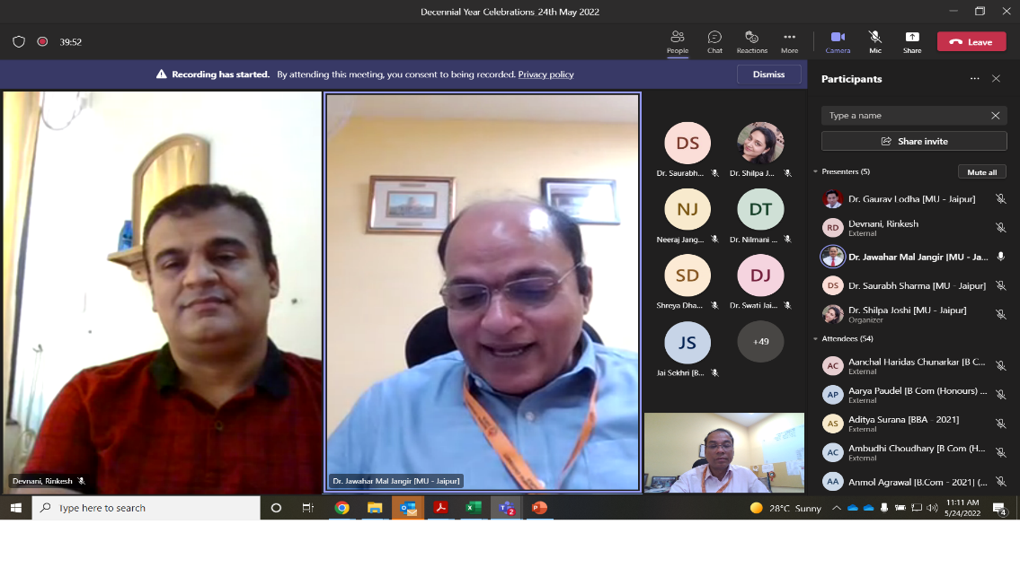  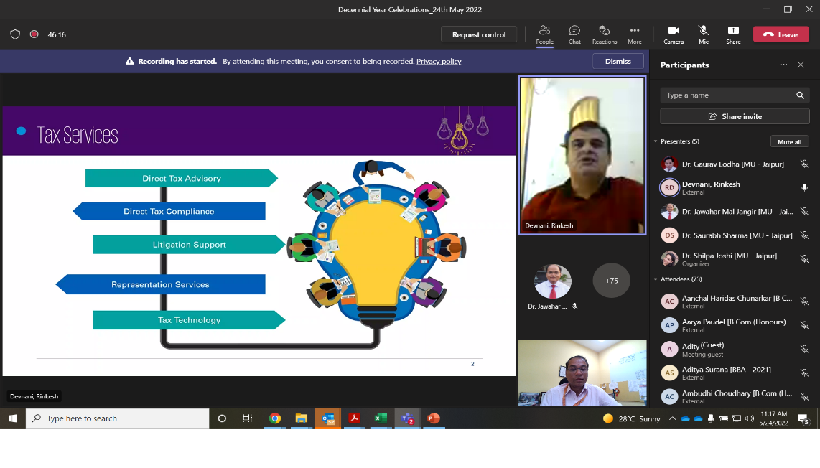
Video URL | https://manipaleducations.sharepoint.com/sites/DecennialYearCelebrations_24thMay2022/Shared%20Documents/General/Recordings/Decennial%20Year%20Celebrations_24th%20May%202022-20220524_105429-Meeting%20Recording.mp4?web=1

Attendance:
Full Name | User Action | Timestamp
Dr. Shilpa Joshi [MU - Jaipur] | Joined | 5/24/2022, 10:48:00 AM
Dr. Gaurav Lodha [MU - Jaipur] | Joined before | 5/24/2022, 10:48:00 AM
Atharva Sachindra Daine [BBA - 2021] | Joined before | 5/24/2022, 10:48:00 AM
Dr. Jawahar Mal Jangir [MU - Jaipur] | Joined | 5/24/2022, 10:48:33 AM
Dr. Jawahar Mal Jangir [MU - Jaipur] | Left | 5/24/2022, 10:50:16 AM
Dr. Jawahar Mal Jangir [MU - Jaipur] | Joined | 5/24/2022, 10:50:39 AM
Dr. Jawahar Mal Jangir [MU - Jaipur] | Left | 5/24/2022, 10:50:57 AM
Dr. Jawahar Mal Jangir [MU - Jaipur] | Joined | 5/24/2022, 10:53:05 AM
Dr. Saurabh Sharma [MU - Jaipur] | Joined | 5/24/2022, 10:53:07 AM
Ishika Sarda [B.Com (Honours In Accounting) - 2020] (Guest) | Joined | 5/24/2022, 10:55:16 AM
Ishika Sarda [B.Com (Honours In Accounting) - 2020] (Guest) | Left | 5/24/2022, 10:55:19 AM
Ishika Sarda [B.Com (Honours In Accounting) - 2020] (Guest) | Joined | 5/24/2022, 10:55:49 AM
Ishika Sarda [B.Com (Honours In Accounting) - 2020] (Guest) | Left | 5/24/2022, 11:10:24 AM
Vandit Lodha [B.Com (Honours In Accounting) - 2020] (Guest) | Joined | 5/24/2022, 10:55:21 AM
Dr. Nilmani Tripathi (Guest) | Joined | 5/24/2022, 10:57:05 AM
Shreya Dharan [B.COM (HONOURS) - 2019] (Guest) | Joined | 5/24/2022, 10:59:41 AM
Devnani, Rinkesh | Joined | 5/24/2022, 11:00:38 AM
Dr. Swati Jain [MU - Jaipur] | Joined | 5/24/2022, 11:01:25 AM
Dr. Nupur Ojha [MU - Jaipur] | Joined | 5/24/2022, 11:02:31 AM
Dr. Nupur Ojha [MU - Jaipur] | Left | 5/24/2022, 11:08:44 AM
Dr. Nupur Ojha [MU - Jaipur] | Joined | 5/24/2022, 11:09:00 AM
Jai Sekhri [B Com (Honours) In Accounting - 2021] | Joined | 5/24/2022, 11:03:18 AM
Dr. Suhasini Verma [MU - Jaipur] | Joined | 5/24/2022, 11:03:26 AM
Dr. Suhasini Verma [MU - Jaipur] | Left | 5/24/2022, 11:11:52 AM
Varsha Agrawal [B Com (Honours) In Accounting - 2021] | Joined | 5/24/2022, 11:03:36 AM
Pranali Premraj Pisal [B Com (Honours) In Accounting - 2021] | Joined | 5/24/2022, 11:03:45 AM
Pratibha Keswani [B Com (Honours) In Accounting - 2021] | Joined | 5/24/2022, 11:03:57 AM
Ms. Savita Panwar [MUJ] | Joined | 5/24/2022, 11:04:25 AM
Ambudhi Choudhary [B Com (Honours) In Accounting - 2021] | Joined | 5/24/2022, 11:04:27 AM
arza1481 (Guest) | Joined | 5/24/2022, 11:04:31 AM
Ms. Nishu Gupta [MUJ] | Joined | 5/24/2022, 11:04:33 AM
Nistha Sethia [B Com (Honours) In Accounting - 2021] | Joined | 5/24/2022, 11:04:38 AM
Mamta Soni [MU - Jaipur] | Joined | 5/24/2022, 11:04:45 AM
Prerana Singh [B Com (Honours) In Accounting - 2021] | Joined | 5/24/2022, 11:04:50 AM
Simran Kaur Arora [B Com (Honours) In Accounting - 2021] | Joined | 5/24/2022, 11:04:54 AM
Hemant Sharma [B Com (Honours) In Accounting - 2021] | Joined | 5/24/2022, 11:04:54 AM
Palak Chouhan [BBA - 2021] | Joined | 5/24/2022, 11:04:58 AM
Palak Chouhan [BBA - 2021] | Left | 5/24/2022, 11:07:12 AM
Riya Lohia [B Com (Honours) In Accounting - 2021] | Joined | 5/24/2022, 11:05:00 AM
Neeraj Jangid [B Com (Honours) In Accounting - 2021] | Joined | 5/24/2022, 11:05:22 AM
Kashish Jain [BBA - 2021] | Joined | 5/24/2022, 11:05:28 AM
Ashish Saini [B Com (Honours) In Accounting - 2021] | Joined | 5/24/2022, 11:05:28 AM
Divyansh Gaur [B Com (Honours) In Accounting - 2021] | Joined | 5/24/2022, 11:05:34 AM
Shreyansh Tayal [B Com (Honours) In Accounting - 2021] | Joined | 5/24/2022, 11:05:35 AM
Shreyansh Tayal [B Com (Honours) In Accounting - 2021] | Left | 5/24/2022, 11:07:35 AM
Shreyansh Tayal [B Com (Honours) In Accounting - 2021] | Joined | 5/24/2022, 11:07:48 AM
Shreyansh Tayal [B Com (Honours) In Accounting - 2021] | Left | 5/24/2022, 11:08:05 AM
Shreyansh Tayal [B Com (Honours) In Accounting - 2021] | Joined | 5/24/2022, 11:08:09 AM
Harsh Kumar Singh [B Com (Honours) In Accounting - 2021] | Joined | 5/24/2022, 11:05:51 AM
Avani Goenka [B Com (Honours) In Accounting - 2021] | Joined | 5/24/2022, 11:05:57 AM
Siddharth Jalan [B.Com - 2021] | Joined | 5/24/2022, 11:06:38 AM
Shruti Singh [B Com (Honours) In Accounting - 2021] | Joined | 5/24/2022, 11:06:41 AM
Shruti Singh [B Com (Honours) In Accounting - 2021] | Left | 5/24/2022, 11:08:44 AM
Shruti Singh [B Com (Honours) In Accounting - 2021] | Joined | 5/24/2022, 11:10:21 AM
Navya Khetan [BBA - 2021] | Joined | 5/24/2022, 11:06:53 AM
Nitesh Gupta [B Com (Honours) In Accounting - 2021] | Joined | 5/24/2022, 11:07:05 AM
Jani Manan Manishkumar [B Com (Honours) In Accounting - 2021] | Joined | 5/24/2022, 11:07:06 AM
Aarya Paudel [B Com (Honours) In Accounting - 2021] | Joined | 5/24/2022, 11:07:25 AM
Aditya Surana [BBA - 2021] | Joined | 5/24/2022, 11:07:25 AM
Prem Raj [B Com (Honours) In Accounting - 2021] | Joined | 5/24/2022, 11:07:36 AM
Bipasha Kar [B.Com - 2021] (Guest) | Joined | 5/24/2022, 11:07:38 AM
Arnav Agarwal [BBA - 2021] (Guest) | Joined | 5/24/2022, 11:07:43 AM
Anmol Agrawal [B.Com - 2021] (Guest) | Joined | 5/24/2022, 11:07:45 AM
Anmol Agrawal [B.Com - 2021] (Guest) | Left | 5/24/2022, 11:08:08 AM
Anmol Agrawal [B.Com - 2021] (Guest) | Joined | 5/24/2022, 11:08:44 AM
Alok Mehta [BBA - 2021] | Joined | 5/24/2022, 11:07:45 AM
Alok Mehta [BBA - 2021] | Left | 5/24/2022, 11:07:54 AM
Kanika Mahajan [BBA - 2021] (Guest) | Joined | 5/24/2022, 11:07:46 AM
Aanchal Haridas Chunarkar [B Com (Honours) In Accounting - 2021] | Joined | 5/24/2022, 11:08:35 AM
Nikhil Naredi [BBA - 2021] | Joined | 5/24/2022, 11:08:43 AM
Nikhil Naredi [BBA - 2021] | Left | 5/24/2022, 11:10:02 AM
Khushiram Jagati [B.Com - 2021] | Joined | 5/24/2022, 11:08:47 AM
Karan Pratap Singh Rathore [B.Com - 2021] | Joined | 5/24/2022, 11:09:37 AM
Kaveri Khandelwal [BBA - 2021] | Joined | 5/24/2022, 11:10:05 AM
Neha Rajawat [B.Com - 2021] | Joined | 5/24/2022, 11:10:07 AM
Palak Agarwal [B Com (Honours) In Accounting - 2021] | Joined | 5/24/2022, 11:10:27 AM
Nidit Jain [B.Com - 2021] | Joined | 5/24/2022, 11:10:28 AM
Bharti Singh [B.Com - 2021] (Guest) | Joined | 5/24/2022, 11:10:30 AM
Pooja Kumawat [B.Com - 2021] | Joined | 5/24/2022, 11:10:31 AM
Harsh Bansal [B Com (Honours) In Accounting - 2021] | Joined | 5/24/2022, 11:10:39 AM
Vyom [B. Com (Honours) Accounting- 2021] | Joined | 5/24/2022, 11:10:42 AM
Dr. Somya Choubey [MUJ] | Joined | 5/24/2022, 11:10:45 AM
Kartik Khatri [B Com (Honours) In Accounting - 2021] | Joined | 5/24/2022, 11:11:09 AM
Mayank Tyagi Bhardwaj [BBA - 2021] | Joined | 5/24/2022, 11:11:19 AM
anirudhjain3456@gmail.com (Guest) | Joined | 5/24/2022, 11:11:29 AM
anirudhjain3456@gmail.com (Guest) | Left | 5/24/2022, 11:12:07 AM
anirudhjain3456@gmail.com (Guest) | Joined | 5/24/2022, 11:12:19 AM
Jay Sharma [BBA - 2021] | Joined | 5/24/2022, 11:11:37 AM
Ishika Khandelwal [B Com (Honours) In Accounting - 2021] | Joined | 5/24/2022, 11:11:41 AM
Kartikey Gupta [BBA - 2021] | Joined | 5/24/2022, 11:11:51 AM
Mahak Nagori [BBA - 2021] | Joined | 5/24/2022, 11:12:07 AM
Nitin Kumar Sharma [BBA - 2021] | Joined | 5/24/2022, 11:12:19 AM

