MUJ/Q&C/021/F/1.01 Event Report Format

Faculty of Management & Commerce

School of Business & Commerce

Department of Commerce & Directorate of Alumni Relations

Alumni Talk series

28th April 2022

- Introduction of the Event
Technical Chapter of Department of Commerce in association with Directorate of Alumni Relations, Manipal University Jaipur organized an alumni talk on “Auditing and Assurance” on 28th April from 12:00 Noon – 01:00 PM.

- Objective of the Event

The aim of this lecture was to make the students aware about present trends in Auditing and Assurance.

- Beneficiaries of the Event

This talk was organized for the students B.Com (Hons.) in accounting 2019 - 2022 to make them aware Auditing and Assurance.

- Details of the Guests
Daniya Beg is an alumnus of B.Com (Hons) (Accounting) Department of Commerce of pass out batch 2020 and Gold Medalist. She is presently working as an Assurance Associate at Ernst & Young GLOBAL DELIVERY SERVICES and ACCA Affiliate.

- Brief Description of the event
The session was started by the welcome speech given by Dr Jampala Maheshchandra Babu, Alumni Coordinator (B.Com) Hons, Department of Business Administration. Dr Jawahar Jangir, Director, School of Business and Commerce and Dr DrSushil Kumar Jain Director, Directorate of Alumni Relations welcomed her, and provided insights about the EY GDS company.

Daniya beg explained the thin line between academics and industry. Daniya Beg explained the complete working process of Ernst & Young GLOBAL DELIVERY SERVICES and provided detailed insights into the different services provided by the company like Financial Accounting, Advisory Services and Forensic & Integrity Services. She emphasized the placement centric focus and how the ACCA helps get placed.

Daniya Beg motivated students for effective time management and stressed clearing all the ACCA papers in one go rather than taking a break, and explained what skills are required for students to choose the big four companies. She also provided tips on management time and how to focus on clearing different modules of ACCA. The session ended with a question-answer and vote of thanks by Teena Shivnani and Dr Saurabh Sharma.

Dr Jawahar Jangir, Director, School of Business and Commerce and Dr Sushil Jain, Director, Directorate of Alumni Relations had concluded the session by providing the moment to Mrs Daniya Beg. The Session ended with a group photograph with all the students.

- Photographs of the event

Welcome of Daniya Beg by Alumni coordinator
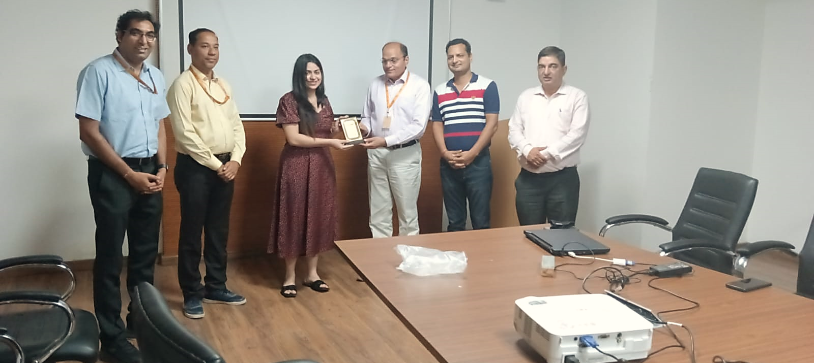
Welcome by Director, School of Business and Commerce
Solving student queries about ACCA
Memomto by Director, SBC and Director, DoAR
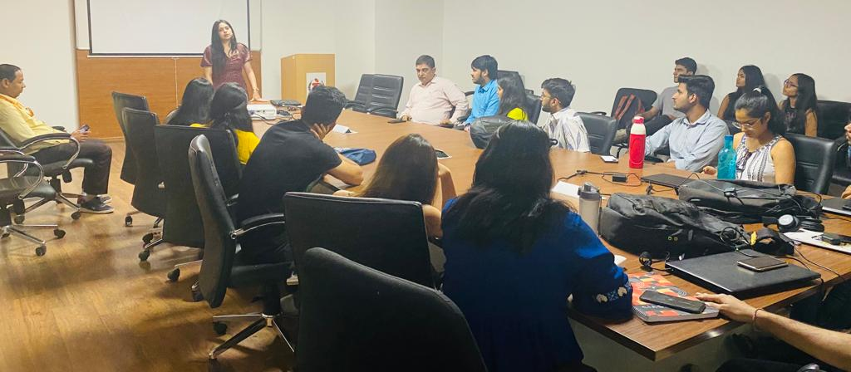
Interacting with B.Com (Hons) Final year students

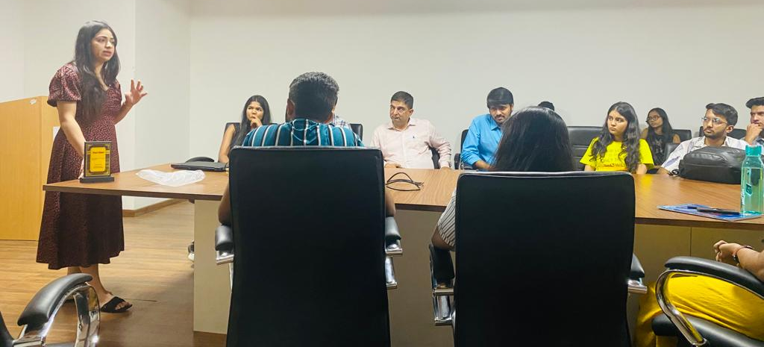
Sharing the knowledge about Auditing and Assurance Process at EY

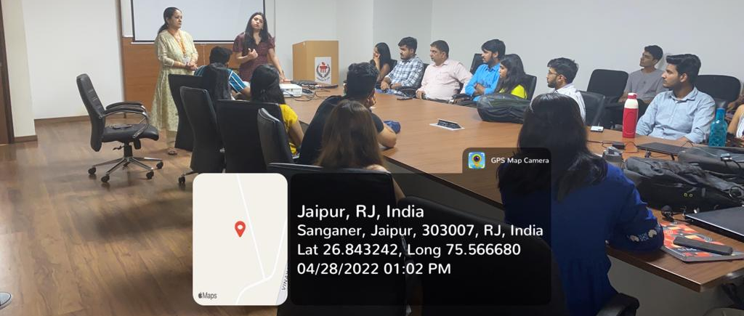

Momento to alumni by Director, DoAR and Head, Department of Commerce
Vote of Thanks by Dr Teena Shivnani

Group Photograph with Alumni

Group Photograph

- Brochure or creative of the event (insert in the document only)
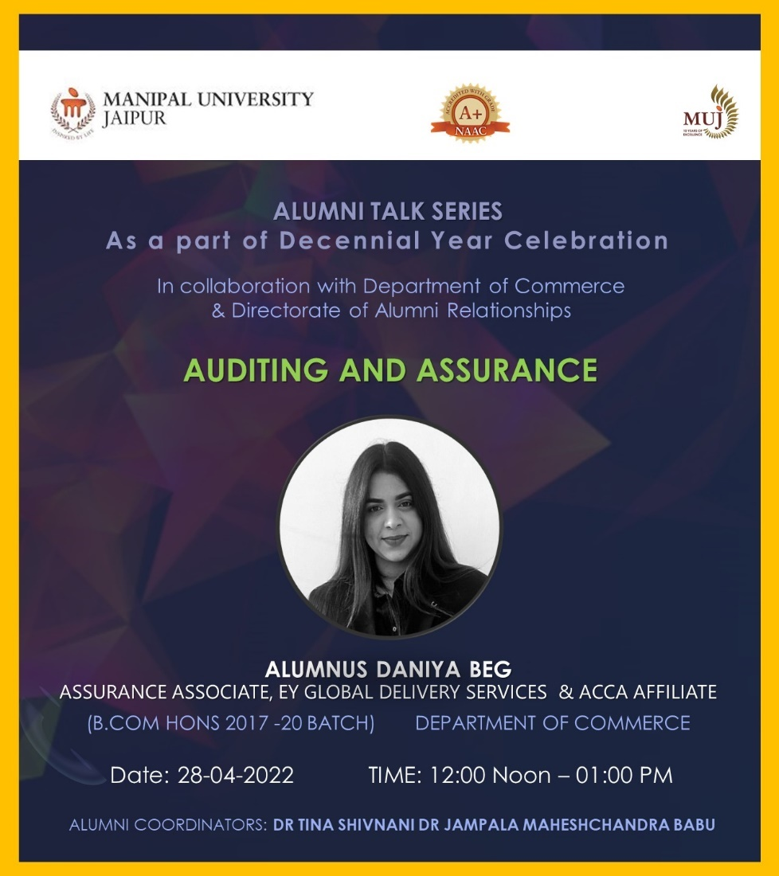
- Schedule of the event (insert in the report)
The talk was conducted on 28th April 2022 from 12:00 noon – 01:00 PM.
- Attendance of the Event :- Total attendee:- 24
Sr. No | Registration Number/Employee code | Name of Attendee | Name of Dept | E- Mail ID
1 | 190903001 | TUSHAR KHANDELWAL | Commerce | tushar.190903001@muj.manipal.edu
2 | 190903002 | SARVANSH SINHA | Commerce | sarvansh.190903002@muj.manipal.edu
3 | 190903003 | JEMIMA MARY MATHEW | Commerce | jemima.190903003@muj.manipal.edu
4 | 190903004 | NEHA SINGH RATHORE | Commerce | neha.190903004@muj.manipal.edu
5 | 190903005 | SANYA KANWAR | Commerce | sanya.190903005@muj.manipal.edu
6 | 190903006 | ABHIGYAN GUPTA | Commerce | abhigyan.190903006@muj.manipal.edu
7 | 190903007 | ISHPREET SINGH WALIA | Commerce | ishpreet.190903007@muj.manipal.edu
8 | 190903008 | VATSAL RASTOGI | Commerce | vatsal.190903008@muj.manipal.edu
9 | 190903009 | HRITHIK BHARADWAJ | Commerce | hrithik.190903009@muj.manipal.edu
10 | 190903010 | ASHUTOSH MAHARSHI | Commerce | ashutosh.190903010@muj.manipal.edu
11 | 190903011 | ARPAN MISHRA | Commerce | arpan.190903011@muj.manipal.edu
12 | 190903012 | KAUSAL AGARWAL | Commerce | kausal.190903012@muj.manipal.edu
13 | 190903013 | SHREYA DHARAN | Commerce | shreya.190903013@muj.manipal.edu
14 | 190903014 | MEGHNA DHURIYA | Commerce | meghna.190903014@muj.manipal.edu
15 | 190903015 | YASHVARDHAN TIWARI | Commerce | yashvardhan.190903015@muj.manipal.edu
16 | 190903016 | JAHNAVI SINGH | Commerce | jahnavi.190903016@muj.manipal.edu
17 | 190903020 | AYUSH BOTHRA | Commerce | ayush.190903020@muj.manipal.edu
18 | 190903021 | PRITAM MILAN LASKAR | Commerce | pritam.190903021@muj.manipal.edu
19 | 190903022 | SAMBHAV GARG | Commerce | sambhav.190903022@muj.manipal.edu
20 | 200903026 | ISHIKA AGARWAL | Commerce | Ishika.200903026@muj.manipal.edu
21 | 200903029 | VANDIT LODHA | Commerce | Vandit.200903029@muj.manipal.edu
22 | 210903053 | DEVANSH | Commerce | devansh.210903053@muj.manipal.edu
23 | 210903051 | MUKUL RAJENDRA HARSH | Commerce | mukul.210903051@muj.manipal.edu
24 | 210903076 | PALAK AGARWAL | Commerce | palak.210903076@muj.manipal.edu
78 | 210903084 | SUKHNOOR SINGH | Commerce | sukhnoor.210903084@muj.manipal.edu
79 | 210903067 | TANISHQA HASIJA | Commerce | tanishqa.210903067@muj.manipal.edu

- Link of MUJ website stating the event is uploaded on website -

