MUJ/Q&C/021/F/1.01 Event Report Format

Faculty of Management & Commerce

School of Business & Commerce

Department of Commerce & Directorate of Alumni Relations

Alumni Talk series

25th April 2022

- Introduction of the Event
Technical Chapter of Department of Commerce in association with Directorate of Alumni Relations, Manipal University Jaipur organized an alumni talk on “ACCA and its future prospects” on 25th April 2022 from 10:30 AM – 11:30 AM.

- Objective of the Event

The aim of this lecture was to make the student aware challenges faced by the ACCA aspirants and what are its prospects.
- Beneficiaries of the Event

This talk was organized for the students B.Com (Hons.) in accounting 2021 - 2024 to make them aware ACCA, its application and future prospects.

- Details of the Guests
Ms. Kashish Agarwal (180903018) is alumni of B. Com (Hons) passed out batch 2018-2021, was the resource person of the Talk. She is presently working as an associate at Alternative Funds Sudrania Fund Services Corporation in Jaipur Branch.
- Brief Description of the event
The session was started by the welcome speech given by Dr Jampala Maheshchandra Babu, Alumni Coordinator (B.Com) Hons, Department of Business Administration. Dr Saurabh Sharma (HoD Commerce) have also welcome Ms. Kashish Agarwal for her interaction with new joined first year students. She started the session by explaining her journey with MUJ. She explained the various challenged faced by the students perusing the ACCA.

She emphasised the complete processes right from choosing the right job to enrolling the perspectives once completed the ACCA. she delivered the lecture on the ACCA and its future prospects to the B.Com (Hons) first year students. She emphasized on the challenges for clearing the ACCA and stressed on the use of Excel and importance of the soft skills, email writing in the industry. She provided the overview of the various prospects and job opportunities after clearing the ACCA courses. She also focused on the role of Manipal University Jaipur for building the career development and how the training will help to clear the ACCA at the university level itself. She provided the overview on ACCA portal and provided the entire list of the job profiles after clearing the ACCA. She stressed on the latest technologies like role big data in the Accounting and also provided the insights on the various online courses to learn the big data. The session was concluded by vote of thanks given by Dr. Tina Shivnani. Dr Sushil Jain, Director, Directorate of Alumni Relations had concluded the session by providing the moment to Mrs Kashish Agarwal. The Session ended with a group photograph with all the students.

- Photographs of the event

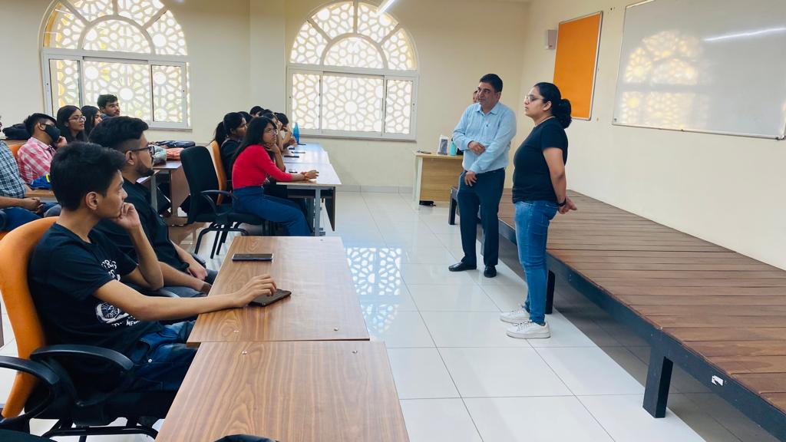
Welcome of Ms. Kashish Agarwal by HoD and Alumni coordinator

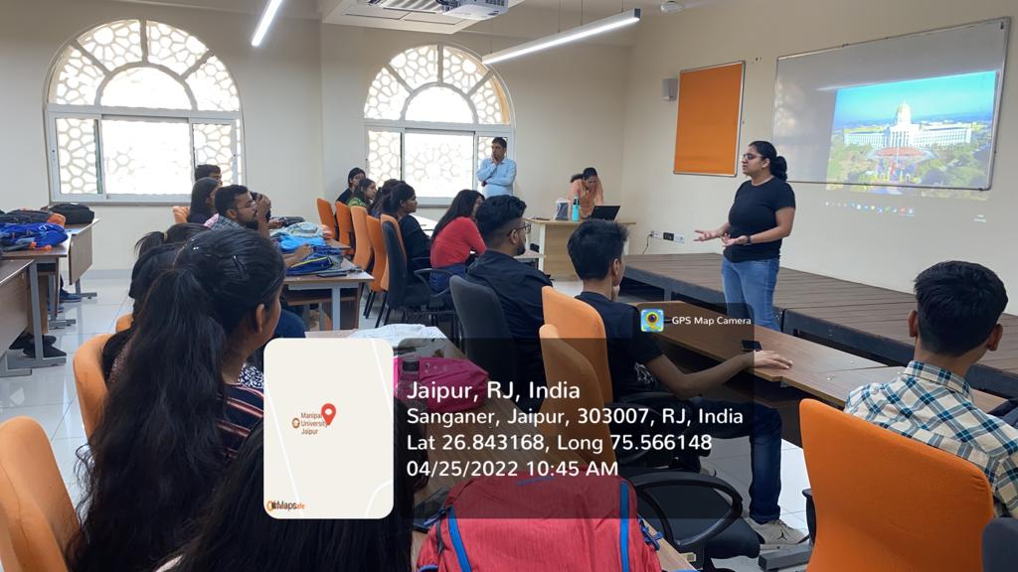
Interacting with B.Com (Hons) First year students
Solving student queries about ACCA

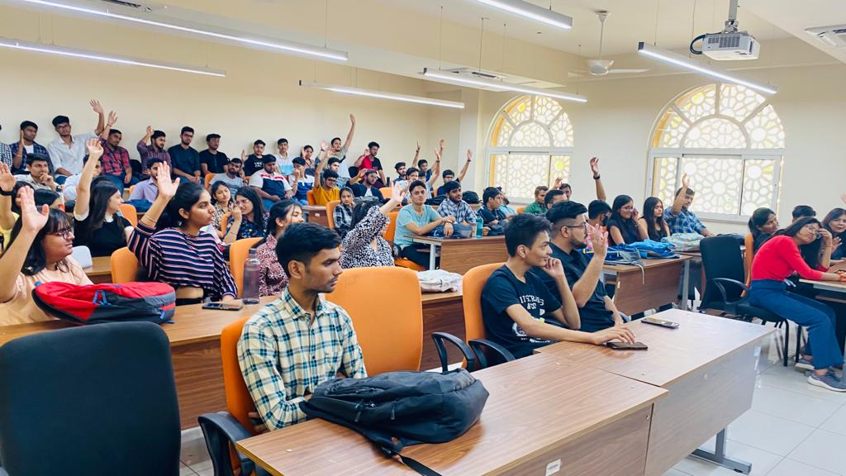
Interacting with B.Com (Hons) First year students

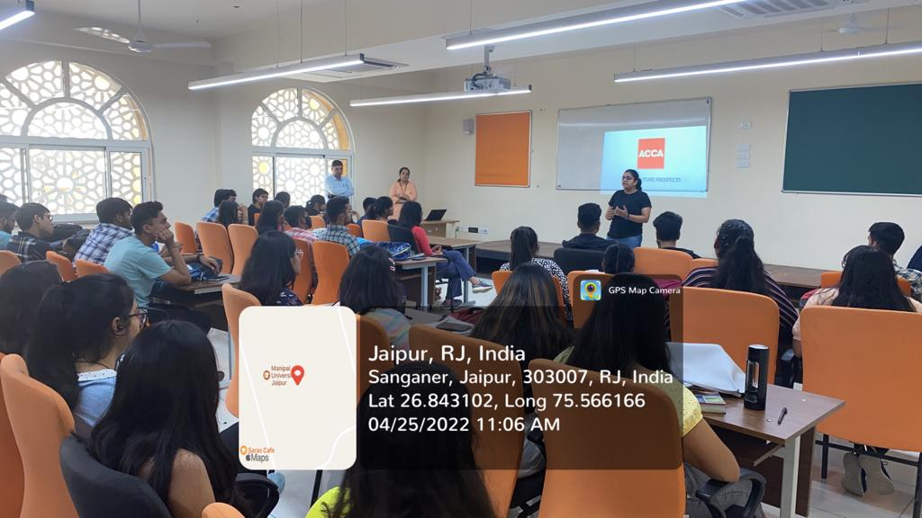
Sharing the knowledge about ACCA and its future prospects

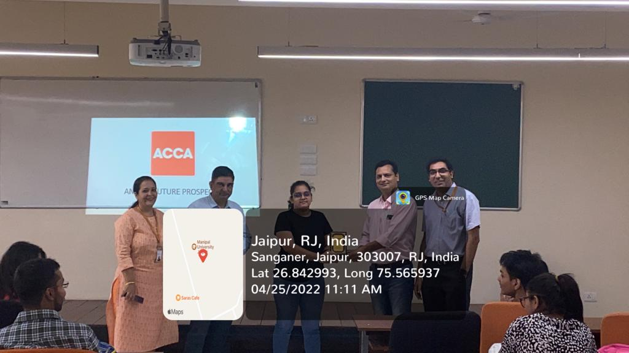
Momento to alumni by Director, DoAR and Head, Department of Commerce

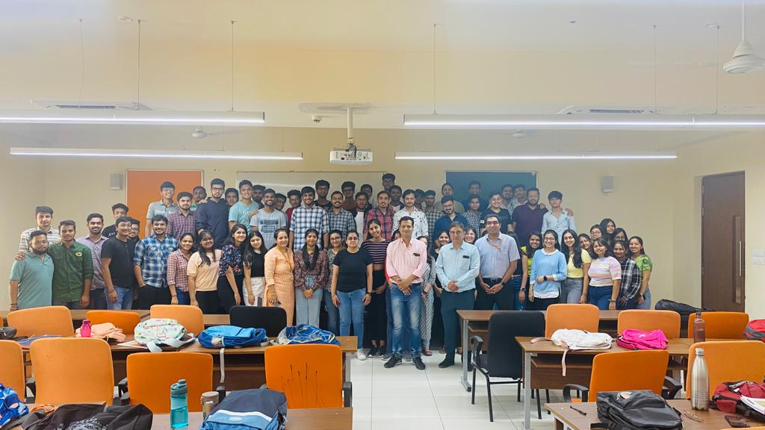

Group Photograph with Alumni

- Brochure or creative of the event (insert in the document only)
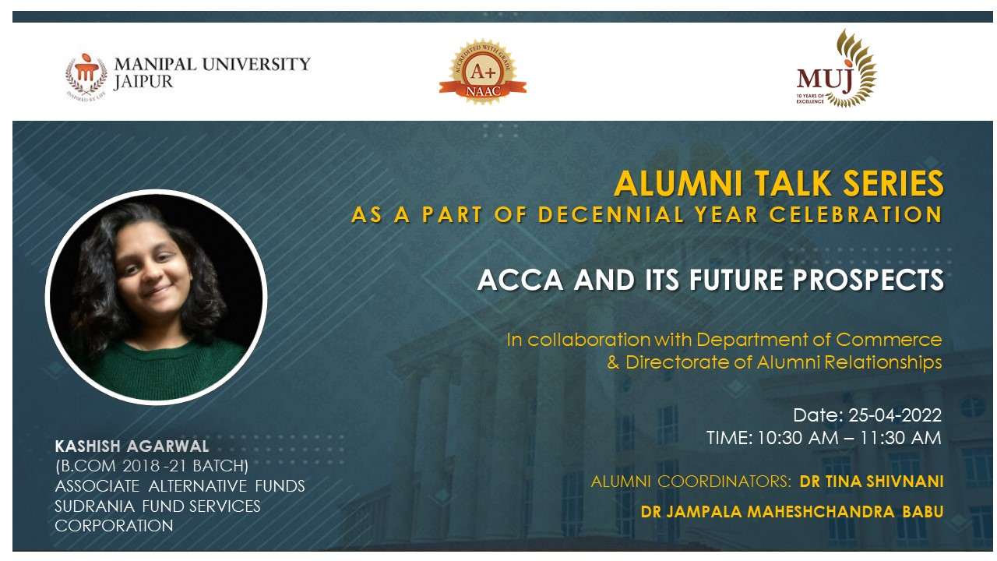
- Schedule of the event (insert in the report)
The talk was conducted on 25th April 2022 from 10:30 AM – 11:30 AM.
- Attendance of the Event :- Total attendee:- 79
Sr. No | Registration Number/Employee code | Name of Attendee | Name of Dept | E- Mail ID
1 | 210903002 | AARON VEERAMANA JOSEPH | Commerce | aaron.210903002@muj.manipal.edu
2 | 210903005 | AARYA PAUDEL | Commerce | aarya.210903005@muj.manipal.edu
3 | 210903034 | ADHIRAJ SINGH CHAUHAN | Commerce | adhiraj.210903034@muj.manipal.edu
4 | 210903037 | AHAMED ALI TALUKDAR | Commerce | ahamed.210903037@muj.manipal.edu
5 | 210903046 | AMBUDHI CHOUDHARY | Commerce | ambudhi.210903046@muj.manipal.edu
6 | 210903017 | ANKIT SINGH | Commerce | ankit.210903017@muj.manipal.edu
7 | 210903007 | ASHISH KUMAR | Commerce | ashish.210903007@muj.manipal.edu
8 | 210903020 | ASHISH SAINI | Commerce | ashish.210903020@muj.manipal.edu
9 | 210903039 | BHARAT MEENA | Commerce | bharat.210903039@muj.manipal.edu
10 | 210903021 | BHUMIKA V HIREMATH | Commerce | bhumika.210903021@muj.manipal.edu
11 | 210903028 | CHINMAY UPADHYAY | Commerce | chinmay.210903028@muj.manipal.edu
12 | 210903019 | DEEPAK SAHU | Commerce | deepak.210903019@muj.manipal.edu
13 | 210903026 | DIVYANSH GAUR | Commerce | divyansh.210903026@muj.manipal.edu
14 | 210903027 | FAISAL AGHA | Commerce | faisal.210903027@muj.manipal.edu
15 | 210903003 | FURQUAN AKHTAR | Commerce | furquan.210903003@muj.manipal.edu
16 | 210903010 | G NIKHIL KUMAR | Commerce | g.210903010@muj.manipal.edu
17 | 210903015 | HARSH BANSAL | Commerce | harsh.210903015@muj.manipal.edu
18 | 210903023 | HEMANT SHARMA | Commerce | hemant.210903023@muj.manipal.edu
19 | 210903036 | ISHAN SHARMA | Commerce | ishan.210903036@muj.manipal.edu
20 | 210903033 | ISHIKA KHANDELWAL | Commerce | ishika.210903033@muj.manipal.edu
21 | 210903004 | JANI MANAN MANISHKUMAR | Commerce | jani.210903004@muj.manipal.edu
22 | 210903009 | KASHISH SINGH | Commerce | kashish.210903009@muj.manipal.edu
23 | 210903016 | KUNAL KAPOOR | Commerce | kunal.210903016@muj.manipal.edu
24 | 210903024 | LAVANYA BAHRI | Commerce | lavanya.210903024@muj.manipal.edu
25 | 210903006 | NISTHA SETHIA | Commerce | nistha.210903006@muj.manipal.edu
26 | 210903030 | NITESH GUPTA | Commerce | nitesh.210903030@muj.manipal.edu
27 | 210903047 | PARTH MALPANI | Commerce | parth.210903047@muj.manipal.edu
28 | 210903041 | PRIYA JAIN | Commerce | priya.210903041@muj.manipal.edu
29 | 210903048 | PURAV BHAYANA | Commerce | purav.210903048@muj.manipal.edu
30 | 210903008 | RISHABH MANTRI | Commerce | rishabh.210903008@muj.manipal.edu
31 | 210903012 | RISHIKA JAIN | Commerce | rishika.210903012@muj.manipal.edu
32 | 210903031 | RIYA LOHIA | Commerce | riya.210903031@muj.manipal.edu
33 | 210903043 | SAMEER | Commerce | sameer.210903043@muj.manipal.edu
34 | 210903018 | SANSKRITI SHARMA | Commerce | sanskriti.210903018@muj.manipal.edu
35 | 210903029 | SARTHAK ANAND | Commerce | sarthak.210903029@muj.manipal.edu
36 | 210903045 | SATVIK TIBREWAL | Commerce | satvik.210903045@muj.manipal.edu
37 | 210903001 | SHANTANU VERMA | Commerce | shantanu.210903001@muj.manipal.edu
38 | 210903013 | SHARAT SALIL | Commerce | sharat.210903013@muj.manipal.edu
39 | 210903035 | SIMRAN KAUR ARORA | Commerce | simran.210903035@muj.manipal.edu
40 | 210903014 | SPARSH SAXENA | Commerce | sparsh.210903014@muj.manipal.edu
41 | 210903011 | TANISHA DOSHI | Commerce | tanisha.210903011@muj.manipal.edu
42 | 210903042 | TIJIL YADAV | Commerce | tijil.210903042@muj.manipal.edu
43 | 210903032 | YASH DANGI | Commerce | yash.210903032@muj.manipal.edu
44 | 210903044 | YASH KAPOOR | Commerce | yash.210903044@muj.manipal.edu
45 | 210903025 | YASHVI GUPTA | Commerce | yashvi.210903025@muj.manipal.edu
46 | 210903085 | AANCHAL HARIDAS CHUNARKAR | Commerce | aanchal.210903085@muj.manipal.edu
47 | 210903052 | AMIT SINGH | Commerce | amit.210903052@muj.manipal.edu
48 | 210903050 | ANJALI MODI | Commerce | anjali.210903050@muj.manipal.edu
49 | 210903062 | AVANI GOENKA | Commerce | avani.210903062@muj.manipal.edu
50 | 210903053 | DEVANSH | Commerce | devansh.210903053@muj.manipal.edu
51 | 210903064 | DHRUV JAIN | Commerce | dhruv.210903064@muj.manipal.edu
52 | 210903081 | DIKSHA GHIMIRE | Commerce | diksha.210903081@muj.manipal.edu
53 | 210903063 | ESHANK KUNTAL | Commerce | eshank.210903063@muj.manipal.edu
54 | 210903077 | HARSH KUMAR SINGH | Commerce | harsh.210903077@muj.manipal.edu
55 | 210903082 | JAI SEKHRI | Commerce | jai.210903082@muj.manipal.edu
56 | 210903074 | JATIN BANSAL | Commerce | jatin.210903074@muj.manipal.edu
57 | 210903056 | KARTIK KHATRI | Commerce | kartik.210903056@muj.manipal.edu
58 | 210903061 | KHUSHI GUPTA | Commerce | khushi.210903061@muj.manipal.edu
59 | 210903069 | LAKSHAY KATHURIA | Commerce | lakshay.210903069@muj.manipal.edu
60 | 210903049 | MANAN SACHDEVA | Commerce | manan.210903049@muj.manipal.edu
61 | 210903071 | MD AKRAM RAZA | Commerce | md.210903071@muj.manipal.edu
62 | 210903051 | MUKUL RAJENDRA HARSH | Commerce | mukul.210903051@muj.manipal.edu
63 | 210903054 | NEERAJ JANGID | Commerce | neeraj.210903054@muj.manipal.edu
64 | 210903076 | PALAK AGARWAL | Commerce | palak.210903076@muj.manipal.edu
65 | 210903072 | PRAGYA JAIN | Commerce | pragya.210903072@muj.manipal.edu
66 | 210903060 | PRAGYAN KISHOR | Commerce | pragyan.210903060@muj.manipal.edu
67 | 210903068 | PRATIBHA KESWANI | Commerce | pratibha.210903068@muj.manipal.edu
68 | 210903083 | PREM RAJ | Commerce | prem.210903083@muj.manipal.edu
69 | 210903065 | PRERANA SINGH | Commerce | prerana.210903065@muj.manipal.edu
70 | 210903086 | RISHIK SARAF | Commerce | rishik.210903086@muj.manipal.edu
71 | 210903055 | ROHIT KUMAR KUMAR | Commerce | rohit.210903055@muj.manipal.edu
72 | 210903070 | SANA GUPTA | Commerce | sana.210903070@muj.manipal.edu
73 | 210903080 | SANSKAR JODHWANI | Commerce | sanskar.210903080@muj.manipal.edu
74 | 210903073 | SHRUTI | Commerce | shruti.210903073@muj.manipal.edu
75 | 210903066 | SHRUTI SINGH | Commerce | shruti.210903066@muj.manipal.edu
76 | 210903075 | SIDDHANT GARG | Commerce | siddhant.210903075@muj.manipal.edu
77 | 210903059 | SUHANI TAYAL | Commerce | suhani.210903059@muj.manipal.edu
78 | 210903084 | SUKHNOOR SINGH | Commerce | sukhnoor.210903084@muj.manipal.edu
79 | 210903067 | TANISHQA HASIJA | Commerce | tanishqa.210903067@muj.manipal.edu

- News Publication- News printed in newspaper or online links if any for news – insert images) - NA

- Feedback of the Event (if obtained) – NIL

- Link of MUJ website stating the event is uploaded on website - NA

