FACULTY OF MANAGEMENT & COMMERCE

SCHOOL OF BUSINESS & COMMERCE

Department of Business Administration

Short Term Course on Goods and Service Tax
Date 25th April to 29th April 2022

- Introduction of the Event
Goods and Service Tax is the indirect tax levied by Government of India on all goods and services barring few exceptions. Since its inception in the year 2017, this act has been a major contention for people. The very dynamic nature of this act makes it even more trivial and complex. Every year amendments are being incorporated and the slabs also are not static. This makes the GST regime more complex and at the same time an important topic to have a knowledge and understanding. Keeping these in view and Short-Term Course on GST was conducted. The course was scheduled from 25th April to 29th April with Industry Experts as speakers and course instructors.
Expense and Income: (Note-sheet attached)
As proposed in the note-sheet.
Rs 100/- charged from the students of MUJ.
Rs 200/- Charged from candidates outside MUJ
Free for Faculty members of MUJ
A link for same was created by the finance department of the university.
Total 537 candidates paid fee out of which one candidate was non-MUJ candidate. Hence total income generated:
536 X 100 = 53600

1 X 200 = 200

Total 53800/- INR

As per the note-sheet 30% of receivables are to be paid to the speakers. Hence net payable 53800@30% = 16140/- INR. (Not paid yet)
The remaining amount shall be accounted for School of Law and School of Business and Commerce (50% each).
- Objective of the Event
To educate participants with basic objectives, and provisions of the GST Act
To educate the participants of basic terms in GST and their importance and application.
To educate the participants of compliance requisites for various businesses and services with respect to the GST regime
To educate the participants of various Government Scheme and policies with regards to exemptions and leverages under GST.
To give the participants the know-how of the GST Act.
Beneficiaries of the Event
The beneficiaries of the event were the students, faculty, and other staff of Manipal University Jaipur, and public.

- Details of the Guests
  - Speaker 1: CA Kshitiz Godika Ph.D. (EAFM), FCA, LLB, B.Com.
Mr. Godika is a fellow member of ICAI with 15 years standing experience in the profession. He is a certified Concurrent Auditor and has a certificate from NSFM and F&O. He is an Associate and founder of K. Godika and Associates a Chartered Accountant firm.
  - Speaker 2: CA Yatindra Kumar Gupta ACA, B.Com.
Mr. Yatindra is a fellow member of ICAI with 15 years standing in profession. Mr. Gupta has worked with the corporates like ERNST & YOUNG, PATNI COMPUTER SYSTEMS PVT LTD, RELIANCE GLOBALCOM LTD, DEUTSCHE BANK etc.

Brief Description of the event: the event was held:
Date: 25th to 29th April 2022
Mode: Virtual (Ms-Teams)

- Photographs of the event or screenshots of the event (if online) with captions
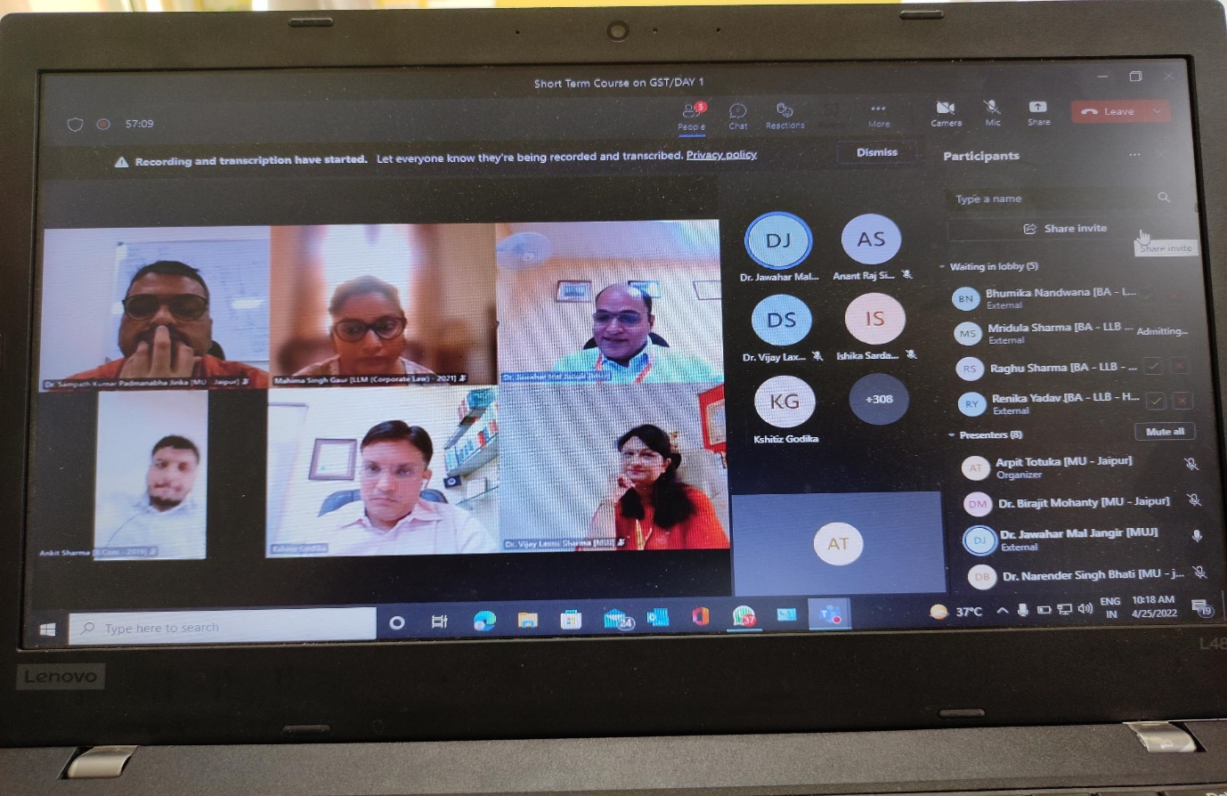
Day 1 opening of the event by Director SoL and Director SBC
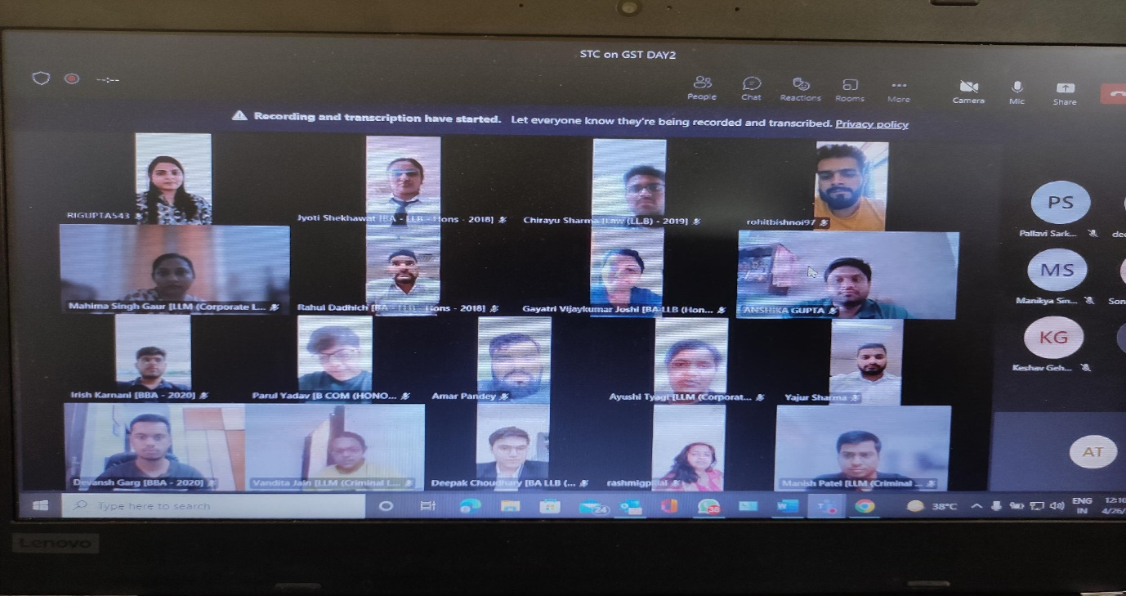
Audience attending the session on day 2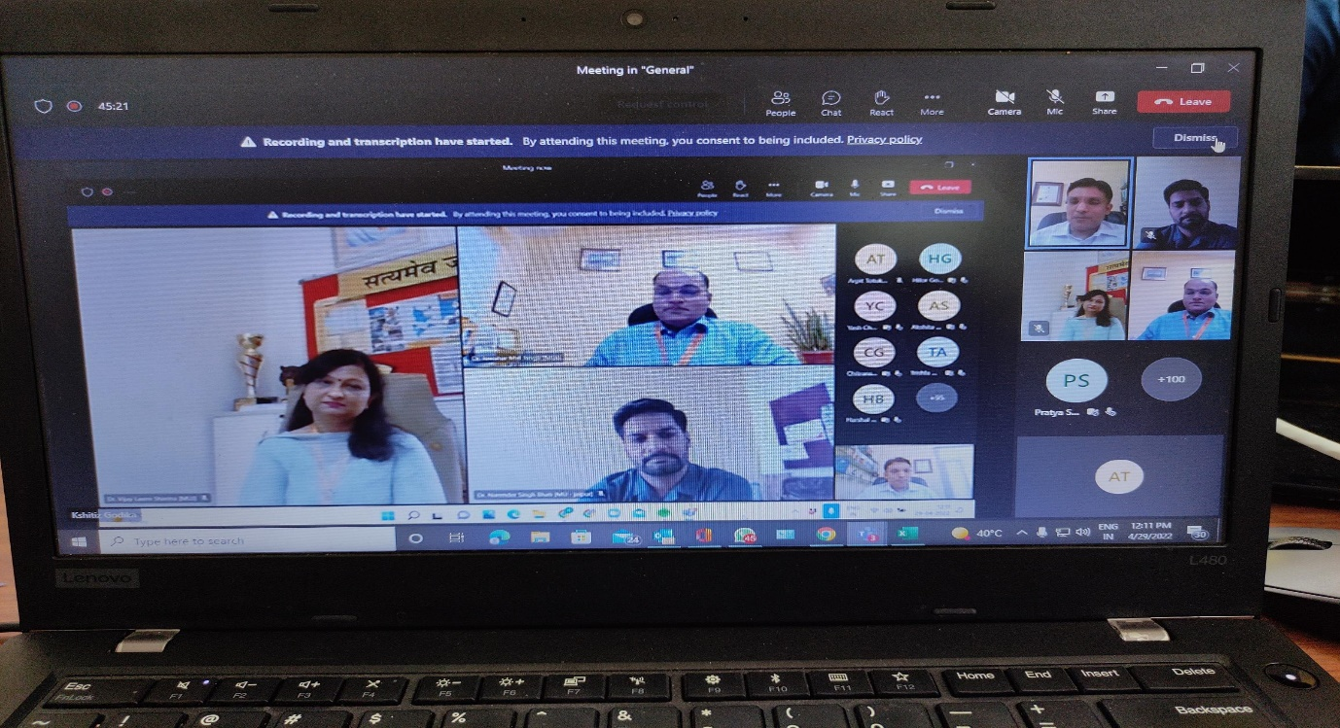
Director SoL and Director SBC rendering thank you address on completion of the event on Day 5

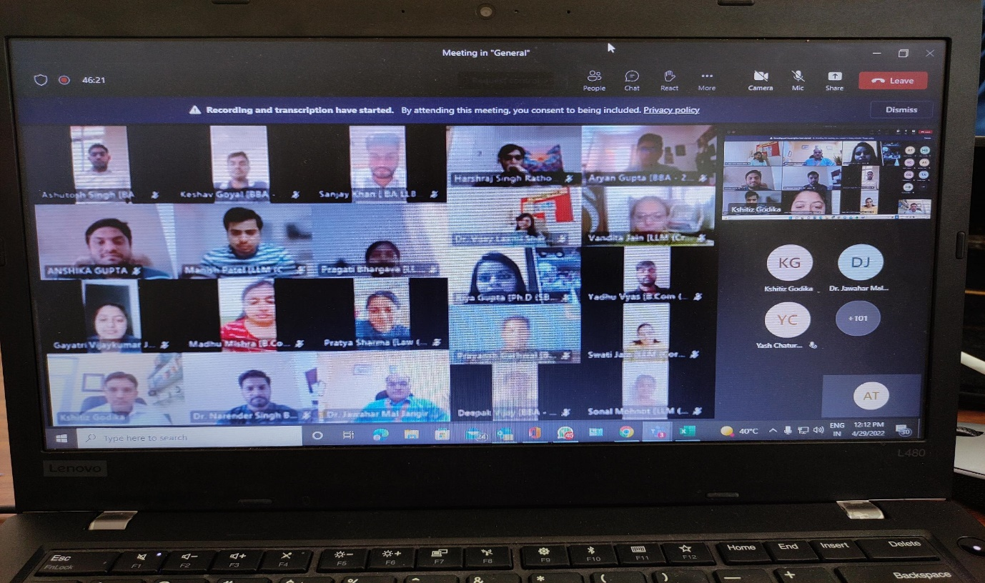
Image of Day 5 with Director SBC and Director SoL, attending the session

- Brochure of the Event:

- Schedule of the event (insert in the report)
25th to 29th April 2022

- Attendance of the Event :- Total attendee:- 33
https://mujmanipal-my.sharepoint.com/:x:/g/personal/muj1100_muj_manipal_edu/ETlB3a5mydxJi31jRVdDlpEBauu-ITmHQn21OgtD0TN9JA?e=VGESxF (List of enrolled participants received from finance department)

- Link of MUJ website stating the event is uploaded on website-

Annexure:

