EVENT REPORT
BY
BIOTECH CLUB MUJ
MANIPAL UNIVERSITY JAIPUR

POSTER-MAKING COMPETITION ON THE LATEST ADVANCEMENTS IN HEALTH, ENVIRONMENT, FOOD SECURITY, AND BIOLOGICAL SAFETY.

On 11th June 2022

Platform: Google Meet

- Web link:-
https://meet.google.com/wir-nzmd-iua

- Poster:- 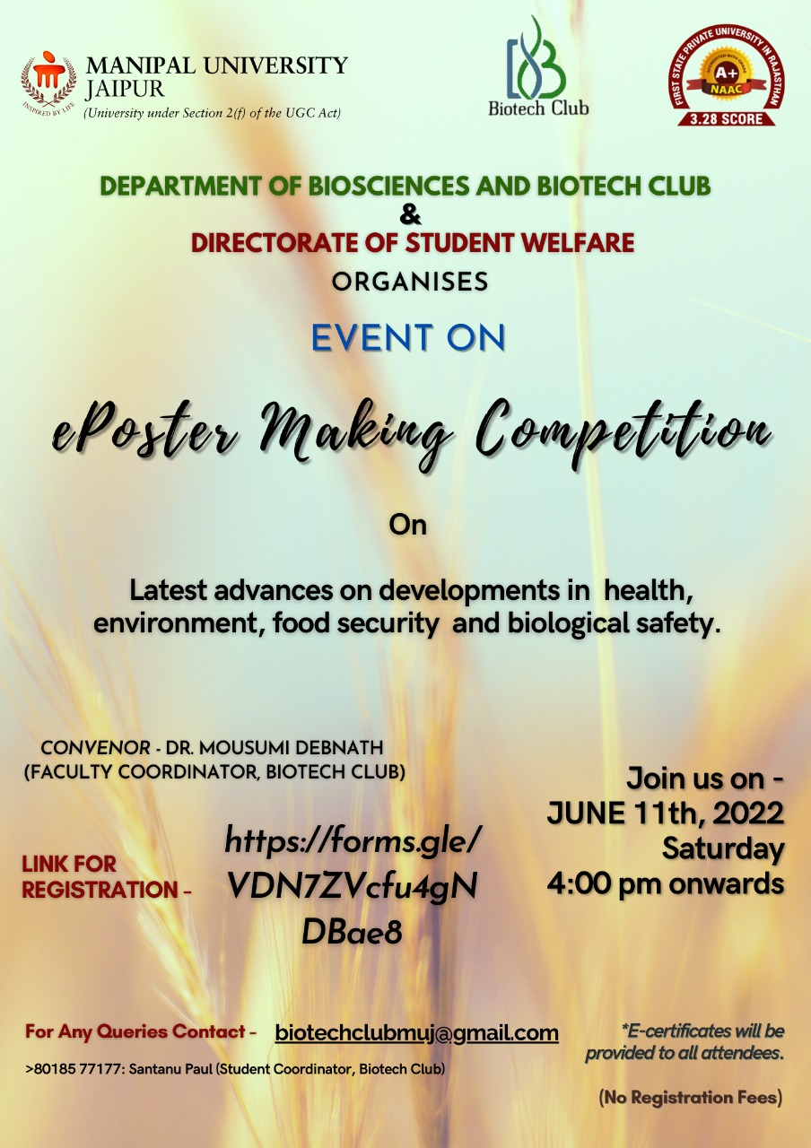

- Event schedule: -
The poster-making competition by the biotech club was conducted on 11th JUNE 2022, Saturday 4 pm onwards on the topic THE LATEST ADVANCEMENTS IN HEALTH, ENVIRONMENT, FOOD SECURITY, AND BIOLOGICAL SAFETY.

- Report of the event:-
The poster making competition was organised with a great zeal to generate a spirit of healthy competition amongst the participants accompanied by exapanding their knowledge and curiosity on the above mentioned topic and increase their presentation and explanation skills. These skills would help an individual to increase his/her confidence and character development and growth.

Mr. Libin Velloth and Dr. Mousumi Debnath were the judges of the event. Mr. Libin is a research oriented professional having 17+ years of experience with strong quality assuarance, technical expertise and business management skills and is currently working for Wipro Limited. He even enlightened the students with his own experiences from the industry and the qualities required to become a trained profession in the field of biotechnology and microbiology and readily answered any career related query proposed to him.

The event was hosted effectively and efficiently by Harsh Saxena (Head Editor, Biotech Club) and there were a total of 13 participants.

The contestants were asked to make the poster prior to the event and then explain their poster within 5-8 minutes. Each participant was asked questions by the judges for wherein they had to defend their idea and showcase their knowledge on the topic within 2 minutes. Participants were evaluated based on the content, creativity and design of their poster, their presentation and technical understanding, explanation, and clarity in their answers during the defence.

It was a proficient, interactive competition which focused on expressing one’s thoughts through creativity. The event was a success with full of enthusiastic participants ready to express their views and importance on the topic.
The posters ranged from various latest advancements in the field of science. Divya gave an excellent presentation on a recent ‘miracle cancer drug’ and its trials. And other concepts and advances were easily explained by other participants such as ‘methods to improve food security’ by Aayushi.
The evaluation was done very carefully and analytically by Mr. Libin Velloth and Dr. Mousumi Debnath and we were pleased to have them as a judges for the event.

The position secured by the students were as follows: -
1st position – Divya (MUJ)

2nd position – Anushka Singh (MUJ)

3rd position – Aayushi Thakkar (MUJ)
Shashank Goyal (MUJ)

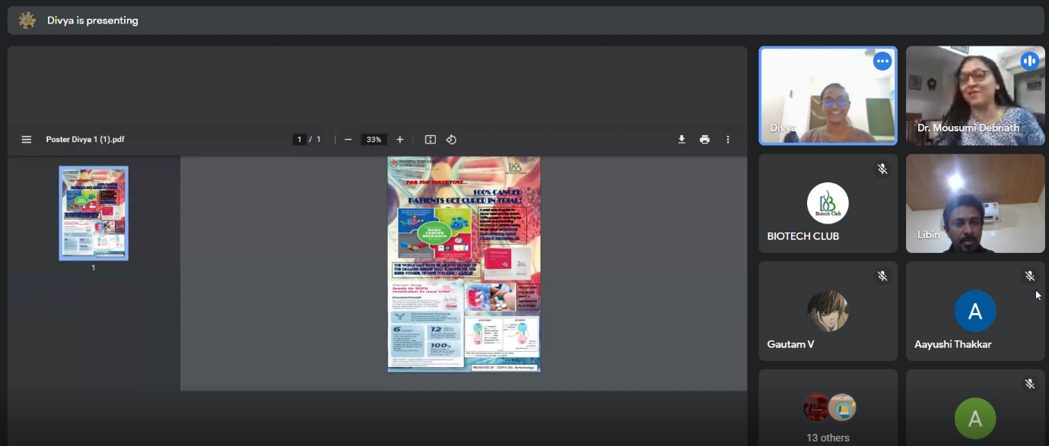

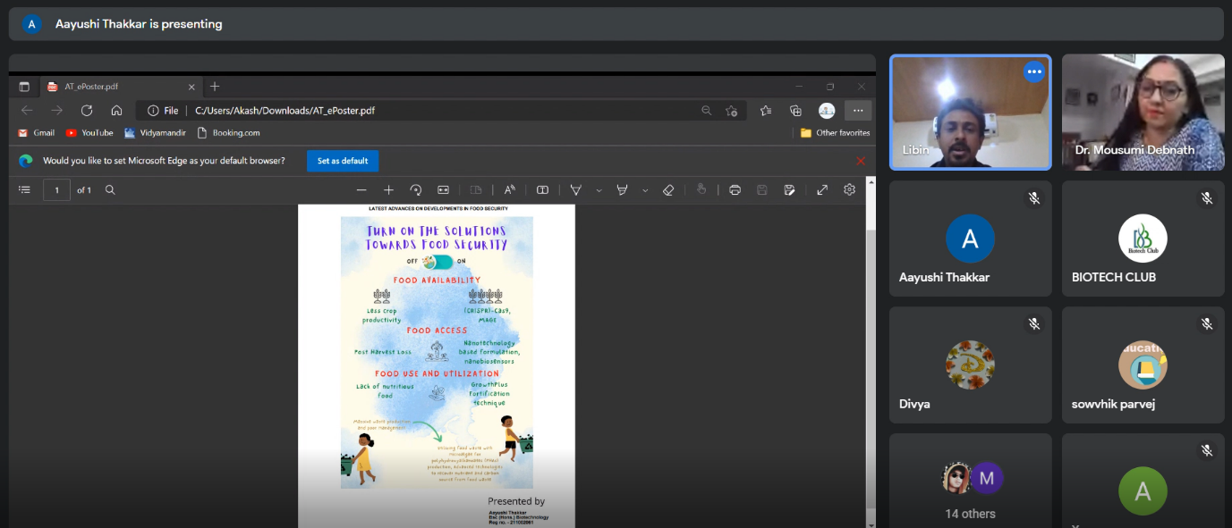
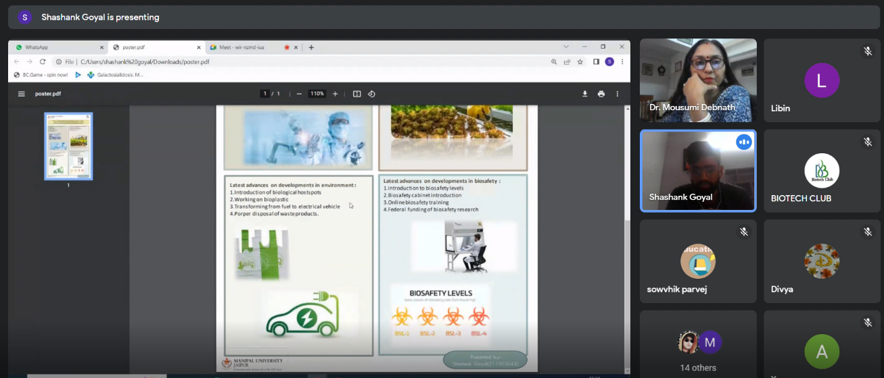

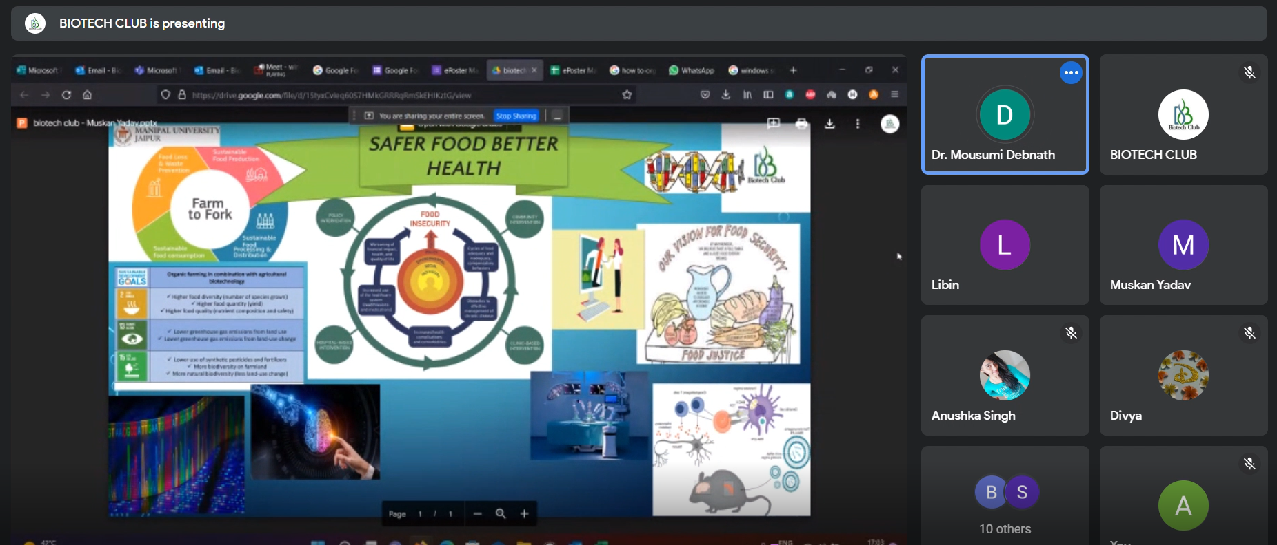

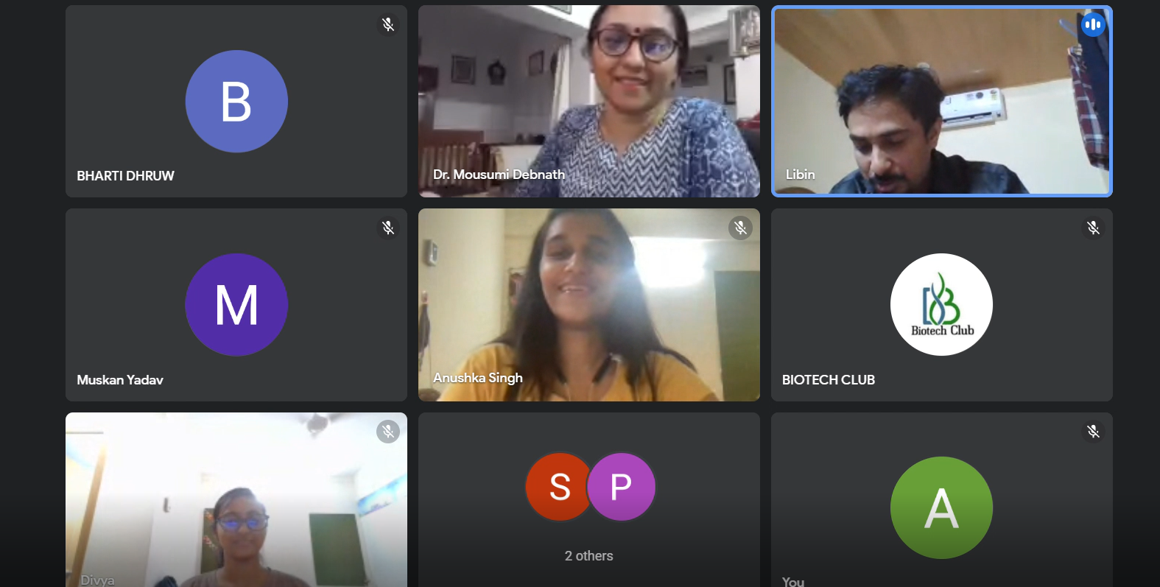

- Faculty coordinator:-

Dr. Mousumi Debnath- Department of biosciences

- Attendance sheet:- Attached along the report in excel sheet pdf file named “Attendance eposter”

