Event Report

by

(BIOTECH CLUB)

Manipal University Jaipur

[STARTUP WEBINAR]
[22th AUGUST 2020]

Platform: MS Teams

- Brochure of the Event

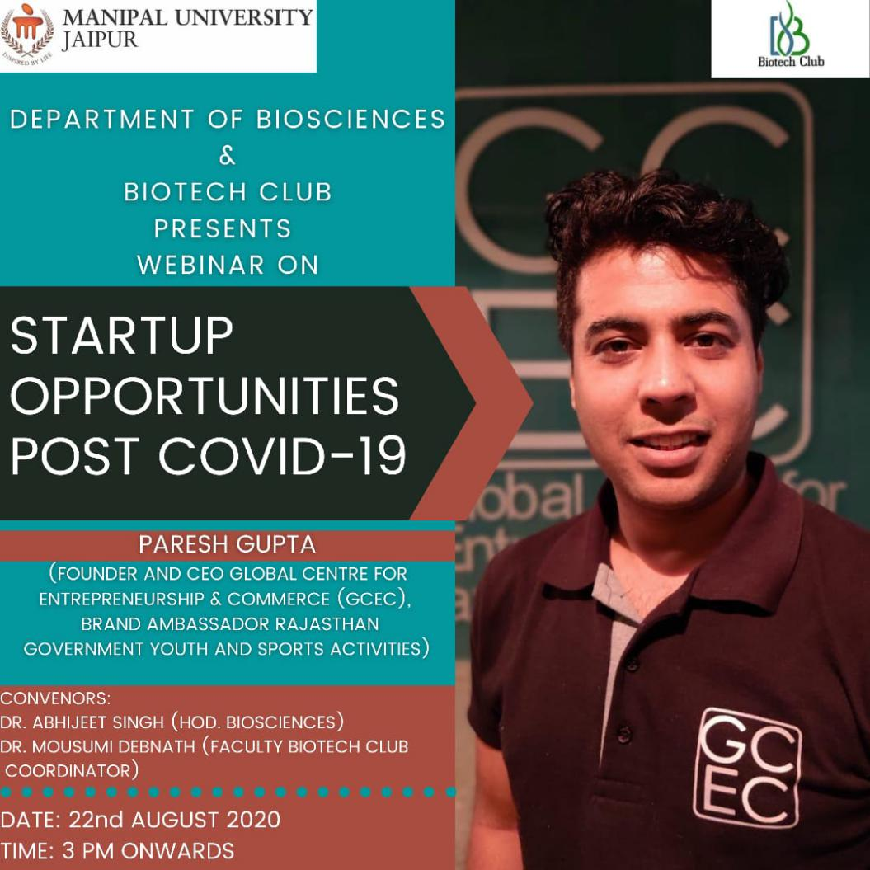
- Event schedule: The event was held on 22nd August 2020 from 3 pm onwards.

Report of the Event (Day wise Report of the event with screenshots/photographs)-

In the forum of 2020 MANIPAL UNIVETSITY JAIPUR again came with new event of seminar on 22 August 2020. This event was conducted by Department of Science in association with Biotech club. Keeping in the mind about the current situation of COVID-19 where millions of people are struggling to live in. Any inventory which we have should be used and any manoeuvre which we have should be applied. Due to current pandemic people are going through losses due to which the students are getting nervous. So at present they need to be bucked up and motivated. So under the guidance of Dr. Mousumi Debnath ( faculty coordinator biotech club) these event took place.
It was a great pleasure to welcome the very well known speaker MR. PARESH GUPTA (6 times TEDx Speaker, Founder and CEO Global Centre for Entrepreneurship & Commerce (GCEC), Brand Ambassador Rajasthan Government Youth and Sports activities and Brand Ambassador Rajasthan Tax Practitioners Association. Mentor to some of the world's best startup award winners, mentor at Startup-O Singapore, Viridian Espark Singapore, MNIT incubation centre, Advisory Board Member at Headstart Network, Startup Mentor and Advisor at CVS, NMIMS, Enactus KMC and many other institutions. The topic of seminar was kept by giving the importance to problems of faculty and students STARTUP OPPORTUNITIES POST COVID -19.

The event took place on a very successful note with proper decorum . The whole event was very inspirational and interesting too. But there are the points which require special highlights :
1. Importance of commercialisation.
2. Every problem comes with a new opportunities. Which u have to grab it smartly.
3. Copying isn't wrong but u need to apply it smartly with a little difference as facebook did.
4 . Before any initiative we should take proper guidance of experts in that field. So that we don't waste your time.
5.Don't give up in any situation.
There were series of question asked. As every good thing must come to and for a new beginning. These event also ended on a successful note. Due to active participation of our faculty :
- Dr. Prof (Dr) Anoop Kumar Mukhopadhyay,
Dean, Faculty of Science
- Dr. Lalita Ledwani , director, School of Basic sciences.
- Dr. Abhijeet Singh (Associate prof. and head at Faculty of Science)
- Dr. Mousumi Debnath.(faculty coordinator, biotech club)
The event would have been incomplete without giving credit to our Student Coordinators:- Pavni Rekhi & Gursneh Kaur.
Last but not the least, all the attendees who attended this webinar enthusiastically are highly appreciated.
The event ended on a successful note and the aim to conduct seminar was completed by again enlightening the hope and bringing all the students into track.

SNAPSHOTS OF THE EVENT:

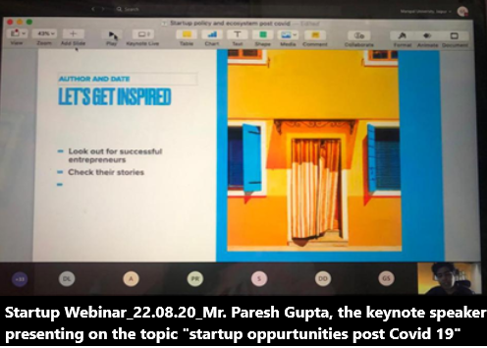
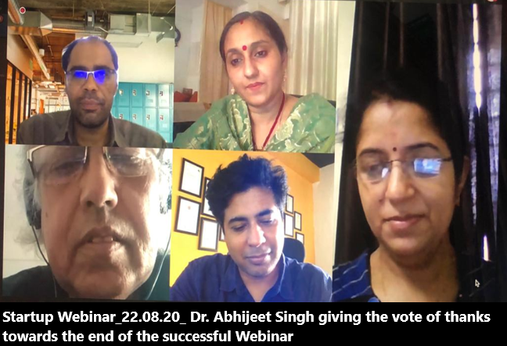

Faculty Coordinator: Dr. Mousumi Debnath
(Department Of Biosciences)

- Attendance of the Event: attached in the mail.

