Event Report

by

(BIOTECH CLUB)

Manipal University Jaipur

[DEBATE COMPETITION]
[10th AUGUST 2020]

Platform: MS Teams

- Brochure of the Event

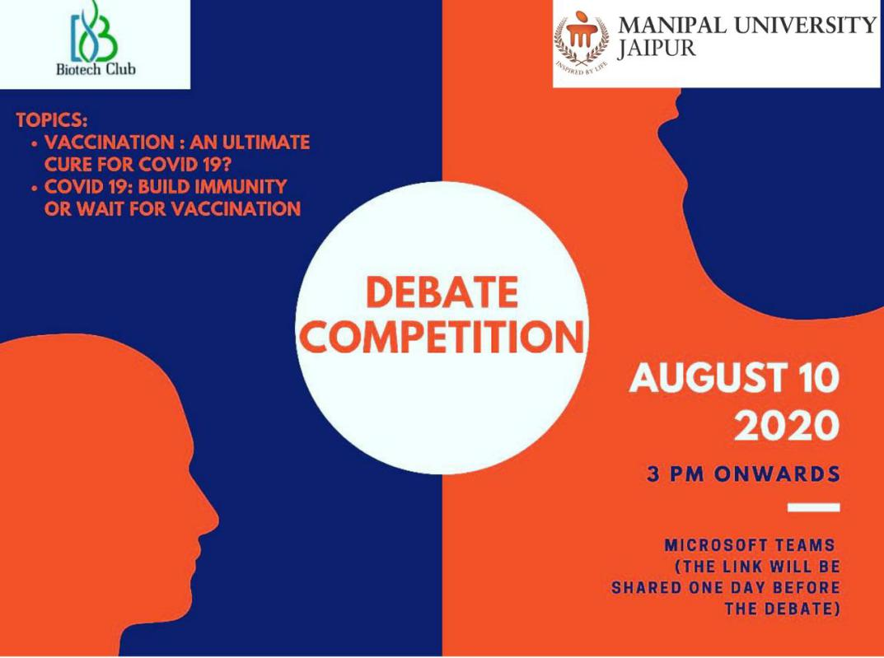

- Event schedule: The event was held on 10th August 2020 from 3 pm onwards.

Report of the Event (Day wise Report of the event with screenshots/photographs)-

MANIPAL UNIVERSITY JAIPUR, has always set the benchmark for conducting activities in such a way that the students not only enjoy but also learn a great deal from it. With the topic chosen for the year being"COVID-19 :: Build immunity or wait for vaccine." Some participants argued for the motion and some against the motion. The teams were well prepared, and they used various skills like overstatement, definition, rhetoric, irony etc. to convince the audience. The participants, armed with statistics and data validated and made their arguments more emphatic with right facial expressions, body movements and gestures. The participants speaking for both ‘for’ and ‘against’ the motion debated enthusiastically. The highlight of the event was the question answer round, as a volley of questions were answered confidently by both the sides, inviting counter questions which were aptly answered by witty and vivacious speakers. The session was a kaleidoscope of opinions, thoughts, ideas, and perspectives that enhanced the knowledge and understanding of the topic among students. All the teams exhibited great oratorical skills. They put in tremendous hard work to showcase their hidden talent The debaters displayed confidence in presenting their arguments before audience and a panel of eminent jury. The whole event was under the guidance of and also our one of the jury member Dr. Mousumi Debnath Faculty coordinator, Biotech Club. At the end of the heated but interesting debate which lasted over two hours finally Moushmi Goswami and Megha Gupta secured 1st position, in the series Shubhangi Seth got 2nd, Arunima Wasan 3rd and Jyotsna got consolation prize. At the end of the function, teachers delivered their presidential speech and thanked all for their participation in the function. They spoke highly of all the debaters for their logical arguments. As everything comes to an end the event ended in a very successful note giving all the audience bouquet of knowledge and motivating them for following the proper precautions and stay safe

SNAPSHOTS OF THE EVENT:

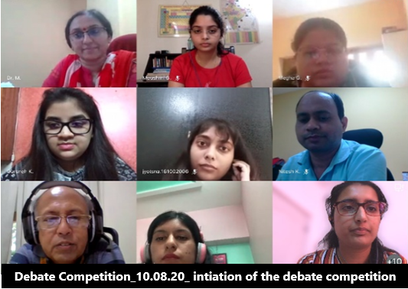

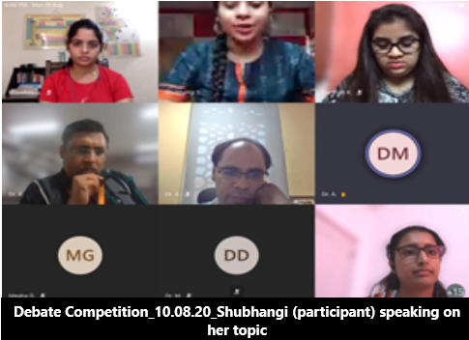

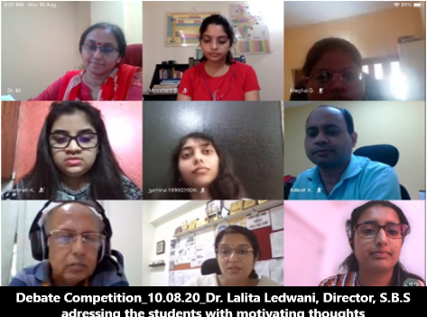

Faculty Coordinator: Dr. Mousumi Debnath
(Department Of Biosciences)

- Attendance of the Event: attached in the mail.

